OLIST BRAZILIAN E-COMMERCE DATASET
SALES PERFORMANCE & CUSTOMER ANALYTICS
Complete Project Report
End-to-End Analytics Workflow: Python · SQL Server · Statistics · Power BI

Prepared for: Marketplace Management, Operations & Seller Teams
Dataset: Olist Brazilian E-Commerce Public Dataset (9 relational tables, ~1.52M rows)
Report Date: August 2026

Table of Contents
1. Executive Summary 3
2. Business Understanding 4
3. Data Overview & Entity Relationship Model 6
4. Data Validation & Quality 8
5. Methodology 11
6. Analytical Findings 13
7. Dashboard Summary 15
8. Business Insights 18
9. Recommendations 19
10. Risks & Limitations 21
11. Conclusion 22

1. Executive Summary
This report presents the complete findings of an end-to-end e-commerce analytics project built on the Olist Brazilian E-Commerce public dataset — nine relational tables spanning customers, orders, order items, products, sellers, payments, reviews, and geolocation, covering the period September 2016 to October 2018.
The project combines Python (data validation, cleaning, feature engineering), SQL Server (business analysis views and queries), statistical analysis, and an interactive three-page Power BI dashboard to answer a central business question: how can Olist improve sustainable marketplace growth by understanding its revenue drivers, customer value, operational performance, and customer experience?
HEADLINE FINDING
Revenue is heavily concentrated in a single state (São Paulo, 37% of revenue) and a handful of product categories. Repeat customer rate is critically low at 3.01%, and delivery time shows a clear negative relationship with review scores — meaning logistics performance is directly shaping customer satisfaction, not just operational efficiency.

Key Figures at a Glance
99K  Total Customers | R$15.84M  Total Revenue | 99K  Total Orders | R$159.33  Avg. Order Value

3.01%  Repeat Customer Rate | 7.87%  Late Delivery Rate | 12.50  Avg. Delivery Days | 4.09 / 5  Avg. Review Score

The remainder of this report walks through the business context, the underlying data model and its validation, the analytical methodology, detailed findings, the dashboard built to communicate them, and the resulting business insights and recommendations.

2. Business Understanding

2.1 Business Problem
The marketplace needs to understand its sales performance, customer behavior, product/category performance, seller performance, delivery operations, and customer satisfaction in order to identify opportunities for revenue growth and operational improvement.

2.2 Business Objective
Use data to identify revenue and sales trends, high-performing products and categories, valuable customer segments, strong and weak sellers, delivery and logistics issues, customer satisfaction patterns, and geographic opportunities — then turn these findings into clear business recommendations.

2.3 Key Business Questions
- Sales — What are total sales, orders, and average order value? How are sales changing over time? Which categories generate the most revenue?
- Customers — Who are the highest-value customers? How many are repeat customers? What segments can be identified? Which regions have the highest demand?
- Products & Sellers — Which categories perform best? Which sellers generate the most sales? Which need attention?
- Delivery & Experience — What is the average delivery time? What percentage of orders are late? Does late delivery relate to lower review scores?
- Payments — Which payment methods are most common? What is the average transaction value by method?

2.4 Central Business Case
CENTRAL QUESTION
How can Olist improve sustainable marketplace growth by understanding its revenue drivers, customer value, operational performance, and customer experience?

2.5 Key KPIs Tracked
KPI | Purpose
Total Sales / Total Orders | Overall business performance and order volume
Unique Customers | Customer base size
Average Order Value | Average transaction value
Sales by Category | Category performance
Repeat Customer Rate | Customer retention
Average Review Score | Customer satisfaction
On-Time / Late Delivery Rate | Delivery performance / logistics problems
Average Delivery Days | Delivery speed
Freight Cost | Shipping cost burden
Sales by Region | Geographic performance
Seller Sales / Orders | Seller performance

2.6 Scope & Limitations
- Analysis is based on the available historical public Olist dataset.
- Findings represent patterns in the dataset and should not be interpreted as confirmed causal relationships.
- True company profit is not calculated because a complete cost structure is not available.
- Data-quality issues identified during validation were investigated and addressed before analysis.

2.7 Analytical Approach
- KPI and trend analysis
- Customer segmentation and RFM-style analysis
- Product/category and seller benchmarking
- Delivery and geographic analysis
- Pareto (80/20) analysis
- Correlation analysis and hypothesis testing where appropriate
- Root-cause analysis

3. Data Overview & Entity Relationship Model
The Olist dataset is fully relational, spread across nine CSV files linked by order, customer, product, and seller identifiers. The core grain is the individual order, with order items, payments, and reviews attaching at finer granularity.

3.1 File Inventory
# | File | Rows | Columns | Grain
1 | olist_customers_dataset.csv | 99,441 | 5 | 1 row / customer-order
2 | olist_geolocation_dataset.csv | 1,000,163 | 5 | Multiple rows / zip prefix
3 | olist_order_items_dataset.csv | 112,650 | 7 | 1 row / order item
4 | olist_order_payments_dataset.csv | 103,886 | 5 | 1+ rows / order
5 | olist_order_reviews_dataset.csv | 99,224 | 7 | 1 row / review
6 | olist_orders_dataset.csv | 99,441 | 8 | 1 row / order
7 | olist_products_dataset.csv | 32,951 | 9 | 1 row / product
8 | olist_sellers_dataset.csv | 3,095 | 4 | 1 row / seller
9 | product_category_name_translation.csv | 71 | 2 | 1 row / category

Total rows across all tables: 1,521,321. Time span: 2016-09-04 to 2018-10-17.

3.2 Entity Relationship Diagram
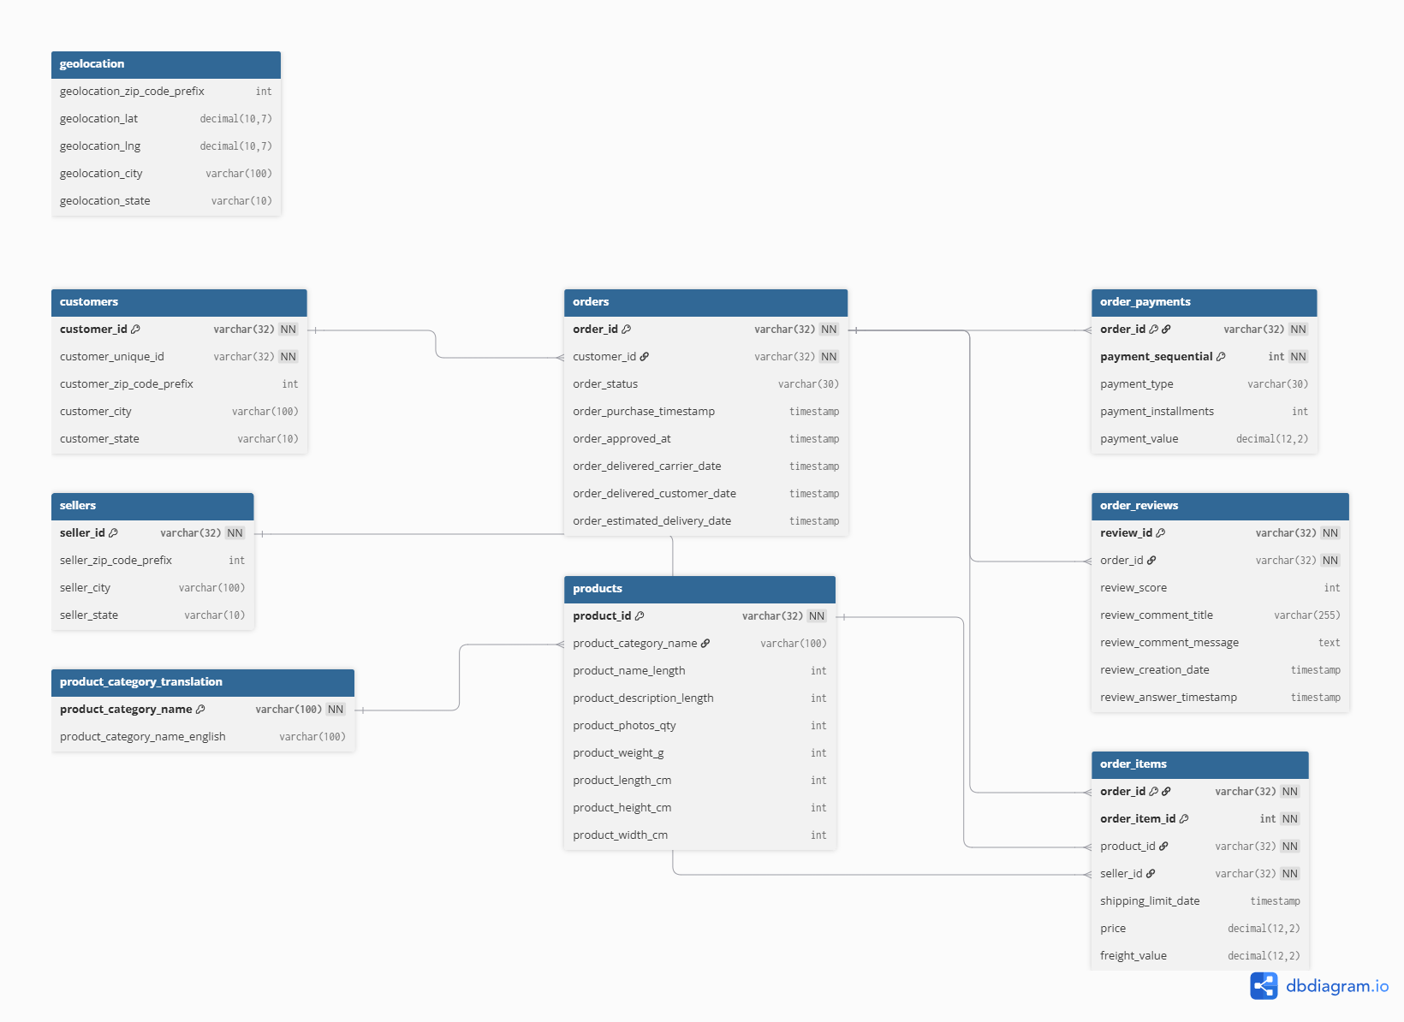
Figure 1 — Relational schema: customers → orders → order_items → products / sellers, with order_payments and order_reviews attached at the order level, and geolocation linked via zip code prefix.

3.3 Relational Structure Summary
Relationship | Cardinality | Status
customers → orders | 1 : M | Pass — 1 customer_id per order
orders → order_items | 1 : M | Pass — 775 orders have zero items
orders → order_payments | 1 : M | Pass — 1 order missing payment record
orders → order_reviews | 1 : M (expected 1:1) | Partial — 768 orders missing review; 1,098 have >1 review
order_items → products | M : 1 | Pass — full match
order_items → sellers | M : 1 | Pass — full match
products → category_translation | M : 1 | Partial — 13 categories unmatched
customers / sellers → geolocation | M : 1 (via zip prefix) | Partial — ~0.3% zip prefixes unmatched

4. Data Validation & Quality
Before any analysis, all nine tables were validated for structural integrity, data types, missing values, duplicates, referential integrity, and business-rule compliance.

4.1 Structural & Data Type Validation
- Consistent column counts, header rows, and comma delimiters — Pass across all 9 files.
- Minor encoding issue: a byte-order-mark (BOM) character in the category translation header.
- All timestamp columns (orders, order_items, order_reviews) were stored as text and required conversion to datetime.
- Price, freight, payment value, and review score fields matched their expected types.

4.2 Missing Values
Table | Column | Missing Count | Missing %
order_reviews | review_comment_title | 87,656 | 88.34%
order_reviews | review_comment_message | 58,247 | 58.70%
orders | order_delivered_customer_date | 2,965 | 2.98%
orders | order_delivered_carrier_date | 1,783 | 1.79%
products | category name / name length / desc length / photos qty | 610 | 1.85%
orders | order_approved_at | 160 | 0.16%
products | weight_g / dimensions | 2 | 0.01%

Missing review comment fields are expected — writing a comment is optional. Missing delivery dates cluster in orders that were canceled or never delivered.

4.3 Duplicate Records
Table | Duplicate Type | Count
geolocation | Full-row duplicates | 261,831
order_reviews | Duplicate review_id | 1,603 rows (814 IDs)
order_reviews | Duplicate order_id (multiple reviews/order) | 1,098 rows
customers / order_items / order_payments / orders / products / sellers | Full-row duplicates | 0

CRITICAL ISSUE
The 261,831 duplicate rows in geolocation (26% of that table) is the single largest data-quality issue in the dataset and required deduplication before the table could be reliably used for zip-code-level joins.

4.4 Business Rule Validation
Rule | Result
price > 0 | Pass (0 violations)
freight_value >= 0 | Pass (0 violations)
payment_value > 0 | Fail — 9 rows ≤ 0
payment_installments >= 1 | Fail — 2 rows with 0 installments
payment_type in defined set | Pass (incl. 'not_defined', 3 rows)
review_score between 1–5 | Pass (0 violations)
order_status = delivered ⇒ delivery date not null | Fail — 8 rows violate
product weight/dimensions > 0 | Fail — 4 rows with 0 weight
customer_state / seller_state valid Brazilian UF codes | Pass (27 / 23 states)

4.5 Date Logic Validation
Check | Violations
order_approved_at >= order_purchase_timestamp | 0
order_delivered_carrier_date >= order_approved_at | 1,359
order_delivered_customer_date >= order_delivered_carrier_date | 23
order_delivered_customer_date >= order_purchase_timestamp | 0
Delivered after order_estimated_delivery_date (late orders) | 7,827 (7.87% of orders)

4.6 Final Validation Summary & SQL Readiness
Metric | Result
Tables validated | 9 / 9
Structural integrity | Pass
Primary key integrity | 8 / 9 Pass (order_reviews fails on review_id uniqueness)
Foreign key integrity | Pass (>99.7% across all relationships)
Overall data quality | Good — usable after targeted cleaning

SQL READINESS DECISION
Ready for SQL load after: (1) datetime casting on all timestamp columns, (2) geolocation deduplication, (3) a review_id surrogate key / dedup strategy, and (4) resolving the 13 unmatched product categories.

5. Methodology

5.1 Python — Data Preparation
Python was used to inspect and validate all nine source files, clean and standardize them, integrate related tables, engineer analytical features (delivery days, late-delivery flags, repeat-customer flags, category revenue), explore distributions, and identify patterns and anomalies ahead of SQL loading.
- Structural, type, missing-value, duplicate, and business-rule validation across all tables (documented in Section 4)
- Timestamp conversion for all date columns
- Geolocation deduplication
- Feature engineering: delivery days, on-time/late flags, repeat vs. one-time customer classification

5.2 SQL Server — Business Analysis
A normalized SQL Server schema (see ERD, Section 3.2) was created with primary and foreign keys enforced across customers, orders, order_items, products, sellers, order_payments, and reviews. Seven reusable analytical views were then built directly on top of the relational model:
View | Purpose
vw_MonthlySales | Monthly order count and revenue trend
vw_CategoryPerformance | Items sold and revenue by product category
vw_SellerPerformance | Orders and revenue by seller
vw_StatePerformance | Orders and revenue by customer state
vw_PaymentPerformance | Payment count, total value, and average by payment type
vw_DeliveryPerformance | On-time vs. late delivery order counts
vw_ReviewPerformance | Distribution of review scores (1–5)

Building these as views (rather than one-off queries) makes the analysis reproducible: any management question about monthly trends, category performance, seller performance, state performance, payments, delivery, or reviews can be answered directly from the database without re-writing logic.

5.3 Statistical Analysis
Statistical analysis was used to understand the shape and variation of the data rather than relying only on totals — using mean, median, standard deviation, quartiles, IQR, percentiles, correlation, and outlier analysis.
- Skewed transaction data: a small number of high-value transactions can pull averages upward, so medians and percentiles were tracked alongside means.
- Delivery variation: average delivery time can mask a subset of extremely delayed orders — the distribution, not just the mean, matters operationally.
- Correlation analysis was used to examine the relationship between delivery time and review score (see Section 6.5).
- Outliers (very high-value orders, very long deliveries) were investigated rather than automatically removed, since they may represent genuine business cases or real operational failures.

5.4 Power BI — Dashboard & Reporting
The final deliverable is a three-page interactive Power BI dashboard — Executive Overview, Customer & Product Performance, and Delivery & Customer Experience — with a year filter allowing stakeholders to explore trends over the full 2016–2018 period. Dashboard findings are detailed in Section 7.

6. Analytical Findings

6.1 Sales & Revenue
The marketplace processed roughly 99,000 orders from 99,000 unique customers, generating R$15.84M in total revenue at an average order value of R$159.33. The monthly revenue trend (see Section 7.1) shows the business scaling from late 2016 through a peak, before the visible decline toward the end of the observed window — consistent with the dataset's known 2018 cut-off rather than a genuine demand collapse.

6.2 Geographic Concentration
Revenue is heavily concentrated by state. Using the state-level revenue breakdown:
State | Orders / Items | Revenue (R$) | Share of Revenue
SP (São Paulo) | 41,375 | 5,921,678 | 37.4%
RJ (Rio de Janeiro) | 12,762 | 2,129,682 | 13.4%
MG (Minas Gerais) | 11,544 | 1,856,161 | 11.7%
RS (Rio Grande do Sul) | 5,432 | 885,827 | 5.6%
PR (Paraná) | 4,998 | 800,935 | 5.1%
All other states (21) | 22,555 | 4,249,270 | 26.8%

PARETO FINDING
The top 5 states generate 73.2% of total revenue, and São Paulo alone accounts for 37.4%. This is a Pareto-style concentration: geographic risk and opportunity are both concentrated in a small number of states.

6.3 Product & Category Performance
Top categories by revenue include beleza_saude (health & beauty), relogios_presentes (watches & gifts), cama_mesa_banho (bed, bath & table), esporte_lazer (sports & leisure), informatica_acessorios (computer accessories), and moveis_decoracao (furniture & decor). Product revenue reached R$13.59M across 33,000 unique products and 3,000 unique sellers.
Category revenue and items sold move closely together (a scatter of category revenue vs. items sold shows a clear positive relationship), but a handful of categories achieve above-trend revenue per item — signaling higher-price or higher-margin categories worth protecting and promoting.

6.4 Customer Retention
CRITICAL FINDING
Repeat Customer Rate is just 3.01%. Roughly 97 of every 100 customers who purchase from Olist never come back for a second order.
This is the single most important customer-side finding in the analysis. With customer acquisition presumably costing real marketing spend, a 3% repeat rate means the business is almost entirely dependent on continuously acquiring new customers rather than growing value from existing ones.

6.5 Delivery Performance & Its Link to Reviews
Metric | Value
Delivered Orders | 96K
Average Delivery Days | 12.50
Late Delivery Rate | 7.87%
Average Review Score | 4.09 / 5

Average delivery time fell sharply from over 50 days in the earliest months (2016) to a stable band close to 10–15 days by 2018 — a clear sign of operational maturation over the observed period.
The delivery-time-vs-review-score relationship is visibly negative: orders with shorter delivery times cluster around 4.0–4.2 average review scores, while orders with delivery times approaching 30 days cluster closer to 3.6–3.8. This is an association, not proof of causation — product quality and seller service also shape reviews — but the pattern is consistent enough to treat delivery as a real driver of customer satisfaction.
Late deliveries are themselves geographically concentrated: São Paulo (2.4K late orders), Rio de Janeiro (1.7K), and Minas Gerais (0.6K) account for the majority of late-delivery volume — notably the same states that drive the most revenue, meaning delivery problems in these states have outsized customer-experience impact.

6.6 Payment Behavior
Credit card is the dominant payment method by a wide margin (R$13M in payment value), followed by boleto (a Brazilian bank-slip payment method, R$3M). Voucher, debit card, and undefined payment types are marginal by comparison. This concentration suggests credit card processing reliability and fees are disproportionately important to the business's payment economics.

6.7 Order Status Mix
The large majority of orders reach 'delivered' status, with small shares of shipped, canceled, unavailable, and invoiced orders. Canceled and unavailable orders, while a small percentage, represent both lost revenue and a customer-experience risk worth monitoring as a discrete KPI rather than folding into the delivered-order totals.

7. Dashboard Summary
The Power BI dashboard translates the analysis into three interactive pages, each filterable by year.

7.1 Page 1 — Executive Overview
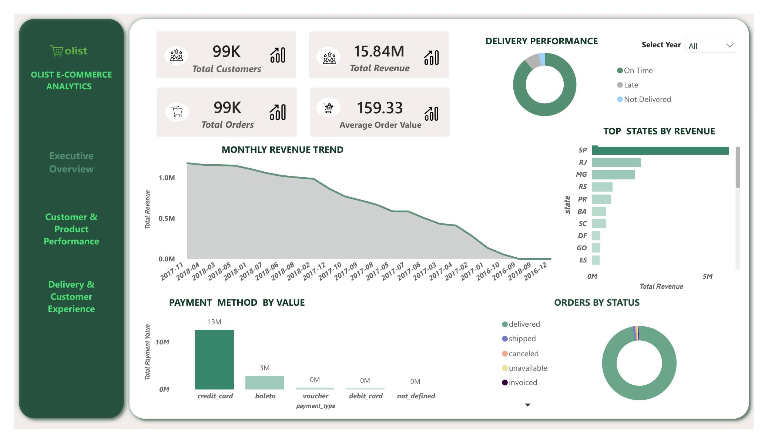
Figure 2 — Executive Overview: headline KPIs, monthly revenue trend, delivery performance, top states by revenue, payment method by value, and orders by status.
- Total Customers 99K · Total Revenue R$15.84M · Total Orders 99K · Average Order Value R$159.33
- Delivery performance donut shows the large majority of orders arriving on time, with smaller Late and Not Delivered slices
- Top states by revenue: SP leads by a wide margin, followed by RJ and MG, consistent with the geographic concentration in Section 6.2
- Payment method by value: credit_card (R$13M) dominates over boleto (R$3M) and marginal voucher / debit_card / not_defined values
- Orders by status: the vast majority are 'delivered', with small slices for shipped, canceled, unavailable, and invoiced

7.2 Page 2 — Customer & Product Performance
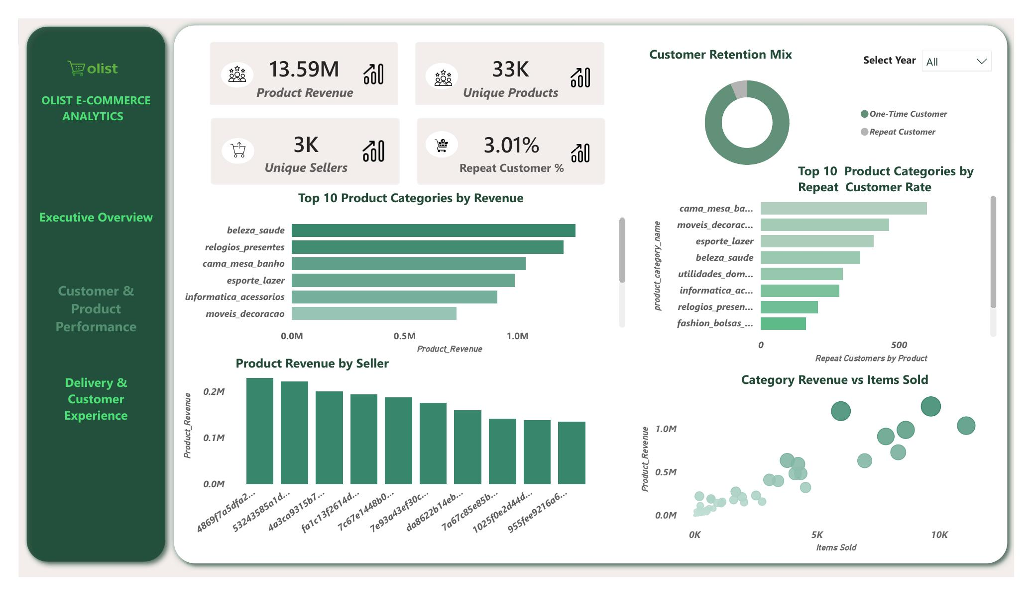
Figure 3 — Customer & Product Performance: product revenue, unique products/sellers, repeat customer mix, top categories by revenue and repeat rate, and category revenue vs. items sold.
- Product Revenue R$13.59M · Unique Products 33K · Unique Sellers 3K · Repeat Customer % 3.01%
- Customer Retention Mix donut visually confirms how small the repeat-customer slice is relative to one-time customers
- Top 10 product categories by revenue: beleza_saude and relogios_presentes lead
- Top 10 categories by repeat customer rate: cama_mesa_banho and moveis_decoracao lead — worth noting these differ from the top-revenue category ranking, meaning the categories that drive revenue are not always the categories that drive loyalty
- Category Revenue vs. Items Sold scatter shows a generally positive relationship with a few categories over-performing on revenue relative to volume

7.3 Page 3 — Delivery & Customer Experience
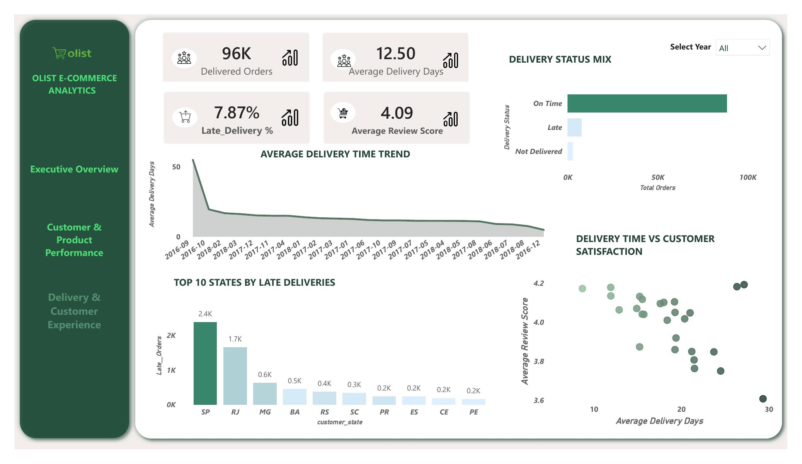
Figure 4 — Delivery & Customer Experience: delivered orders, delivery speed trend, delivery status mix, late deliveries by state, and delivery time vs. review score.
- Delivered Orders 96K · Average Delivery Days 12.50 · Late Delivery % 7.87% · Average Review Score 4.09
- Average Delivery Time Trend shows delivery speed improving dramatically from 2016 through 2018 — from roughly 50+ days down to a stable ~10–15 day band
- Delivery Status Mix confirms On Time orders vastly outnumber Late and Not Delivered orders
- Top 10 States by Late Deliveries: SP, RJ, and MG again dominate, mirroring the revenue concentration seen in Section 6.2 and 7.1
- Delivery Time vs. Customer Satisfaction scatter shows a visible downward slope — longer delivery times associate with lower average review scores, supporting the finding in Section 6.5

8. Business Insights
The central business lesson from this project is that sales performance should not be viewed in isolation. Revenue, order volume, customer behavior, seller quality, delivery performance, and reviews are connected — and the analysis was used to identify practical areas where the business can protect revenue, improve customer experience, and support sustainable growth.

Insight 1 — Growth is driven by two separate levers: order volume and order value.
Revenue can rise from more orders, higher-value orders, or both. Management should track Revenue, Orders, and Average Order Value together every month, and specifically investigate any period where orders increase but AOV falls, since that signals a shift toward lower-value baskets that could erode margin even as top-line revenue grows.

Insight 2 — Customer acquisition and retention are two different problems, and Olist has solved only one.
A 99K-customer base with a 3.01% repeat rate means acquisition is working, but almost nothing is being done — or is working — to bring customers back. A large customer base does not automatically mean strong long-term customer value.

Insight 3 — The highest-volume category is not automatically the highest-value category.
Categories need to be evaluated on sales, orders, average price, freight, reviews, and delivery together — not order volume alone. The mismatch between top-revenue categories and top-repeat-rate categories (Section 7.2) is direct evidence of this: a category can drive one-time revenue without building loyalty.

Insight 4 — Seller sales alone are not a quality measure.
A high-sales seller with poor delivery or low reviews creates outsized customer-experience risk, because their problems touch more customers than a low-volume seller's would. Seller performance needs to be scored on sales, review score, and late-delivery rate together, not sales alone.

Insight 5 — Delivery is a customer-experience issue, not just a logistics issue.
The negative relationship between delivery time and review score (Section 6.5, 7.3) shows that operational performance directly shapes how customers perceive the marketplace. Late deliveries also concentrate in the same top-revenue states (SP, RJ, MG), meaning delivery problems there carry the largest customer-experience cost.

Insight 6 — Geography represents both concentrated risk and a clear expansion framework.
With 73% of revenue coming from just 5 states, Olist's growth is geographically concentrated. A region with strong demand but weak delivery represents both a problem and an opportunity — and should be prioritized for logistics investment before further demand-generation spend.

Insight 7 — Customers experience total cost, not product price alone.
A low product price can still feel unattractive when freight is high. Freight-to-price ratio should be monitored by category and seller-region combination, since shipping cost is a real driver of purchase decisions even when it doesn't appear in the headline product price.

9. Recommendations
The following recommendations are ordered by expected business impact, drawing directly on the findings above.

1. Improve delivery reliability in high-impact states — highest priority.
Focus first on São Paulo, Rio de Janeiro, and Minas Gerais, which combine the highest revenue share with the highest late-delivery volume. Separate seller-handling delays from carrier/transportation delays, set improvement targets, and monitor late deliveries weekly rather than monthly.

2. Build a seller scorecard combining sales, reviews, and delivery performance.
Classify sellers as Strategic (high sales + strong service), Growth (good service + room to grow), At Risk (high sales + poor service), or Low Contribution (low sales + weak performance). Prioritize improvement plans for high-sales, poor-performing sellers first, since fixing them protects the most customers.

3. Launch a repeat-purchase program — urgent given the 3.01% baseline.
Identify one-time customers specifically and launch post-purchase and second-purchase campaigns, product recommendations, and loyalty incentives. Track repeat customer rate and orders-per-customer as primary retention KPIs going forward — even modest improvement here compounds significantly given how low the current baseline is.

4. Optimize the product category portfolio using multiple KPIs, not just revenue.
Protect high-volume/high-value categories, investigate low-volume/high-value categories for targeted growth, and use cross-selling and complementary-product recommendations on high-volume/lower-value categories to increase basket size.

5. Apply a demand-vs-delivery framework to regional investment.
Use the decision matrix below to decide where to expand marketing spend versus where to fix logistics first, rather than investing in demand generation ahead of service capability.
Situation | Recommended Action
High demand + good delivery | Expand
High demand + poor delivery | Fix logistics first
Low demand + good delivery | Test targeted marketing
Low demand + poor delivery | Keep investment limited

6. Monitor customer experience through low-review rates, not just averages.
Track the proportion of 1–2 star reviews specifically (not just the overall average, which can hide problem pockets), connect poor reviews to delivery and seller performance, and investigate repeated low-review patterns by seller/category/region combination.

7. Monitor freight burden relative to product price.
Identify categories and seller-region combinations with unusually high freight-to-price ratios, explore regional seller coverage to reduce shipping distance, and test free-shipping thresholds where commercially viable.

9.1 Priority Action Matrix
Priority | Focus Area | Primary KPI | Recommended Action
1 — Highest urgency | Delivery in SP / RJ / MG | Late delivery %, avg. delivery days | Root-cause delays; weekly monitoring
2 — Protect experience | Seller quality | Review score, late-delivery rate | Scorecard + improvement plans for at-risk sellers
3 — Fix the leak | Customer retention | Repeat customer % | Second-purchase campaigns, loyalty incentives
4 — Grow value | Category portfolio | Category sales, AOV | Cross-sell on strong categories, revive weak ones
5 — Prioritize expansion | Regional investment | Regional demand vs. delivery rate | Demand/delivery decision framework
6 — Early warning system | Review monitoring | Low-review % (1–2 star) | Track and investigate patterns by seller/region

10. Risks & Limitations
- Correlation is not causation. The delivery-time / review-score relationship is a strong association, but reviews are also shaped by product quality, seller service, and customer expectations that are not fully captured in this dataset.
- True profit cannot be calculated — a complete cost structure (cost of goods, marketing spend, fulfillment cost) is not available in the public dataset, so all financial findings are revenue-based, not margin-based.
- The apparent revenue decline toward the end of the observed window (late 2018) most likely reflects the dataset's cut-off date rather than genuine business decline, and should not be read as a demand collapse.
- Known data-quality issues were addressed before analysis, but some — such as the 13 unmatched product categories and residual review_id duplicates — mean a small share of category- and review-level figures carry minor uncertainty.
- Geolocation join accuracy is approximately 99.7%, so a small fraction of state/region-level figures may carry minor positional imprecision.
- Findings reflect patterns in a specific historical dataset (Sept 2016 – Oct 2018) and may not directly generalize to current marketplace conditions.

11. Conclusion
This project demonstrates a complete, evidence-based analytics workflow for an e-commerce marketplace — from raw relational data through validation, SQL business analysis, statistical testing, and an interactive dashboard — arriving at a connected view of the business rather than a collection of isolated metrics.
The strongest management takeaway is that Sales, Customers, Products, Sellers, Delivery, and Reviews form a single connected chain. Revenue growth that ignores retention, seller quality, or delivery reliability is fragile. The most practical path forward is to protect revenue by tracking orders and AOV together, fix the customer retention leak (3.01% repeat rate), raise seller accountability through a combined sales-and-service scorecard, resolve delivery problems in the highest-impact states first, and use review patterns as an early warning system for operational issues.

RECOMMENDED NEXT STEP
Recommended first move: launch a repeat-purchase pilot for one-time customers in the top 3 revenue states (SP, RJ, MG), paired with a delivery root-cause review in those same states — testing whether fixing the delivery experience measurably lifts the repeat-purchase rate.

