Name : Harit Joshi

Branch : IT - 2A

Roll no. : 1900300130038

Subject : Python (KCS - 453)

Prac - 1:

**AIM:** WAP a python program to perform selection sort.

**PROGRAM:**

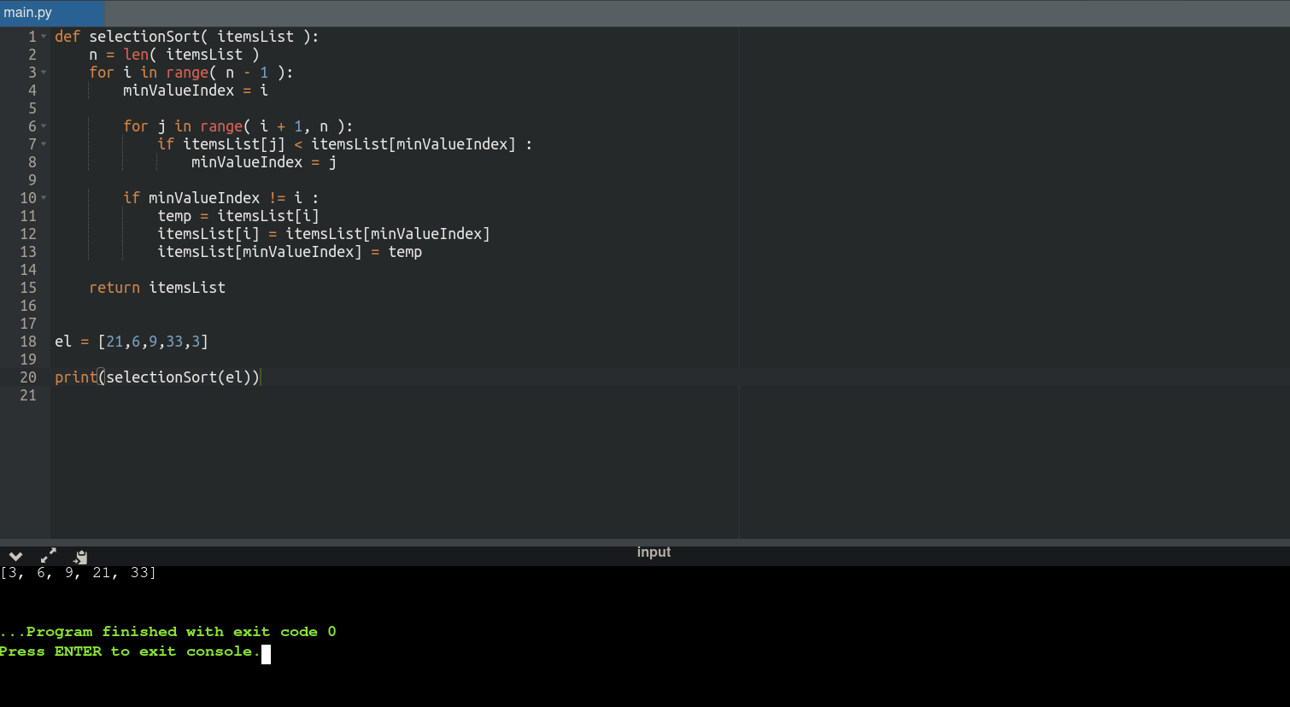

Prac - 2:

**AIM:** WAP a python program to find GCD of 2 numbers.

**PROGRAM:**

