MADURAI KAMARAJ UNIVERSITY
MASTER OF SCIENCE IN COMPUTER SCIENCE
PROJECT REPORT
SMART AGRICULTURE ANALYTICS
A Data Analytics and Machine Learning Based Agricultural Analytics System
Submitted by
HARIVATHANI A
Register Number: ____________________
Under the Guidance of
____________________________
Project Guide
DEPARTMENT OF COMPUTER SCIENCE
MADURAI KAMARAJ UNIVERSITY
2026

CERTIFICATE
This is to certify that the project report entitled “SMART AGRICULTURE ANALYTICS” is a bonafide work carried out by HARIVATHANI A in partial fulfillment of the requirements for the award of the degree of Master of Science in Computer Science under Madurai Kamaraj University, during the academic year 2025–2026.
The work presented in this report has been completed under the guidance and supervision of the undersigned and is submitted for academic evaluation.

Project Guide | Head of the Department
Signature: ____________________ | Signature: ____________________
Name: _________________________ | Name: _________________________

Date: ____________________
Place: ___________________

DECLARATION
I, HARIVATHANI A, hereby declare that the project entitled
“SMART AGRICULTURE ANALYTICS” is my original work carried out as part of the requirements for the completion of the Master of Science in Computer Science under Madurai Kamaraj University.
I further declare that this project has been developed under the guidance of my project guide and that the work presented in this report has not been submitted previously, either in whole or in part, for the award of any other degree, diploma, or qualification.

Place: ___________________
Date: ____________________
Signature of the Student: __________________________
Name: HARIVATHANI A

ACKNOWLEDGEMENT
I express my sincere gratitude to Madurai Kamaraj University for providing the academic environment and opportunity to undertake this project as part of the Master of Science in Computer Science programme.
I would like to express my sincere thanks to the faculty members of the Department of Computer Science for their valuable support, encouragement, and guidance throughout the development of this project.
I am especially grateful to my project guide for the continuous guidance, constructive suggestions, technical support, and encouragement provided during the planning, development, testing, and documentation of the project.
I also thank my classmates, friends, and family members for their encouragement and support during the successful completion of this project.
Finally, I thank everyone who directly or indirectly contributed to the successful completion of Smart Agriculture Analytics.

HARIVATHANI A

ABSTRACT
Agriculture generates large volumes of information related to crop production, soil characteristics, weather conditions, irrigation, fertilizer usage, market prices, and yield. Effective analysis of these factors can help identify patterns and support data-driven agricultural decision-making.
Smart Agriculture Analytics is a Python-based data analytics and machine learning project developed to analyze agricultural data through a single interactive platform. The project works with approximately 5,000 agricultural records containing information about crops, states, seasons, soil nutrients, rainfall, temperature, humidity, irrigation, fertilizer, pesticide usage, production, yield, market price, and revenue.
The system performs data generation, data cleaning, exploratory data analysis, database management, SQL analytics, machine learning, and interactive visualization. SQLite is used to store agricultural records and analytical summaries. SQL queries are used to obtain crop-wise, state-wise, seasonal, irrigation-related, production, yield, and revenue insights.
A Random Forest Classification model is implemented for crop recommendation using soil and environmental attributes such as nitrogen, phosphorus, potassium, temperature, humidity, rainfall, and soil pH. A Random Forest Regression model is implemented to predict yield in tons per hectare using agricultural, environmental, soil, management, market, crop, season, and irrigation attributes.
The final system is presented through an interactive Streamlit dashboard containing Dashboard, Data Analysis, Crop Recommendation, Yield Prediction, SQL Analytics, and Dataset sections. The project demonstrates the integration of data analytics, SQL, machine learning, and visualization techniques in an agricultural domain.

TABLE OF CONTENTS
1. Introduction
2. Problem Statement
3. Objectives
4. Existing System
5. Proposed System
6. System Requirements
7. System Analysis and Design
8. Dataset Description
9. Data Preprocessing
10. Exploratory Data Analysis
11. Database and SQL Analysis
12. Machine Learning Methodology
13. Crop Recommendation
14. Yield Prediction
15. System Implementation
16. Streamlit Dashboard
17. Results and Discussion
18. Testing
19. Conclusion
20. Future Enhancements
21. References

CHAPTER 1
INTRODUCTION

1.1 Background
Agriculture is an important sector that contributes to food production, employment, and economic development. Agricultural productivity depends on multiple interacting factors, including soil nutrients, rainfall, temperature, humidity, irrigation, fertilizer application, crop type, season, and geographical conditions.
Modern agriculture increasingly produces digital data from field records, environmental measurements, production statistics, and market information. Data analytics provides methods for transforming such raw data into useful information, while machine learning can identify relationships and patterns that may not be easily recognized through manual analysis.

1.2 Project Overview
Smart Agriculture Analytics is an integrated analytical application developed using Python, SQL, machine learning, and Streamlit. The system processes agricultural records, performs data cleaning and exploratory analysis, stores information in SQLite, executes analytical SQL queries, trains machine learning models, and presents results through an interactive dashboard.

1.3 Need for the Project
Agricultural datasets can contain thousands of records and multiple variables. Manual examination of such datasets is time-consuming and makes it difficult to identify trends in production, yield, environmental conditions, irrigation, and revenue. A centralized analytical platform can simplify these tasks and make the results easier to explore.
- Organize and clean agricultural data.
- Identify patterns in production and yield.
- Analyze environmental and soil factors.
- Perform database and SQL-based analytics.
- Recommend crops from soil and environmental inputs.
- Predict crop yield using machine learning.
- Present analytical results through an interactive dashboard.

1.4 Scope of the Project
- Agricultural data cleaning and preprocessing.
- Exploratory data analysis and visualization.
- SQLite database creation and SQL analytics.
- Crop recommendation using Random Forest Classification.
- Yield prediction using Random Forest Regression.
- Interactive Streamlit-based analytical dashboard.
- Downloadable analytical outputs and dataset exploration.

1.5 Technologies Used
Technology | Purpose
Python | Core development and analytics
Pandas | Data processing and manipulation
NumPy | Numerical operations
Matplotlib | Data visualization
Seaborn | Statistical visualization
SQLite | Database storage
SQL | Analytical queries
Scikit-learn | Machine learning
Random Forest | Classification and regression
Joblib | Model serialization
Streamlit | Interactive dashboard
Visual Studio Code | Development environment

1.6 Project Workflow
The overall workflow begins with agricultural data generation and cleaning. The cleaned dataset is explored using statistical summaries and visualizations. The data is then stored in an SQLite database for SQL-based analysis. Machine learning models are trained for crop recommendation and yield prediction. Finally, the outputs are integrated into a Streamlit dashboard.
Agricultural Data → Data Cleaning → EDA → SQLite Database → SQL Analysis → Machine Learning → Streamlit Dashboard

1.7 Advantages
- Provides centralized agricultural data analysis.
- Combines analytics, SQL, machine learning, and visualization.
- Supports interactive exploration of agricultural records.
- Provides crop recommendation based on input conditions.
- Provides yield prediction in tons per hectare.
- Makes analytical outputs accessible through a web-based local dashboard.

1.8 Organization of the Report
The report presents the complete development of Smart Agriculture Analytics, beginning with the project background and objectives, followed by system analysis, dataset preparation, exploratory analysis, database and SQL implementation, machine learning models, system implementation, dashboard development, results, testing, conclusion, and future enhancements.

CHAPTER 2
PROBLEM STATEMENT
Agricultural data contains information from multiple dimensions such as crop type, location, season, soil, weather, irrigation, agricultural inputs, production, yield, and market conditions. When these records are maintained as raw tabular data, users may find it difficult to identify important patterns and relationships.
Traditional analysis may require separate tools for data cleaning, visualization, database analysis, and prediction. This separation can make the overall analytical workflow less convenient and can increase the time required to obtain useful insights.

2.1 Problem Definition
The problem addressed by this project is to design and implement an integrated agricultural analytics system that can clean and analyze agricultural data, store it in a structured database, perform SQL analytics, recommend suitable crops based on selected environmental and soil parameters, predict crop yield, and present the results through an interactive dashboard.

2.2 Key Challenges
- Handling and preparing multi-variable agricultural data.
- Understanding relationships between environmental conditions and yield.
- Organizing analytical data for SQL queries.
- Building machine learning models for classification and regression tasks.
- Presenting multiple analytical functions in a single user interface.

CHAPTER 3
OBJECTIVES
The primary objective of Smart Agriculture Analytics is to develop an integrated platform for agricultural data analysis and machine learning.

3.1 Specific Objectives
- Generate and maintain a structured agricultural dataset.
- Clean and preprocess agricultural records.
- Perform exploratory data analysis using statistical summaries and charts.
- Create an SQLite database for structured storage.
- Develop SQL queries for agricultural analytics.
- Build a Random Forest classification model for crop recommendation.
- Build a Random Forest regression model for yield prediction.
- Develop an interactive Streamlit dashboard.
- Provide users with an easy-to-use interface for analysis and prediction.
- Generate downloadable analytical outputs where appropriate.

CHAPTER 4
EXISTING SYSTEM
In a conventional agricultural analysis workflow, data may be stored in spreadsheets or raw datasets and analyzed manually using separate tools. Users may need to perform data cleaning, calculations, visualization, database analysis, and prediction as separate activities.

4.1 Limitations of the Existing Approach
- Manual analysis can be time-consuming for large datasets.
- Raw data may contain inconsistencies or missing values.
- Analytical results may be distributed across different files or tools.
- Machine learning predictions are not always integrated with conventional analytics.
- Users may not have a single interface for data exploration and prediction.

CHAPTER 5
PROPOSED SYSTEM
The proposed Smart Agriculture Analytics system integrates data preparation, exploratory analysis, SQL, machine learning, and visualization into a single application. The system uses a cleaned agricultural dataset as the main analytical source and provides separate dashboard sections for major tasks.

5.1 Major Modules
Module | Description
Data Processing | Generates, cleans, and prepares agricultural records.
EDA | Produces statistical summaries and visualizations.
Database | Stores agricultural data and summaries in SQLite.
SQL Analytics | Runs analytical queries and exports results to Excel.
Crop Recommendation | Predicts a suitable crop from soil and environmental inputs.
Yield Prediction | Predicts yield in tons per hectare.
Dashboard | Provides an interactive user interface through Streamlit.
Dataset Viewer | Allows filtering, searching, and downloading data.

CHAPTER 6
SYSTEM REQUIREMENTS

6.1 Software Requirements
- Windows operating system or another Python-compatible operating system.
- Python 3.x
- Visual Studio Code
- Pandas
- NumPy
- Matplotlib
- Seaborn
- SQLite
- Scikit-learn
- Joblib
- Streamlit

6.2 Hardware Requirements
- Processor: Modern dual-core processor or better.
- RAM: 4 GB minimum; 8 GB or more recommended.
- Storage: Sufficient space for Python environment, datasets, models, and reports.
- Display: Standard monitor capable of running a web browser.

CHAPTER 7
SYSTEM ANALYSIS AND DESIGN

7.1 System Architecture
The system follows a pipeline architecture. Agricultural records are first prepared and cleaned. The cleaned data is used by the EDA module and inserted into the SQLite database. SQL analytics produce summarized results. The machine learning modules train and load models for crop recommendation and yield prediction. Streamlit connects these components through an interactive interface.
DATASET
↓
CLEANING & PREPROCESSING
↓
EDA + SQLITE DATABASE
↓
SQL ANALYTICS + MACHINE LEARNING
↓
STREAMLIT DASHBOARD

7.2 Data Flow
- Input: Agricultural records and user-provided prediction parameters.
- Processing: Cleaning, transformation, analysis, and model inference.
- Storage: CSV files, SQLite database, Excel analytical output, and serialized models.
- Output: Charts, summaries, recommended crop, predicted yield, and dashboard views.

CHAPTER 8
DATASET DESCRIPTION
The project uses an agricultural dataset containing approximately 5,000 records. The dataset represents agricultural, environmental, soil, management, production, and financial attributes used for analysis and machine learning.

8.1 Important Dataset Attributes
Attribute | Description
Crop | Crop category.
State | Geographical state/category.
Season | Agricultural season.
Area_Hectares | Cultivated area in hectares.
Rainfall_mm | Rainfall measurement in millimetres.
Temperature_C | Temperature in degrees Celsius.
Humidity_Percent | Humidity percentage.
Soil_N | Soil nitrogen level.
Soil_P | Soil phosphorus level.
Soil_K | Soil potassium level.
Soil_pH | Soil pH value.
Irrigation | Irrigation category.
Fertilizer_kg | Fertilizer quantity.
Pesticide_Liters | Pesticide quantity.
Production_Tons | Agricultural production in tons.
Yield_Tons_Per_Hectare | Yield per hectare.
Market_Price_Per_Ton | Market price per ton.
Revenue | Revenue generated from production.

CHAPTER 9
DATA PREPROCESSING
Data preprocessing is an important stage because machine learning and analytical results depend on the quality of the input data. The project uses a separate cleaning process to prepare the raw agricultural dataset.

9.1 Cleaning Steps
- Load the raw CSV dataset using Pandas.
- Inspect column names and data types.
- Check for missing values.
- Handle duplicate or inconsistent records where required.
- Convert numerical attributes into appropriate numeric formats.
- Prepare the cleaned dataset for EDA, SQL, and machine learning.
- Save the cleaned data as clean_agriculture_data.csv.

9.2 Output
The cleaned dataset is stored in the dataset folder and is used as the common analytical source for the subsequent modules.

CHAPTER 10
EXPLORATORY DATA ANALYSIS
Exploratory Data Analysis (EDA) is used to understand the distribution, relationships, and trends present in the agricultural dataset. The project generates visualizations for production, yield, environmental variables, irrigation, fertilizer usage, correlation, and revenue.

10.1 Visualizations Generated
No. | Visualization
1 | Production by Crop
2 | Average Yield by Crop
3 | Production by State
4 | Production by Season
5 | Rainfall vs Yield
6 | Temperature vs Yield
7 | Yield by Irrigation
8 | Fertilizer vs Yield
9 | Correlation Heatmap
10 | Revenue by Crop
These visualizations provide a graphical view of agricultural patterns and support interpretation of the dataset before machine learning and dashboard integration.

CHAPTER 11
DATABASE AND SQL ANALYSIS
SQLite is used as the database management system because it is lightweight, file-based, and suitable for a self-contained academic analytics application.

11.1 Database Tables
Table | Purpose
agriculture_data | Stores the main agricultural records.
crop_summary | Stores crop-level summary information.
state_summary | Stores state-level summary information.
season_summary | Stores season-level summary information.
irrigation_summary | Stores irrigation-level summary information.

11.2 SQL Analysis
The project contains 25 analytical SQL queries covering key performance indicators, crop analysis, state analysis, season analysis, irrigation analysis, production, yield, and revenue. The results are exported to an Excel workbook named agriculture_sql_analysis.xlsx.

CHAPTER 12
MACHINE LEARNING METHODOLOGY
Machine learning is used in two separate tasks: classification for crop recommendation and regression for yield prediction. Scikit-learn is used to train and evaluate the models, while Joblib is used to save the trained models for later use by the dashboard.

12.1 Crop Recommendation
This is a classification problem in which the target variable is Crop.

12.2 Yield Prediction
This is a regression problem in which the target variable is Yield_Tons_Per_Hectare.

12.3 Algorithm
Random Forest is used for both tasks. The classifier predicts a crop category, while the regressor estimates a numerical yield value. The models are trained from the cleaned agricultural dataset.

CHAPTER 13
CROP RECOMMENDATION
The crop recommendation module predicts a suitable crop category based on soil and environmental conditions. A Random Forest Classifier is trained using the following input features:
- Soil_N
- Soil_P
- Soil_K
- Temperature_C
- Humidity_Percent
- Rainfall_mm
- Soil_pH

13.1 Model Output
The model produces a predicted crop category. The trained model and label encoder are stored in the models folder.

13.2 Generated Outputs
- crop_recommendation_model.pkl
- crop_label_encoder.pkl
- 11_crop_confusion_matrix.png
- 12_crop_feature_importance.png

CHAPTER 14
YIELD PREDICTION
The yield prediction module estimates agricultural yield in tons per hectare using a Random Forest Regressor.

14.1 Input Features
- Area_Hectares
- Rainfall_mm
- Temperature_C
- Humidity_Percent
- Soil_N
- Soil_P
- Soil_K
- Soil_pH
- Fertilizer_kg
- Pesticide_Liters
- Market_Price_Per_Ton
- Crop
- Season
- Irrigation

14.2 Model Output
The model returns predicted Yield_Tons_Per_Hectare.

14.3 Generated Outputs
- yield_prediction_model.pkl
- 13_yield_actual_vs_predicted.png
- yield_prediction_results.csv

CHAPTER 15
SYSTEM IMPLEMENTATION

15.1 Project Structure
The project is organized into separate folders for source code, datasets, charts, models, database files, SQL scripts, Excel outputs, reports, and presentation materials.
Smart Agriculture Analytics/
├── app.py
├── README.md
├── dataset/
├── charts/
├── database/
├── excel/
├── models/
├── python/
├── sql/
├── powerbi/
├── ppt/
└── report/

15.2 Python Modules
File | Function
data_generator.py | Generates agricultural dataset.
data_cleaning.py | Cleans and prepares the dataset.
eda.py | Performs exploratory analysis and creates charts.
database.py | Creates and populates SQLite database.
sql_analysis.py | Runs SQL analytics and creates Excel output.
crop_recommendation.py | Trains the crop recommendation model.
yield_prediction.py | Trains the yield prediction model.
app.py | Runs the Streamlit dashboard.

CHAPTER 16
STREAMLIT DASHBOARD
The Streamlit application provides a centralized interface for the project's analytics and machine learning features. A sidebar is used to navigate between different sections.

16.1 Dashboard Sections
Section | Function
Dashboard | Displays key agricultural KPIs and overview charts.
Data Analysis | Provides filters and visual analytical views.
Crop Recommendation | Accepts soil/environment inputs and predicts crop.
Yield Prediction | Accepts agricultural inputs and predicts yield.
SQL Analytics | Displays SQL-based analytical Excel results.
Dataset | Provides dataset search, filtering, and download.

16.2 Key Performance Indicators
- Total Records
- Total Production
- Average Yield
- Total Revenue
The dashboard is designed to make the project's analytical results accessible through a clean and interactive interface without requiring users to execute individual Python scripts manually.

CHAPTER 17
RESULTS AND DISCUSSION
The completed system integrates data analytics, SQL, machine learning, and visualization into a single application. The agricultural dataset contains approximately 5,000 records and supports multiple analytical views.

17.1 Dashboard Results
Metric | Observed Value
Total Records | 5,000
Total Production | 1,211,816 Tons
Average Yield | 4.80 Tons/Hectare
Total Revenue | ₹3,593,611,320
The dashboard provides overview-level KPIs together with crop, state, season, and irrigation visualizations. Additional model-specific charts support interpretation of the machine learning components.

17.2 Machine Learning Outputs
- Crop recommendation model with confusion matrix and feature-importance visualization.
- Yield prediction model with actual-versus-predicted visualization.
- Serialized model files for reuse by the Streamlit dashboard.

CHAPTER 18
TESTING
Testing was performed to verify that the major modules of the application execute correctly and that the dashboard can load the required datasets, database, Excel analysis, and machine learning models.
Test Case | Expected Result | Status
Load cleaned dataset | Dataset loads successfully | Passed
Create SQLite database | Database and tables are created | Passed
Run SQL analysis | Excel analytical workbook is generated | Passed
Train crop model | Model and charts are generated | Passed
Train yield model | Model and prediction results are generated | Passed
Start Streamlit | Dashboard opens successfully | Passed
Crop recommendation | Predicted crop is displayed | Passed
Yield prediction | Predicted yield is displayed | Passed
Dataset filtering | Filtered records are displayed | Passed

18.1 Testing Approach
Testing focused on module execution, file generation, dashboard navigation, model loading, input handling, and output display. The successful execution of the modules confirmed the functional integration of the system.

CHAPTER 19
CONCLUSION
Smart Agriculture Analytics successfully demonstrates how data analytics, SQL, machine learning, and interactive visualization can be integrated into an agricultural analytics application. The project processes agricultural records, performs data cleaning and exploratory analysis, stores data in SQLite, executes SQL analytics, and provides machine learning capabilities.
The Random Forest Classification module provides crop recommendations based on selected soil and environmental conditions, while the Random Forest Regression module predicts agricultural yield. The Streamlit dashboard combines these capabilities with analytical visualizations and dataset exploration.
Overall, the project provides a complete academic implementation of an agricultural data analytics workflow from data preparation to interactive presentation.

CHAPTER 20

FUTURE ENHANCEMENTS
- Integration with real-time weather APIs.
- Integration with IoT-based soil and environmental sensors.
- Satellite imagery and remote-sensing based crop monitoring.
- Agricultural disease detection using computer vision.
- Fertilizer and irrigation recommendation modules.
- Time-series based crop yield forecasting.
- Cloud deployment for remote access.
- Mobile application integration.
- Role-based user authentication.
- Integration with real-world agricultural datasets.

CHAPTER 21

REFERENCES
- Python Software Foundation. Python Documentation.
- Pandas Documentation. Data analysis and manipulation using Python.
- NumPy Documentation. Numerical computing with Python.
- Matplotlib Documentation. Visualization with Python.
- Seaborn Documentation. Statistical data visualization.
- Scikit-learn Documentation. Machine learning in Python.
- SQLite Documentation. SQLite database engine.
- Streamlit Documentation. Python framework for data applications.
- Joblib Documentation. Model persistence and Python utilities.

APPENDIX

A. MAJOR PROJECT FILES

Path | Description
app.py | Main Streamlit application.
dataset/agriculture_data.csv | Generated agricultural dataset.
dataset/clean_agriculture_data.csv | Cleaned agricultural dataset.
database/agriculture.db | SQLite database.
excel/agriculture_sql_analysis.xlsx | SQL analysis results.
models/crop_recommendation_model.pkl | Trained crop recommendation model.
models/yield_prediction_model.pkl | Trained yield prediction model.
charts/ | Generated analytical and ML charts.
sql/agriculture_queries.sql | SQL analytical queries.
README.md | Project documentation.

APPENDIX B
SYSTEM SCREENSHOTS
This appendix presents screenshots captured from the completed Smart Agriculture Analytics application. The screenshots demonstrate the dashboard, analytical visualizations, machine learning interfaces, SQL analytics, and dataset exploration features implemented in the project.

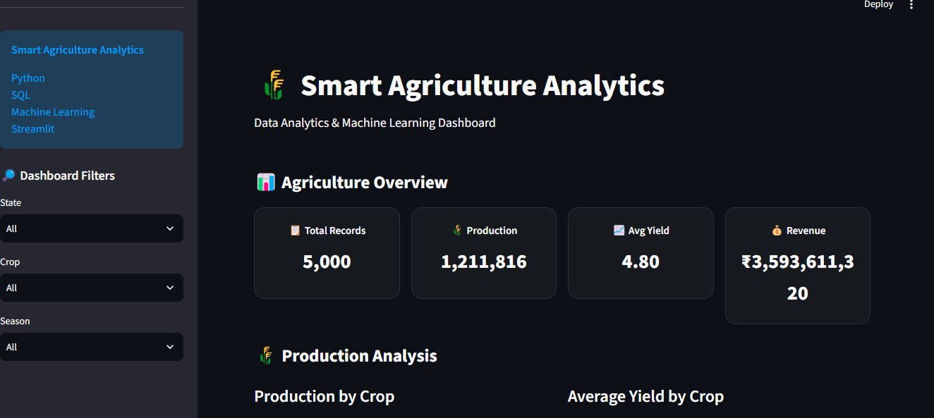
Figure 22.1 – Smart Agriculture Analytics Main Dashboard

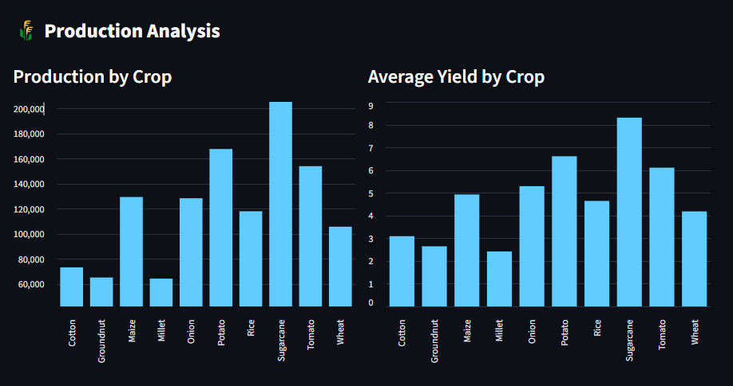
Figure 22.2 – Production Analysis: Production and Average Yield by Crop

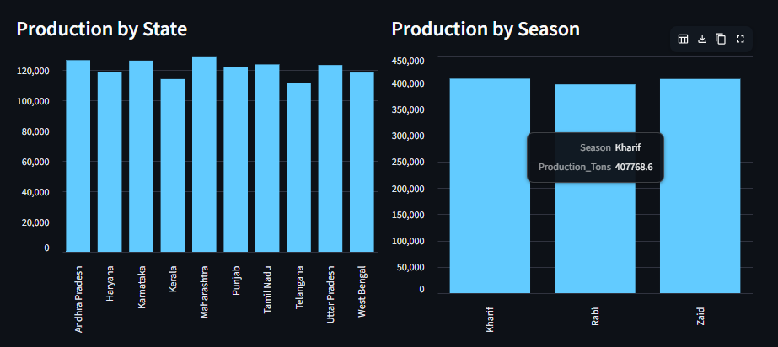
Figure 22.3 – Production Analysis: State-wise and Season-wise Production

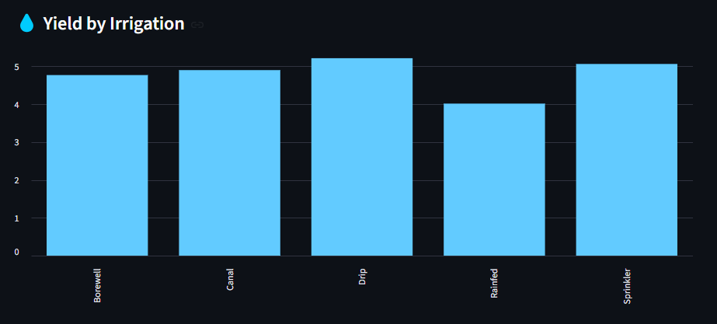
Figure 22.4 – Yield Analysis by Irrigation Type

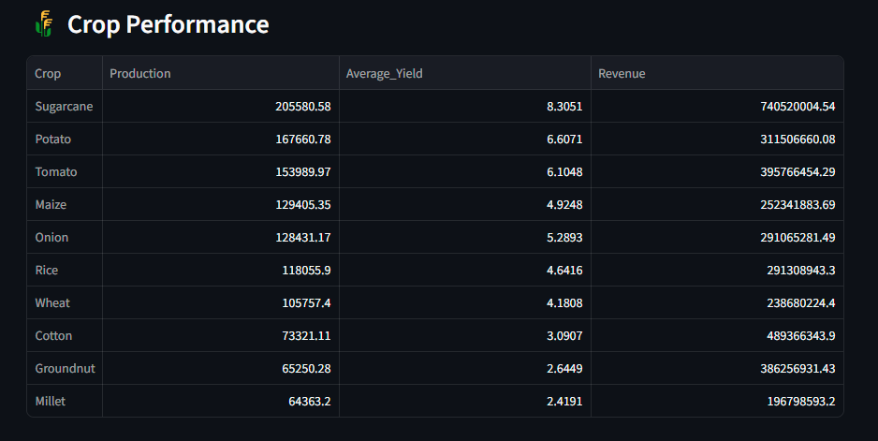
Figure 22.5 – Crop Performance Summary

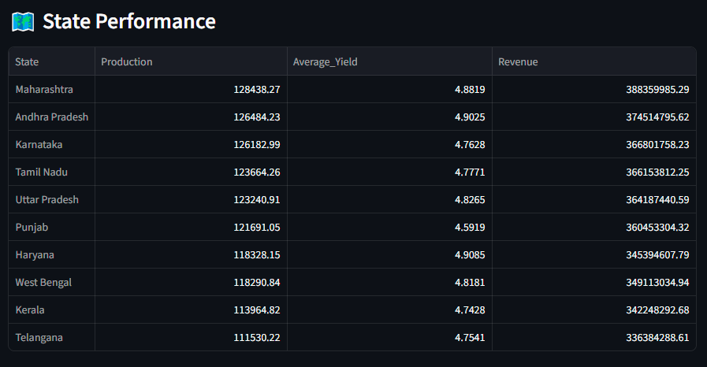
Figure 22.6 – State Performance Summary

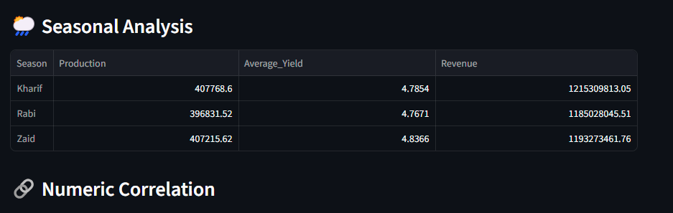
Figure 22.7 – Seasonal Analysis Summary

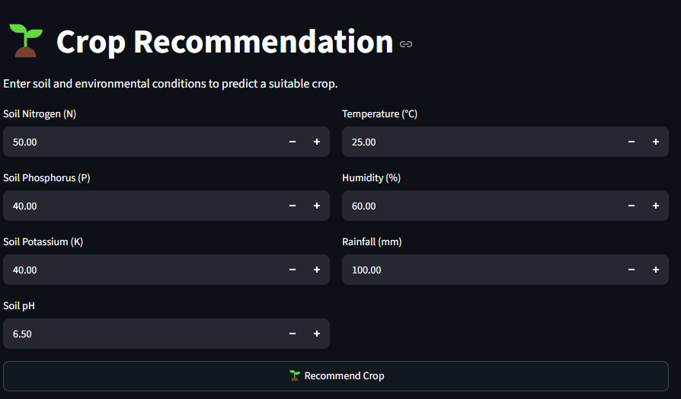
Figure 22.8 – Crop Recommendation Interface

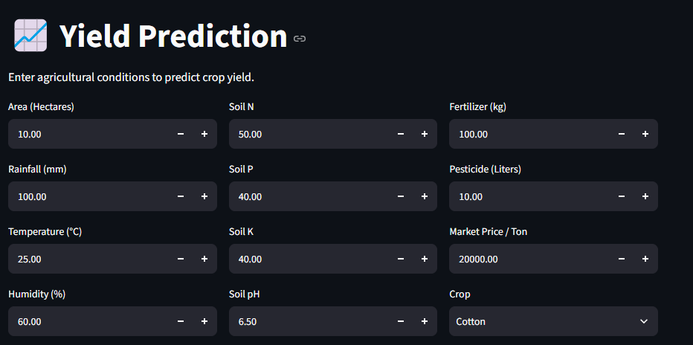
Figure 22.9 – Yield Prediction Interface

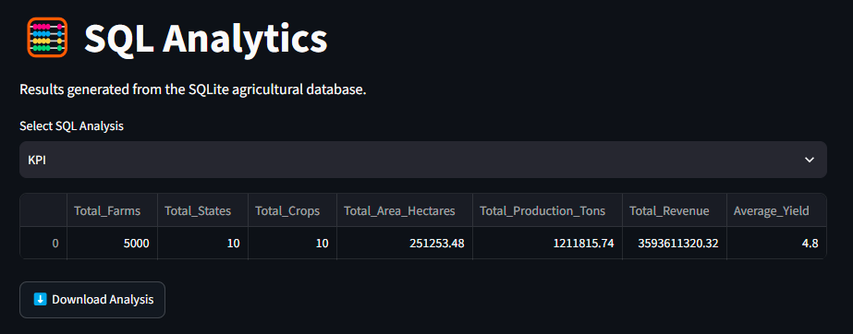
Figure 22.10 – SQL Analytics Interface

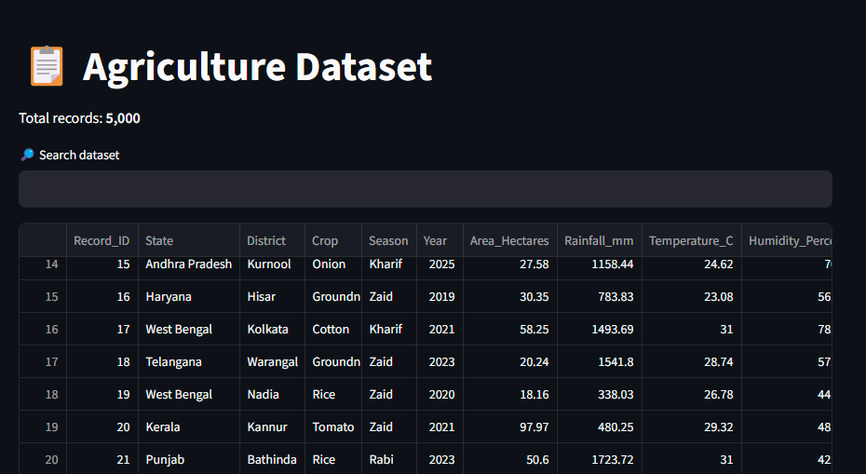
Figure 22.11 – Agriculture Dataset Viewer

