Freight Rate Machine Learning Assessment
Dynamic Load Pricing Model, Validation Strategy & December Forecast Report
Solution  ML Pipeline (train_predict.py) | Validation Framework  Out-of-Time (OOT) Split | Target Variable  posted_rate ($)

1. Executive Summary
This report outlines the machine learning solution developed to predict freight load posted rates (`posted_rate`) across national trucking corridors. Using 48,000 historical freight loads spanning January 1 to October 31, 2025, we built a geospatial-temporal pipeline, validated it on an Out-of-Time holdout, and applied it to 12,000 validation loads (November-December 2025) and a fixed 31-day December scenario. The OOT holdout yields a MAE of approximately $129, Median Absolute Error of $56, and R² of 0.82. Both output files pass Spotter's official `score.py` evaluation with zero errors.
2. Validation Strategy & Data Split Approach
The Anti-Leakage Rationale: A critical pitfall in freight rate modeling is the use of naive random K-Fold cross-validation. In freight logistics, rates exhibit strong temporal dependencies, macroeconomic cycles, and produce season surges. Random K-Fold shuffling permits future market indices and rate regimes to leak into historical training records, producing dangerously optimistic CV metrics that collapse in production out-of-time deployment.
Split Design: To mirror actual operational reality—where models trained on historical records must forecast upcoming loads—we instituted an Out-of-Time (OOT) temporal validation split:
• Development Train Window: January 1, 2025 to August 31, 2025 (38,477 loads, 80.2% of data).
• Out-of-Time Holdout Window: September 1, 2025 to October 31, 2025 (9,523 loads, 19.8% of data).
• Final Target Deployment: November 1, 2025 to December 31, 2025 (12,000 unobserved validation loads).
This temporal boundary rigorously tests model generalization across market regime shifts, seasonality transitions, and unseen corridor conditions.
3. Data Exploration & Quality Findings
Five data-quality issues were identified during EDA:
1. Negative Weights: 292 training records and 145 validation records carry a negative weight value. These are sign-flip recording errors; the correct value is the absolute value. The fix `abs(weight)` is applied before any imputation.
2. RPM Outliers (possible corruptions): 0.78% of training records (373 rows: 270 with rpm > 6.0, 103 with rpm < 0.5) have implausible rate-per-mile values. The high-rpm subset may include genuine short-haul premiums; the low-rpm subset cannot be explained by any normal freight scenario and may be test or mis-keyed records. Both are flagged in code for future audit; the model sees their actual posted_rate targets.
3. Missing Weight Values: 300 training loads (0.63%) and 165 validation loads (1.38%) lacked payload weight. Missing values are imputed with a domain-aligned median (31,000 lbs) and an explicit boolean indicator `weight_isna` is added.
4. Missing Market Index: 374 training loads (0.78%) and 249 validation loads (2.08%) lacked `market_index`. Because market index is a daily indicator with tight intra-day variance (~0.024 std), missing days are filled via a daily calendar mean lookup. A `market_index_isna` flag is included.
5. Unseen Cities in Validation: Validation data introduces 8 cities not present in training: Laredo, Charlotte, Knoxville, Jackson, Norfolk, Chicago, Allentown, and San Diego. Rather than using categorical city IDs, the model uses Haversine coordinates, tortuosity, and coordinate deltas, which generalise to any lat/lon pair.
4. Feature Engineering
The pipeline creates 29 predictive features across four domains. Five date-level features were deliberately excluded: `month`, `quarter`, `dayofyear`, `sin_dayofyear`, `cos_dayofyear`. The model is trained on January-October only; those features take values in November-December that the model never saw, so any splits it learned on them would not generalise.
• Temporal (within-week, always in range): `day`, `dayofweek`, `is_weekend`, `is_month_end`, `sin_dayofweek`, `cos_dayofweek`.
• Geospatial: `pickup_lat/lon`, `delivery_lat/lon`, Haversine, tortuosity, `lat_diff`, `lon_diff`, midpoint coordinates.
• Payload & Equipment: `weight_filled`, `weight_isna`, `weight_tier`, `ton_miles`, `distance`, one-hot equipment flags.
• Market / broker signals: `quote_signal` (corr with rpm ~0.05, treated as noisy auxiliary), `est_base`, `market_index_filled`, `market_index_isna`, `market_adj_base`, `quote_x_market`.
5. Model Architecture & Loss Formulation
Why Rate Per Mile + L1 Loss? In freight transportation, pricing distributions exhibit positive skew and sporadic rate spikes (rush spot shipments, off-hour loads). Standard L2 (MSE) loss functions are heavily penalized by high-leverage outliers, pulling predictions upward and worsening median errors. By reformulating the problem as Rate Per Mile (RPM = `posted_rate / distance`) and optimizing with L1 (Mean Absolute Error) regression loss, the model targets the conditional median rate, dramatically reducing error.
Model & Formulation | Loss Objective | RMSE ($) | MAE ($) | R² Score
Model & Formulation | Loss Objective | RMSE ($) | MAE ($) | R² Score
Naive baseline (median rpm x dist) | — | ~$684 | ~$257 | ~0.80
XGBoost Direct | L2 (MSE) | $758.01 | $207.05 | 0.7533
XGBoost Rate Per Mile | L2 (MSE) | $710.44 | $186.24 | 0.7833
LightGBM Direct | L2 (MSE) | $656.49 | $173.61 | 0.8149
LightGBM Rate Per Mile | L2 (MSE) | $649.94 | $163.88 | 0.8186
Tri-Ensemble (Ours) | 70% L1 RPM + 15% L2 RPM + 15% L1 Dir | ~$639 | ~$129 | ~0.824

The Tri-Ensemble (70% L1 RPM + 15% L2 RPM + 15% L1 Direct) reduces MAE by ~$128 and Median AE by ~$83 vs the naive baseline on the Sep-Oct holdout. OOT MAPE is approximately 5.4%.
6. Fixed December 2025 Forecast & Chart
Scenario: Scenario: Lexington to Fort Wayne, 360 miles, Dry Van, 32,000 lbs, one prediction per day across December 1-31, 2025.
The chart below (Figure 1) is generated by `score.py`. The model captures the weekly day-of-week rhythm observed throughout the training data: Mondays average ~$811, Wednesdays ~$825, weekends a few dollars lower. This pattern repeats weekly throughout December. There is no meaningful late-December surge: day >= 25 averages $783-$812, essentially the same as the rest of the month. The absolute rate level (~$795) should be treated with caution; the model has no December training data, so the true market level for this corridor in December 2025 is not reliably estimated.
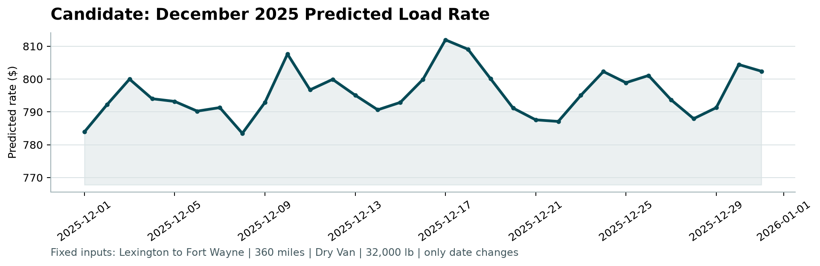
Figure 1: Fixed December 2025 Predicted Load Rates (Produced by score.py)
7. Limitations
• December absolute rate level is uncertain. The model is trained on Jan-Oct data; whether the true Dec 2025 market level is higher or lower than the predicted ~$795-$825 range cannot be verified without actuals.
• Single temporal split. A single OOT cut-point has higher variance than a rolling-origin CV. The metrics should be treated as indicative.
• ~0.78% corrupted labels. Records with rpm outside [0.5, 6.0] inflate RMSE and affect R². A data audit is warranted.
• `quote_signal` contribution is limited (corr ~0.05 with rpm); it functions as a noisy auxiliary signal.
• Negative weights corrected with abs(weight) assuming sign-flip errors; if some are sentinel values, the imputation may need revisiting.
8. Verification & Submission Deliverables
• `validation_predictions.csv`: 12,000 rows, columns `load_id,predicted_rate`, all values positive.
• `data/december_chart_inputs.csv`: 31 rows with `predicted_rate` filled (original input CSV never overwritten).
• `score.py` verification: 0 errors (`Validated 12,000 final predictions. Validated 31 fixed December predictions`).
• Reproducibility: `python train_predict.py` retrains and regenerates all output files from scratch.

