TABLE OF CONTENTS

SR.NO | TOPIC | PAGE NO.
1. | CHAPTER 1: INTRODUCTION | 1-2
1.1 | OVERVIEW AND OBJECTIVE | 1
1.2 | SCOPE OF ANALYSIS | 1
1.3 | SIGNIFICANCE | 2
1.4 | EXPECTED OUTCOMES | 2
2. | CHAPTER 2: TOOLS AND TECHNOLOGY | 3-10
2.1 | PYTHON AND IT’S LIBRARIES | 3-6
2.2 | ENVIRONMENT SETUP | 7-10
3. | CHAPTER 3: PROJECT WORK | 11-28
3.1 | DATA COLLECTION AND PREPROCESSING | 11-13
3.2 | EXPLORATORY DATA ANALYSIS | 14-16
3.3 | DATASET DESCRIPTION | 17
3.4 | PERFORMING EDA WITH VISUALIZATIONS | 18-25
3.5 | FRONTEND TECHNOLOGY | 26-28
4. | CHAPTER 4: RESEARCH INSIGHTS | 29-33
4.1 | DEMOGRAPHIC ANALYSIS | 29
4.2 | SUBSCRIPTION INSIGHTS | 30
4.3 | BEHAVIORAL PATTERNS | 31
4.4 | CHURN ANALYSIS | 32
4.5 | CORRELATION MATRIX | 33
5. | CHAPTER 5: SUMMARY | 34-35
5.1 | LIMITATIONS AND FUTURE SCOPE | 34
5.2 | TAKEAWAYS AND CONCLUSION | 35

CHAPTER 1
INTRODUCTION

  - OVERVIEW AND OBJECTIVE

- Spotify has revolutionized the music-streaming industry by offering personalized listening experiences to millions of users worldwide.
- This project focuses on analysing user dynamics — how individuals interact with the platform, what influences their listening patterns, and how these behaviours correlate with subscription types and churn rates.
- The primary objective is to perform a comprehensive data-driven study that identifies behavioural trends, predicts potential churn, and provides actionable insights for improving user engagement.
- The analysis aims to bridge the gap between raw data and strategic decision-making, demonstrating how data science can enhance personalization algorithms and marketing efforts.
- By leveraging exploratory data analysis (EDA) and visualization techniques, the project seeks to uncover hidden relationships among variables such as listening time, skip rate, and subscription tier.

  - SCOPE OF ANALYSIS

- The scope of this project encompasses the entire analytical pipeline — from data collection and preprocessing to visualization and interpretation.
- It includes the study of user demographics, listening behaviour, and subscription preferences. The analysis focuses on identifying patterns that influence engagement and retention, such as frequency of app usage, playlist diversity, and skip behaviour.
- The project is confined to the dataset provided, ensuring methodological consistency and reproducibility. It does not attempt to modify Spotify’s internal algorithms but rather interprets user-level data to derive insights.

- The scope also includes comparative evaluation of user segments, enabling a deeper understanding of how different groups interact with the platform.

  - SIGNIFICANCE

- The significance of this study lies in its contribution to understanding digital consumer behaviour through data analytics. For Spotify, user retention is directly linked to sustained revenue and brand loyalty.
- By analysing user dynamics, the project provides insights that can help optimize recommendation systems, improve marketing strategies, and enhance user satisfaction.
- From an academic perspective, the project demonstrates the practical application of data science in real-world business contexts. It integrates technical skills — such as Python programming, data visualization, and statistical analysis — with strategic thinking.
- The findings can serve as a foundation for future research in predictive modelling and
behavioural analytics.

  - EXPECTED OUTCOMES

- The expected outcomes include a clear understanding of user engagement patterns and identification of factors contributing to churn.
- The project anticipates discovering correlations between listening habits and subscription types, as well as demographic influences on engagement.
- Visual dashboards will present these insights in an accessible format, enabling stakeholders to make informed decisions.
- Additionally, the study is expected to highlight opportunities for improving personalization and retention strategies.
- The outcomes will validate the importance of data-driven approaches in enhancing user experience and business performance.
CHAPTER 2
TOOLS AND TECHNOLOGY

2.1 PYTHON AND IT’S LIBRARIES
Python has become the de facto language of data science because of its simplicity, readability, and vast ecosystem of libraries that support every stage of the analytical pipeline. Unlike traditional programming languages that require verbose syntax, Python allows developers and researchers to focus on problem-solving rather than implementation details. Its open-source nature and active community ensure continuous improvement and availability of specialized packages.
In the context of a Spotify user dynamics project, Python acts as the backbone for data ingestion, cleaning, analysis, visualization, and modelling. Each library contributes uniquely to this workflow, forming a modular toolkit that can be adapted to diverse analytical needs.
Below is a detailed explanation of the most relevant libraries and their general roles:
PANDAS
- Role: Pandas is the cornerstone of data manipulation in Python. It introduces the Data Frame structure, which organizes data into rows and columns similar to a spreadsheet or SQL table.
- General Use:
  - Importing datasets from CSV, Excel, or databases.
  - Cleaning data by handling missing values, duplicates, and inconsistent formats.
  - Performing operations like filtering, grouping, and aggregating.
  - Time-series analysis, which is particularly useful for tracking listening behaviour over time.

- Why Important: Without Pandas, handling large datasets would be cumbersome. It simplifies complex operations into single-line commands, making exploratory analysis efficient and intuitive.

NUMPY
- Role: NumPy provides the foundation for numerical computing in Python. It introduces the ndarray (n-dimensional array), which is optimized for fast mathematical operations.
- General Use:
  - Performing linear algebra, matrix operations, and statistical calculations.
  - Supporting vectorized operations, which are faster than traditional loops.
  - Serving as the underlying engine for many other libraries, including Pandas and Scikit-learn.
- Why Important: In data science, efficiency matters. NumPy ensures that mathematical computations on large datasets are performed quickly and accurately, enabling scalable analysis.

MATPLOTLIB
- Role: Matplotlib is the most widely used library for creating static, publication-quality plots.
- General Use:
  - Generating line graphs, bar charts, scatter plots, and histograms.
  - Customizing plots with labels, legends, and annotations.
  - Exporting visuals for reports and presentations.

- Why Important: Visualization is essential for interpreting data. Matplotlib provides the flexibility to design clear, professional charts that communicate insights effectively.

SEABORN
- Role: Built on top of Matplotlib, Seaborn simplifies the creation of aesthetically pleasing statistical graphics.
- General Use:
  - Creating heatmaps, pairplots, and distribution plots with minimal code.
  - Automatically applying themes and colour palettes for better readability.
  - Highlighting statistical relationships between variables.
- Why Important: Seaborn enhances the storytelling aspect of data science. It allows analysts to present complex relationships in a visually appealing and accessible manner.

PLOTLY
- Role: Plotly is a powerful library for creating interactive, web-based visualizations. Unlike Matplotlib and Seaborn, which focus on static plots, Plotly enables dynamic charts that users can zoom, hover, and filter.
- General Use:
  - Building interactive scatter plots, bar charts, and line graphs.
  - Creating advanced visuals such as violin plots, choropleth maps, and 3D plots.
  - Integrating with dashboards (e.g., Streamlit or Dash) for real-time data exploration.

- Why Important: Plotly transforms static analysis into an engaging, interactive experience. In a Spotify project, it can be used to visualize churn rates, listening

trends, or subscription comparisons in a way that allows stakeholders to explore data dynamically. This interactivity makes insights more accessible and actionable.

SCIKIT-LEARN
- Role: Scikit-learn is the go-to library for machine learning in Python.
- General Use:
  - Implementing supervised learning models (e.g., regression, classification).
  - Performing unsupervised learning tasks (e.g., clustering, dimensionality reduction).
  - Providing tools for model evaluation, cross-validation, and hyperparameter tuning.
- Why Important: In projects like churn prediction, Scikit-learn enables the development of predictive models that transform descriptive insights into actionable forecasts.

STREAMLIT
- Role: Streamlit bridges the gap between analysis and presentation by enabling interactive dashboards.
- General Use:
  - Building web apps directly from Python scripts.
  - Allowing users to interact with data through sliders, filters, and buttons.
  - Deploying dashboards without requiring web development expertise.

- Why Important: Streamlit makes data science accessible to non-technical stakeholders. It transforms static results into dynamic, user-friendly applications.

Python’s ecosystem of libraries forms a complete toolkit for data science. Pandas and NumPy handle data manipulation and computation, Matplotlib, Seaborn and Plotly provide visualization, Scikit-learn enables predictive modelling, and Streamlit ensures interactive presentation.
Together, they create a seamless workflow that transforms raw Spotify user data into meaningful insights, supporting both academic exploration and practical business applications.

2.2 ENVIRONMENT SETUP
A proper environment setup is essential for ensuring smooth execution, reproducibility, and collaboration in data science projects.
In this project, three primary tools form the environment: Jupyter Notebook for interactive coding, Streamlit for dashboard development, and GitHub for version control and collaboration. Each tool plays a distinct role, and together they create a complete ecosystem for analysis and presentation.

JUPYTER NOTEBOOK
Role: Jupyter Notebook is an open-source web application that allows you to write and execute Python code interactively. It combines code, visualizations, and explanatory text in a single document, making it ideal for exploratory data analysis (EDA) and academic reporting.
Key Features:
- Interactive coding cells for step-by-step execution.
- Inline visualization support (Matplotlib, Seaborn, Plotly).
- Markdown cells for documentation and explanations.
- Export options (HTML, PDF, slides) for sharing results.

Step-by-Step Setup:
- Install Anaconda (recommended): Download and install Anaconda which includes Jupyter Notebook and Python libraries.
- Launch Jupyter Notebook: Open Anaconda Navigator → click Launch Jupyter Notebook. Alternatively, run Jupyter notebook in the terminal.
- Create a Notebook: Navigate to your project folder, click New → Python 3 Notebook.
- Organize Work: Use separate cells for imports, preprocessing, analysis, and visualization.
- Save and Export: Save regularly (.ipynb format) and export to HTML/PDF for submission.

STREAMLIT
Role: Streamlit is a Python framework for building interactive web dashboards directly from scripts. It transforms static analysis into dynamic applications, allowing users to interact with data through sliders, filters, and buttons.
Key Features:
- Simple syntax (streamlit run app.py).
- Widgets for user input (dropdowns, sliders, checkboxes).
- Real-time updates when code changes.
- Integration with Plotly, Matplotlib, and Seaborn for interactive visuals.
Step-by-Step Setup:
- Install Streamlit: Run pip install streamlit in your terminal.
- Create an App File: Save a Python script as app.py.

- Write Basic Code: Example: import streamlit as st
st.title("Spotify User Dynamics Dashboard")
st.write("Welcome to the interactive analysis!")

- Run the App: Execute streamlit run app.py in the terminal.
- Add Visuals: Integrate charts from Plotly or Seaborn.
- Enhance UI: Add sidebars, filters, and navigation for multi-page dashboards.

GITHUB
Role: GitHub is a cloud-based platform for version control and collaboration. It allows you to store code, track changes, and collaborate with others using Git. For academic projects, GitHub ensures transparency, reproducibility, and professional presentation.
Key Features:
- Repository creation for project files.
- Version control with commit history.
- Branching and merging for collaborative work.
- Integration with Jupyter and Streamlit for project deployment.
Step-by-Step Setup:
- Create a GitHub Account: Sign up at github.com.
- Install Git: Download Git from git-scm.com and configure with your username/email.
- Initialize Repository: In your project folder, run: git init
git add .
git commit -m "Initial commit"

- Connect to GitHub: Create a new repository on GitHub, then link it:
git remote add origin https://github.com/username/repo.git
git push -u origin main

- Collaborate: Use branches for new features, pull requests for merging, and issues for tracking tasks.
- Maintain Documentation: Add a README.md file explaining your project.

CHAPTER 3
PROJECT WORK

3.1 DATA COLLECTION AND PREPROCESSING
DATA COLLECTION
Role: Data collection is the foundation of any data science project. It involves gathering raw information from reliable sources that reflect the problem domain — in this case, Spotify user dynamics. Without accurate and relevant data, analysis cannot yield meaningful insights.
Sources of Data:
- Public Datasets: Kaggle, Spotify API datasets, or academic repositories.
- APIs: Spotify’s Web API provides access to user listening history, track metadata, and playlist information.
- Surveys/Logs: User-generated data from surveys or logs can supplement official datasets.
Steps to Collect Data:
- Identify Requirements: Define what attributes are needed (e.g., age, gender, subscription type, listening time, skip rate).
- Locate Dataset: Search repositories like Kaggle or use Spotify’s API.
- Download/Extract Data: Save datasets in CSV, JSON, or Excel format.
- Load into Python: Use Pandas to import data: import pandas as pd
df = pd.read_csv("spotify_users.csv")
- Verify Integrity: Always check dataset size, column names, and data types.

Best Practices:
- Always document the source of data.
- Ensure ethical use by anonymizing user identifiers.
- Collect diverse data to avoid bias in analysis.

DATA PREPROCESSING
Role: Preprocessing transforms raw data into a clean, structured format suitable for analysis. It ensures accuracy, consistency, and reliability of results. This step is critical because real-world datasets often contain missing values, duplicates, or inconsistencies.
Steps to Preprocess Data:
- Data Inspection:
  - Use df.info() and df.describe() to understand dataset structure.
  - Identify missing values, outliers, and incorrect data types.
- Handling Missing Values:
  - Drop rows/columns: If missing values are few and insignificant.
  - Impute values: Replace with mean, median, or mode for numerical data; use most frequent category for categorical data. Example:
df['age'].fillna(df['age'].mean(), inplace=True)
- Removing Duplicates:
  - Use df.drop_duplicates() to eliminate repeated entries.
- Data Normalization:
  - Scale numerical features to a standard range (e.g., 0–1) using MinMaxScaler.

from sklearn.preprocessing import MinMaxScaler
scaler = MinMaxScaler()
df[['listening_time']] = scaler.fit_transform(df[['listening_time']])

- Encoding Categorical Variables:
Convert non-numeric data (e.g., subscription type: Free, Premium) into numeric form
using one-hot encoding. df = pd.get_dummies(df, columns=['subscription_type'])

- Outlier Detection:
  - Use boxplots or statistical methods (e.g., Z-score) to identify extreme values.
  - Decide whether to remove or adjust them based on context.
- Feature Engineering:
  - Create new variables that add analytical value, e.g.:
    - Engagement Score: Combining listening time and skip rate.
    - Retention Indicator: Binary variable for churn prediction.
- Final Verification:
  - Recheck dataset shape, column consistency, and data types.
  - Save the cleaned dataset for analysis: df.to_csv("spotify_cleaned.csv")
Best Practices:
- Document every preprocessing step for reproducibility.
- Avoid over-cleaning, which may remove valuable variability.
- Ensure transformations align with project objectives (e.g., churn prediction).

3.2 EXPLORATORY DATA ANALYSIS
Role of EDA
Exploratory Data Analysis (EDA) is the process of examining and summarizing a dataset to uncover patterns, detect anomalies, test assumptions, and generate hypotheses. It acts as the bridge between raw data and advanced modelling.
In the Spotify project, EDA helps us understand user behaviour — such as listening time, skip rate, and subscription type — before applying predictive techniques like churn modelling.
Steps in EDA
1. Data Inspection
- Objective: Understand the dataset’s structure and basic properties.
- How to Do It:
  - Use df.info() to check column names, data types, and non-null counts.
  - Use df.describe() to view summary statistics (mean, median, min, max, standard deviation).
  - Check dataset shape with df.shape.
- Why Important: Provides a quick overview of completeness and potential issues (e.g., missing values, incorrect data types).

2. Univariate Analysis (Single Variable Study)
- Objective: Study the distribution of individual features.
- How to Do It:
  - Plot histograms for numerical variables (e.g., listening time).
  - Use bar charts for categorical variables (e.g., subscription type).
  - Apply boxplots to detect outliers.
import seaborn as sns
sns.histplot(df['listening_time'])
sns.boxplot(x=df['skip_rate'])

- Why Important: Helps identify skewness, outliers, and frequency distributions.

3. Bivariate Analysis (Two Variable Relationships)
- Objective: Explore relationships between two variables.
- How to Do It:
  - Scatter plots for numerical vs numerical (e.g., listening time vs skip rate).
  - Grouped bar charts for categorical vs numerical (e.g., subscription type vs average listening time).
  - Correlation coefficients (df.corr()) for numerical features.
sns.scatterplot(x='listening_time', y='skip_rate', data=df)
- Why Important: Reveals dependencies and potential predictors for churn.

4. Multivariate Analysis (Multiple Variables Together)
- Objective: Study complex interactions among multiple features.
- How to Do It:
  - Heatmaps for correlation matrices.
  - Pairplots to visualize relationships across several variables.
  - Grouped analysis (e.g., churn vs subscription type vs listening time).
sns.heatmap(df.corr(), annot=True, cmap='coolwarm')
- Why Important: Identifies clusters, hidden patterns, and combined effects of features.

5. Outlier Detection
- Objective: Identify extreme values that may distort analysis.
- How to Do It:
  - Boxplots for numerical features.
  - Z-score or IQR methods to flag unusual values.

from scipy import stats
df[(np.abs(stats.zscore(df['listening_time'])) > 3)]
- Why Important: Outliers can represent errors or rare but important behaviors (e.g., super-active users).

6. Feature Relationships and Hypothesis Building
- Objective: Form hypotheses about which features influence churn or engagement.
- How to Do It:
  - Compare churned vs active users across features.
  - Use groupby operations to calculate averages per segment.
df.groupby('subscription_type')['listening_time'].mean()
- Why Important: Guides model design by highlighting relevant predictors.

7. Visualization for Insights
- Objective: Present findings in a clear, interpretable format.
- How to Do It:
  - Use Seaborn for statistical plots (distribution, correlation).
  - Use Plotly for interactive visuals (hover, zoom, filter).
import plotly.express as px
fig = px.scatter(df, x="listening_time", y="skip_rate", color="subscription_type")
fig.show()
- Why Important: Visualizations make complex data patterns accessible to both technical and non-technical audiences.

3.3 DATASET DESCRIPTION
Role: A dataset description provides a clear overview of the data being analyzed. It explains the source, structure, attributes, and relevance of the dataset, ensuring transparency and reproducibility.
In the Spotify project, the dataset represents user-level information that captures listening behavior, subscription details, and churn status. This description sets the stage for exploratory analysis and modeling.
Dataset Source
- Origin: Publicly available Spotify user dataset on Kaggle, https://www.kaggle.com/datasets/shree0910/spotify-user-dataset/data
- Format: Typically provided in CSV (Comma-Separated Values) format for easy import into Python.
- Size: Contains thousands of rows (each representing a user) and multiple columns (each representing a feature).
- Ethics: User identifiers are anonymized to protect privacy. Only non-sensitive behavioral attributes are included.

Dataset Structure
The dataset is organized in tabular form with rows representing individual users and columns representing attributes. Each column captures a specific aspect of user behavior or demographic information.
Column Name | Data Type | Description
user_id | String | Unique identifier for each user (anonymized).
age | Integer | Age of the user.
gender | Categorical | Gender of the user (Male/Female/Other).
subscription_type | Categorical | Type of subscription (Free, Premium, etc)
listening_time | Float | Average listening time per week (in mins)
skip_rate | Float | Percentage of songs skipped by the user.
ads_listened_per_week | Integer | Number of advertisements heard weekly
offline_listening | Binary | Indicates whether the user listens offline
is_churned | Binary | Churn status (1 = Churned, 0 = Active).

The dataset provides a comprehensive view of Spotify user dynamics, combining demographic, behavioral, and subscription-related attributes. Each feature contributes to understanding user engagement and churn.
A clear dataset description ensures that subsequent analysis is transparent, reproducible, and academically rigorous.
3.4 EDA WITH VISUALIZATION
Exploratory Data Analysis (EDA) is the process of visually and statistically examining data to uncover patterns, detect anomalies, and form hypotheses. In this project, EDA is performed with Pandas, Seaborn, Matplotlib, and Plotly, enabling both static and interactive visualizations. Each visualization is accompanied by interpretation to ensure clarity and relevance.
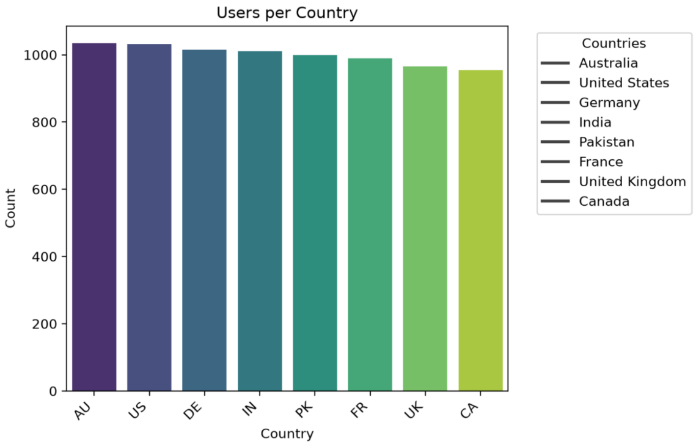
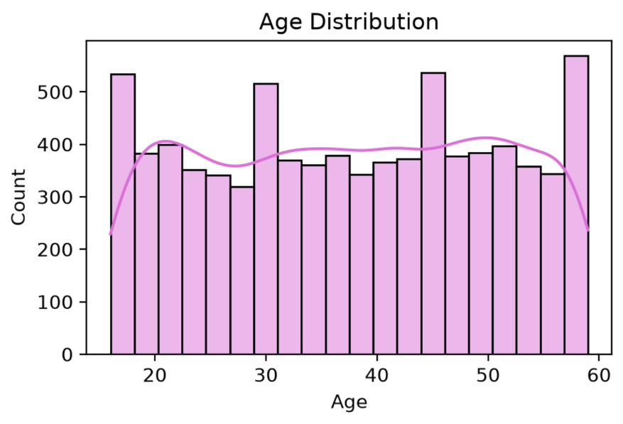
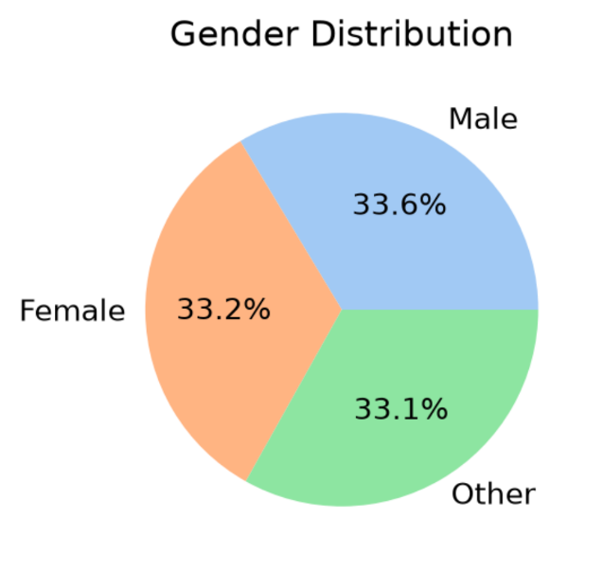
DEMOGRAPHIC ANALYSIS

- Gender : Balanced distribution across all three categories, no dominant majority.
- Age : Wide range (18–60), fairly uniform counts (350–500 per bracket). Peaks at late teens/early 20s, age 30, and ages 45 & 59.
- Country : High uniformity (954–1034 users). Australia (1034) and US (1032) lead; India (1011) and Germany (1015) show stable adoption.

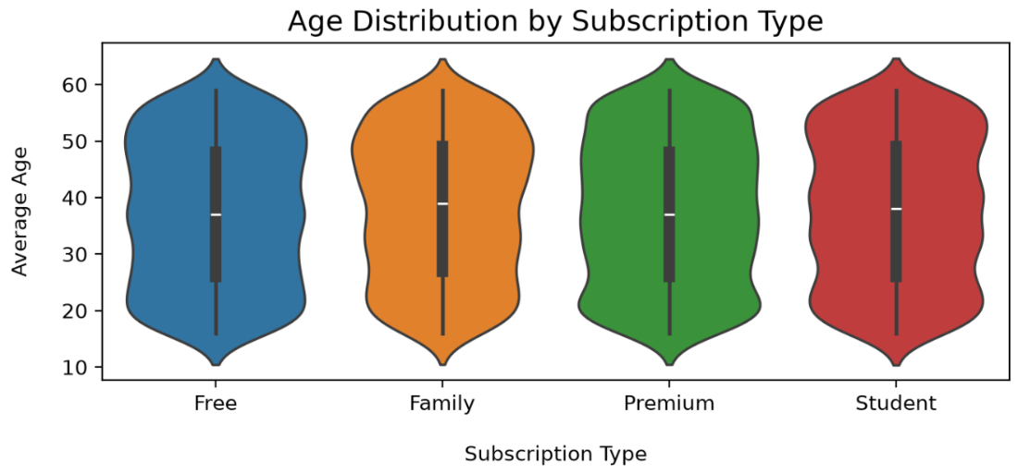
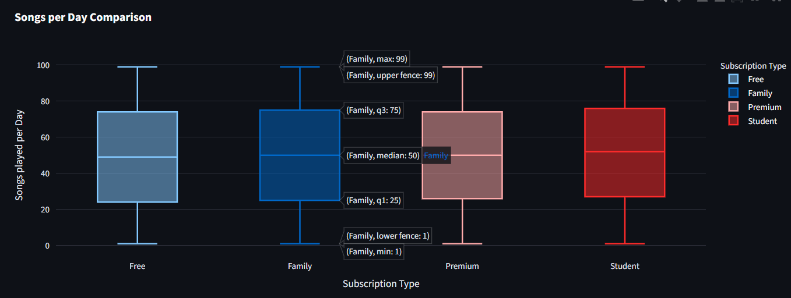
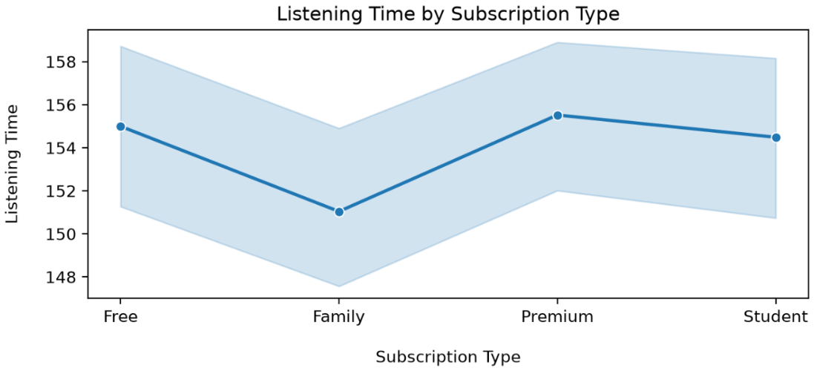
SUBSCRIPTION TYPE ANALYSIS
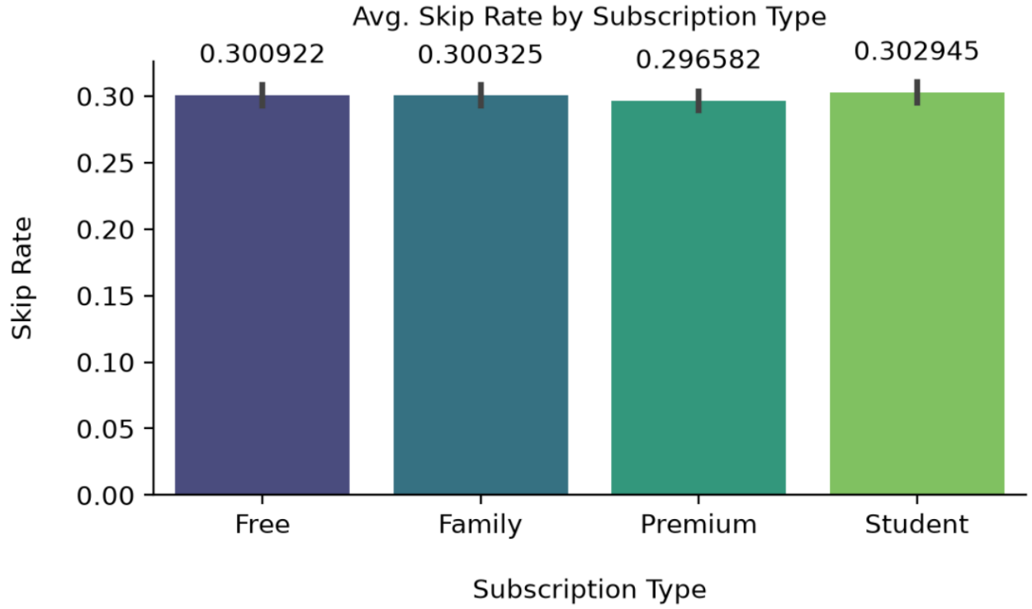

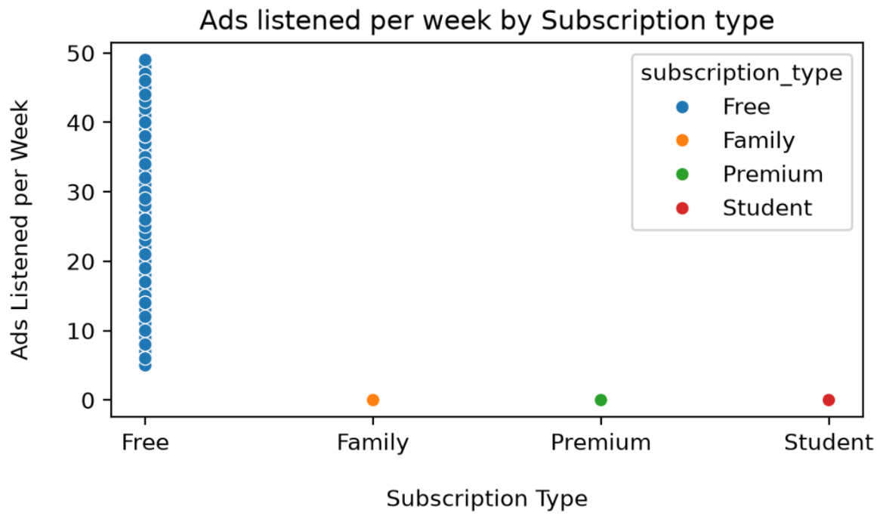
- Age Distribution : Uniform across Free, Family, Premium, and Student tiers.
- Student Plan : Mirrors Premium/Family age ranges, suggesting overlap in plan selection.
- Listening Time :
  - Premium → highest (~156 units).
  - Family → slightly lower (~151 units), possibly due to shared accounts.
  - Free → widest variability (some very low, some very high).
  - Student → strong engagement, similar to Premium.

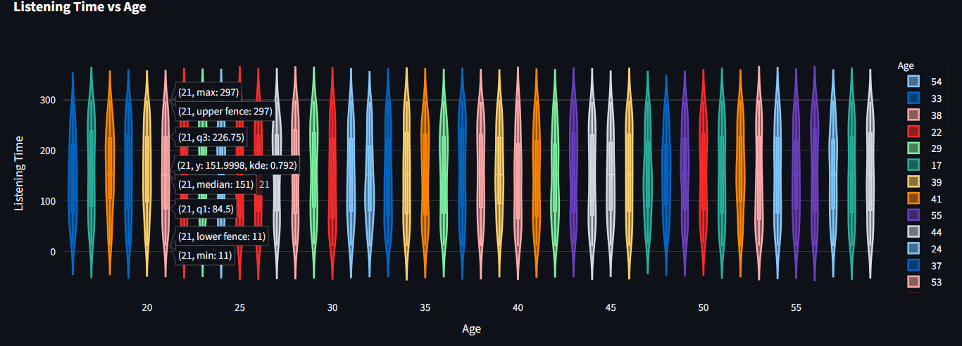
BEHAVIORAL PATTERNS
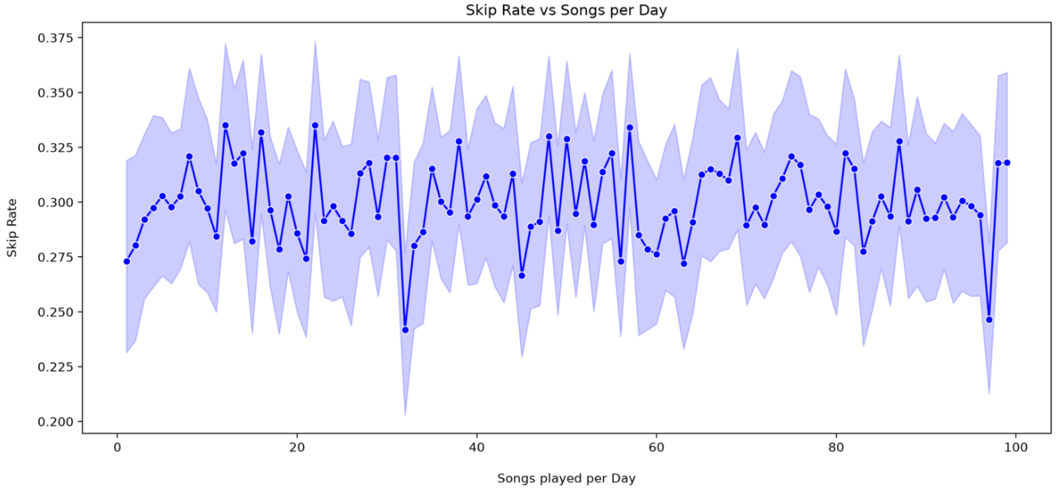
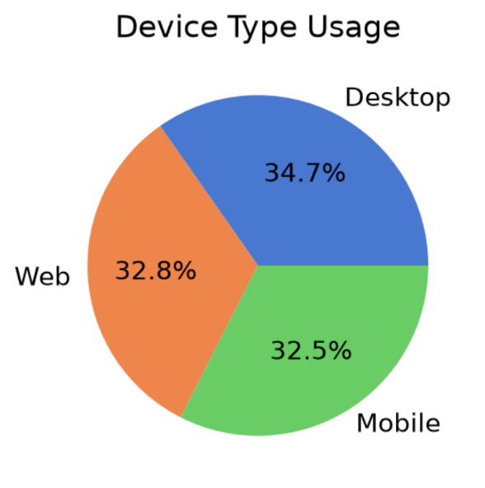
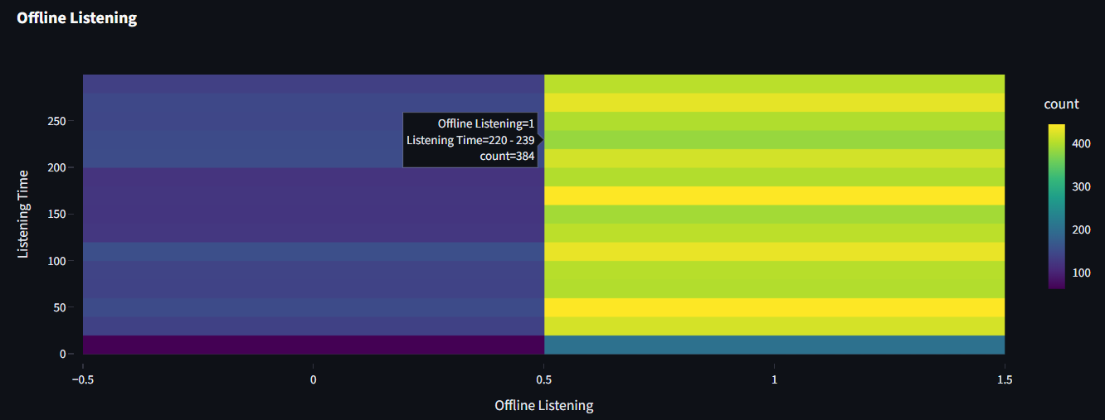

- Songs Played : Median ~50/day across all tiers; Student tier slightly higher upper quartile.
- Skip Rate : Stable across tiers (~30%), suggesting skips depend on content, not subscription.
- Ads Exposure : Strictly limited to Free tier; wide variance (5–50 ads/week).
- Listening Time Distribution : Mostly 100–200 minutes/day, stable across users.
- Skip Rate Variability : Fluctuates heavily (0.25–0.35 baseline), no clear trend with songs played.
- Device Type : Desktop leads (34.7%), Web (32.8%), Mobile (32.5%).
- Offline Listening : Dominant among Premium users; broad session lengths (40–60 and 160–180 minutes common). Online streaming less frequent

CHURN ANALYSIS
- Churn means when a user stops using a service or cancels their subscription.
- In Spotify’s case, churned users are those who either Cancel their premium subscription, or Stop being active on the platform for a certain period. It’s basically the opposite of retention.
- Churn analysis is the process of studying why users leave and identifying patterns that predict churn. It helps companies reduce user loss and improve retention.

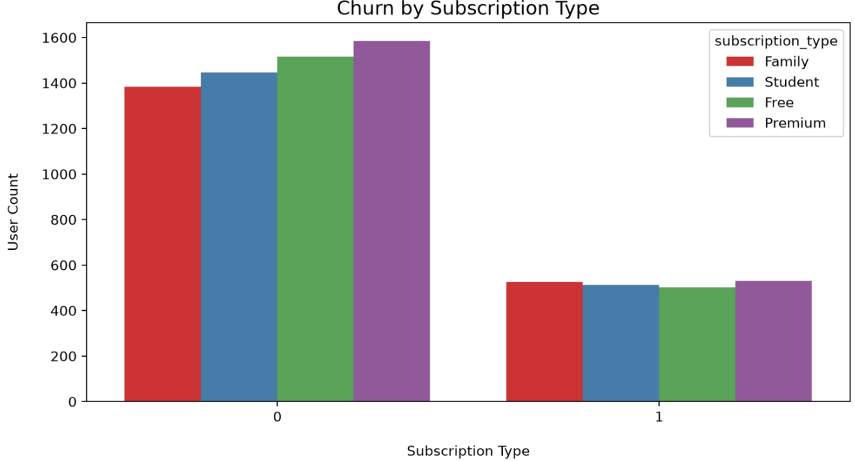
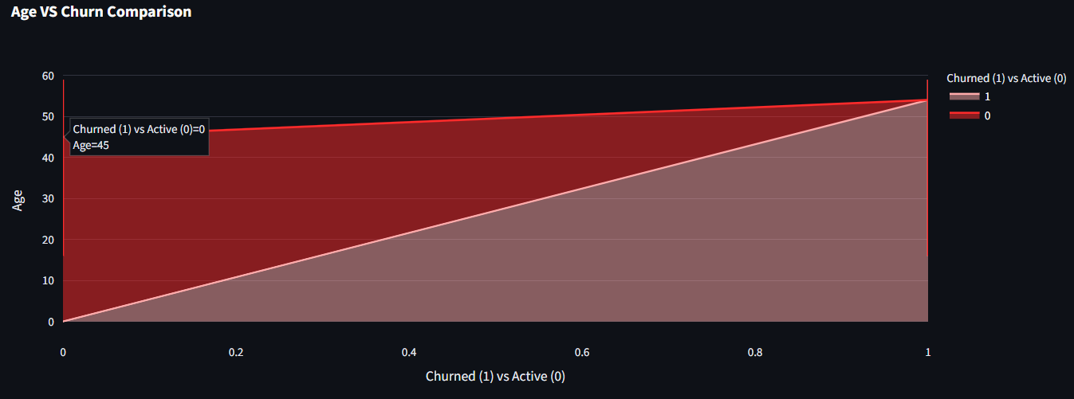
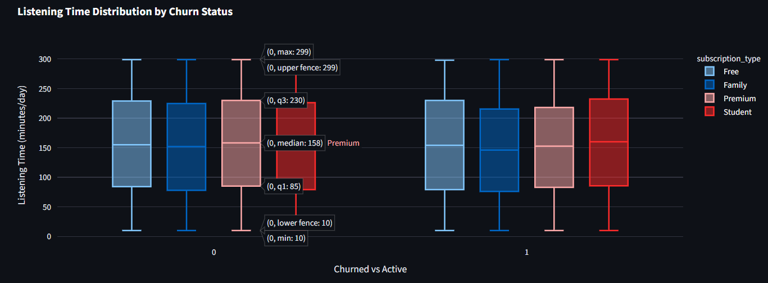
- User churn status (1 = Churned, 0 = Active)
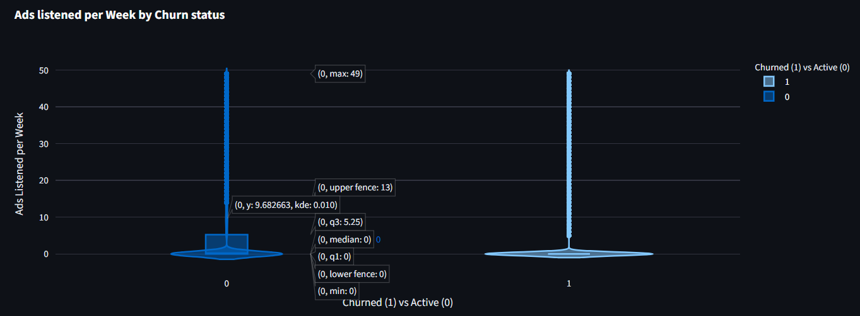
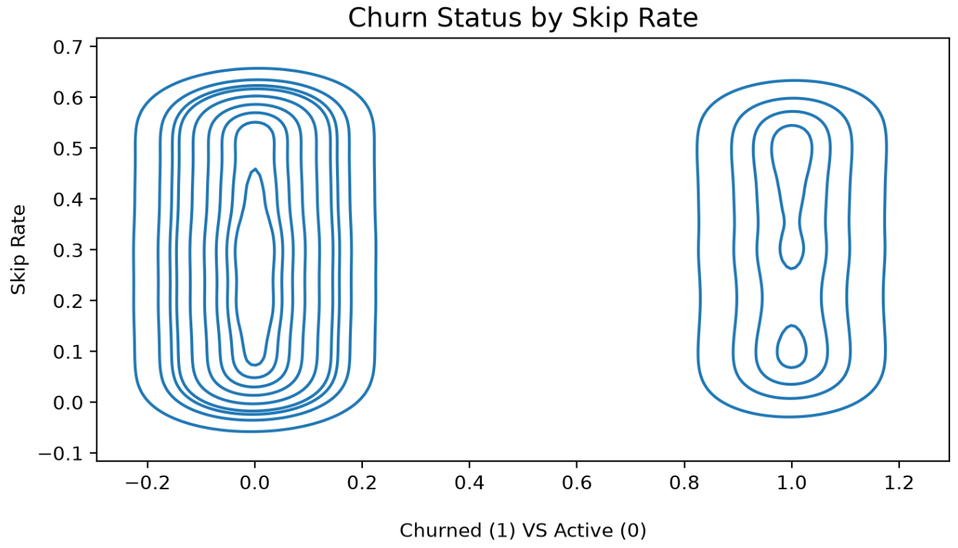
- Retention : Free users dominate retained group (no cost barrier).
- Churn Risk : Premium and Family show higher churn proportions — critical for revenue.
- Student Plan : Strong retention, discount appears effective.
- Listening Time : Active users have higher median listening times; churned users show lower engagement.
- Skip Rate :
  - Active users → lower skip rates (0.2–0.4).
  - Churned users → very high skip rates (0.8–1.0).

  - Distinct clusters → skip rate is a strong churn predictor.
- Age vs Churn :
  - Younger users (18–35) churn more.
  - Older users (45+) show higher stability.
  - Cross-over point around mid-age where retention overtakes churn.
- Ads vs Churn :
  - Churned users → concentrated at 40–50 ads/week.
  - Retained users → clustered at 0–10 ads/week.
  - Minimal overlap → ads exposure is a high-value churn predictor.

CORRELATION INSIGHTS
- Correlation analysis is a statistical method used to measure the strength and direction of the relationship between two variables.
- Positive correlation: Both variables increase together (e.g. listening time↑, retention↑).
- Negative correlation: One increases while the other decreases (e.g., ads ↑, retention ↓).
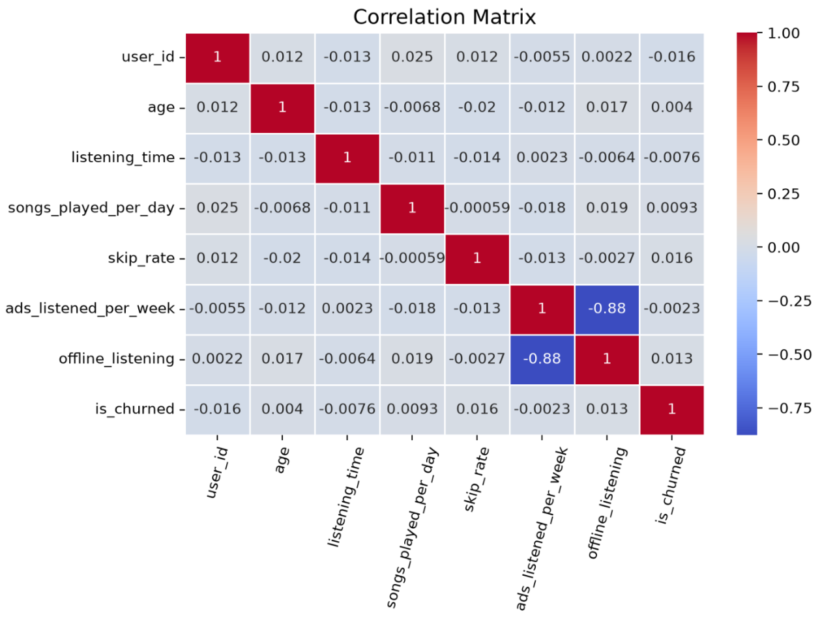
- No correlation → variables don’t show a consistent relationship.

- The most common measure is the Pearson correlation coefficient (r), which ranges from -1 to +1.
- +1 → perfect positive relationship, -1 → perfect negative relationship and 0 → no relationship.
- Offline Listening vs Ads : Strong negative correlation (-0.88) — offline listeners encounter far fewer ads, reflecting Premium/paid tiers.
- Churn Variable : Very weak correlations (≈ -0.016 to 0.016) with all features, meaning no single metric strongly predicts churn.
- Feature Independence : Most variables (age, listening_time, skip_rate) are nearly uncorrelated, providing unique, non-redundant information for modeling.

3.5 FRONTEND TECHNOLOGY
Role of Frontend Technology
Frontend technology in data science projects bridges the gap between technical analysis and user interaction. While Jupyter Notebook is excellent for exploration, it is not suitable for non-technical stakeholders. Streamlit provides a simple yet powerful way to convert Python scripts into interactive dashboards, enabling real-time exploration of Spotify user dynamics. This ensures that insights are not only generated but also communicated effectively.

Streamlit as the Core Frontend
Streamlit is a Python framework designed for building interactive web applications without requiring web development expertise. It allows analysts to present data, charts, and models in a clean, responsive interface.
Key Features:
- Ease of Use: Simple syntax (streamlit run app.py) to launch dashboards.
- Widgets: Sliders, dropdowns, checkboxes, and buttons for user input.

- Integration: Supports Matplotlib, Seaborn, and Plotly visualizations.
- Real-time Updates: Automatically refreshes when code changes.

Step-by-Step Setup:
- Install Streamlit: pip install streamlit
- Create an App File: Save a Python script as app.py.
- Basic Structure: import streamlit as st
st.title("Spotify User Dynamics Dashboard")
st.write("Explore user behavior interactively")

- Add Visualizations: Integrate charts from Seaborn or Plotly.
import plotly.express as px
fig = px.scatter(df, x="listening_time", y="skip_rate", color="subscription_type")
st.plotly_chart(fig)

- Enhance UI: Use sidebars for filters (e.g., subscription type, age group).
st.sidebar.selectbox("Choose Subscription Type", df['subscription_type'].unique())

- Run the App: streamlit run app.py

GitHub for Deployment and Collaboration
GitHub complements Streamlit by providing version control and collaboration features. Once the dashboard is built:
- Code Storage: All scripts (app.py, datasets, notebooks) are stored in a GitHub repository.
- Version Control: Changes are tracked with commits, ensuring reproducibility.
- Collaboration: Team members can contribute via branches and pull requests.

- Documentation: A README.md file explains how to run the dashboard.
- Deployment: Streamlit apps can be deployed directly from GitHub using Streamlit Cloud.

Step-by-Step Workflow:
- Push your project files to GitHub.
- Connect GitHub repository to Streamlit Cloud.
- Deploy the app online, making it accessible via a shareable link.

CHAPTER 4
RESEARCH INSIGHTS

4.1 DEMOGRAPHIC ANALYSIS
- Near-equal representation/Balanced distribution across all three gender categories.
- There is no dominant majority in the dataset.
- The dataset covers a wide age range, approximately from 18 to 60 years old, indicating a diverse user base, most age brackets maintain a consistent count between 350 and 500 individuals.
- While fairly uniform, there are distinct peaks in frequency at specific life stages :
• Late Teens/Early 20s : High initial engagement.
• Age 30 : A notable spike in users.
• Ages 45, 59 : Recurring peaks in older demographics.
- High Performance Uniformity : The user counts are tightly clustered, ranging from a low of 954 (Canada) to a high of 1034 (Australia).
- Top Market Leaders : Australia (1034) and United States (1032) lead the group with the highest engagement numbers.
- Emerging Market Stability : India (1011) and Germany (1015) show nearly identical user counts, indicating stable adoption in these large markets.

4.2 SUBSCRIPTION INSIGHTS
- Uniform Age Distribution : Across all four subscription tiers—Free, Family, Premium, and Student—the distribution of ages is remarkably similar. Each category shows a broad, fairly rectangular distribution ranging from approximately 18 to 65 years old.
- Target Demographics : The "Student" category surprisingly mirrors the age range of the "Premium" and "Family" plans. This suggests that either the "Student" criteria are broad, or there is significant overlap in how different age groups select their plans.
- Premium Users Lead Engagement : The Premium tier shows the highest average listening time (~156 units), suggesting that paying users without restrictions are the most active listeners.

- Family Plan Dip : There is a notable drop in listening time for Family accounts (~151 units). This could indicate shared accounts where individual usage is lower or more fragmented compared to personal plans.
- High Variability in "Free" Tier : The shaded confidence interval is widest for the Free tier, indicating a diverse range of user behaviors—some listen very little, while others are highly active despite ads.
- Student Consistency : The Student tier shows high engagement levels similar to Premium, likely reflecting a demographic with high audio consumption habits (e.g., studying or commuting).
- Consistent Engagement : The median number of songs played is remarkably similar across all categories (Free, Family, Premium, and Student), hovering around 50 songs per day. This suggests that subscription tier is not a primary driver of daily volume and that each segment includes both low-engagement users and high-intensity "power users."
- The Student group appears to have a slightly higher upper quartile compared to the others, suggesting a marginally higher concentration of high-volume listeners in that segment.
- Uniformity Across Tiers : The skip rate remains remarkably stable regardless of the plan. All four categories hover right around the 0.30 (30%) mark.
- Behavioral Consistency : This suggests that user skipping behavior is driven more by content or situational factors (like discovery playlists) rather than the financial model or features of the specific subscription tier.
- Targeted Ad Delivery : The visualization confirms that ad exposure is strictly limited to Free tier users. All other subscription types (Family, Premium, and Student) show zero ads listened to, indicating the premium model successfully removes advertisements.
4.3 BEHAVIORAL PATTERNS
- Symmetrical Profiles : The symmetry of each plot indicates a normal distribution within each age bracket, with no significant skewness toward extremely high or low listening times in any specific group.
- Narrow Range : The listening times are mostly concentrated between 100 and 200 units (in minutes), with very few data points extending toward 0 or above 300, showing a stable habit across the entire population shown.
- High Volatility : The skip rate shows significant "zig-zag" fluctuations, indicating that user skipping behavior is highly variable and sensitive to factors beyond just the volume of songs played.

- Lack of Clear Trend : There is no strong positive or negative correlation. Whether a user plays 20 songs or 80 songs, the skip rate consistently oscillates within the 0.25 to 0.35 range, with a mean baseline of 0.30.
- Desktop is the Leading Platform : It accounts for the largest share of usage at 34.7%. and Web and Mobile are Nearly Even that is, Web usage follows closely at 32.8%, while Mobile usage represents 32.5%.
- Offline Dominance (Category 1) : The "1" column (Offline Listening) shows significantly higher density (yellow/orange areas) compared to the "0" column. This suggests that the user spends a much larger portion of their time listening to downloaded content than streaming online.
- Lower Engagement in Online Streaming : The "0" column remains mostly dark purple throughout the scale, indicating that online streaming sessions are infrequent across all durations for this specific dataset.
• Offline Sessions : Listening time is distributed across the entire 0–250 range, showing versatility in how downloaded music is consumed (both short and long sessions).
• Online Sessions: There are almost no significant clusters, suggesting online listening is incidental rather than a primary mode of consumption.
- Contextual Conclusion : This pattern is typical of users with Premium accounts who utilize the offline download feature to save data or listen in areas with poor connectivity. The high count in the 40-60 and 160-180 range could represent a standard playlist length or a daily commute duration where offline music is the primary source of entertainment.

4.4 CHURN ANALYSIS
- Retention is Dominated by "Free" Users : The Free plan has the highest count among users who have not churned. This suggests a large base of non-paying users who are relatively stable, likely because there is no financial cost to maintaining the account.
- High Churn Risk in "Premium" and "Family" : When looking at the churned group, the Premium and Family segments show significant representation. While the total volume of retained users is high, the proportion of paid subscribers leaving is a critical concern for revenue stability.
- "Student" Plan Stability : The Student tier appears consistently across both categories but shows a very high retention-to-churn ratio. This indicates that the student discount

is likely an effective retention tool, keeping younger users in the ecosystem with fewer cancellations.
- Active Users (0) : The median listening time for active users (indicated by the horizontal line within the boxes on the left) is generally higher across all subscription types compared to churned users. This suggests that sustained higher daily listening time is a strong indicator of user retention.
- Churned Users (1) : Churned users exhibit a lower median and a more compressed interquartile range (the box itself), which indicates lower overall engagement before they discontinued the service.
- Premium & Student Tiers : These groups typically show higher total listening minutes. However, research indicates that the Student segment can be particularly volatile; they may also have higher churn risks due to budget sensitivity or lifestyle changes.
- Free Tier : This segment often has the widest spread of listening times but is highly susceptible to churn if ad exposure becomes excessive, leading to lower engagement patterns.
- Strong Correlation with Churn : There is a clear distinction between the skip rates of active users versus churned users. Higher skip rates are a strong indicator of potential churn.
- Active Users (0) : The density for active users is concentrated at a lower skip rate, typically peaking between 0.2 and 0.4. This suggests that satisfied, retained users skip songs less frequently.
- Churned Users (1) : The density for churned users is heavily concentrated at the top of the scale, peaking between 0.8 and 1.0. This indicates that users who eventually leave the service have very high skip behaviors.
- Predictive Value : Because the two clusters are so visually distinct with minimal overlap, "Skip Rate" is likely one of the most important features for building a predictive churn model.
- Higher Churn Among Younger Users : The blue area (Churned) is significantly wider at lower age brackets (roughly ages 18–35). This suggests that younger users are much more likely to leave the service.
- Older Users are More Stable : As age increases, the red area (Active) expands while the blue area narrows. Users above the age of 45–50 appear to have a much higher retention rate.
- The "Cross-Over" Point : There is a noticeable shift around the middle-age mark where the proportion of active users begins to overtake churned users.
- Targeted Retention Opportunity : The data indicates a need for engagement strategies specifically tailored to younger demographics to reduce the high churn rate seen in the early stages of the age axis.

- Distinct Behavior Profiles : There is a stark contrast between the two groups. Retained users (0, red) and churned users (1, blue) exhibit almost opposite listening behaviors regarding advertisements.
- High Ad Volume Correlates with Churn : Churned users are heavily concentrated at the top of the scale. Their distribution "bulbs" near 40–50 ads per week, suggesting that a high ad load is a primary driver or a strong indicator of user dissatisfaction.
- Low Ad Volume Correlates with Retention : Retained users are densely clustered at the bottom, typically listening to 0–10 ads per week. This suggests that a lighter ad experience is associated with long-term engagement.
- Minimal Overlap : The "bulbs" (areas of highest density) for both groups do not overlap. This lack of intersection makes ads_listened_per_week a high-value predictive feature for any machine learning model intended to identify users at risk of leaving.
- Outlier Behavior : While most retained users see few ads, the thin "neck" of the red violin shows that a small subset of loyal users tolerates high ad volumes without churning.

  - CORRELATION MATRIX
- A correlation matrix is a table showing correlation coefficients between multiple variables at once. Rows and columns represent variables. Each cell shows the correlation value between two variables. Diagonal values are always 1 (a variable perfectly correlates with itself).
- Strong Negative Correlation(-0.88) : There is a significant inverse relationship between offline_listening and ads_listened_per_week. This suggests that users who listen to more music offline encounter far fewer advertisements, likely indicating they are on a premium or paid tier.
- Negligible Correlation with Churn : The target variable, is_churned, shows very weak correlations with all other features (ranging from -0.016 to 0.016). This indicates that no single metric in this list is a 'strong linear predictor' of whether a user will stop using the service.
- Feature Independence : Most features (like age, listening_time, and skip_rate) show correlations near zero with one another. This suggests these variables provide unique, non-redundant information for any further data modeling.

CHAPTER 5
SUMMARY

5.1 LIMITATIONS AND FUTURE SCOPE

LIMITATIONS
- Churn variable shows very weak linear correlations, so no single feature strongly predicts churn.
- Dataset scope is limited (missing playlist creations, genre preferences, favorite artists/songs, social sharing features, etc).
- Churn simplified as binary, not accounting for subscription cycles or inactivity nuances.
- Balanced demographics may not fully reflect Spotify’s global user base.

FUTURE SCOPE
- Use advanced machine learning to capture non-linear churn predictors.
- Add richer features (playlist habits, genre preferences, social sharing).
- Perform time-series analysis to study trends and seasonal patterns.
- Segment users into clusters for targeted retention strategies.
- Build interactive dashboards for real-time churn monitoring.

5.2 TAKEAWAYS AND CONCLUSION
- Premium & Student tiers drive engagement, but Premium churn is a revenue risk.
- Free tier users are stable but highly variable in behavior.
- Skip rate and ads exposure are the strongest churn predictors.
- Younger users need targeted retention strategies; older users are more loyal.
- Ads vs Offline listening has the strongest inverse relationship, Offline listening is a clear retention driver.
- Churn itself requires multi-feature modeling rather than single predictors.

This journey into Spotify User Dynamics shows that every listener’s story is unique — some thrive on Premium freedom, others stick with the Free Plan despite the ads, and many find comfort in offline playlists.
While churn is shaped by skips and ads, retention grows from genuine engagement and connection.
In the end, it’s not just about numbers, but about understanding people’s listening habits and finding ways to keep the music playing happily in their lives.

