1. **Deploy this node application on two different EC2 instances - Not on container environment(Upload your code using SSH).**
2. **Local IPs should be from in this range - 192.168.0.0 - 192.168.0.255**
3. **Both the EC2 instances are in the single Virtual Private Network - not in the default Virtual Private Network**
4. **Use AWS load balancer to divide your request into these two instances - in round robin fashion**
5. **Put health check for these two instances - i.e. if any of the server will go down.. request will be served from the server which one is up and running.**
6. **We can able to browse this node API through the internet - using AWS given domain only**

**->First of all create custome vpc and define vpc range 192.168.0.0/24**

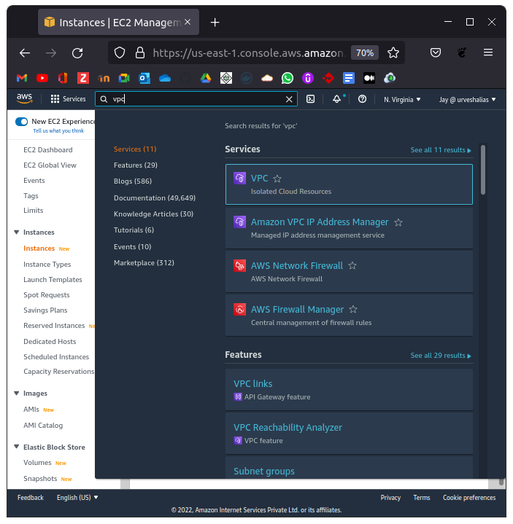

Create vpc vizard and give 2 subnet configuration with is configured to be public.

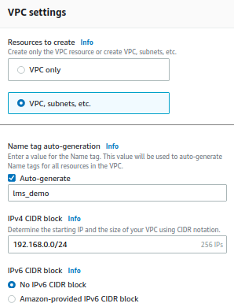

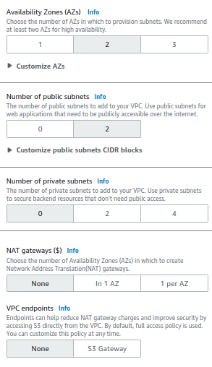

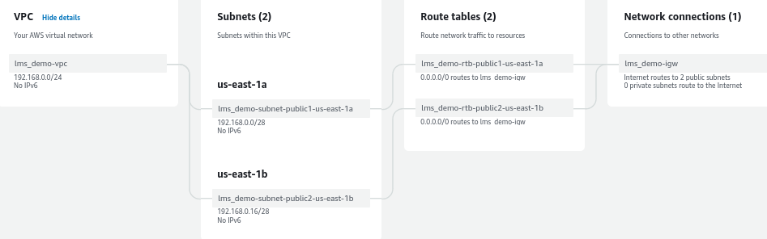

Verify all the processing step and check vpc configuration after it’s creation.

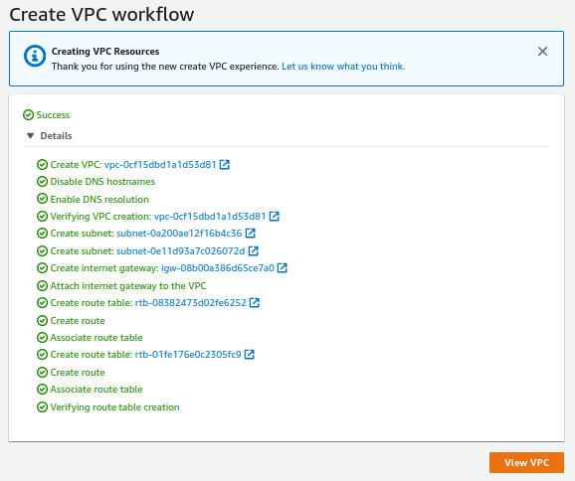

Create ec2 instance in under different AZ and custome vpc created.

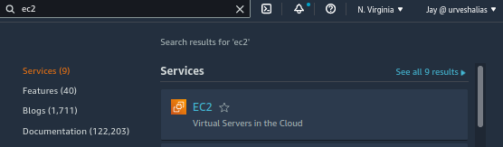

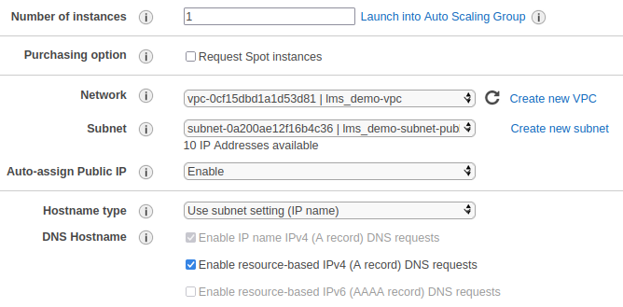

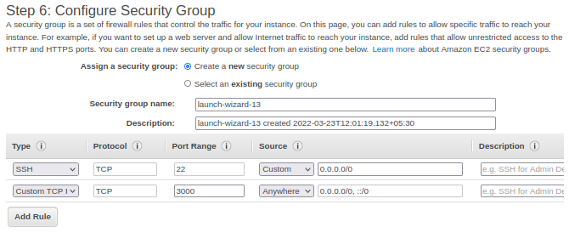

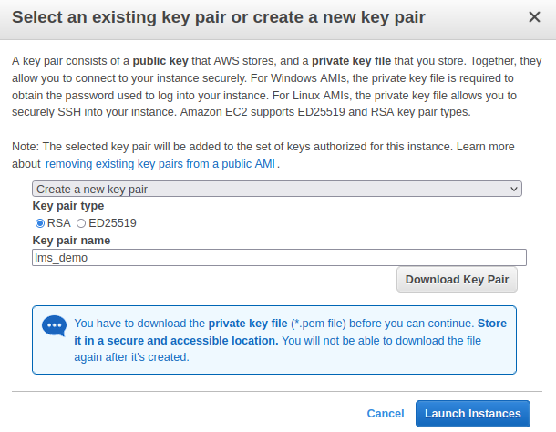

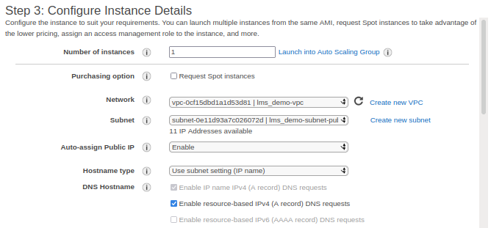

Allow sequrity group to access 3000 port (application running port) to accessed by internet.

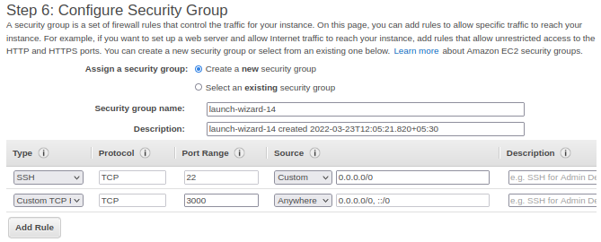

Create two instance using same method and verify status.



Upload application using scp command and verify at server by using ssh.

