### **Create an EC2 Instance**

1. Navigate to the EC2 dashboard, and click **Launch Instance**.

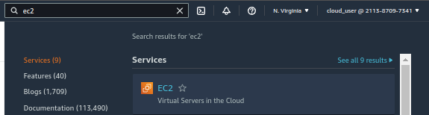

1. On the AMI page, select the **Amazon Linux 2 AMI**.

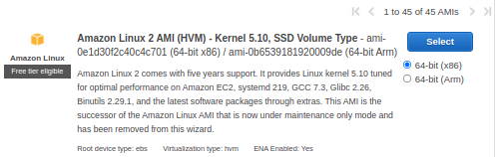

1. Leave *t2.micro* selected, and click **Next: Configure Instance Details**.

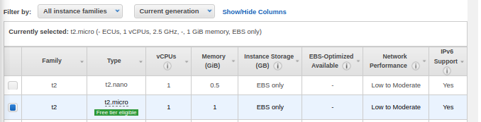

1. On the *Configure Instance Details* page:
   * *Network*: Leave default
   * *Subnet*: **us-east-1**
   * *Auto-assign Public IP*: **Enable**

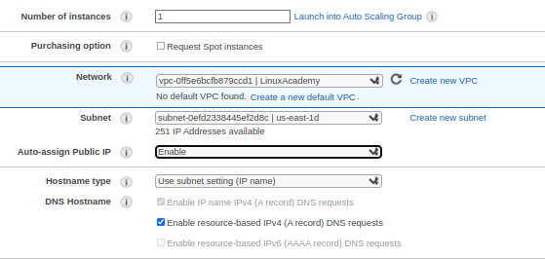

sudo yum update -y

sudo yum install -y httpd

sudo service httpd start

sudo chkconfig httpd on

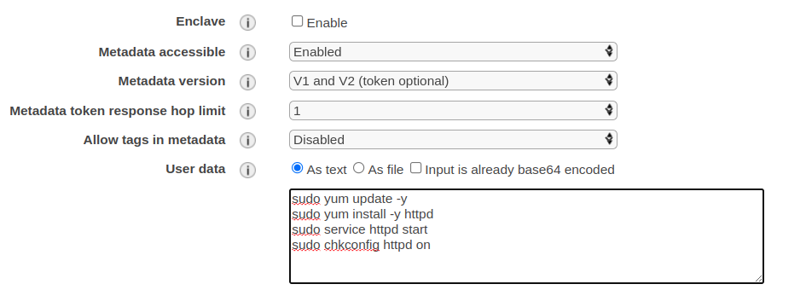

1. Click **Next: Add Storage**, and then click **Next: Add Tags**.
2. 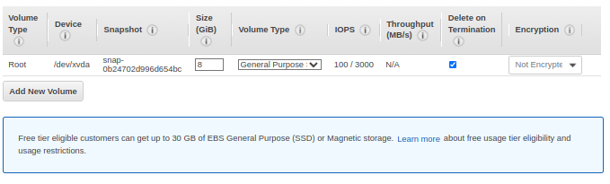
3. On the *Add Tags* page, add the following tag:
   * *Key*: **Name**
   * *Value*: **FQDN EC2**

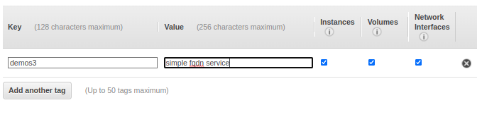

1. Click **Next: Configure Security Group**.
2. Select **Create a new security group**.
3. Click **Add Rule**, and set the *Type* to **HTTPS**.
4. Click **Add Rule**, and set the *Type* to **HTTP**.

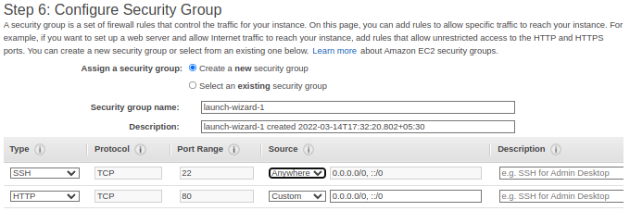

1. Click **Review and Launch**, and then **Launch**.
2. In the key pair dialog, select **Create a new key pair**.
3. Give it a *Key pair name* of "FQDNEC2".
4. Click **Download Key Pair**, and then **Launch Instances**.

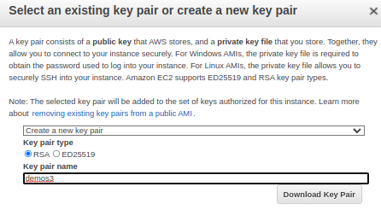

1. Click **View Instances**, and give it a few minutes to allow the instance to enter the *running* state.

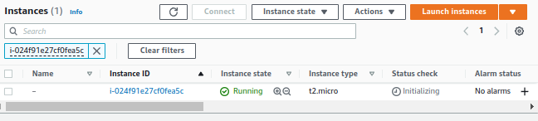

1. Once it's running, copy its public IP and paste it into a text file — we'll need it a few times in the rest of the lab.

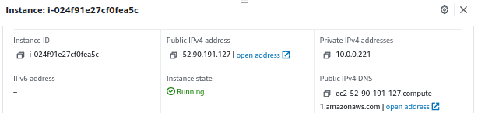

### **Create Record Sets**

#### **First Record Set**

1. Navigate to Route 53 in the AWS console.

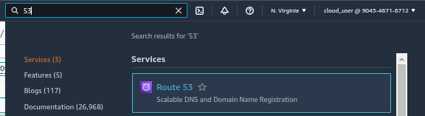

1. Click Hosted zones.

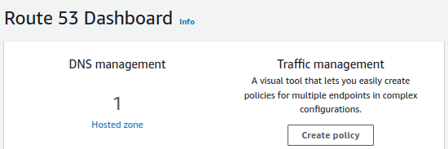

1. Select the listed zone.

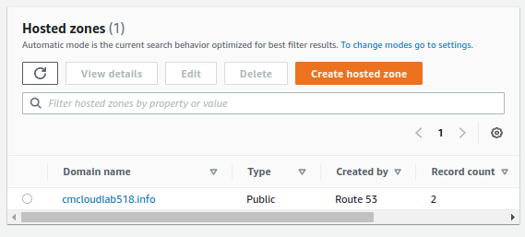

1. Update: The AWS Portal has changed. Choose **Create record**.
   * **Routing policy**:Simple routing
   * **Record type**: A
   * **Value**: Public IP of Instance
   * Select **Create Records**

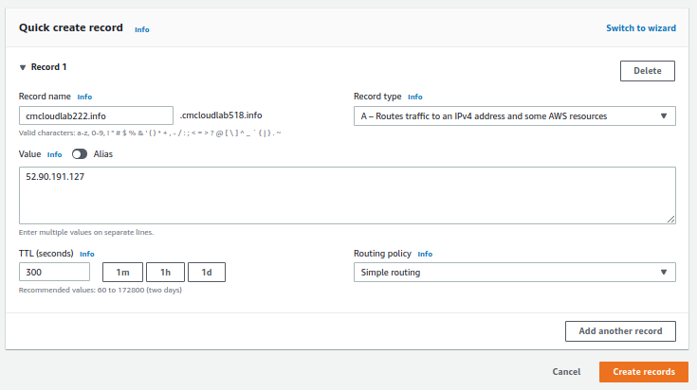

#### **Second Record Set**

1. Choose **Create record**.
   * **Record Name**: www
   * **Record Type**: A
   * **Routing policy**: Simple Routing
   * **Value**: Public IP of Instance
   * Select **Create Records**

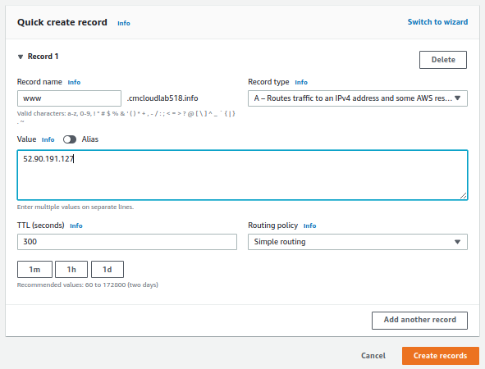

1. Copy the **Record Name**, also known as the domain name.
2. After a few minutes, open a new browser tab and paste in the domain names for both record sets we created. They should both result in the Apache test page.