# **Create And Configure Basic VPC Components in AWS**

Create And Configure Basic VPC Components in AWS.

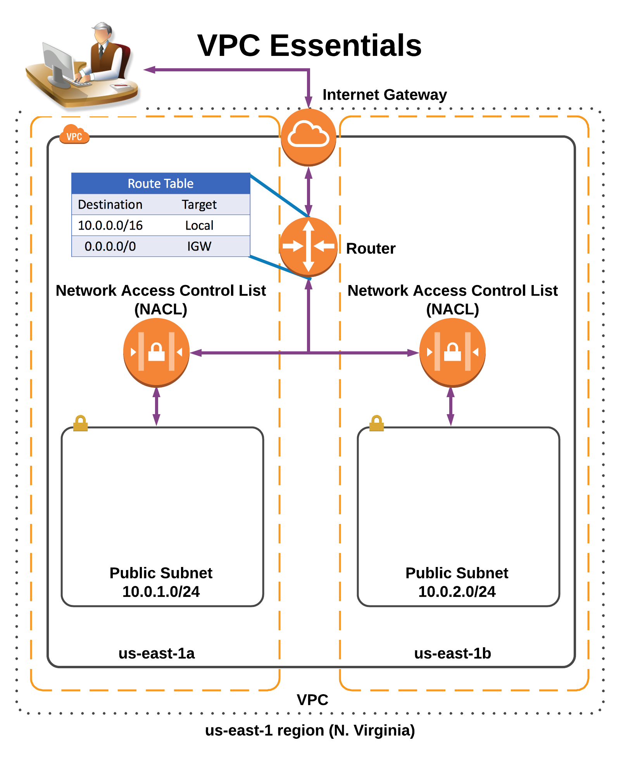

Create a VPC

Create a VPC from scratch (without using the VPC Wizard). Set the VPC CIDR to 10.0.0.0/16

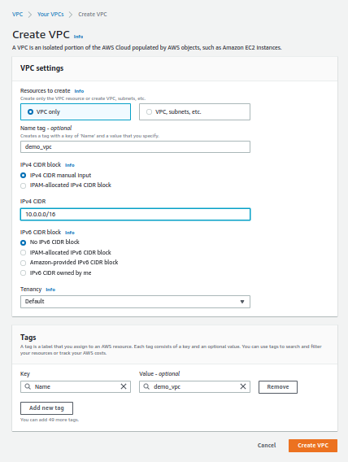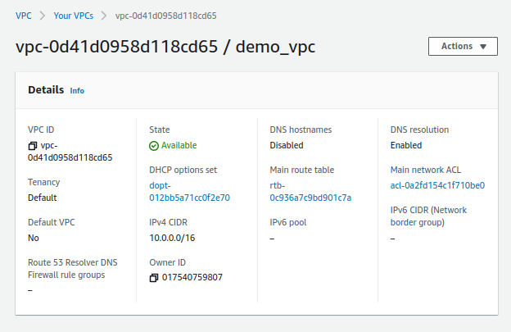

Create an Internet Gateway

Create an Internet Gateway and connect it to the VPC.

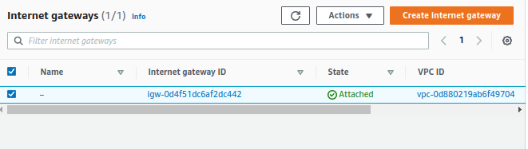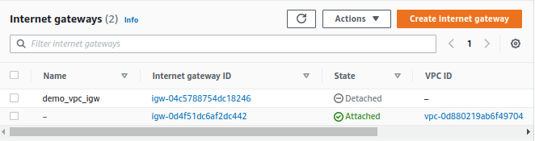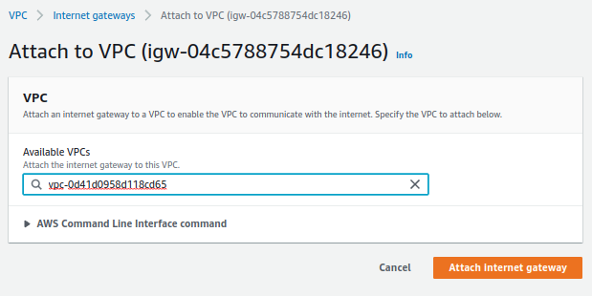

Edit the Main Route Table

Edit the Main Route Table with two entries.  
1. Create a default route to the internet using the 0.0.0.0/0 CIDR notation 2. Create a local route to allow internal communication within the VPC between the two public subnets.

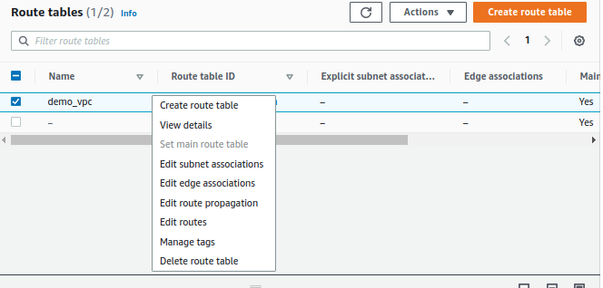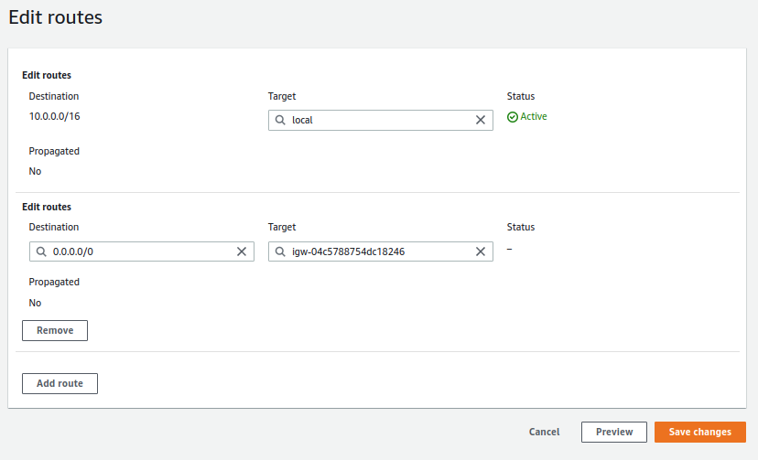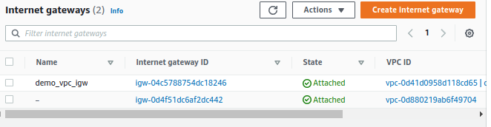

Create a Network Access Control List (NACL) and associate it.

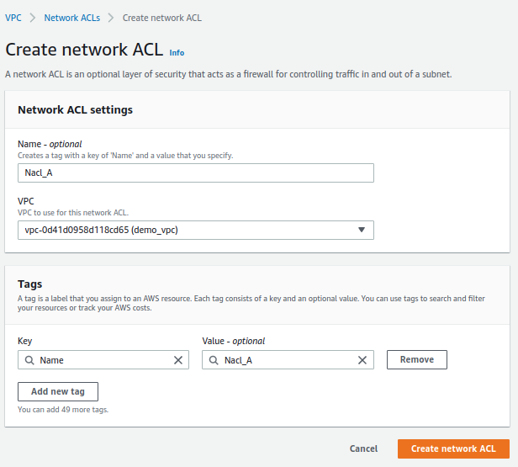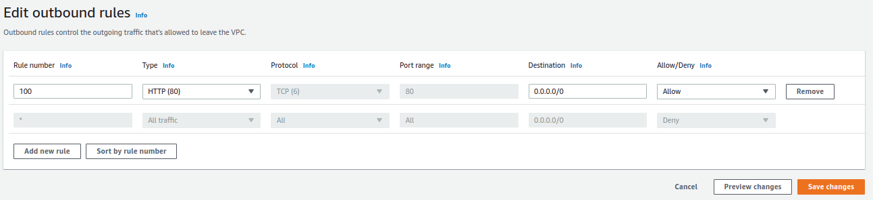

Create two public subnets

Create two public subnets in different availability zones using the following IP CIDR addresses: 1. Subnet 1 in us-east-1a: 10.0.1.0/24 2. Subnet 2 in us-east-1b: 10.0.2.0/24

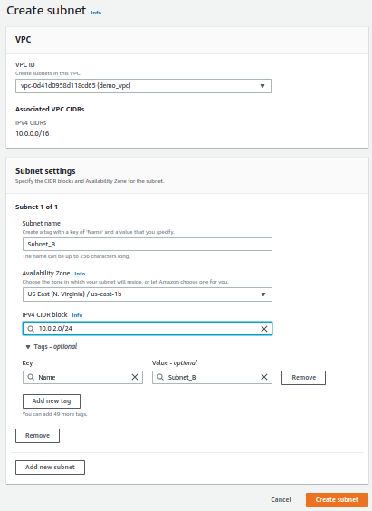

Verify route tables and ACL configuration on Subnet_A and Subnet_B.

