### **Create an SNS Topic and Subscribe an Email Address**

1. In the AWS Management Console, navigate to Simple Notification Service (SNS).

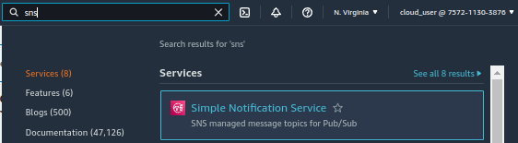

1. In the *Create topic* box, enter a *Topic name* of "EC2statechange".
2. Click **Next step**.

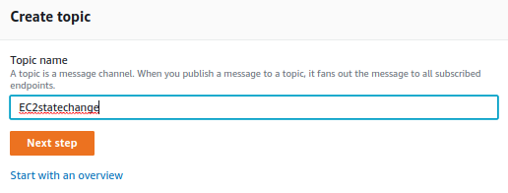

1. On the *Create topic* page, leave everything as default, and click **Create topic**.

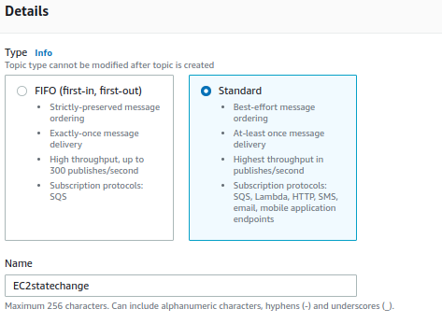

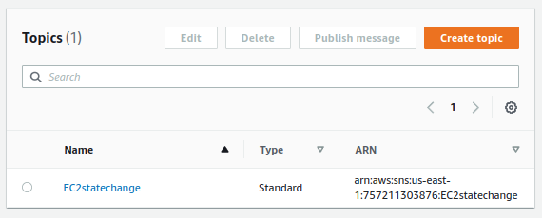

1. In the *Subscriptions* section, click **Create subscription**.
2. On the *Create subscription* page, change the *Protocol* to **Email**.
3. For *Endpoint*, type your email address.
4. Click **Create subscription**.

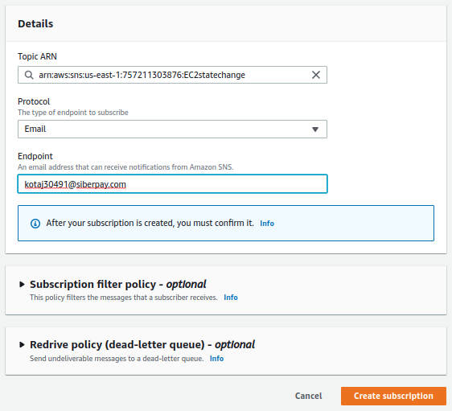

1. In a new browser tab, navigate to your email inbox.
2. Open the *AWS Notification - Subscription Confirmation* email, and click the **Confirm subscription** link.

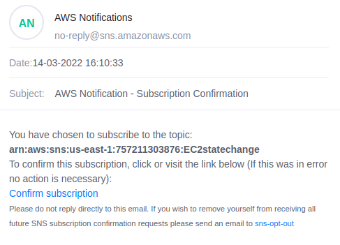

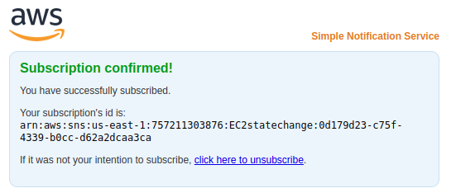

1. Go back to your AWS Management Console browser tab, and refresh the page. The subscription should now be confirmed.

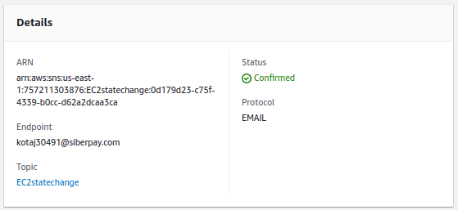

### **Create an Amazon EventBridge Rule to Trigger the SNS Topic When There Is a State Change to an EC2 Instance**

1. Go to Amazon EventBridge.
2. Click Create Rule.
3. Name the rule "EC2instancestatechange".

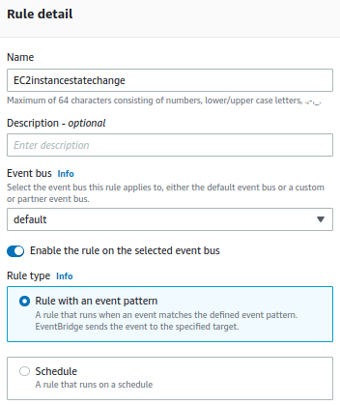

1. Choose Even Pattern.
2. Under Event matching pattern, choose Pre-defined pattern by service.
3. Choose the Service Provider AWS.
4. Choose the service name EC2.
5. For Even Type, choose EC2 Instance State-change Notification.

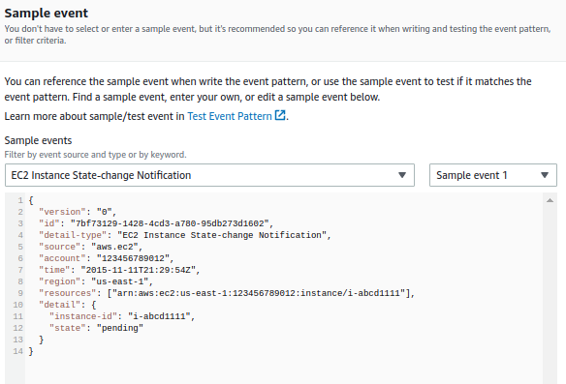

1. Leave the Any state and Any instance options selected.
2. Click into the field at the top of the Targets menu, and select SNS topic from the dropdown.
3. For Topic, select EC2statechange from the dropdown.
4. Click Create.

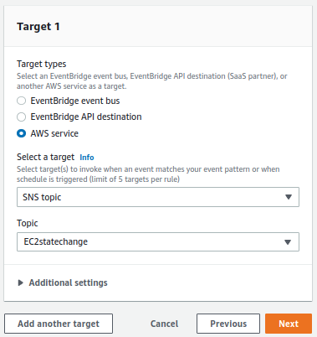

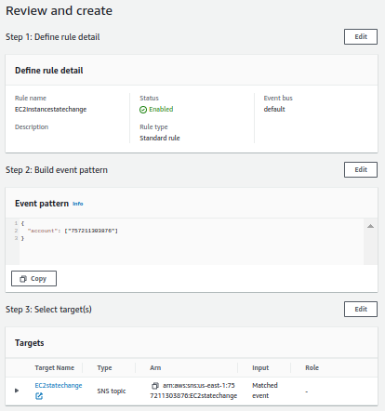

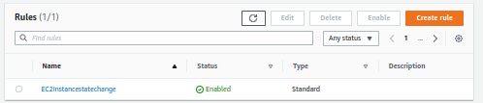

### **Change the State of the EC2 Instance and Verify Receipt of the SNS Notification**

1. Navigate to EC2.

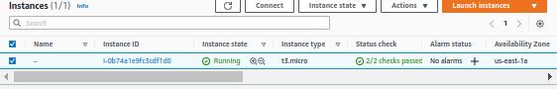

1. Click **Instances (running)** at the top of the page.
2. With the instance selected, click **Instance State** > **Stop**.
3. Click **Stop**.
4. While the instance state is *stopping*, go back to your email inbox, and check for an email from AWS Notifications.
5. Open the email. The message content should indicate that the instance state is currently *stopping*.

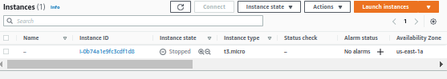

1. Go back to the AWS Management Console, and wait for the instance state to be *stopped*.
2. Go back to your email, and check for another email from AWS Notifications.

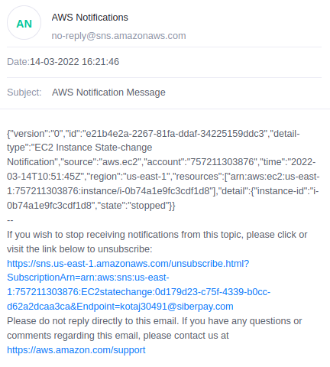

1. Open the email. The message content should indicate that the state is now *stopped*.