# **Installing Nginx in AWS EC2**

1.Inside the AWS EC2 Service, click on Launch instances

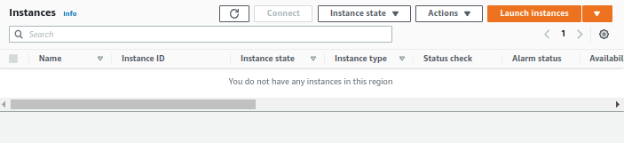

2. Choose the Amazon Linux 2 AMI with 64-bit (x86). Click on Next.

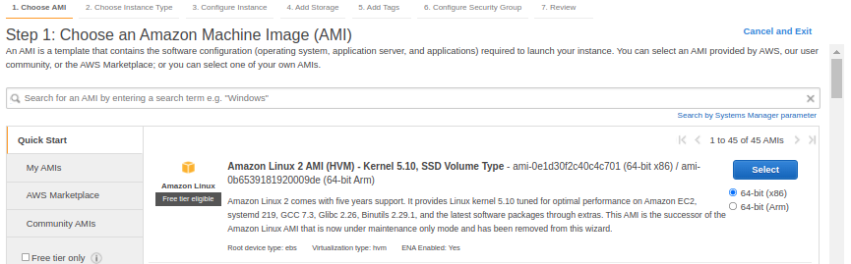

3. Choose an Instance type that will match your application load. I chose **t2.micro** for demo purposes. Click on Next: Configure Instance Details

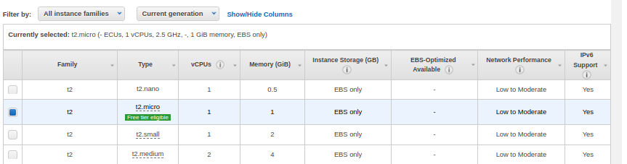

4. Choose your desired VPC, public subnet and enable Auto-assign Public IP

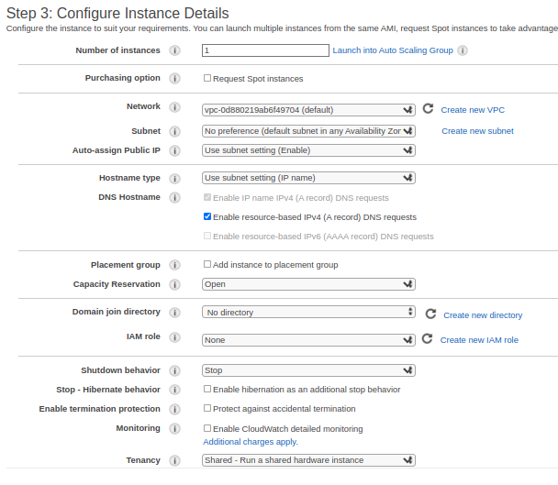

5. Scroll down and add the following lines to the User Data section and enter following data.

#!/bin/bash  
sudo yum update -y  
sudo amazon-linux-extras install nginx1 -y   
sudo systemctl enable nginx  
sudo systemctl start nginx

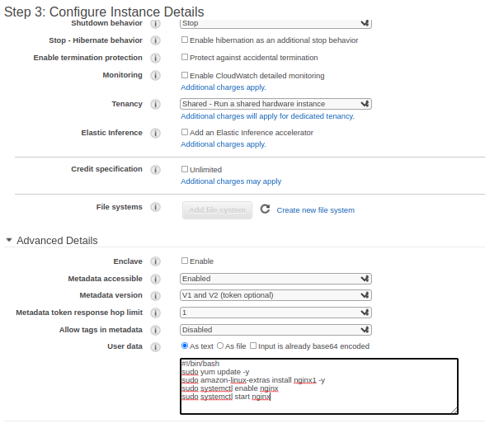

6. Click on Next: Add Storage. Leave it to default unless you need more storage.

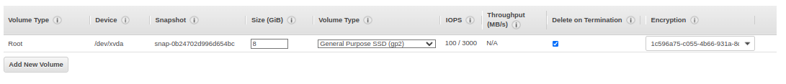

7. Click on Next: Add Tag

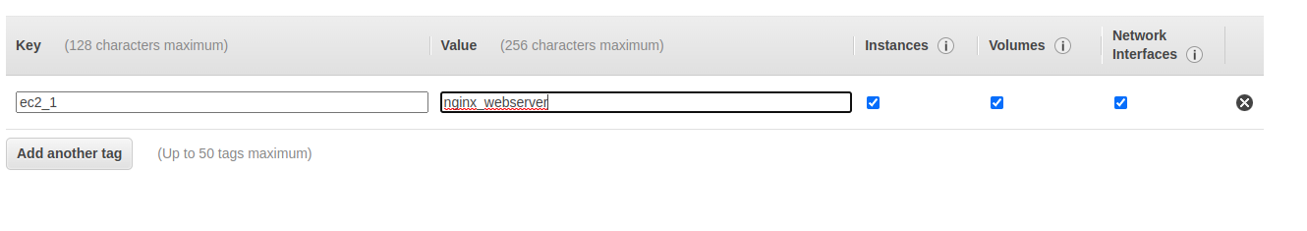

8. Click on Next: Configure Security Group. Create a new security group with SSH access from your public IP and port 80 from everywhere

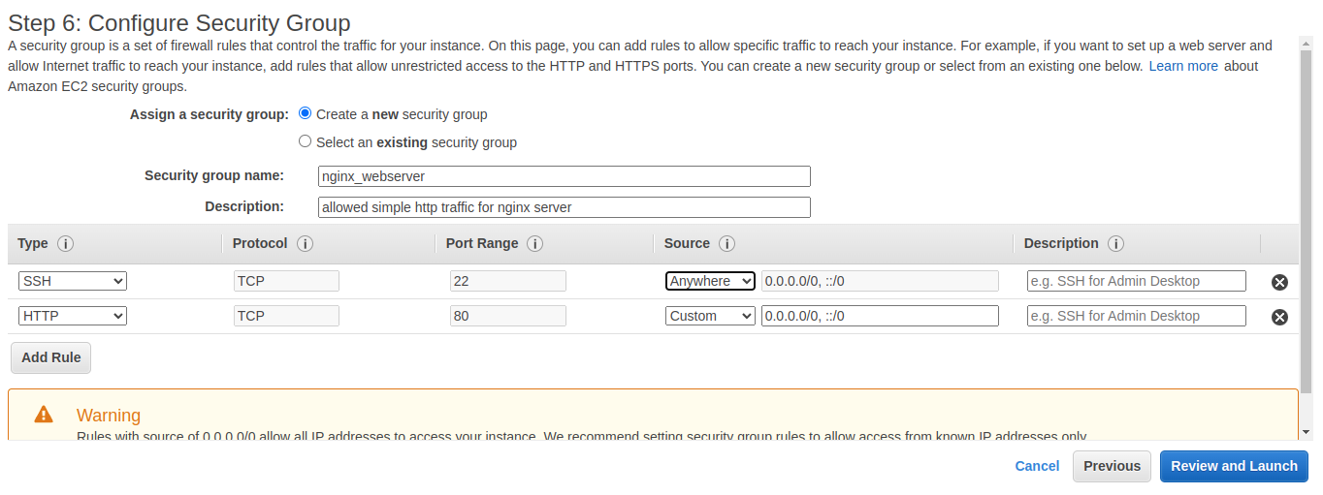

9. Click on Review and Launch. Review all the settings, click on Launch.

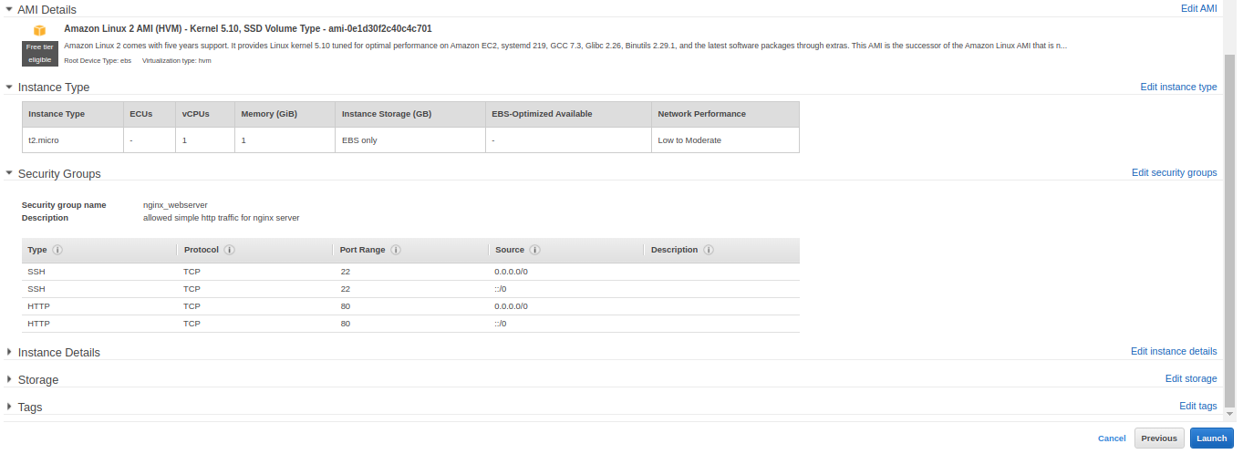

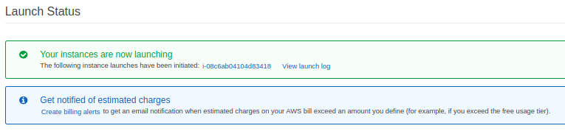

11. Verify After the instance has been created, and fully initialized.

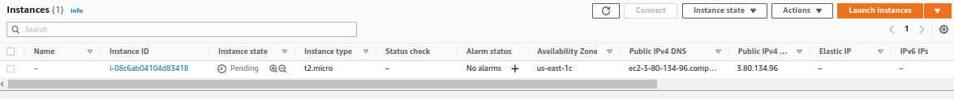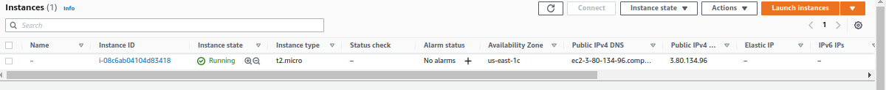

12.Copy public DNS from the instance description and do a curl on it verify the nginx webserver is running.

