Creating a Lambda Function Using the AWS Console

**Node.js Lambda Function in AWS Console**

1. Navigate to Lambda.
2. Click Create function.

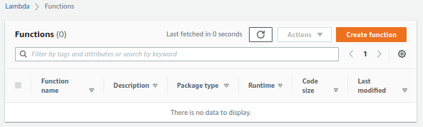

1. Select Author from scratch.

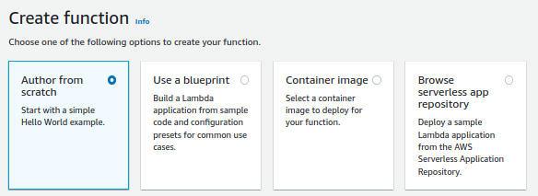

1. Name your function.
2. Select Node.js as the runtime.
3. Select Create a new role with basic Lambda permissions.
4. Click Create function.

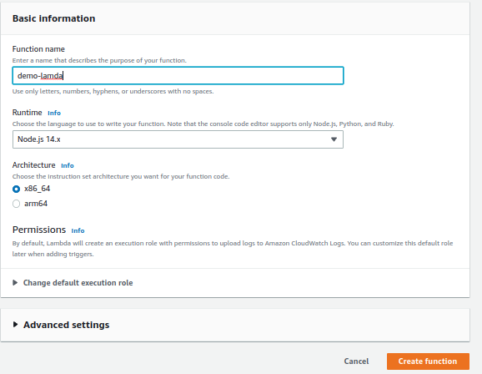

1. In a new browser tab, navigate to the lab GitHub repository link provided on the lab page.

<https://github.com/linuxacademy/content-aws-ccp-labs/blob/master/creating-a-lambda-function-using-the-aws-console/index.js>

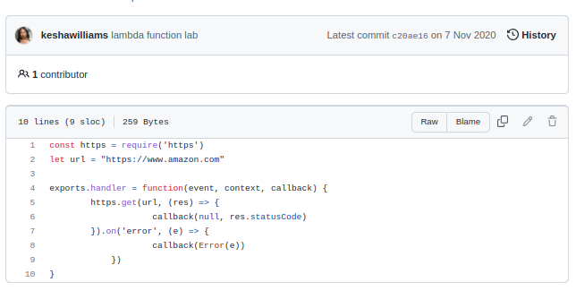

1. Copy the index.js code, and replace the Lambda function code with it.

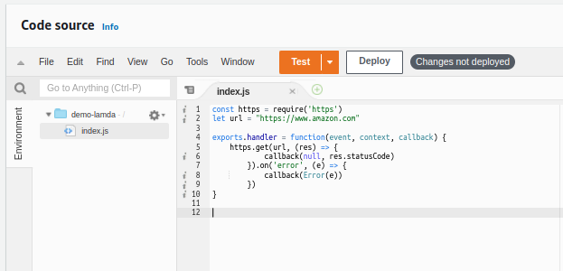

1. Deploy your function.

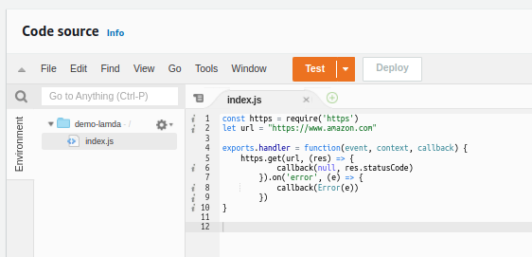

**Test Function Using a Test Event**

1. Click Test in the upper right.
2. For the Event name, enter "mytestEvent".
3. Leave the other default values.
4. Click Create.

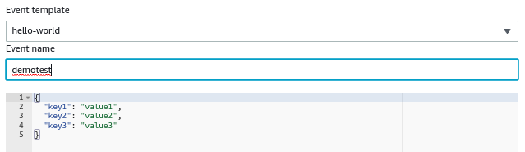

1. Click Test again.
2. Review the output response.
3. It should be 200, which means the website is up and running.

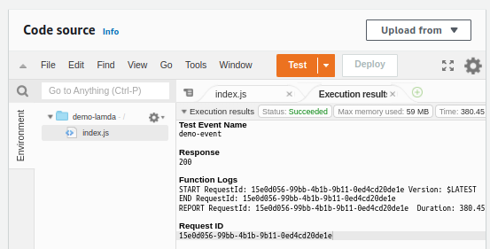

**View Lambda's CloudWatch Logs**

1. Click the Monitoring tab.

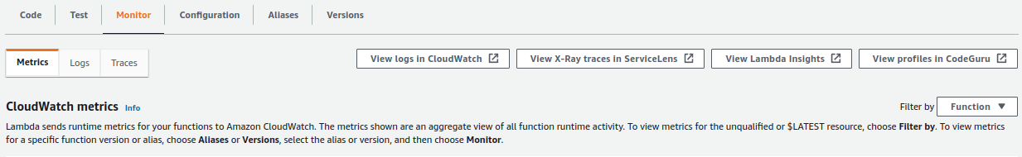

1. Click View logs in CloudWatch.
2. Click on the most recent log stream in the Log streams section.

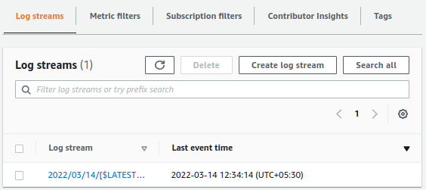

1. Notice the billed duration.

