**Application deployment threw Dockerization**

Check Node app in Local enviroment

1. First create empty directry and do npm init for initialization for node project

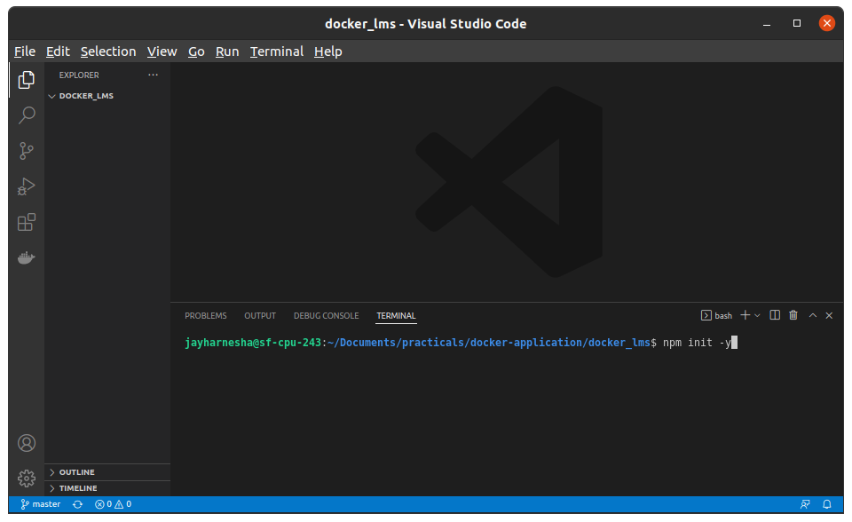

1. Verify packerg.json file.

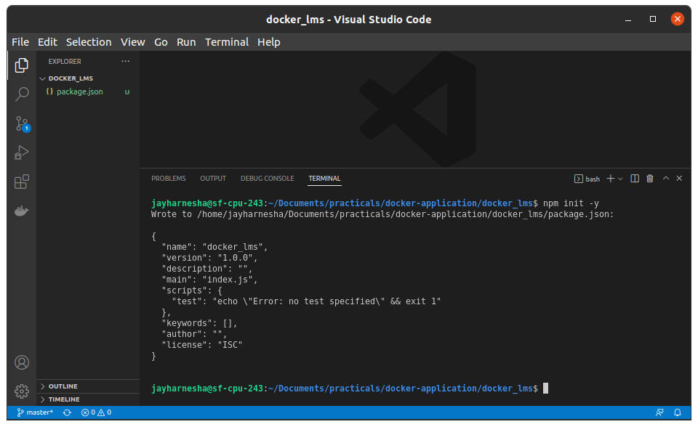

1. Create index.js file as name in packeg.json file.
2. Do write following code in index.js file

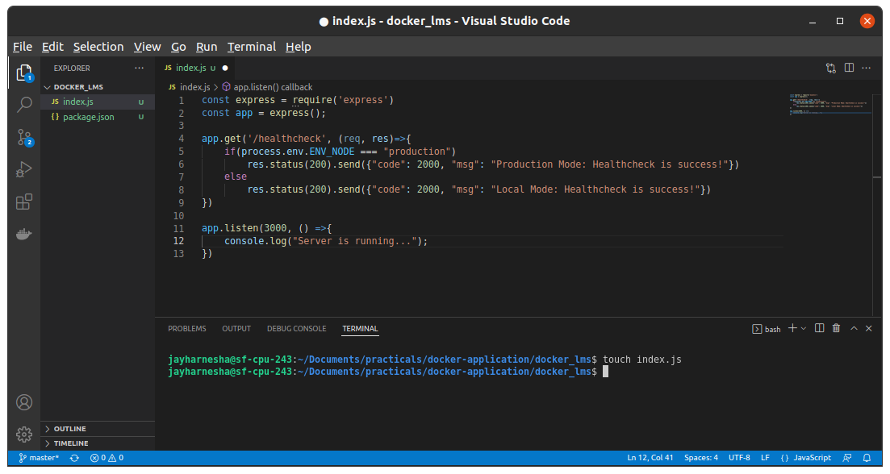

1. After that for adding depedency to json file and install depedency to local system run npm install express –save

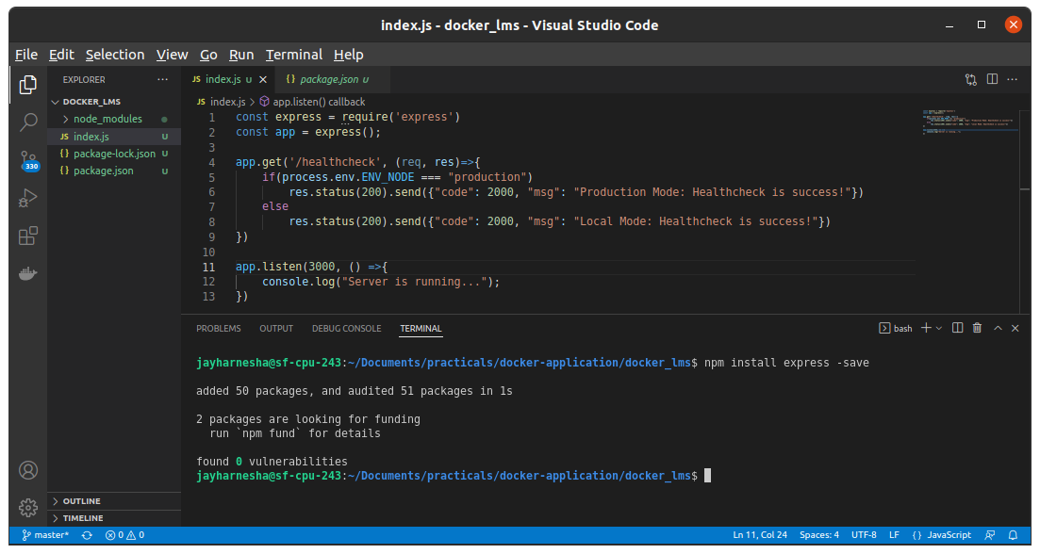

1. This action will install node_module depedency to out project folder

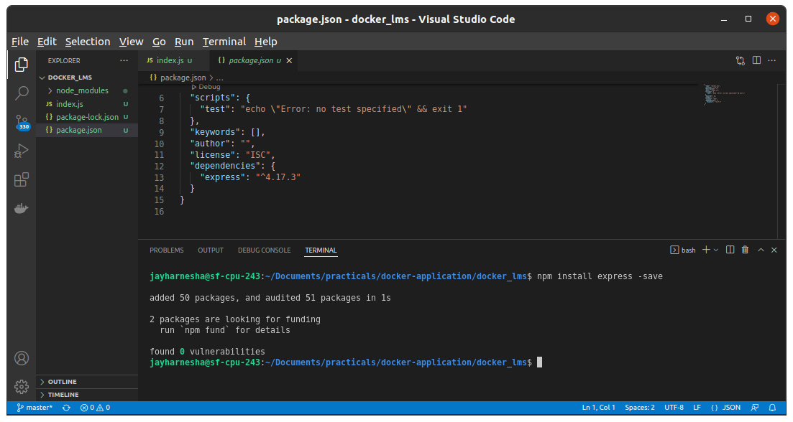

1. For running our app run “node index.js” and verify in browser via localhost:3000/healthchech uri

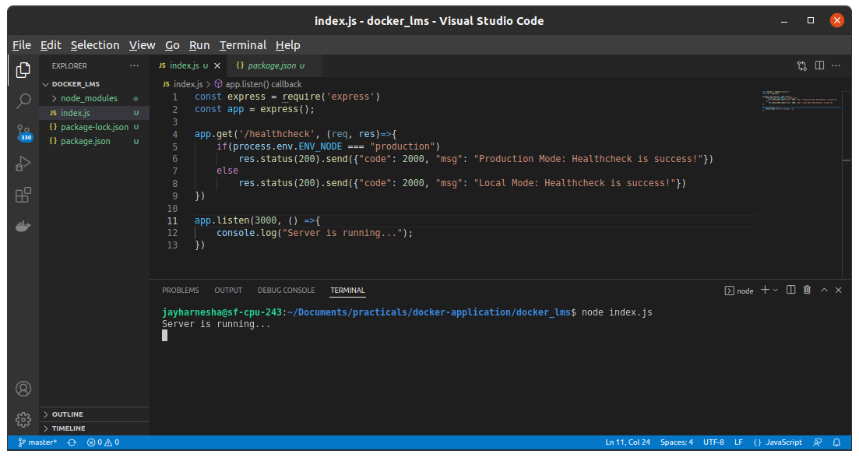

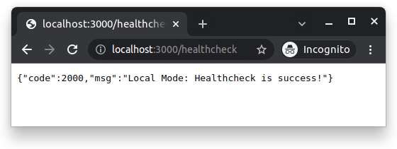

Make Container and run app with container

Create Docker file and write following data into it.

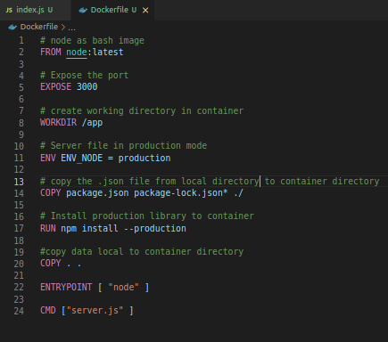

1. Image Should have proper name and tag

Make docker images by following command and verify output.

**docker build -t node_app:latest .**

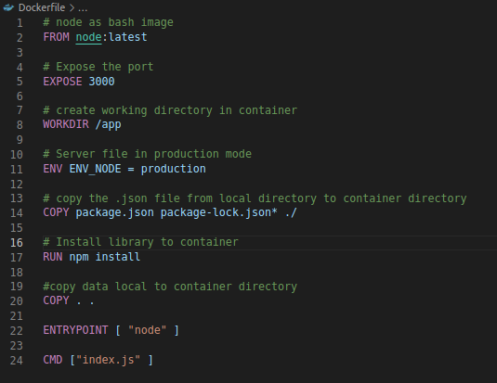

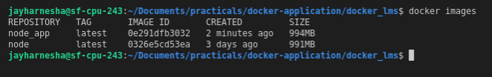

1. Application should be running on port 5000

**docker run -d -p 5000:3000 node_app:latest**

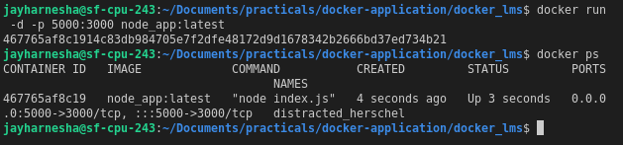

1. Logs folders should be mounted on the local disk - that means if someone restarts the container logs folder’s data should be persisted.

**docker run -d -v node_app_logs:/app/logs -p 5000:3000 node_app:latest**



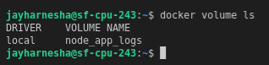

1. Application should run in “Production Mode” not in “Local Mode”

**docker run -d -v node_app_logs:/app/logs -e ENV_NODE=production -p 5000:3000 node_app:latest**

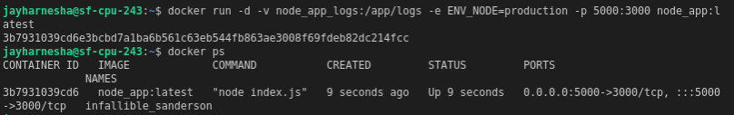

1. Create a docker image an run it in your local environment

