**Docker container registry practical.**

1. **Login to docker hub from cli.**

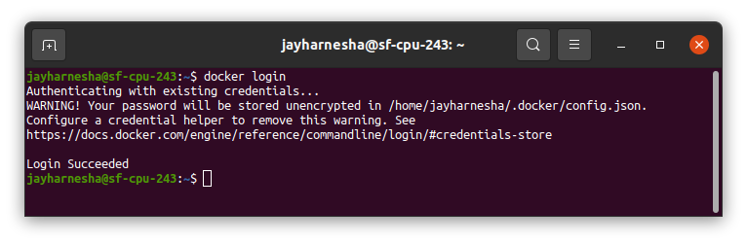

1. **List your available docker images.**

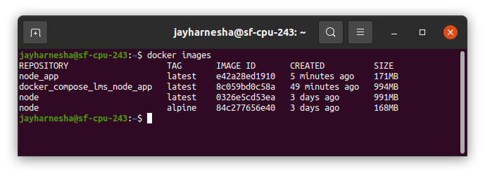

1. **Create private repositery in docker hub.**

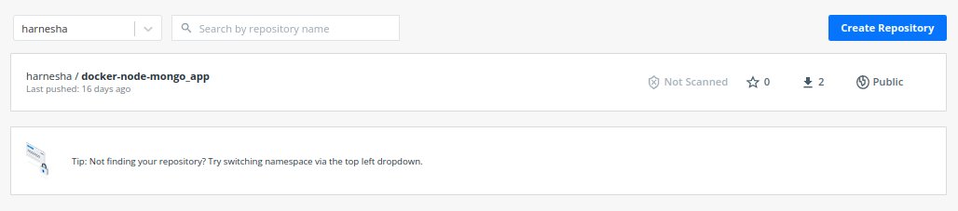

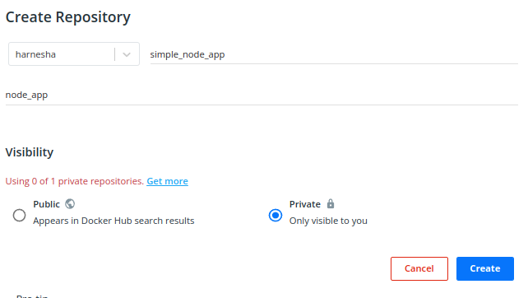

1. **Give proper name and tag to docker image.**

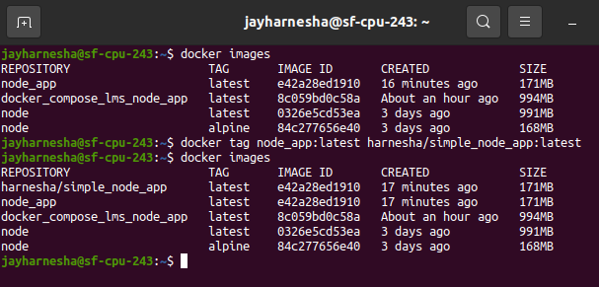

1. **Push docker image to docker private registry.**

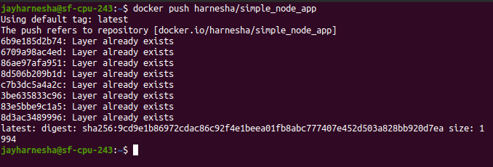

1. **Verify pushed image from docker hub.**

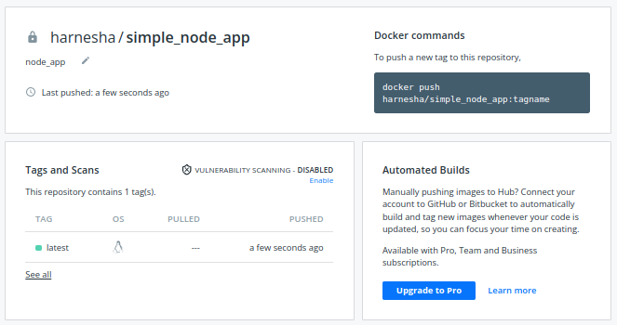

1. **Run docker images from docker hub.**

