**Application deployment threw Dockerization**

Check Node app in Local enviroment

1. First create empty directry and do npm init for initialization for node project

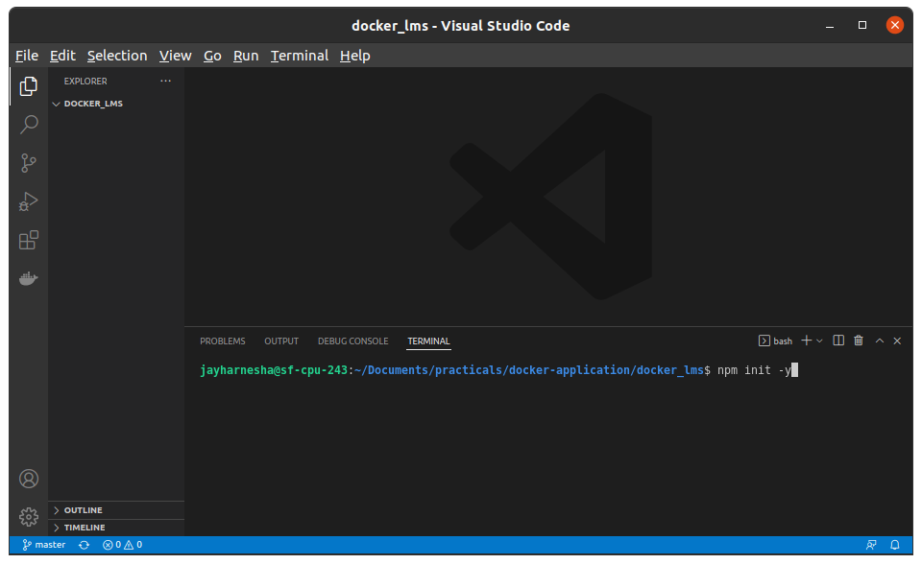

1. Verify packerg.json file.

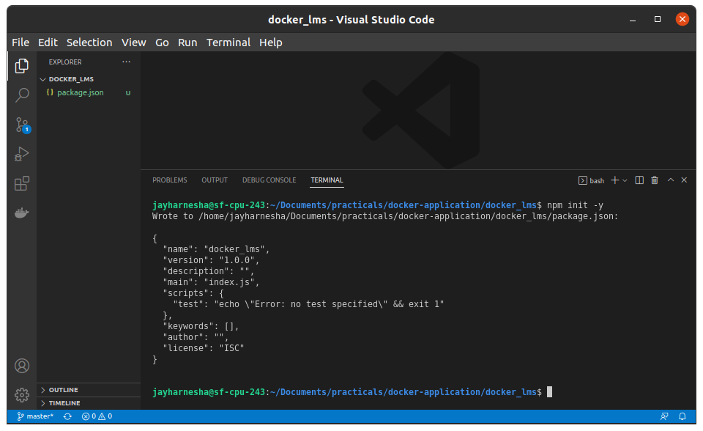

1. Create index.js file as name in packeg.json file.
2. Do write following code in index.js file

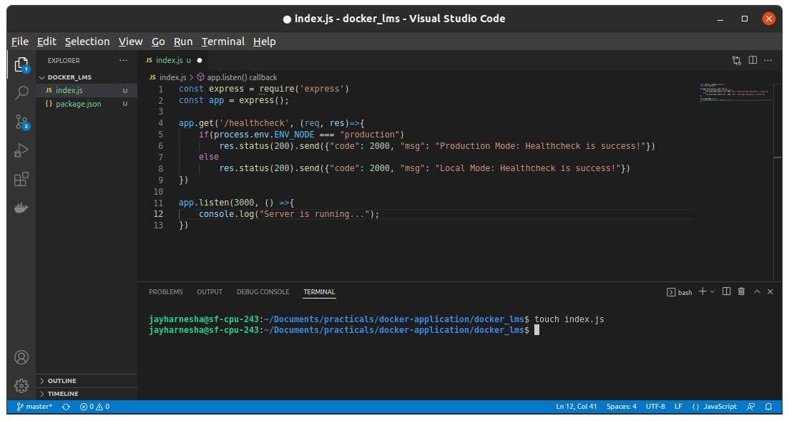

1. After that for adding depedency to json file and install depedency to local system run npm install express –save

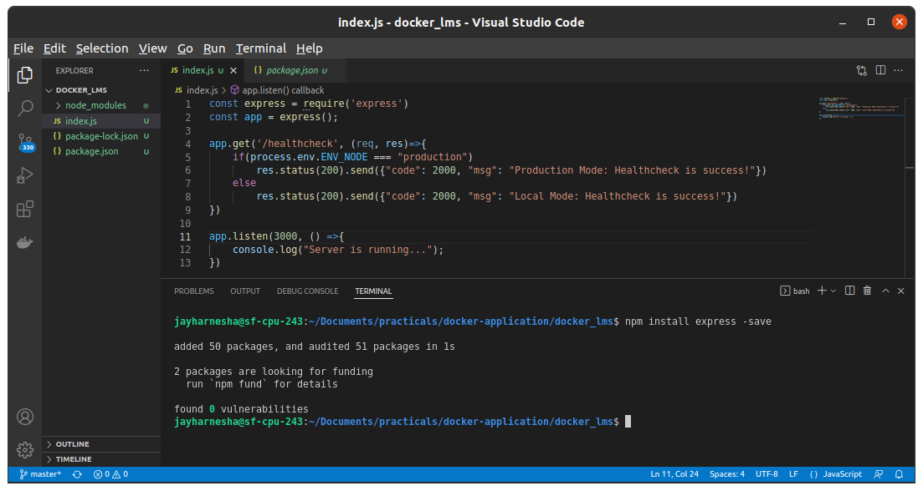

1. This action will install node_module depedency to out project folder

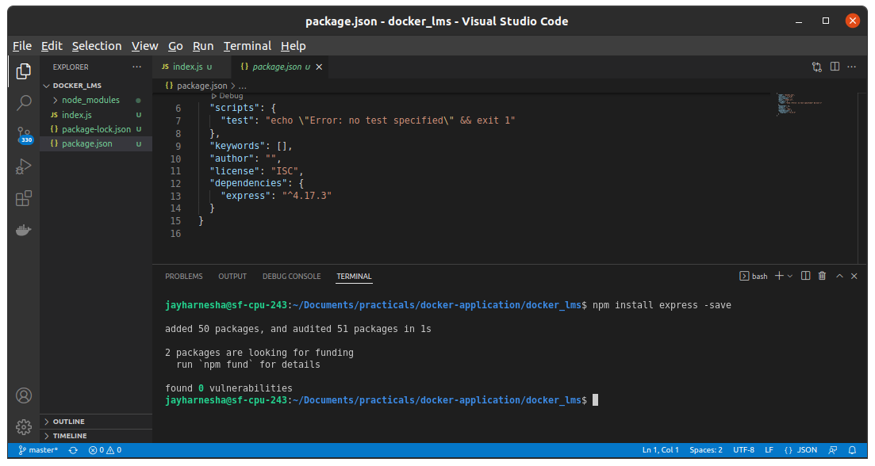

1. For running our app run “node index.js” and verify in browser via localhost:3000/healthchech uri

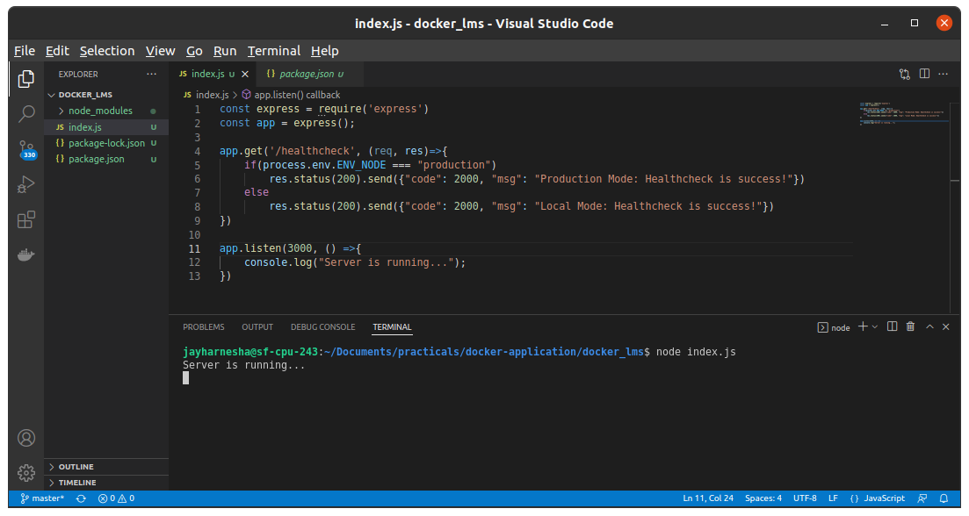

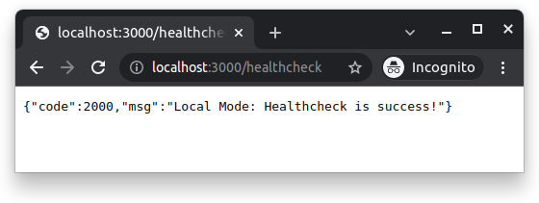

**Make Container and run app with container**

1. Create Docker file and write following data into it.

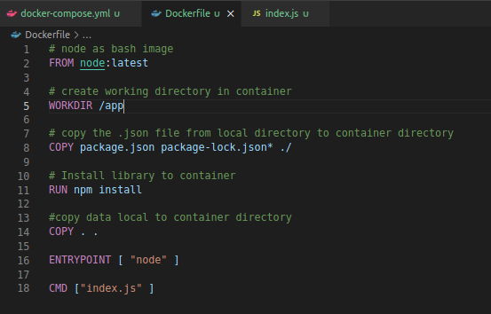

1. Create docker-compose.yml file and write following data into it.

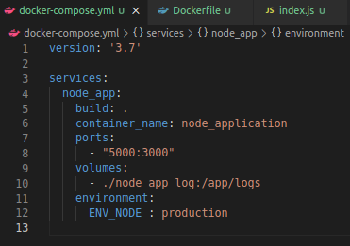

1. Run following command for build of docker image from docker-compose file.

**docker-compose build**

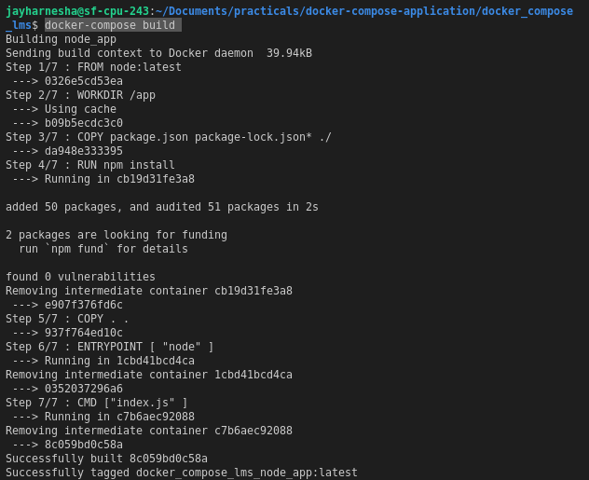

1. Run following command for running built docker-compose image file.

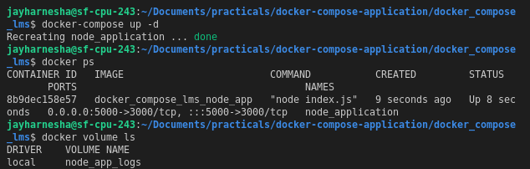

1. Verify application running endpoint from browser.



1. Enter following command to stop docker-compose running service.

