## Practical Exercise - Programming

Create a script file to take MongoDB database backup

**Conditions**:

* Setup MongoDB in your local with test database and tables
* Take a MongoDB database backup in to /tmp folder first.
* Move that backup file to /var/backup folder - if backup folder is not there create it otherwise move it
* Folder name inside backup folder should be - <DBName>-<YYYY>-<MM>-<DD>, There must be only one folder for each day, Backup name can be anything.
* This script file will be run automatically daily at 11 AM
* In case of manual run - If backup file is already there in the date folder then it should be overwrite (Delete and Create).
* Upload your shell script (.sh) file while submitting your exercise

**Installation of MongoDB**

First you need to update and upgrade your system repository in order to install MongoDB. Type the following command in your terminal and then press Enter.

install the MongoDB package using **‘apt’**. Type the following command and press Enter.

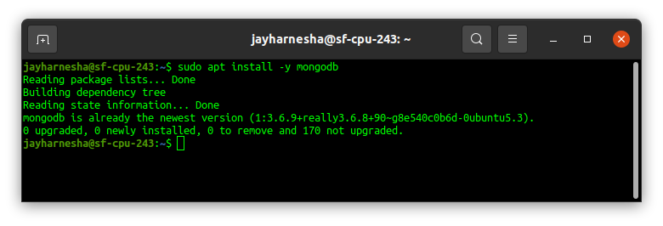

Check the service status for MongoDB with the help of following command:

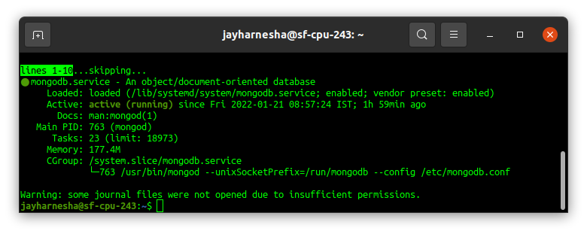

Now check if the installation process is done correctly and everything is working fine. Go through the following command:

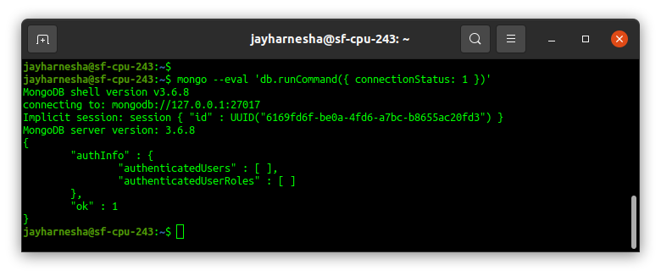

MongoDB services can be started and stopped with the use of following commands:

To stop running the MongoDB service, use command :

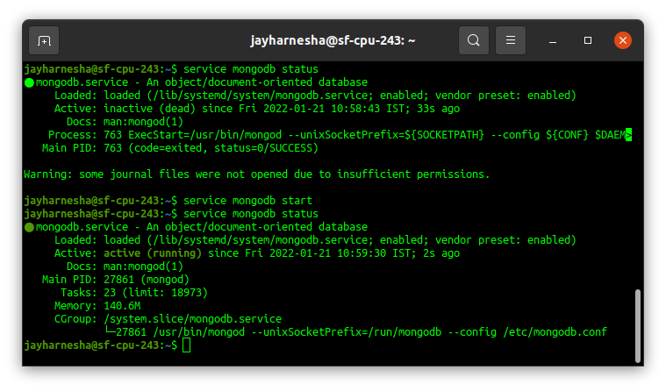

**Insert Test Data**

First, connect to the running database using the MongoDB shell:

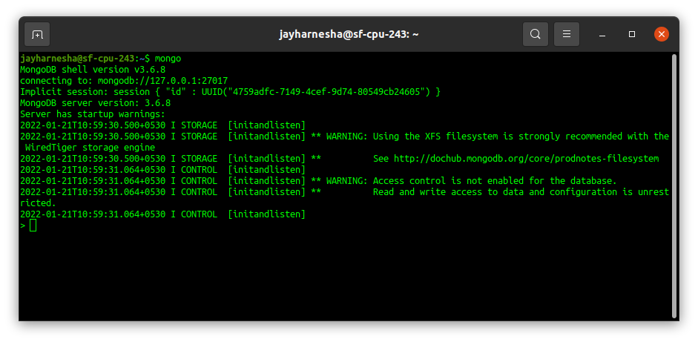

Make database name test and move into test database.

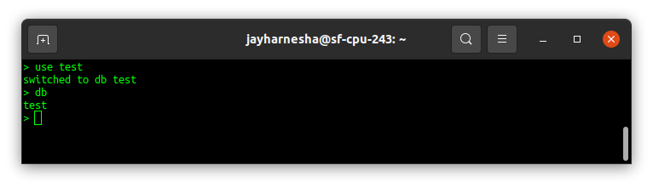

Let’s insert a document into a dummy collection, which will automatically be created

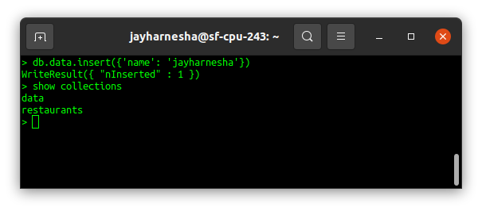

Now, insert user into database with following command.

db.createUser(

{

user: "admin",

pwd: "123456",

roles:[{db:"Employee"}]})

You can see inserted user with following command

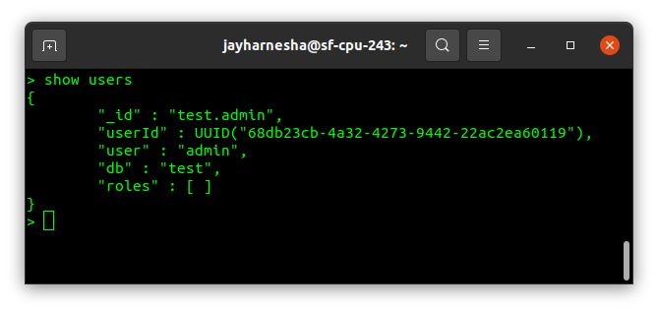

**Make script for backuping up data in to specifird folder**

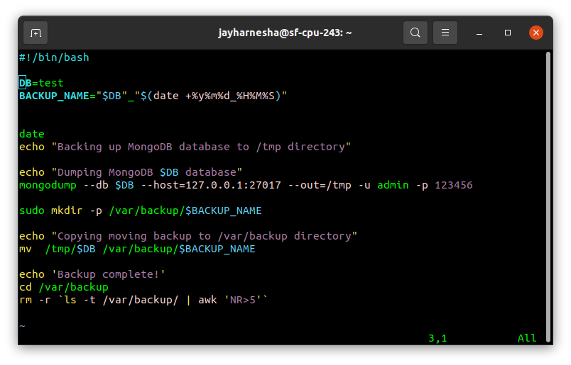

#!/bin/bash -> will tell interpreter that this is a bash file.

DB=test -> declared bash variable for setting database name which we have to backup.

BACKUP_NAME="$DB"_"$(date +%y%m%d_%H%M%S)" -> declared bash variable for setting database backup name which we have to backup correspond to time and date.

Date -> will tell time to consol to which time backup has done (logging purpose)

echo "________” -> all the echo statement are wrriten for logging purpose.

mongodump --db $DB --host=127.0.0.1:27017 --out=/tmp -u admin -p 123456

-> mongodump – command for dumping database backup

-> --db -> option for specing which database have to be backed up

-> --host -> option for where the database server is running

->--out -> output directory where the database has to be backed up

->-u,-p -> respective username and password for connection to database

sudo mkdir -p /var/backup/$BACKUP_NAME -> create directory if does not excites for backup folder

sudo mkdir -p /var/backup/$BACKUP_NAME -> move backup to the /tmp directoyr to /var/backup directory

cd /var/backup -> navigate to /var/backup direcoty

rm -r `ls -t /var/backup/ | awk 'NR>5'` -> remove old backup if more than five backup are there in /var/backup directory

**Check the script sunning properly**

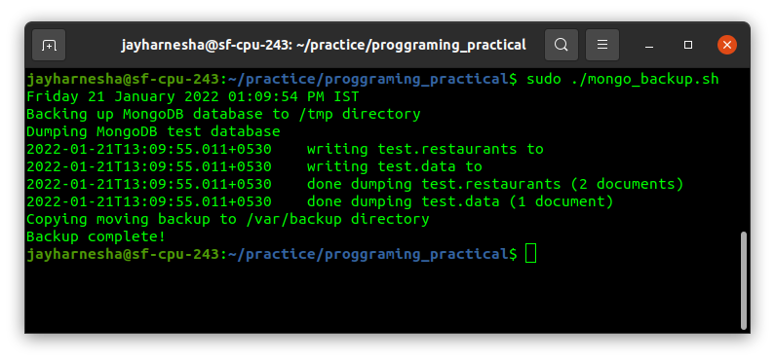

**Create cronjob and schedule it for one minute and see the output**

