**serve new static page in nginx**

1.create static page in /var/www directory

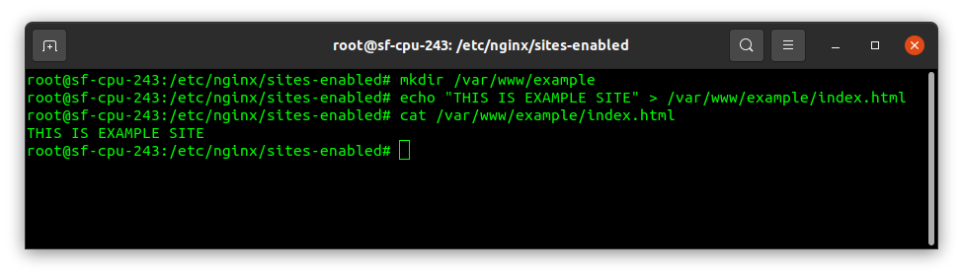

2.copy /etc/nginx/sites-avalible/default file data to /etc/nginx/sites-avalible/example

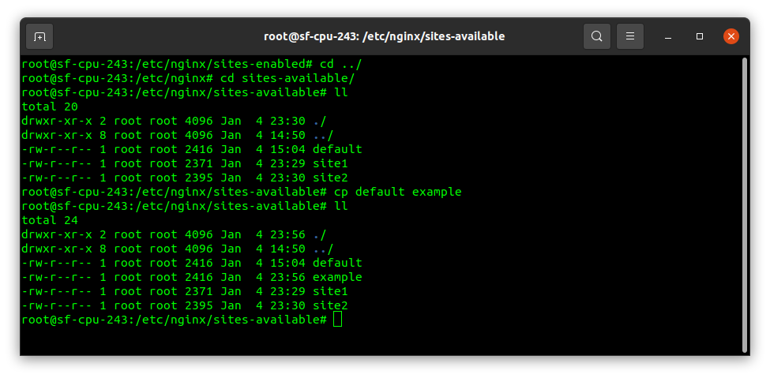

3.do modification in example file

-remove default_server from listening port

-set root directory to /var/www/example

-set server_name example.com

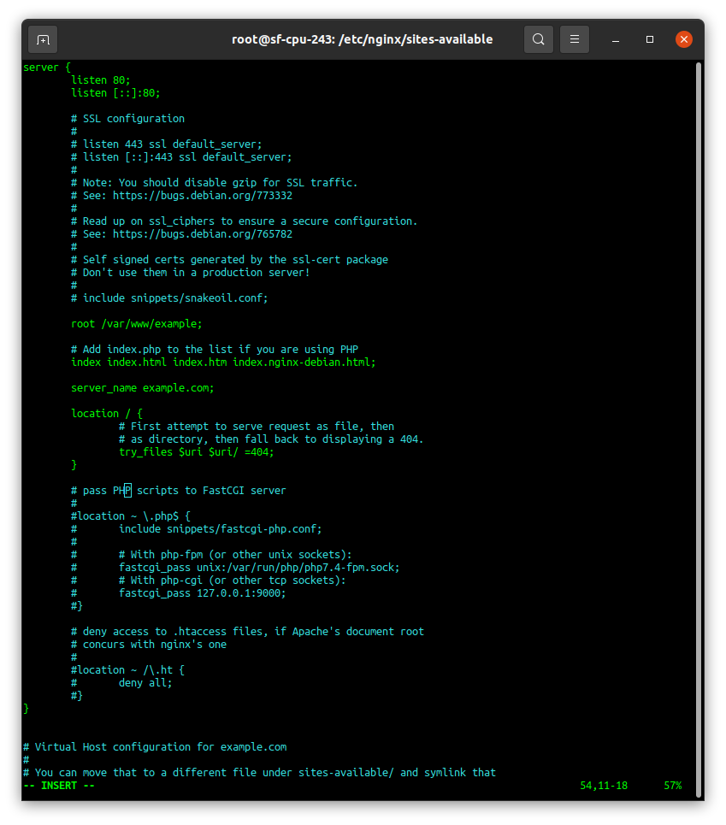

4.create symbolic link of /sites-available/example to /sites-enable with name example

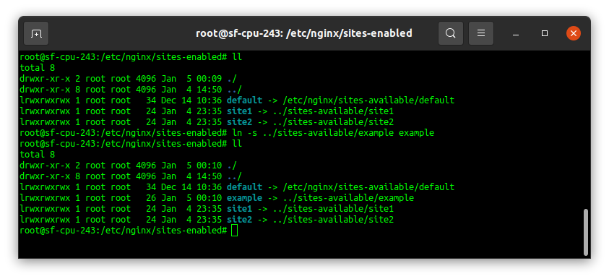

5.chech nginx config setting and then restart nginx service

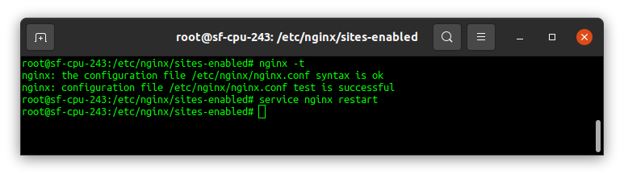

6.configure /etc/hosts file respect to your website and chech connectivity

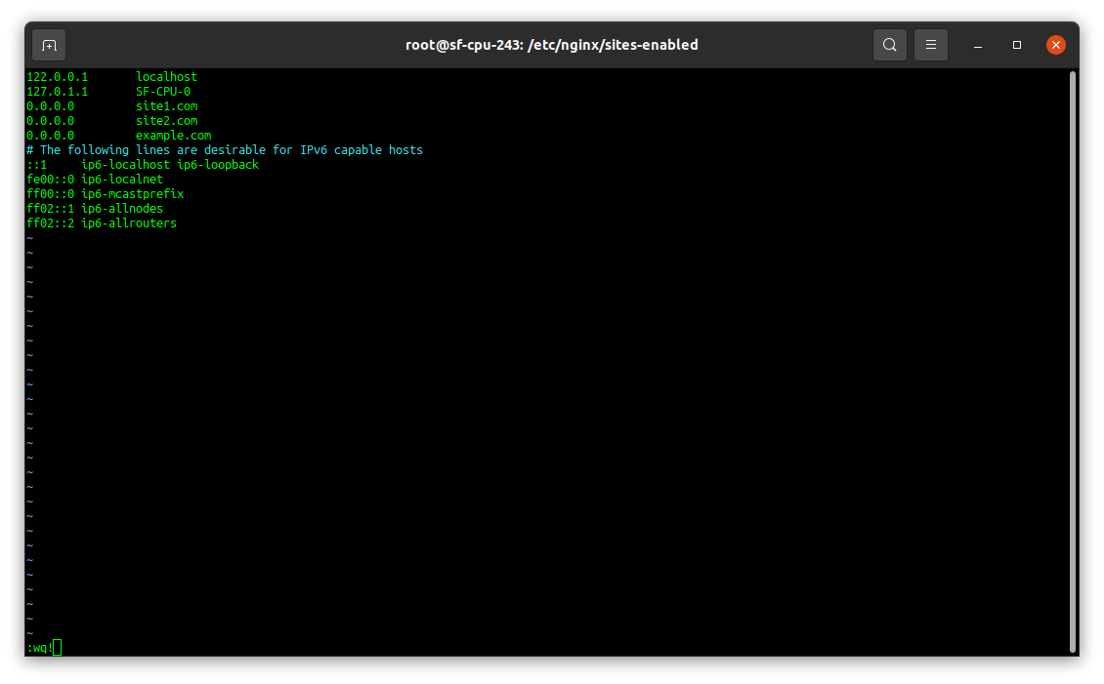

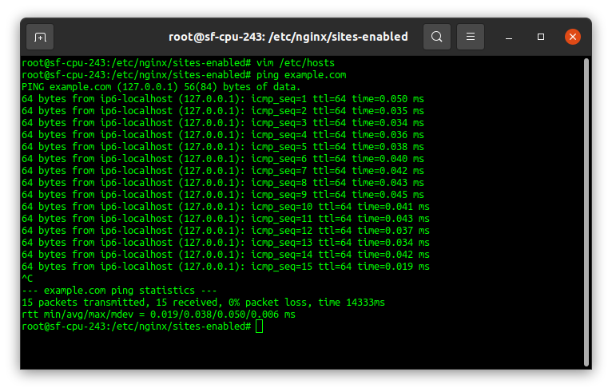

7.serve the content from browser

