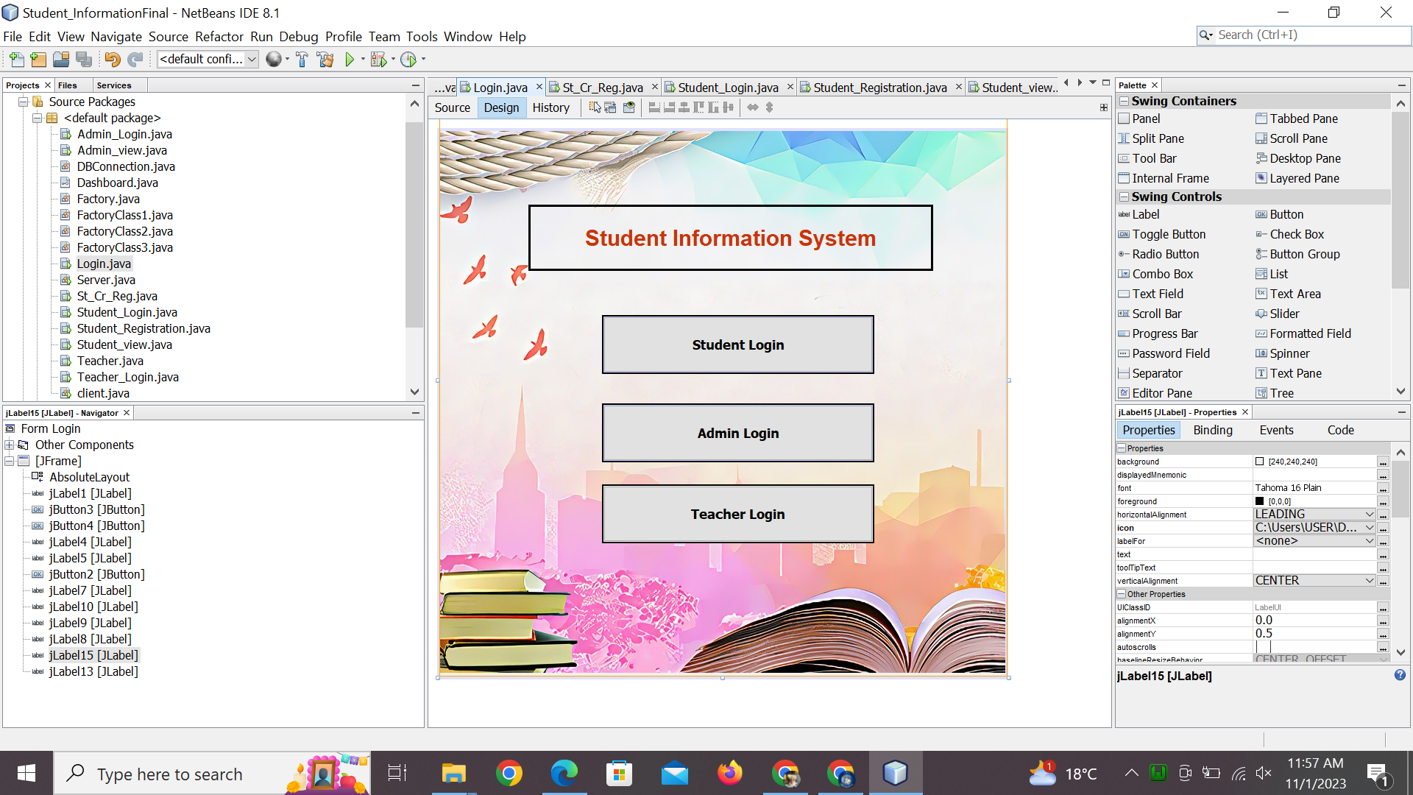

import java.sql.Connection;

/*

* To change this license header, choose License Headers in Project Properties.

* To change this template file, choose Tools | Templates

* and open the template in the editor.

*/

/**

*

* @author Chaudhry Hammad

*/

public class Login extends javax.swing.JFrame {

Factory fc=new Factory();

Dashboard db1=fc.getShape("student");

Dashboard db2=fc.getShape("admin");

Dashboard db3=fc.getShape("teacher");

/**

* Creates new form Login

*/

public Login() {

initComponents();

}

/**

* This method is called from within the constructor to initialize the form.

* WARNING: Do NOT modify this code. The content of this method is always

* regenerated by the Form Editor.

*/

@SuppressWarnings("unchecked")

// <editor-fold defaultstate="collapsed" desc="Generated Code">

private void initComponents() {

jLabel2 = new javax.swing.JLabel();

jLabel3 = new javax.swing.JLabel();

jLabel11 = new javax.swing.JLabel();

jLabel12 = new javax.swing.JLabel();

jLabel14 = new javax.swing.JLabel();

jLabel6 = new javax.swing.JLabel();

jLabel1 = new javax.swing.JLabel();

jButton3 = new javax.swing.JButton();

jButton4 = new javax.swing.JButton();

jLabel4 = new javax.swing.JLabel();

jLabel5 = new javax.swing.JLabel();

jButton2 = new javax.swing.JButton();

jLabel7 = new javax.swing.JLabel();

jLabel10 = new javax.swing.JLabel();

jLabel9 = new javax.swing.JLabel();

jLabel8 = new javax.swing.JLabel();

jLabel15 = new javax.swing.JLabel();

jLabel13 = new javax.swing.JLabel();

jLabel2.setText("jLabel2");

jLabel3.setText("jLabel3");

jLabel11.setIcon(new javax.swing.ImageIcon(getClass().getResource("/ICONS/22.jpg"))); // NOI18N

jLabel11.setText("jLabel11");

jLabel12.setText("jLabel12");

jLabel14.setText("jLabel14");

jLabel6.setText("jLabel6");

setDefaultCloseOperation(javax.swing.WindowConstants.EXIT_ON_CLOSE);

getContentPane().setLayout(new org.netbeans.lib.awtextra.AbsoluteLayout());

jLabel1.setBackground(new java.awt.Color(0, 102, 102));

jLabel1.setFont(new java.awt.Font("Arial", 1, 30)); // NOI18N

jLabel1.setForeground(new java.awt.Color(204, 51, 0));

jLabel1.setHorizontalAlignment(javax.swing.SwingConstants.CENTER);

jLabel1.setText("Student Information System");

jLabel1.setBorder(javax.swing.BorderFactory.createLineBorder(new java.awt.Color(0, 0, 0), 3));

getContentPane().add(jLabel1, new org.netbeans.lib.awtextra.AbsoluteConstraints(120, 100, 550, 90));

jButton3.setBackground(new java.awt.Color(204, 204, 255));

jButton3.setFont(new java.awt.Font("Tahoma", 1, 18)); // NOI18N

jButton3.setText("Student Login");

jButton3.setBorder(javax.swing.BorderFactory.createMatteBorder(2, 2, 2, 2, new java.awt.Color(0, 0, 0)));

jButton3.addActionListener(new java.awt.event.ActionListener() {

public void actionPerformed(java.awt.event.ActionEvent evt) {

jButton3ActionPerformed(evt);

}

});

getContentPane().add(jButton3, new org.netbeans.lib.awtextra.AbsoluteConstraints(220, 250, 370, 80));

jButton4.setBackground(new java.awt.Color(204, 204, 255));

jButton4.setFont(new java.awt.Font("Tahoma", 1, 18)); // NOI18N

jButton4.setText("Admin Login");

jButton4.setBorder(javax.swing.BorderFactory.createMatteBorder(2, 2, 2, 2, new java.awt.Color(0, 0, 0)));

jButton4.addActionListener(new java.awt.event.ActionListener() {

public void actionPerformed(java.awt.event.ActionEvent evt) {

jButton4ActionPerformed(evt);

}

});

getContentPane().add(jButton4, new org.netbeans.lib.awtextra.AbsoluteConstraints(220, 370, 370, 80));

getContentPane().add(jLabel4, new org.netbeans.lib.awtextra.AbsoluteConstraints(140, 120, -1, 40));

getContentPane().add(jLabel5, new org.netbeans.lib.awtextra.AbsoluteConstraints(139, 203, -1, 35));

jButton2.setFont(new java.awt.Font("Tahoma", 1, 18)); // NOI18N

jButton2.setText("Teacher Login");

jButton2.setBorder(javax.swing.BorderFactory.createMatteBorder(2, 2, 2, 2, new java.awt.Color(0, 0, 0)));

jButton2.addActionListener(new java.awt.event.ActionListener() {

public void actionPerformed(java.awt.event.ActionEvent evt) {

jButton2ActionPerformed(evt);

}

});

getContentPane().add(jButton2, new org.netbeans.lib.awtextra.AbsoluteConstraints(220, 480, 370, 80));

getContentPane().add(jLabel7, new org.netbeans.lib.awtextra.AbsoluteConstraints(140, 290, -1, 40));

getContentPane().add(jLabel10, new org.netbeans.lib.awtextra.AbsoluteConstraints(140, 290, -1, 40));

getContentPane().add(jLabel9, new org.netbeans.lib.awtextra.AbsoluteConstraints(140, 290, -1, 40));

getContentPane().add(jLabel8, new org.netbeans.lib.awtextra.AbsoluteConstraints(140, 290, -1, 40));

jLabel15.setIcon(new javax.swing.ImageIcon("C:\\Users\\USER\\Desktop\\pix\\f.jpeg")); // NOI18N

getContentPane().add(jLabel15, new org.netbeans.lib.awtextra.AbsoluteConstraints(0, -60, 770, 800));

jLabel13.setText("jLabel13");

getContentPane().add(jLabel13, new org.netbeans.lib.awtextra.AbsoluteConstraints(0, 0, 770, 740));

pack();

}// </editor-fold>

private void jButton3ActionPerformed(java.awt.event.ActionEvent evt) {

// TODO add your handling code here:

st_login();

}

public boolean st_login(){

try{

db1.loginChoose();

dispose();

return true;

}

catch(Exception e){

return false;

}

}

private void jButton4ActionPerformed(java.awt.event.ActionEvent evt) {

// TODO add your handling code here:

adm_login();

}

public boolean adm_login(){

try{

db2.loginChoose();

dispose();

return true;

}

catch(Exception e){

return false;

}

}

private void jButton2ActionPerformed(java.awt.event.ActionEvent evt) {

// TODO add your handling code here:

teacher_login();

}

public boolean teacher_login(){

try{

db3.loginChoose();

dispose();

return true;

}

catch(Exception e){

return false;

}

}

/**

* @param args the command line arguments

*/

public static void main(String args[]) {

/* Set the Nimbus look and feel */

//<editor-fold defaultstate="collapsed" desc=" Look and feel setting code (optional) ">

/* If Nimbus (introduced in Java SE 6) is not available, stay with the default look and feel.

* For details see http://download.oracle.com/javase/tutorial/uiswing/lookandfeel/plaf.html

*/

try {

for (javax.swing.UIManager.LookAndFeelInfo info : javax.swing.UIManager.getInstalledLookAndFeels()) {

if ("Nimbus".equals(info.getName())) {

javax.swing.UIManager.setLookAndFeel(info.getClassName());

break;

}

}

} catch (ClassNotFoundException ex) {

java.util.logging.Logger.getLogger(Login.class.getName()).log(java.util.logging.Level.SEVERE, null, ex);

} catch (InstantiationException ex) {

java.util.logging.Logger.getLogger(Login.class.getName()).log(java.util.logging.Level.SEVERE, null, ex);

} catch (IllegalAccessException ex) {

java.util.logging.Logger.getLogger(Login.class.getName()).log(java.util.logging.Level.SEVERE, null, ex);

} catch (javax.swing.UnsupportedLookAndFeelException ex) {

java.util.logging.Logger.getLogger(Login.class.getName()).log(java.util.logging.Level.SEVERE, null, ex);

}

//</editor-fold>

/* Create and display the form */

java.awt.EventQueue.invokeLater(new Runnable() {

public void run() {

new Login().setVisible(true);

}

});

}

// Variables declaration - do not modify

private javax.swing.JButton jButton2;

private javax.swing.JButton jButton3;

private javax.swing.JButton jButton4;

private javax.swing.JLabel jLabel1;

private javax.swing.JLabel jLabel10;

private javax.swing.JLabel jLabel11;

private javax.swing.JLabel jLabel12;

private javax.swing.JLabel jLabel13;

private javax.swing.JLabel jLabel14;

private javax.swing.JLabel jLabel15;

private javax.swing.JLabel jLabel2;

private javax.swing.JLabel jLabel3;

private javax.swing.JLabel jLabel4;

private javax.swing.JLabel jLabel5;

private javax.swing.JLabel jLabel6;

private javax.swing.JLabel jLabel7;

private javax.swing.JLabel jLabel8;

private javax.swing.JLabel jLabel9;

// End of variables declaration

}