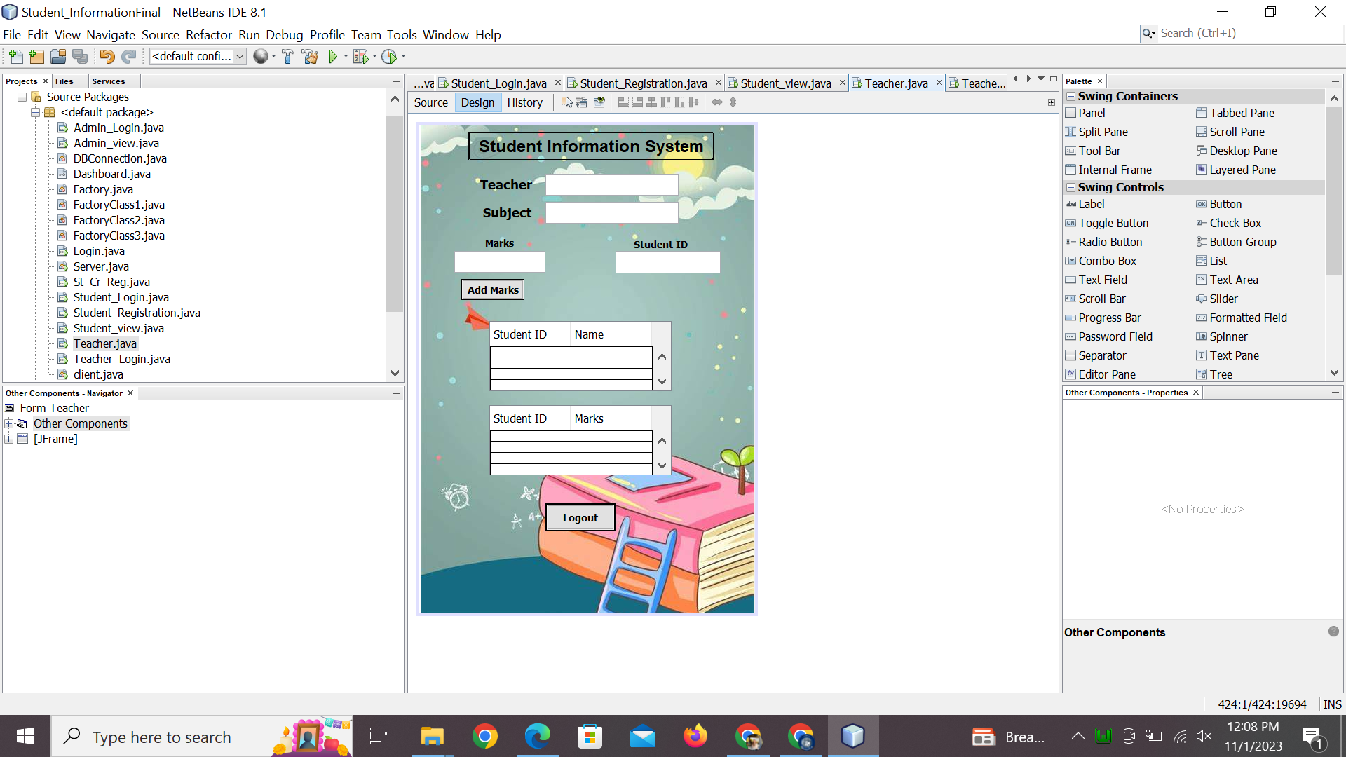

import java.sql.Connection;

import java.sql.Connection;

import java.sql.PreparedStatement;

import java.sql.ResultSet;

import java.sql.Statement;

import javax.swing.JOptionPane;

import javax.swing.JTextField;

import javax.swing.table.DefaultTableModel;

/*

* To change this license header, choose License Headers in Project Properties.

* To change this template file, choose Tools | Templates

* and open the template in the editor.

*/

/**

*

* @author dell

*/

public class Teacher extends javax.swing.JFrame {

Connection con=DBConnection.getDBConnection();

/**

* Creates new form Teacher

*/

public Teacher() {

initComponents();

}

String username;

public Teacher(String username) {

initComponents();

try {

Statement stm = con.createStatement();

// String sql="select * from student where username="+username+" ";

// ResultSet rs= stm.executeQuery(sql);

String sql2="select * from teacher where Tusername='"+username+"'";

ResultSet rs= stm.executeQuery(sql2);

if(rs.next()){

tname.setText(rs.getString("Tname"));

tcourse.setText(rs.getString("Tcourse"));

}

String course_name=tcourse.getText();

String sql3="select * from course inner join student_course on "

+ "course.courseid=student_course.cr_st_id inner join student on "

+ "student.id=student_course.st_cr_id where course.coursetitle='"+course_name+"'";

ResultSet rs1= stm.executeQuery(sql3);

while(rs1.next()){

String stid=String.valueOf(rs1.getInt("id"));

String stname=rs1.getString("name");

String tbData[]={stid,stname};

DefaultTableModel tblModel=(DefaultTableModel)Table.getModel();

tblModel.addRow(tbData);

}

// con.close();

} catch (Exception e) {

System.out.println(e);

}

}

/**

* This method is called from within the constructor to initialize the form.

* WARNING: Do NOT modify this code. The content of this method is always

* regenerated by the Form Editor.

*/

@SuppressWarnings("unchecked")

// <editor-fold defaultstate="collapsed" desc="Generated Code">

private void initComponents() {

jLabel6 = new javax.swing.JLabel();

tname = new javax.swing.JTextField();

jLabel1 = new javax.swing.JLabel();

txtmarks = new javax.swing.JTextField();

jLabel2 = new javax.swing.JLabel();

jLabel3 = new javax.swing.JLabel();

jLabel4 = new javax.swing.JLabel();

txtid = new javax.swing.JTextField();

jScrollPane1 = new javax.swing.JScrollPane();

Table = new javax.swing.JTable();

tcourse = new javax.swing.JTextField();

jButton1 = new javax.swing.JButton();

jButton2 = new javax.swing.JButton();

jScrollPane2 = new javax.swing.JScrollPane();

Table2 = new javax.swing.JTable();

jLabel5 = new javax.swing.JLabel();

jLabel7 = new javax.swing.JLabel();

jLabel8 = new javax.swing.JLabel();

jLabel6.setText("jLabel6");

setDefaultCloseOperation(javax.swing.WindowConstants.EXIT_ON_CLOSE);

getContentPane().setLayout(new org.netbeans.lib.awtextra.AbsoluteLayout());

tname.addActionListener(new java.awt.event.ActionListener() {

public void actionPerformed(java.awt.event.ActionEvent evt) {

tnameActionPerformed(evt);

}

});

getContentPane().add(tname, new org.netbeans.lib.awtextra.AbsoluteConstraints(180, 70, 190, 31));

jLabel1.setFont(new java.awt.Font("Tahoma", 1, 14)); // NOI18N

jLabel1.setHorizontalAlignment(javax.swing.SwingConstants.CENTER);

jLabel1.setText("Student ID");

getContentPane().add(jLabel1, new org.netbeans.lib.awtextra.AbsoluteConstraints(300, 160, 89, 20));

txtmarks.addKeyListener(new java.awt.event.KeyAdapter() {

public void keyTyped(java.awt.event.KeyEvent evt) {

txtmarksKeyTyped(evt);

}

});

getContentPane().add(txtmarks, new org.netbeans.lib.awtextra.AbsoluteConstraints(50, 180, 130, 31));

jLabel2.setFont(new java.awt.Font("Tahoma", 1, 14)); // NOI18N

jLabel2.setHorizontalAlignment(javax.swing.SwingConstants.CENTER);

jLabel2.setText("Marks");

getContentPane().add(jLabel2, new org.netbeans.lib.awtextra.AbsoluteConstraints(70, 160, 89, -1));

jLabel3.setFont(new java.awt.Font("Tahoma", 1, 18)); // NOI18N

jLabel3.setHorizontalAlignment(javax.swing.SwingConstants.CENTER);

jLabel3.setText("Teacher");

getContentPane().add(jLabel3, new org.netbeans.lib.awtextra.AbsoluteConstraints(80, 70, 89, 30));

jLabel4.setFont(new java.awt.Font("Tahoma", 1, 18)); // NOI18N

jLabel4.setHorizontalAlignment(javax.swing.SwingConstants.CENTER);

jLabel4.setText("Subject");

getContentPane().add(jLabel4, new org.netbeans.lib.awtextra.AbsoluteConstraints(80, 110, 90, 30));

txtid.addActionListener(new java.awt.event.ActionListener() {

public void actionPerformed(java.awt.event.ActionEvent evt) {

txtidActionPerformed(evt);

}

});

txtid.addKeyListener(new java.awt.event.KeyAdapter() {

public void keyReleased(java.awt.event.KeyEvent evt) {

txtidKeyReleased(evt);

}

public void keyTyped(java.awt.event.KeyEvent evt) {

txtidKeyTyped(evt);

}

});

getContentPane().add(txtid, new org.netbeans.lib.awtextra.AbsoluteConstraints(280, 180, 150, 32));

Table.setAutoCreateRowSorter(true);

Table.setBorder(javax.swing.BorderFactory.createLineBorder(new java.awt.Color(0, 0, 0)));

Table.setModel(new javax.swing.table.DefaultTableModel(

new Object [][] {

{null, null},

{null, null},

{null, null},

{null, null}

},

new String [] {

"Student ID", "Name"

}

));

Table.setColumnSelectionAllowed(true);

Table.setGridColor(new java.awt.Color(0, 0, 0));

jScrollPane1.setViewportView(Table);

Table.getColumnModel().getSelectionModel().setSelectionMode(javax.swing.ListSelectionModel.SINGLE_INTERVAL_SELECTION);

getContentPane().add(jScrollPane1, new org.netbeans.lib.awtextra.AbsoluteConstraints(100, 280, 260, 100));

getContentPane().add(tcourse, new org.netbeans.lib.awtextra.AbsoluteConstraints(180, 110, 190, 31));

jButton1.setFont(new java.awt.Font("Tahoma", 1, 14)); // NOI18N

jButton1.setText("Logout");

jButton1.setBorder(javax.swing.BorderFactory.createMatteBorder(2, 2, 2, 2, new java.awt.Color(0, 0, 0)));

jButton1.addActionListener(new java.awt.event.ActionListener() {

public void actionPerformed(java.awt.event.ActionEvent evt) {

jButton1ActionPerformed(evt);

}

});

getContentPane().add(jButton1, new org.netbeans.lib.awtextra.AbsoluteConstraints(180, 540, 100, 40));

jButton2.setFont(new java.awt.Font("Tahoma", 1, 14)); // NOI18N

jButton2.setText("Add Marks");

jButton2.setBorder(new javax.swing.border.MatteBorder(null));

jButton2.addActionListener(new java.awt.event.ActionListener() {

public void actionPerformed(java.awt.event.ActionEvent evt) {

jButton2ActionPerformed(evt);

}

});

getContentPane().add(jButton2, new org.netbeans.lib.awtextra.AbsoluteConstraints(60, 220, 90, 30));

Table2.setBorder(javax.swing.BorderFactory.createLineBorder(new java.awt.Color(0, 0, 0)));

Table2.setModel(new javax.swing.table.DefaultTableModel(

new Object [][] {

{null, null},

{null, null},

{null, null},

{null, null}

},

new String [] {

"Student ID", "Marks"

}

));

Table2.setGridColor(new java.awt.Color(0, 0, 0));

jScrollPane2.setViewportView(Table2);

getContentPane().add(jScrollPane2, new org.netbeans.lib.awtextra.AbsoluteConstraints(100, 400, 260, 100));

jLabel5.setBackground(new java.awt.Color(0, 0, 0));

jLabel5.setFont(new java.awt.Font("Arial", 1, 24)); // NOI18N

jLabel5.setHorizontalAlignment(javax.swing.SwingConstants.CENTER);

jLabel5.setText("Student Information System");

jLabel5.setBorder(new javax.swing.border.SoftBevelBorder(javax.swing.border.BevelBorder.RAISED));

getContentPane().add(jLabel5, new org.netbeans.lib.awtextra.AbsoluteConstraints(70, 10, 350, 40));

jLabel7.setHorizontalAlignment(javax.swing.SwingConstants.CENTER);

jLabel7.setIcon(new javax.swing.ImageIcon("C:\\Users\\USER\\Desktop\\pix\\e.jpeg")); // NOI18N

jLabel7.setBorder(new javax.swing.border.SoftBevelBorder(javax.swing.border.BevelBorder.RAISED));

getContentPane().add(jLabel7, new org.netbeans.lib.awtextra.AbsoluteConstraints(0, -10, 480, 710));

jLabel8.setText("jLabel8");

getContentPane().add(jLabel8, new org.netbeans.lib.awtextra.AbsoluteConstraints(0, 0, 480, 700));

pack();

}// </editor-fold>

private void jButton2ActionPerformed(java.awt.event.ActionEvent evt) {

// TODO add your handling code here:

reg(tcourse.getText());

}

public boolean reg(String course_name){

// if("Test".equals(course_name)){

// return true;

// }

try{

Statement stmt = con.createStatement();

String id=txtid.getText();

String marks=txtmarks.getText();

if(course_name.equals("Database")){

String sql1 = "insert into st_marks(st_id,cr_id,marks) " + "values ("+id+",'"+111+"','"+marks+"') ";

stmt.executeUpdate(sql1);

String data[]={id,marks};

DefaultTableModel tblModel=(DefaultTableModel)Table2.getModel();

tblModel.addRow(data);

JOptionPane.showMessageDialog(null, "marks added successfully");

txtid.setText("");

txtmarks.setText("");

}

if(course_name.equals("Discrete")){

String sql2 = "insert into st_marks(st_id,cr_id,marks) " + "values ("+id+",'"+222+"','"+marks+"') ";

stmt.executeUpdate(sql2);

String data[]={id,marks};

DefaultTableModel tblModel=(DefaultTableModel)Table2.getModel();

tblModel.addRow(data);

JOptionPane.showMessageDialog(null, "marks added successfully");

txtid.setText("");

txtmarks.setText("");

}

if(course_name.equals("Linear Algebra")){

String sql3 = "insert into st_marks(st_id,cr_id,marks) " + "values ("+id+",'"+333+"','"+marks+"') ";

stmt.executeUpdate(sql3);

String data[]={id,marks};

DefaultTableModel tblModel=(DefaultTableModel)Table2.getModel();

tblModel.addRow(data);

JOptionPane.showMessageDialog(null, "marks added successfully");

txtid.setText("");

txtmarks.setText("");

}

if(course_name.equals("OOP")){

String sql4 = "insert into st_marks(st_id,cr_id,marks) " + "values ("+id+",'"+444+"','"+marks+"') ";

stmt.executeUpdate(sql4);

String data[]={id,marks};

DefaultTableModel tblModel=(DefaultTableModel)Table2.getModel();

tblModel.addRow(data);

JOptionPane.showMessageDialog(null, "marks added successfully");

txtid.setText("");

txtmarks.setText("");

}

if(course_name.equals("Economics")){

String sql5 = "insert into st_marks(st_id,cr_id,marks) " + "values ("+id+",'"+555+"','"+marks+"') ";

stmt.executeUpdate(sql5);

String data[]={id,marks};

DefaultTableModel tblModel=(DefaultTableModel)Table2.getModel();

tblModel.addRow(data);

JOptionPane.showMessageDialog(null, "marks added successfully");

txtid.setText("");

txtmarks.setText("");

}

return true;

}

catch(Exception e){

System.out.println(e);

return false;

}

}

private void txtidActionPerformed(java.awt.event.ActionEvent evt) {

// TODO add your handling code here:

}

private void txtidKeyReleased(java.awt.event.KeyEvent evt) {

// TODO add your handling code here:

}

private void txtidKeyTyped(java.awt.event.KeyEvent evt) {

// TODO add your handling code here:

char c=evt.getKeyChar();

if(Character.isLetter(c))

{

txtid.setEditable(false);

JOptionPane.showMessageDialog(this,"Enter number only");

}

else{

txtid.setEditable(true);

}

}

private void txtmarksKeyTyped(java.awt.event.KeyEvent evt) {

// TODO add your handling code here:

char c=evt.getKeyChar();

if(Character.isLetter(c))

{

txtmarks.setEditable(false);

JOptionPane.showMessageDialog(this,"Enter number only");

}

else{

txtmarks.setEditable(true);

}

}

private void jButton1ActionPerformed(java.awt.event.ActionEvent evt) {

// TODO add your handling code here:

Login login=new Login();

login.setVisible(true);

dispose();

}

private void tnameActionPerformed(java.awt.event.ActionEvent evt) {

// TODO add your handling code here:

}

/**

* @param args the command line arguments

*/

public static void main(String args[]) {

/* Set the Nimbus look and feel */

//<editor-fold defaultstate="collapsed" desc=" Look and feel setting code (optional) ">

/* If Nimbus (introduced in Java SE 6) is not available, stay with the default look and feel.

* For details see http://download.oracle.com/javase/tutorial/uiswing/lookandfeel/plaf.html

*/

try {

for (javax.swing.UIManager.LookAndFeelInfo info : javax.swing.UIManager.getInstalledLookAndFeels()) {

if ("Nimbus".equals(info.getName())) {

javax.swing.UIManager.setLookAndFeel(info.getClassName());

break;

}

}

} catch (ClassNotFoundException ex) {

java.util.logging.Logger.getLogger(Teacher.class.getName()).log(java.util.logging.Level.SEVERE, null, ex);

} catch (InstantiationException ex) {

java.util.logging.Logger.getLogger(Teacher.class.getName()).log(java.util.logging.Level.SEVERE, null, ex);

} catch (IllegalAccessException ex) {

java.util.logging.Logger.getLogger(Teacher.class.getName()).log(java.util.logging.Level.SEVERE, null, ex);

} catch (javax.swing.UnsupportedLookAndFeelException ex) {

java.util.logging.Logger.getLogger(Teacher.class.getName()).log(java.util.logging.Level.SEVERE, null, ex);

}

//</editor-fold>

/* Create and display the form */

java.awt.EventQueue.invokeLater(new Runnable() {

public void run() {

new Teacher().setVisible(true);

}

});

}

// Variables declaration - do not modify

private javax.swing.JTable Table;

private javax.swing.JTable Table2;

private javax.swing.JButton jButton1;

private javax.swing.JButton jButton2;

private javax.swing.JLabel jLabel1;

private javax.swing.JLabel jLabel2;

private javax.swing.JLabel jLabel3;

private javax.swing.JLabel jLabel4;

private javax.swing.JLabel jLabel5;

private javax.swing.JLabel jLabel6;

private javax.swing.JLabel jLabel7;

private javax.swing.JLabel jLabel8;

private javax.swing.JScrollPane jScrollPane1;

private javax.swing.JScrollPane jScrollPane2;

private javax.swing.JTextField tcourse;

private javax.swing.JTextField tname;

private javax.swing.JTextField txtid;

private javax.swing.JTextField txtmarks;

// End of variables declaration

}