Test HSP2 Model Summary

05/30/2023

# Table of contents

The models compared in this document are:

**Table** **:** Properties of each model compared in this document.

| **Properties** | **Model 1** | **Model 2** |
| --- | --- | --- |
| Model | Appomatox River | Appomatox River |
| Hydrocode | vahydrosw_wshed_JA4_7280_7340 | vahydrosw_wshed_JA4_7280_7340 |
| Ftype | vahydro | vahydro |
| Model Version | vahydro-1.0 | vahydro-1.0 |
| Run ID | runid_11 | runid_13 |

# Flow Modeling

## Flow Duration Curve

## Mean Flow, Withdrawals and Point Sources

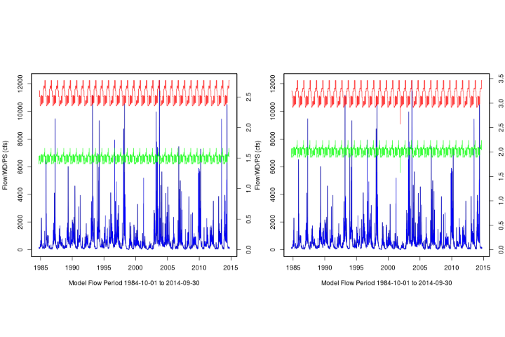

**Figure** **:** Discharge, point sources, and withdrawals from VAHydro: Appomatox River vs Appomatox River

## Dry Period Hydrograph

## 90-day Low Flows over a 2 year Period

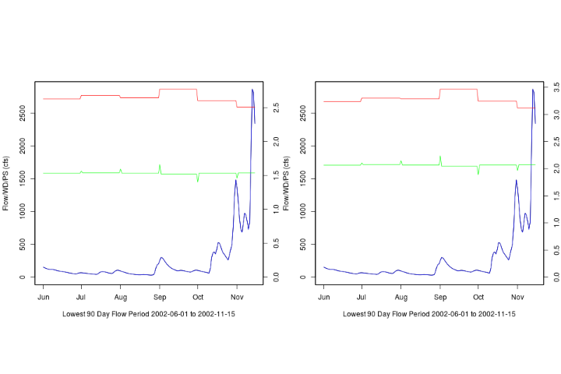

**Figure** **:** The 2 year, 90-day low flows from VAHydro: Appomatox River vs Appomatox River

## FTABLE Visual

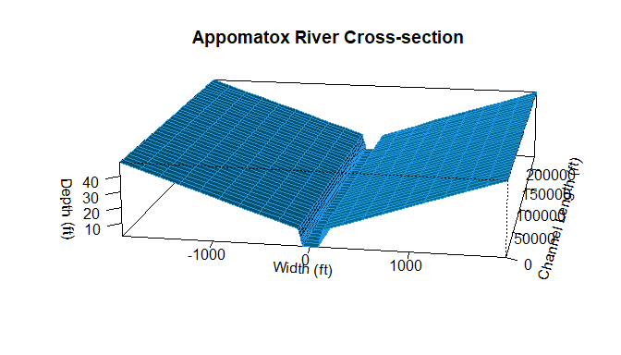



# Time Series Analysis

## 90-Day Low Flow Comparison

## 30-Day Low Flow Comparison

## 7-Day Low Flow Comparison

## 1-Day Low Flow Comparison

## Model Performance Scatterplots

## Model %-Difference

# Metrics Summary

| **Description** | **runid_11** | **runid_13** |
| --- | --- | --- |
| River Segment Model Statistics: | Appomatox River | Appomatox River |
| Mean Flow Out (cfs) | 633.23 | 633.15 |
| 90 Day Low Flow (cfs) | 42.05 | 41.95 |
| 30 Day Low Flow (cfs) | 13 | 12.95 |
| 7 Day Low Flow (cfs) | NA | NA |
| 1 Day Low Flow (cfs) | NA | NA |
| Consumptive Use Fraction (1.0-Qout/Qbaseline) | 0 | 0 |
| Cumulative Withdrawal Flow Out (mgd) | 1.64 | 2.03 |
| Cumulative Point Source Flow In (mgd) | 0.97 | 1.31 |
| Withdrawal Flow Out (mgd) | 0.26 | 0.26 |
| Point Source Flow In (mgd) | 0.97 | 1.31 |