Test HSP2 Model Summary

05/19/2023

# Table of contents

The models compared in this document are:

**Table** **:** Properties of each model compared in this document.

| **Properties** | **Model 1** | **Model 2** |
| --- | --- | --- |
| Model | Rappahannock River cbp-6.0 | Rappahannock River cbp-6.1 |
| Hydrocode | RU4_5640_6030 | vahydrosw_wshed_RU4_5640_6030 |
| Ftype | cbp60 | vahydro |
| Model Version | cbp-6.0 | cbp-6.1 |
| Run ID | hsp2_2022 | subsheds |

# Flow Modeling

## Flow Duration Curve

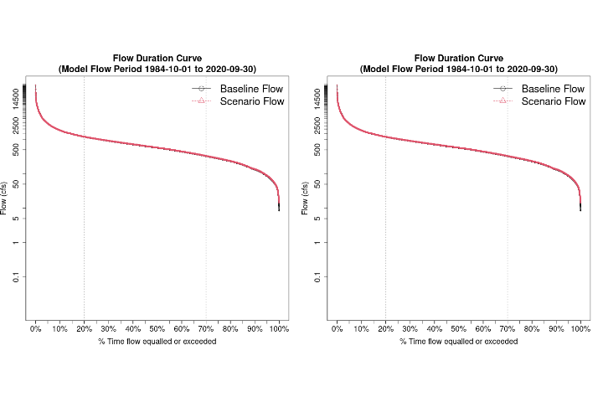

**Figure** **:** Flow duration curves from VAHydro: Rappahannock River cbp-6.0 vs Rappahannock River cbp-6.1

## Mean Flow, Withdrawals and Point Sources

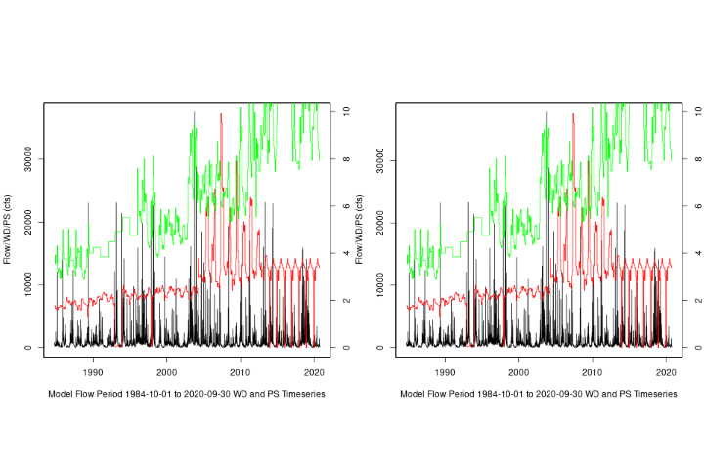

**Figure** **:** Discharge, point sources, and withdrawals from VAHydro: Rappahannock River cbp-6.0 vs Rappahannock River cbp-6.1

## Dry Period Hydrograph

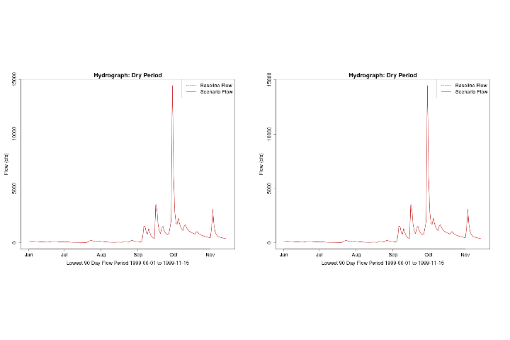

**Figure** **:** The dry periods from VAHydro: Rappahannock River cbp-6.0 vs Rappahannock River cbp-6.1

## 90-day Low Flows over a 2 year Period

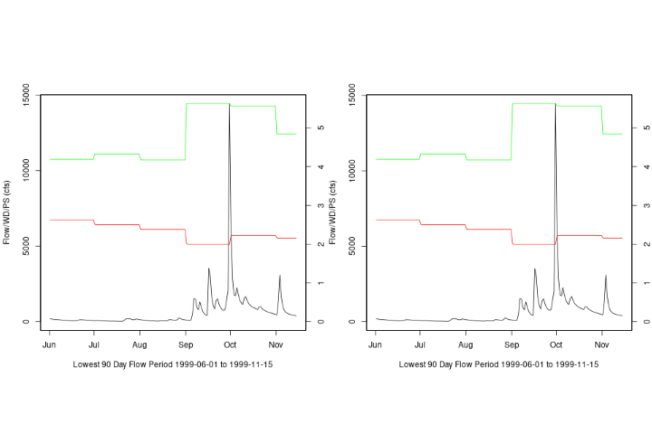

**Figure** **:** The 2 year, 90-day low flows from VAHydro: Rappahannock River cbp-6.0 vs Rappahannock River cbp-6.1

## FTABLE Visual

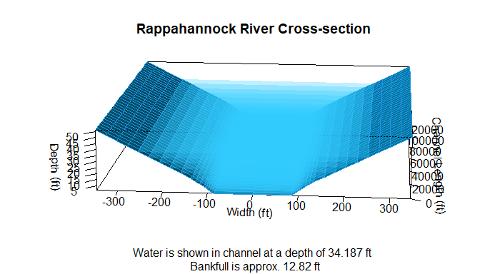

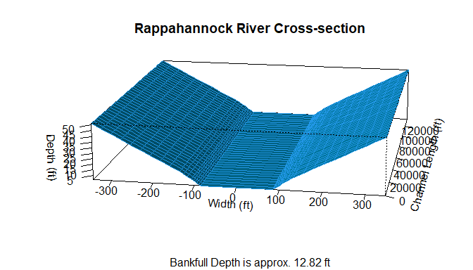

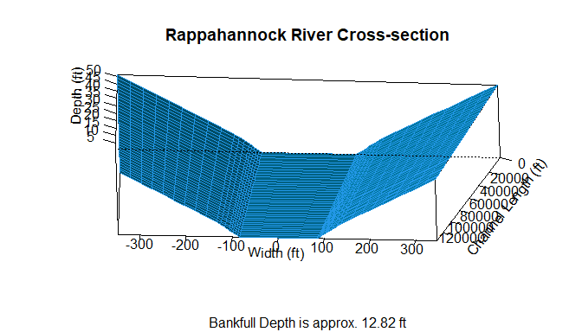

# Time Series Analysis

## 90-Day Low Flow Comparison

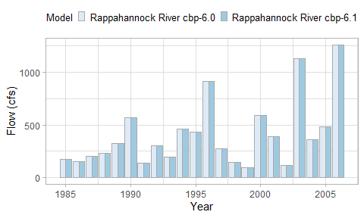

**Figure** **:** The 90-day low flows: Rappahannock River cbp-6.0 vs Rappahannock River cbp-6.1

## 30-Day Low Flow Comparison

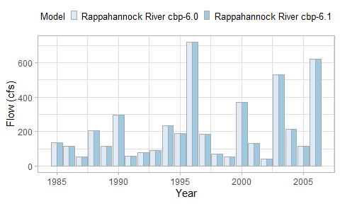

**Figure** **:** The 30-day low flows: Rappahannock River cbp-6.0 vs Rappahannock River cbp-6.1

## 7-Day Low Flow Comparison

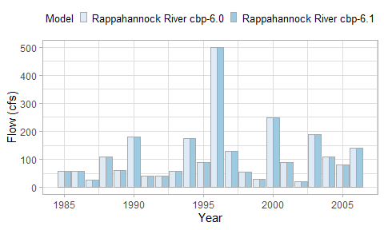

**Figure** **:** The 7-day low flows: Rappahannock River cbp-6.0 vs Rappahannock River cbp-6.1

## 1-Day Low Flow Comparison

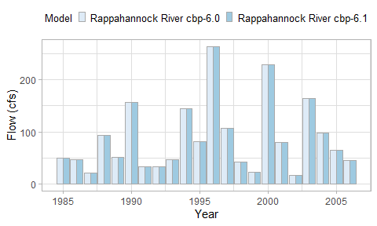

**Figure** **:** The 1-day low flows: Rappahannock River cbp-6.0 vs Rappahannock River cbp-6.1

## Model Performance Scatterplots

## Model %-Difference

# Metrics Summary

| **Description** | **hsp2_2022** | **subsheds** |
| --- | --- | --- |
| River Segment Model Statistics: | Rappahannock River cbp-6.0 | Rappahannock River cbp-6.1 |
| Mean Flow Out (cfs) | 948.32 | 948.4 |
| 90 Day Low Flow (cfs) | 93.2 | 93.16 |
| 30 Day Low Flow (cfs) | 43.72 | 43.67 |
| 7 Day Low Flow (cfs) | 15 | 15 |
| 1 Day Low Flow (cfs) | 14.45 | 14.45 |
| Consumptive Use Fraction (1.0-Qout/Qbaseline) | 0 | 0 |
| Cumulative Withdrawal Flow Out (mgd) | 1.77 | 1.77 |
| Cumulative Point Source Flow In (mgd) | 4.47 | 4.47 |
| Withdrawal Flow Out (mgd) | 1.77 | 1.77 |
| Point Source Flow In (mgd) | 4.47 | 4.47 |