USGS Gage vs VAHydro Model

09/11/2023

# Appendix X - Model Calibration Analysis:

## Flow Duration Curve Plot:

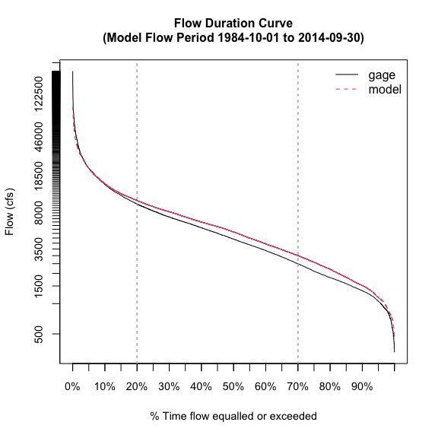

## L90 Model Performance Bar Plot:

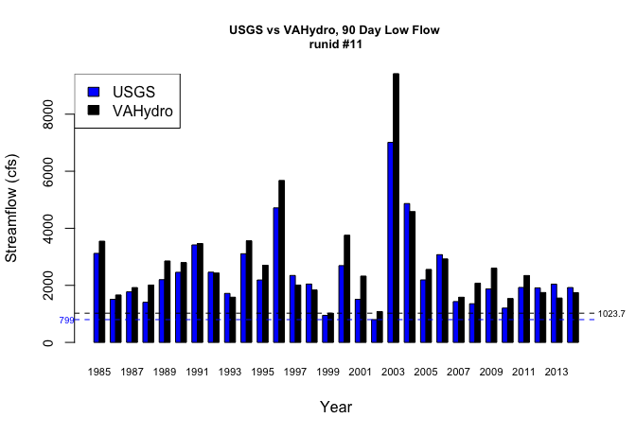

## L30 Model Performance Bar Plot:

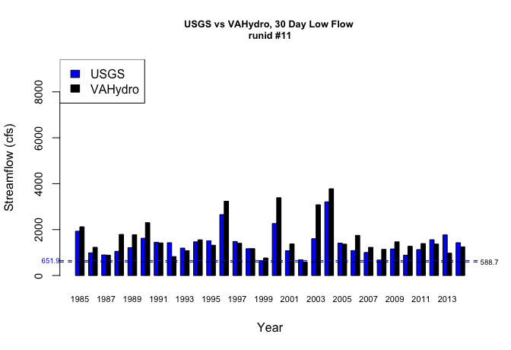

## L7 Model Performance Bar Plot:

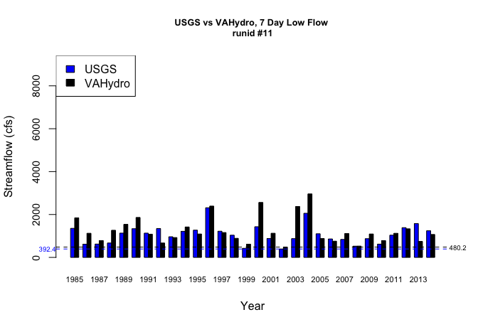

## L1 Model Performance Bar Plot:

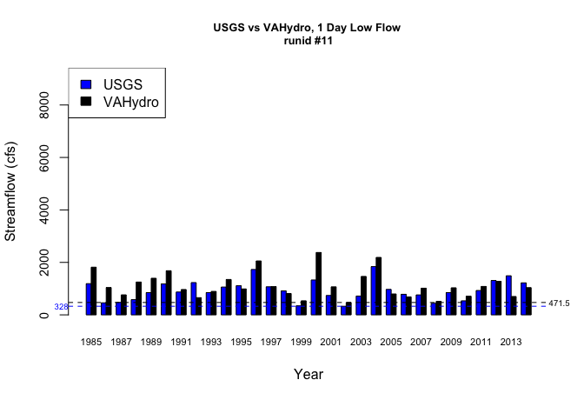

## Model Performance Scatterplots:

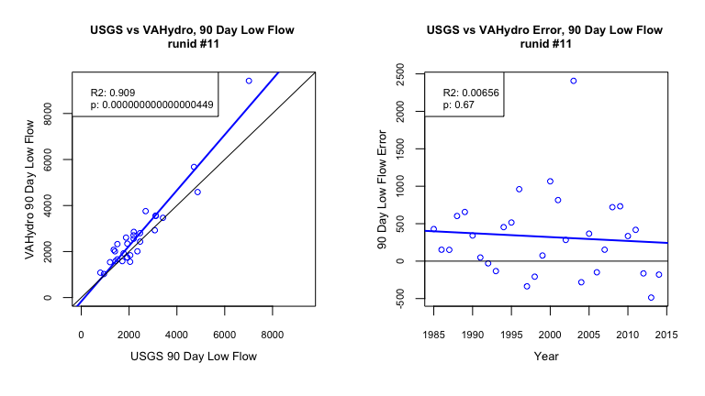

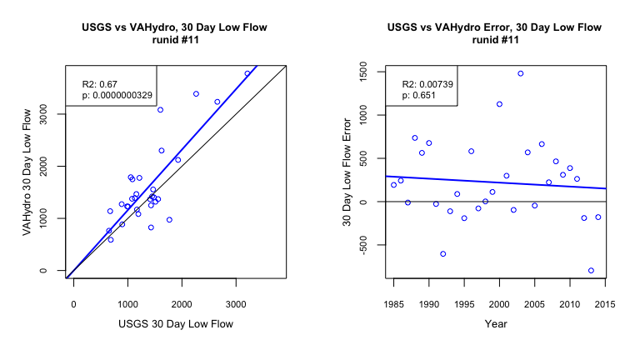

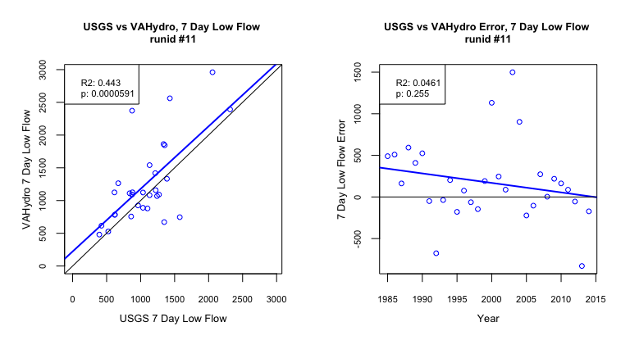

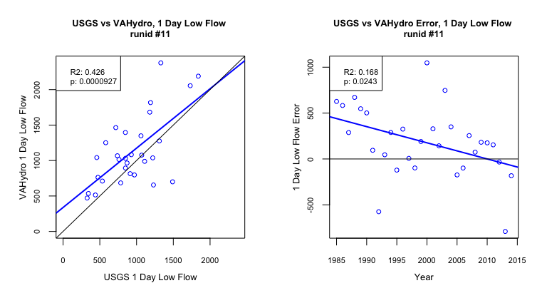

## Metrics Table:

| stat | gage | gage_year | model | model_year |
| --- | --- | --- | --- | --- |
| l90 | 799.01 | 2002 | 1023.74 | 1999 |
| l30 | 651.9 | 1999 | 588.65 | 2002 |
| l7 | 392.43 | 2002 | 480.17 | 2002 |
| l1 | 328 | 2002 | 471.47 | 2002 |