USGS Gage vs VAHydro Model

09/11/2023

# Appendix X - Model Calibration Analysis:

## Flow Duration Curve Plot:

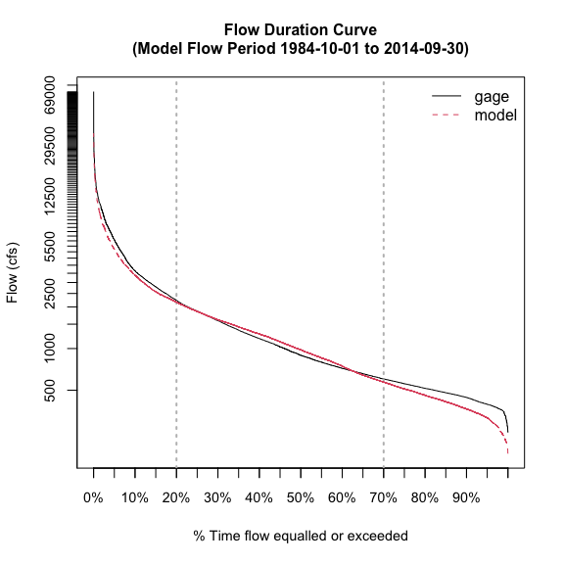

## L90 Model Performance Bar Plot:

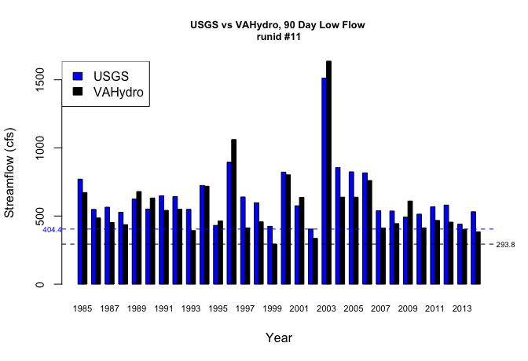

## L30 Model Performance Bar Plot:

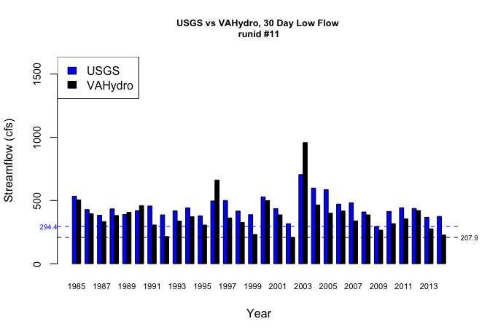

## L7 Model Performance Bar Plot:

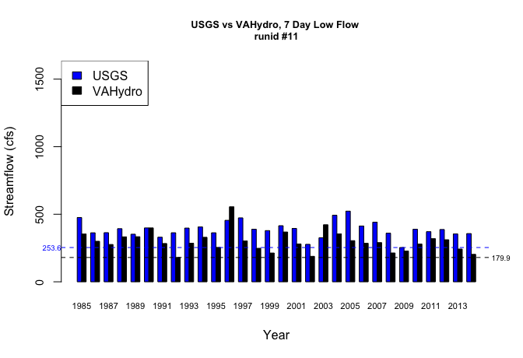

## L1 Model Performance Bar Plot:

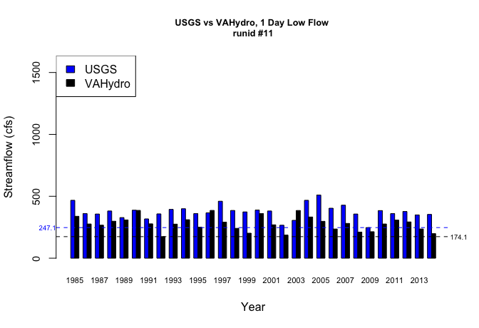

## Model Performance Scatterplots:

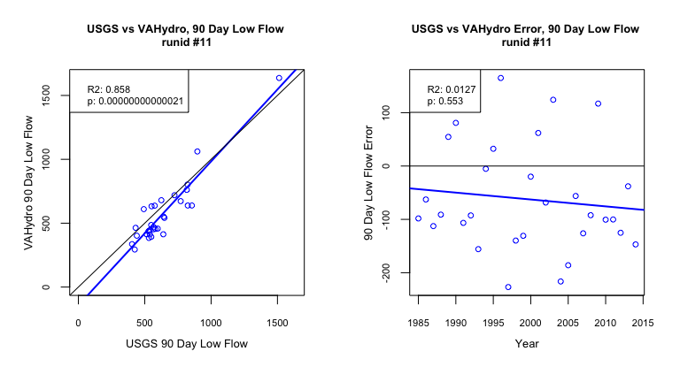

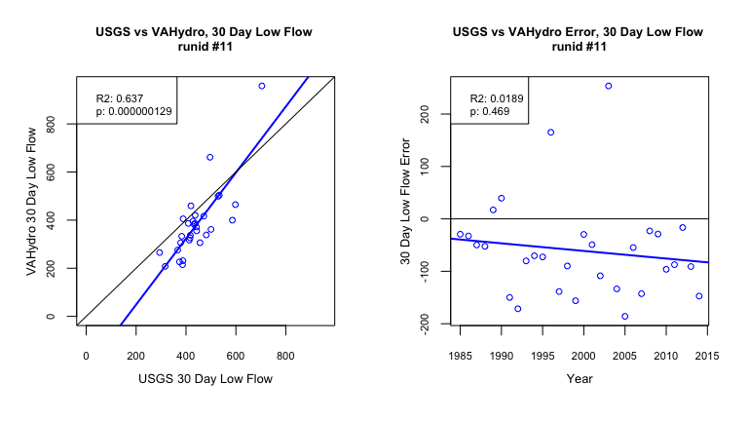

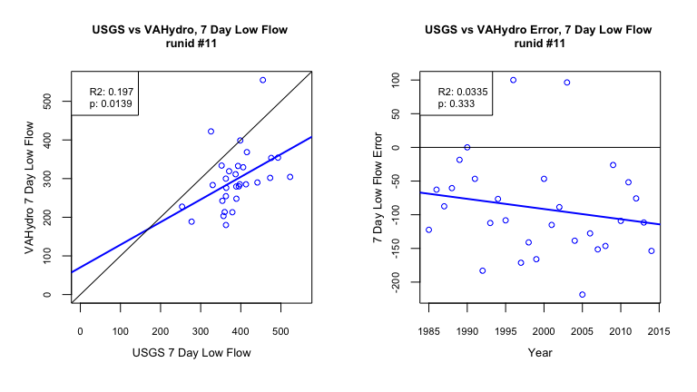

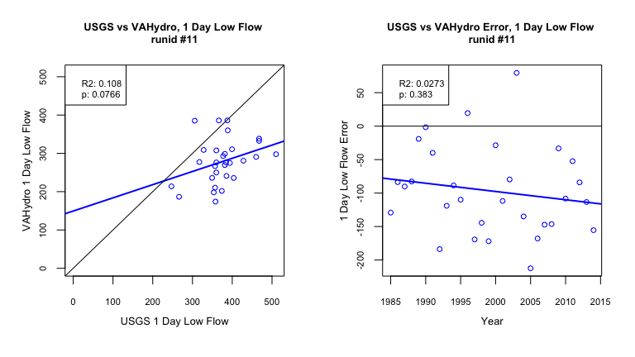

## Metrics Table:

| stat | gage | gage_year | model | model_year |
| --- | --- | --- | --- | --- |
| l90 | 404.39 | 2002 | 293.82 | 1999 |
| l30 | 294.35 | 2009 | 207.89 | 2002 |
| l7 | 253.61 | 2009 | 179.91 | 1992 |
| l1 | 247.07 | 2009 | 174.07 | 1992 |