USGS Gage vs VAHydro Model

09/11/2023

# Appendix X - Model Calibration Analysis:

## Flow Duration Curve Plot:

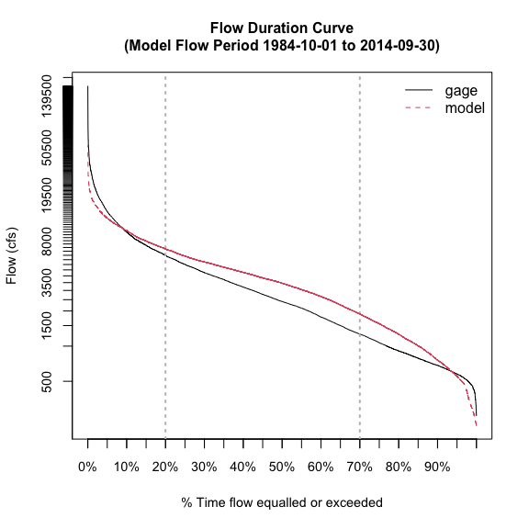

## L90 Model Performance Bar Plot:

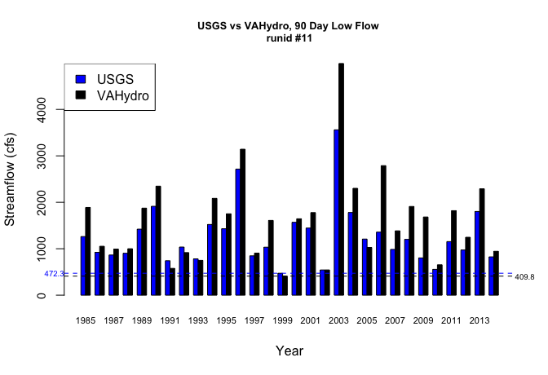

## L30 Model Performance Bar Plot:

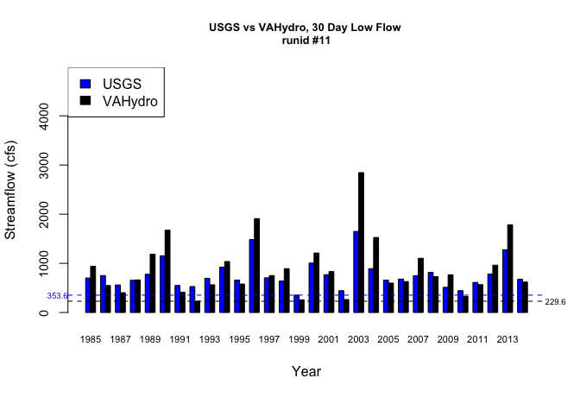

## L7 Model Performance Bar Plot:

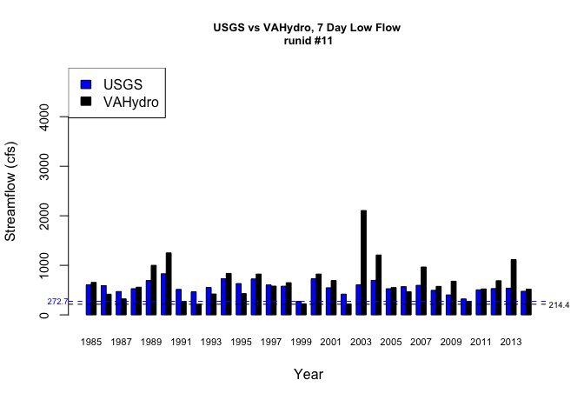

## L1 Model Performance Bar Plot:

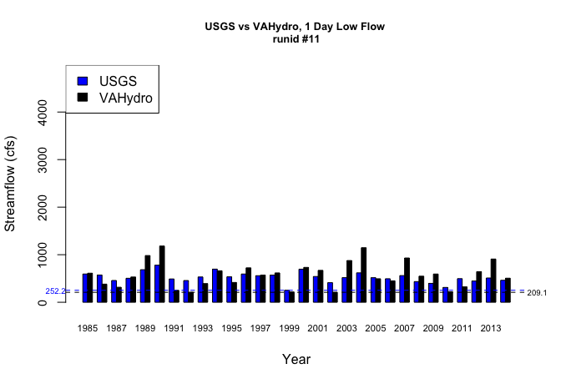

## Model Performance Scatterplots:

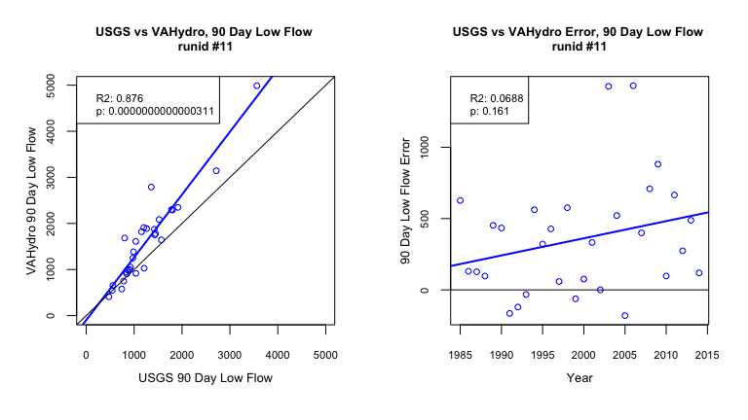

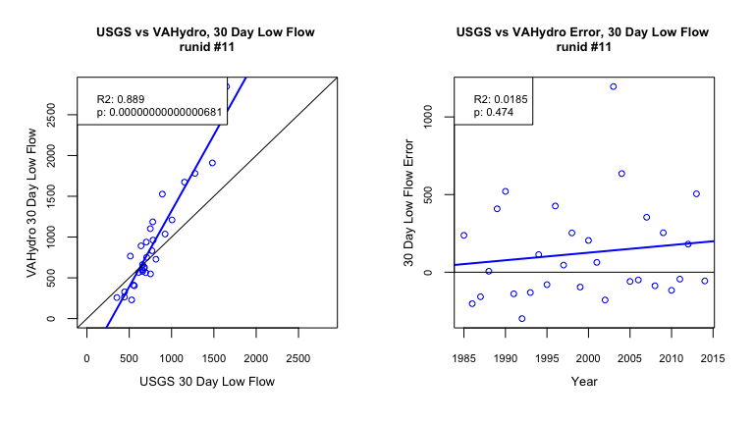

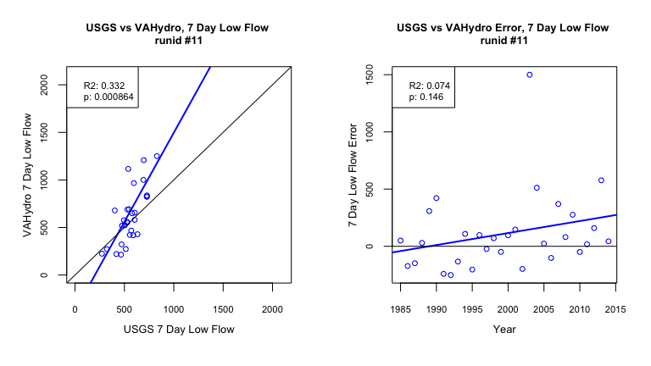

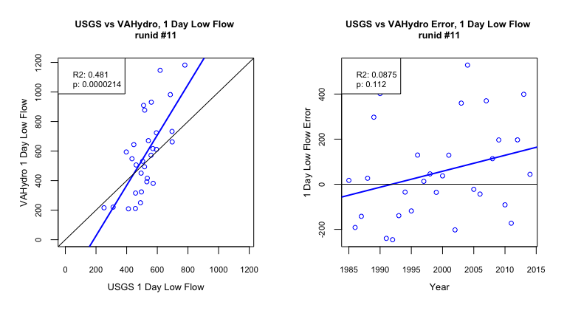

## Metrics Table:

| stat | gage | gage_year | model | model_year |
| --- | --- | --- | --- | --- |
| l90 | 472.28 | 1999 | 409.82 | 1999 |
| l30 | 353.59 | 1999 | 229.59 | 1992 |
| l7 | 272.67 | 1999 | 214.4 | 1992 |
| l1 | 252.2 | 1999 | 209.08 | 2002 |