Case Study Template (Rough Draft)
2026-07-28

Overview
AGWRC analysis for USGS 02056900: BLACKWATER RIVER NEAR ROCKY MOUNT, VA. This is a “flashy” gage where the frequent ups and downs of flow make predicting flow difficult. Predictions for this gage are also sensitive to start dates.

Terminology
Regression AGWRC: the AGWRC calculated by imputing starting flow from manually selected flow event into AGWRC vs Flow Regression
Event AGWRC: the AGWRC from a known baseflow event identified by the workflow
Iterative AGWRC: the manually selected AGWRC that provides the “best fit” for the manually selected baseflow event
Starting flow: the observed flow at the first day of the manually selected baseflow event
MAE: Mean Absolute Error
RMSE: Root Mean Square Error
MAPE: Mean Absolute Percentage Error

Analysis number 1

Regression Analysis
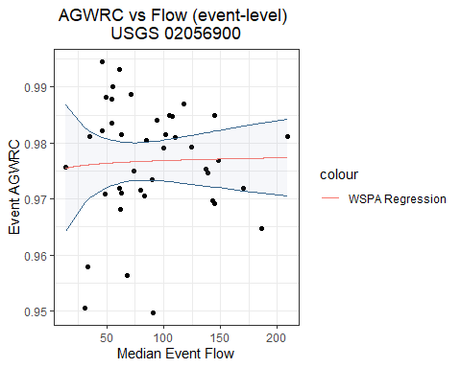
Image 1. AGWRC vs Flow Regression
The R-squared value is: 0.0013787. This small value suggests that very little of the observed variation in the data can be explained by the regression model.

First Baseflow Event Investigation
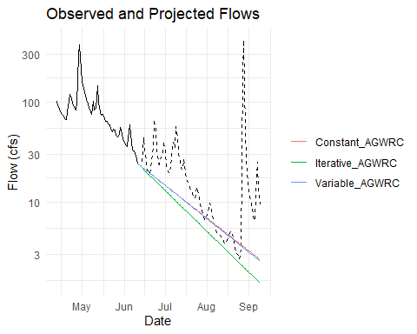
Image 2. Observed and Projected Flows from 2008-06-11
Although none of the AGWRC values were very effective in surviving the storms and catching the “troughs” following the peaks in flow, the iterative AGWRC performed the best of the three.
Table 1. Constant, Variable, and Iterative AGWRC Flow Forecast from 2008-06-11
Day | Date | Obs_Flow | Con_AGWRC_Flow | Var_AGWRC_Flow | Itr_AGWRC_Flow
15 | 2008-06-26 | 25.40 | 16.70 | 16.67 | 15.26
30 | 2008-07-11 | 32.10 | 11.58 | 11.49 | 9.66
45 | 2008-07-26 | 11.00 | 8.02 | 7.92 | 6.12
90 | 2008-09-09 | 9.45 | 2.67 | 2.59 | 1.55

Second Baseflow Event Investigation
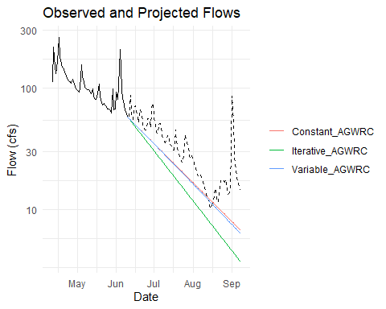
Image 3. Observed and Projected Flows from 2007-06-10
The iterative AGWRC overpredicted the first trough, but predicted the subsequent three troughs well. The iterative and variable AGWRC predictions were effective in surviving the first storm and predicting the first trough, but they greatly underpredicted the remaining flows.
Table 2. Constant, Variable, and Iterative AGWRC Flow Forecast from 2007-06-10
Day | Date | Obs_Flow | Con_AGWRC_Flow | Var_AGWRC_Flow | Itr_AGWRC_Flow
15 | 2007-06-25 | 45.7 | 40.51 | 40.44 | 36.67
30 | 2007-07-10 | 35.8 | 28.35 | 28.13 | 23.22
45 | 2007-07-25 | 35.8 | 19.83 | 19.50 | 14.70
90 | 2007-09-08 | 14.6 | 6.79 | 6.38 | 3.73

Third Baseflow Event Investigation
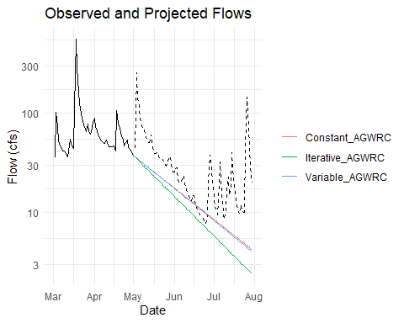
Image 4. Observed and Projected Flows from 2002-05-01
The iterative AGWRC was effective in the predicting the first trough, but overpredicted flow in the second trough where the flow approached 0 cfs. The iterative AGWRC and constant AGWRC produced very similar predictions and also overpredicted flow in mid August.
Table 3. Constant, Variable, and Iterative AGWRC Flow Forecast from 2002-05-01
Day | Date | Obs_Flow | Con_AGWRC_Flow | Var_AGWRC_Flow | Itr_AGWRC_Flow
15 | 2002-05-16 | 42.8 | 25.90 | 25.86 | 23.56
30 | 2002-05-31 | 25.6 | 18.04 | 17.90 | 14.92
45 | 2002-06-15 | 14.8 | 12.56 | 12.35 | 9.45
90 | 2002-07-30 | 19.7 | 4.24 | 4.03 | 2.40

Fourth Baseflow Event Investigation
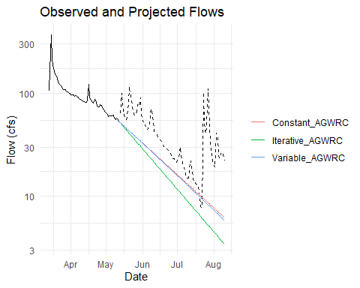
Image 5. Observed and Projected Flows from 1986-05-12
Of the three AGWRC predictions, the iterative AGWRC was the most effective in surviving the storms. The precipitation events at the end of July and the start of August impacted the accuracy of the 90-day prediction.
Table 4. Constant, Variable, and Iterative AGWRC Flow Forecast from 1986-05-12
Day | Date | Obs_Flow | Con_AGWRC_Flow | Var_AGWRC_Flow | Itr_AGWRC_Flow
15 | 1986-05-27 | 66 | 37.05 | 36.98 | 33.56
30 | 1986-06-11 | 43 | 25.90 | 25.70 | 21.25
45 | 1986-06-26 | 24 | 18.10 | 17.79 | 13.46
90 | 1986-08-10 | 22 | 6.18 | 5.82 | 3.42
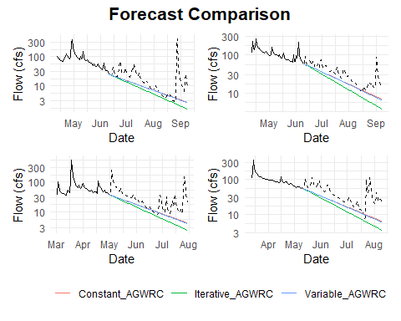
Image 5. Observed and Projected Flows for All Four Start Dates

Recommended AGWRC
The constant AGWRC and variable AGWRC were not effective in surviving storms at this gage. The iterative AGWRC of 0.98 produced better predictions and was more resilient to small, frequent precipitation events during the identified baseflow periods. It is recommended that an AGWRC value of 0.98 be used at all times for this gage.

Analysis number 2
Table 5. Calculations of the MAE, RMSE, MAPE, Bias, and $R^{2}$ values for all group IDs for 02056900: BLACKWATER RIVER NEAR ROCKY MOUNT, VA
Statistic | MAE | RMSE | MAPE | Bias | r2
Mean | 10.21 | 17.72 | 9.54 | -0.38 | 0.73
Median | 6.51 | 7.26 | 8.34 | 0.40 | 0.93
Min | 0.98 | 1.11 | 2.21 | -80.93 | 0.01
Max | 89.44 | 324.21 | 31.46 | 31.32 | 0.99
Std Dev | 14.56 | 51.05 | 6.53 | 16.17 | 0.32
Table 6. All GroupIDs with an MAPE over 20%
GroupID | MAE | RMSE | MAPE | Bias | r2
5 | 13.34 | 13.96 | 22.66 | 13.34 | 0.99
19 | 9.45 | 9.64 | 31.46 | 9.45 | 0.98
20 | 7.05 | 7.29 | 21.81 | 7.05 | 0.96
30 | 21.19 | 23.55 | 23.55 | 14.80 | 0.09
The following GroupIDs in table 6 present a list of event that did not preform well and should be treated with caution.

Analysis number 3
Determines accurate of a forecast. More text to come as function is changed.
Image 6. Observed and Projected Flows from 2008-06-11
Image 7. Observed and Projected Flows from 2007-06-10
Image 8. Observed and Projected Flows from 2002-05-01
Image 9. Observed and Projected Flows from 1986-05-12

Case Studies
## <RomFeature>
## Inherits from: <RomEntity>
## Public:
## add_mp: function (thismp)
## base_entity_type: dh_feature
## base_only: TRUE
## bundle: watershed
## clone: function (deep = FALSE)
## datasource: RomDataSource, R6
## delete: function (delete_remote = FALSE)
## delete_props: function (delete_remote = FALSE)
## description: NA
## entity_id: NA
## feat_sf: sf, data.frame
## find_spatial_relations: function (target_entity = "dh_feature", inputs = list(bundle = NA,
## from_list: function (config)
## fstatus: active
## ftype: usgs_full_drainage
## geom: MULTIPOLYGON(((-80.135930610801 36.998859048058,-80.1358 ...
## geom_CRS: 4326
## get_id: function ()
## get_mps: function ()
## get_prop: function (propname = NULL, varkey = NULL, propcode = NULL, remote = TRUE)
## get_raster_ts: function (varkey = "prism_mod_daily", starttime = FALSE, endtime = Sys.Date(),
## get_vardef: function (config = FALSE, refresh = FALSE)
## handle_config: function (config)
## has_vardef: FALSE
## hydrocode: usgs_ws_02056900
## hydroid: 289998
## initialize: function (datasource = NULL, config, load_remote = FALSE)
## insure_varid: function (config)
## load_data: function (config, load_remote)
## load_plugin: function ()
## matrix_revision_id: NA
## mps: list
## name: BLACKWATER RIVER NEAR ROCKY MOUNT, VA
## nextdown_id: NA
## parent_id: NA
## pk_name: hydroid
## plot_feat: function (useggplot = TRUE, other_geom = list())
## plugin: NA
## propvalues: function (propname = NULL, varid = NULL, propcode = NULL)
## save: function (push_remote = FALSE)
## save_field: function (class_field_name, field_table, value_pairs, pkeys = c("entity_type",
## set_prop: function (propname, propcode = NULL, propvalue = NULL, varkey = NULL,
## sql_select_from:
## select * from dh_feature_fielded
##
## to_list: function (base_only = FALSE)
## tsvalues: function (varkey = NULL, tstime = NULL, tsendtime = NULL)
## vardef: NULL
## varid: NA
## wkt_to_sf: function ()
