Sediment Calibration Strategies of Phase 5 Watershed Model

1. Land Calibration

Sediment parameter determination - Phase 5

Rule 1: 90% detached sediment re-attached to soil matrix in 30 days

AFFIX Calculation:

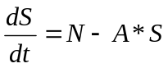

Where S = detached sediment storage
N = NVSI
A = AFFIX
T = time

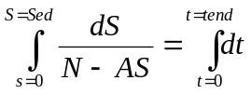

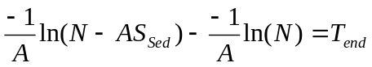

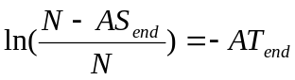

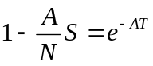

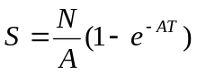

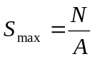 when 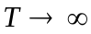

Therefore, applying the rule1:

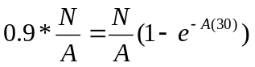

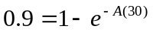
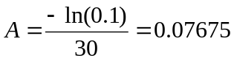 (fixed value for all land uses/all segments)

Rule 2: vertical input during dry period should be high enough for hysteresis (first- flush)

NVSI Calculation:

Total generated loads = a* target loads

NVSI *365 = a*(NRI Target)

Assuming a = 0.5

Therefore, 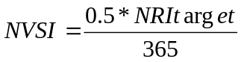

NVSI can be determined from the equation for each landuse based on their NRI target.

* NRI = National Research Institute

*NRI target = Edge of Field Sediment Erosion Rate estimated from RUSLE equation by NRI

2. River calibration

