Date: 12/22/2004 First Draft Jing Wu

Sediment Calibration Strategies of Phase 5 Watershed Model

Sediment is a primary constituent of concern for the Chesapeake Bay due to its effect on water clarity. Accurate representation of sediment processes and behavior in Chesapeake Bay watershed model is critical for developing sound load reduction strategies. HSPF simulates sediment in both land process and river process. Corresponding to model structure, sediment calibration of Phase 5 Chesapeake Bay watershed model is broken into two parts - first land calibration, and then river calibration, to ensure a reasonable simulation of the sediment sources, delivery, and transport within the watershed.

I. Land Calibration

Land calibration tries to match the simulated Edge Of Field (EOF) sediment with the target provided by National Research Institute (NRI). NRI target represents EOF Sediment loading Rate (in units of tons/acre/year) estimated from RUSLE equation. Land calibration is to ensure that the simulated erosion rates from each land category are reasonable, and thereby provides a sound basis for calibrating in-stream processes.

Land calibration was carried out separately for each county and each land use. Four primary parameters - KRER, KSER, AFFIX, NVSI, are involved in the calibration. KRER is the coefficient in the soil detachment equation; KSER is the coefficient in the detached sediment washoff equation; AFFIX is the fraction by which detached sediment storage decreases each day as a result of soil compaction; and NVSI is the rate at which sediment enters detached storage from the atmosphere. Calibration rules were set for these four parameters to ensure that there are appropriate hysteresis in washoff and appropriate response to high rainfall events.

Rule 1: 90% detached sediment re-attached to soil matrix in 30 days.

This rule is used to regulate the behavior of AFFIX. The following mathematic equations are used to drive the value of AFFIX.

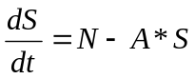

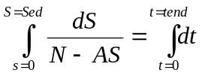

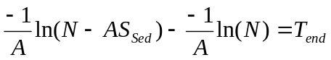

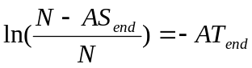

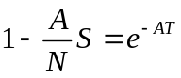
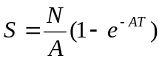

When 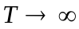, 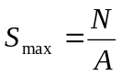

Therefore, applying the rule:

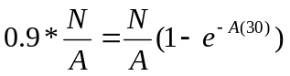

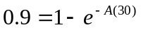

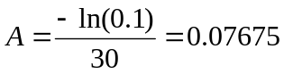

Where S = detached sediment storage
N = NVSI
A = AFFIX
T = time

The AFFIX value of 0.07675 is a fixed value for all land uses/all segments, and it will not be changed during calibration process.

Rule 2: vertical input during dry period should be high enough for hysteresis

This rule solely deals with NVSI determination. The rationale behind the rule is that there should be enough sediment accumulation during dry period so that there will be first flush when storm events occur. Mathematically, the rule can be expressed as:

Total accumulated loads during dry days = a* target loads

NVSI *365 = a*(NRI Target)

a is the fraction that represents how much of total target loads come from vertical input from the atmosphere. For Phase 5 sediment calibration, a was assumed as 0.5, meaning that half of total sediments should come from atmospheric deposition during dry days.

Therefore, 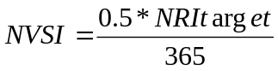

NVSI can be determined from this equation for each landuse based on their NRI targets.

Rule 3: Zero Detached Sediment after Large Storms

In general, the accumulated sediment on the land surface should not be continually increasing or decreasing throughout the calibration period. This rule is used to adjust
KRER and KSER to ensure: 1) there is no sediment build-up
after most big storms; and 2) simulated EOF erosion rate reaches to the NRI targets.

II. Sediment Delivery Factor

As Edge of Field loads are transported sequentially through model segments, loss occurs due to depositional processes that occur in overland flow prior to reaching a stream channel. Therefore, it is necessary to reduce the gross erosion by a fraction. This fraction or portion of sediment that is available for deliver is referred to as the Delivery Factor (DF). This factor is then multiplied by the predicted EOF erosion rate to estimate the eroded sediments actually delivered to a specific location.

There is no generally accepted procedure to estimate the DF. However, several empirical formulas exist. EPA region 4 compared four formulas used for DF estimation, as listed below, and the comparison result is presented in Figure XXX. The result shows that the method 1 and method 4 predict very low DF values, while method 2 gives the highest value.

DF = (1 - 0.97 * L / C) (Sun and Mcnulty 1998)

DF = exp(-0.4233*L*exp (-16.1* (Y/L + 0.057)) - 0.6) (Yagow 1988)

DF = 0.417762 * A -0.134958 - 0.127097 (SCS 1983)

DF = .9004 - .1341 (lnL) - .0465 (lnL)2 +.00749 (lnL)3 - .0399 (lnY) +.0144 (lnY)2 +.00308(lnY)3 (Swift 2000)
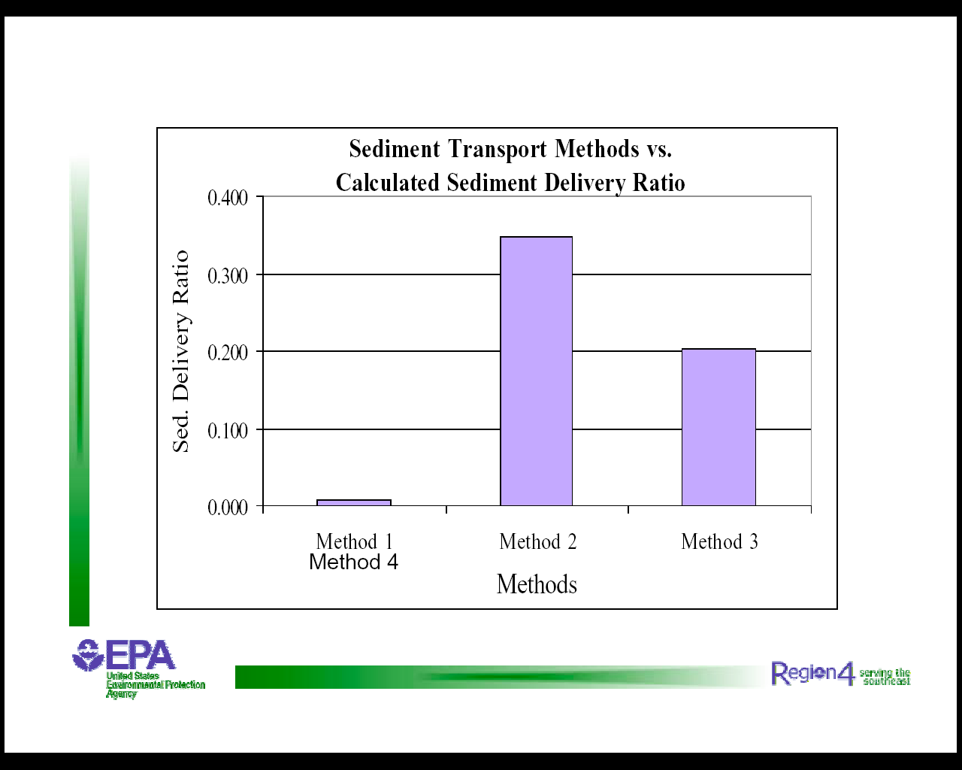

Figure XXX

Method 3 -Soil Conservation Service (SCS) method, was adopted for Phase 5 sediment calibration. This method is less data intensive and more stable than other methods. It is not particular to a land use type. Also, the DF predicted by this method is similar to the value calculated by the successful Phase 4 method.

DF = 0.417762 * A -0.134958 - 0.127097

Where A = drainage area

Single factor for each land use in each segment was calculated using SCS method. The factor is related to watershed size and unique for each land use. The drainage area in the equation was estimated by assuming the area is a circle and the mean distance from land to river is the radius. The mean distance from a land use to a particular river was estimated using GIS tools.

III. River calibration

Once the sediment loading rates were calibrated to provide the expected input to the stream channel and the reasonable delivery factors were estimated, the sediment calibration then focused on the channel processes of deposition, scour, and transport that determine both the total sediment load and the outflow sediment concentrations to be compared with observed data.

HSPF divides the sediment load from land surface into sand, silt and clay fractions and simulates them in separate in-stream processes. In Chesapeake Bay watershed, sand comprises a small fraction of the total sediment concentration and discharge, and thus the sand parameters are set to reflect this small contribution. The primary focus of river calibration is on the cohesive fractions –silt and clay.

In HSPF, the critical shear stress parameters, one for scour and one for deposition, are adjusted to regulate the scour, deposition and transport of cohesive particles. River calibration involves adjusting the critical shear stress parameters for the silt and clay size particles so that the model calculates scour during high flow events, deposition and setting during low flow periods, and transport with either scour nor setting for moderate flow rates.

Three strategies were developed to guide parameter adjustments for sediment river calibration, including 1) comparing observed and simulated sediment rating curves for different parts of the hydrograph; 2) analyzing change of bed depth over time and transport fluxes; and 3) calculating “goodness-of-fit’ statistics to compare simulated results with available data. The calibration was conducted on 55 stations where observed sediment data are available.

Sediment rating curve –
Sediment rating curves demonstrate the relationship between flow rate and sediment concentration, and the concept in the comparison of simulated rating curve to the observed rating curve is to evaluate whether the model and the data demonstrate similar relationships.

Pollutographs analysis indicates that the flow-concentration relationships are different for ascending lib, descending lib, and base flow of the hydrograph. To realistically capture the dynamic and minimize the discrepancy, three different rating curves - ascending, descending, and base flow, were developed for Phase 5 sediment calibration. The calibration processes involve comparing the slopes of the simulated and observed rating curves for different parts of the hydrograph.

Bed behavior and transport fluxes –
The value of bed depth represents the amount of sediment that can be scoured from the stream reach. Bed behavior needs to be reviewed to establish the basis for parameter adjustments on a reach-by-reach basis. In general, bed depth should not grow or shrink much over long period of time. Time series of bed depth was examined for each river, and the probabilities of bed depth within different limits were derived. This information can be compared with historical accounts or field observations to identify the ‘expected’ behavior for those river segments.

The deposition and scour fluxes over simulation period were also analyzed to help diagnose the simulated behavior. The simulated scour and deposition were related to total annual loads to quantify how much of total sediment was contributed by scouring and how much was from deposition. This information was used in conjunction with bed depth analysis to help keep reasonable rates of scour and deposition and to help identify critical source areas;

Statistics –
Traditional “goodness-of-fit’ statistics were also derived to assist in the overall sediment calibration. Mean, Correlation, and Variance were calculated for both sediment loads and concentrations, simulated and observed, in both base and log scale.

Model efficiency was estimated for each of 55 calibration stations as an indictor of model performance.

