Summary Statistics for Hydrology Calibration

1) Observed daily discharge, o: N daily values

2) Simulated daily discharge, s: N daily values

3) Mean, , :
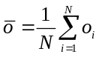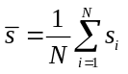

4) Median: the middle value in a series of ranked values.

5) Variance, 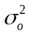, 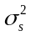:

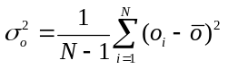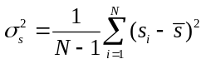

6) Error variance, 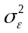:

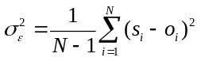

7) Relative bias, :

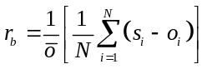

8) Relative standard error, :

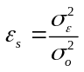

9) Nash-Sutcliffe model efficiency, E:

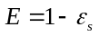

The efficiency is like a statistical coefficient of determination (Beven, 2001), or r² value. It has a value of one for a perfect fit when = zero; it has the value of zero when =, which is to say that the model is no better than a one-=parameter "no-knowledge" model that gives a prediction of the mean of the observations for all time steps. Negative values of E indicate that the model is performing worse than the "no-knowledge" model.

Beven, K.J., 2001, Rainfall-Runoff Modelling: The Primer: Chichester, John Wiley & Sons, LTD, 360 p.

