ELF Monthly Comparisons

## gdata: Unable to locate valid perl interpreter  
## gdata:   
## gdata: read.xls() will be unable to read Excel XLS and XLSX files  
## gdata: unless the 'perl=' argument is used to specify the location  
## gdata: of a valid perl intrpreter.  
## gdata:   
## gdata: (To avoid display of this message in the future, please  
## gdata: ensure perl is installed and available on the executable  
## gdata: search path.)

## gdata: Unable to load perl libaries needed by read.xls()  
## gdata: to support 'XLX' (Excel 97-2004) files.

##

## gdata: Unable to load perl libaries needed by read.xls()  
## gdata: to support 'XLSX' (Excel 2007+) files.

##

## gdata: Run the function 'installXLSXsupport()'  
## gdata: to automatically download and install the perl  
## gdata: libaries needed to support Excel XLS and XLSX formats.

##   
## Attaching package: 'gdata'

## The following object is masked from 'package:stats':  
##   
## nobs

## The following object is masked from 'package:utils':  
##   
## object.size

## The following object is masked from 'package:base':  
##   
## startsWith

## [1] "Using URI: http://deq1.bse.vt.edu/d.dh/export_elf_statistics/fe_quantreg_pwit/active/full/aqbio_nt_darter/species/0.8/max/all/1300/nhd_huc8/all/monthly-1300"

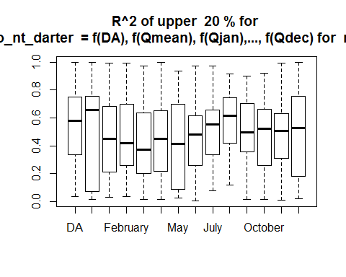 * Location: all * quantile: 0.8 * Metric: aqbio_nt_darter * Geospatial Unit: nhd_huc8 * Analysis Type: fe_quantreg_pwit * Timespan: full 