Percent Habitat Change with Flow Reduction

IFIM Site: Lynwood

Area (mi^2): 1147.3

MAF (cfs): 1247.3

|  |
| --- |
| Site Metrics |
| smb_sub_adult, smb_adult, rbs_juv, rbs_adult, c_ssp., mm, rc, canoe |

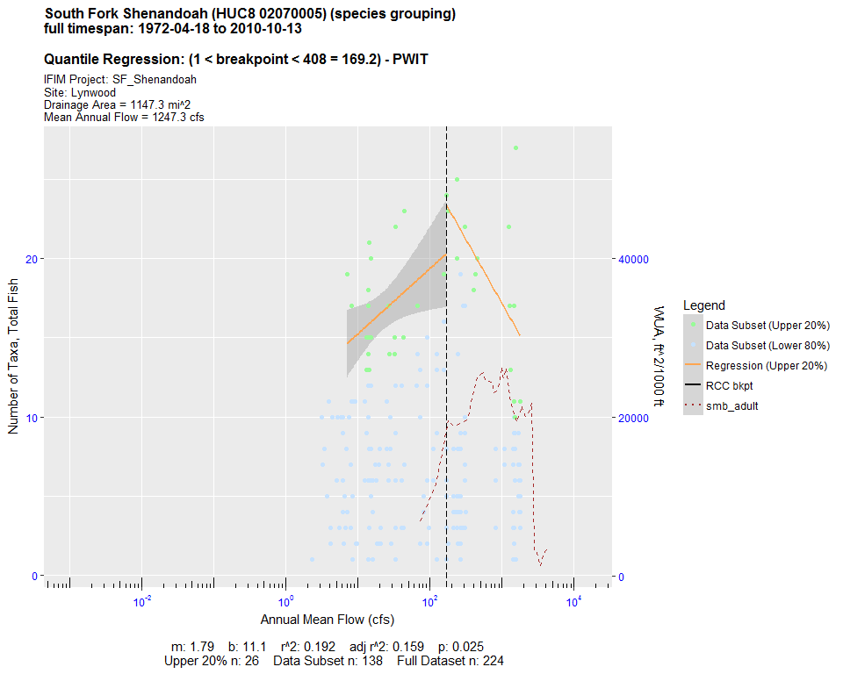

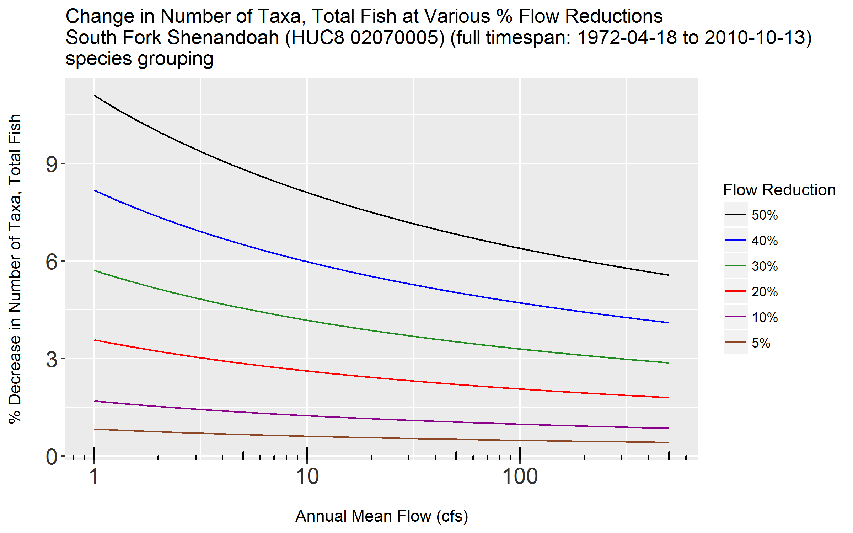

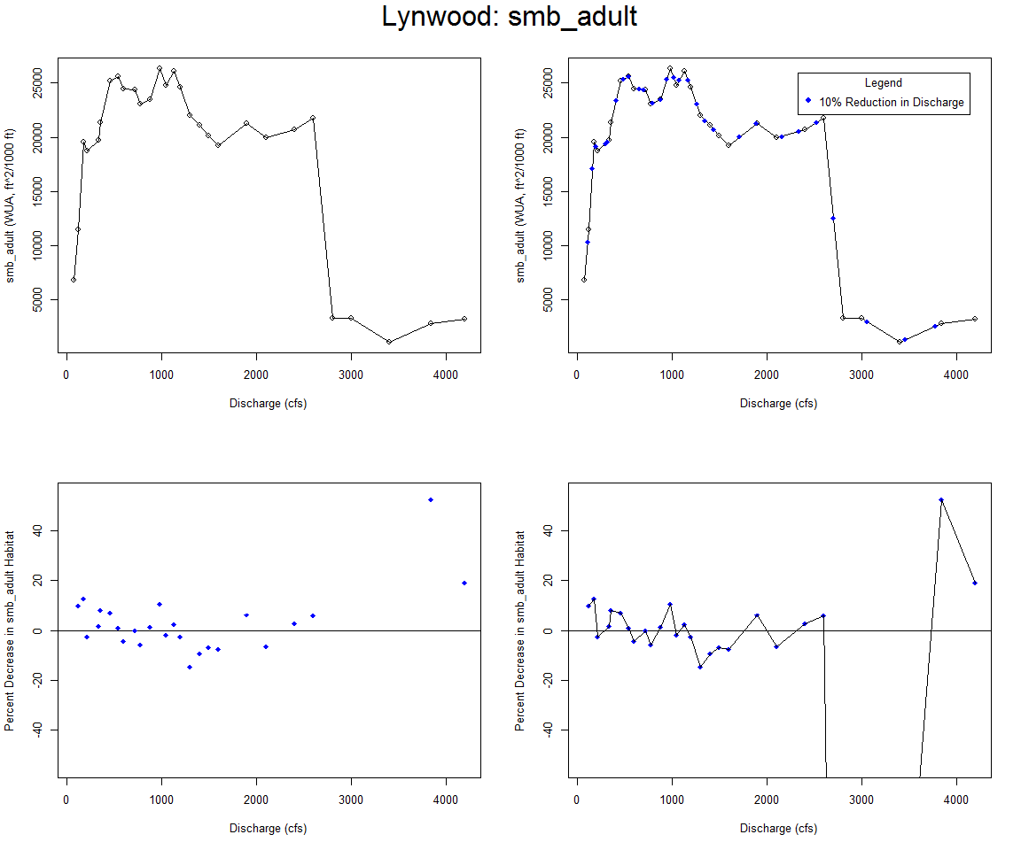

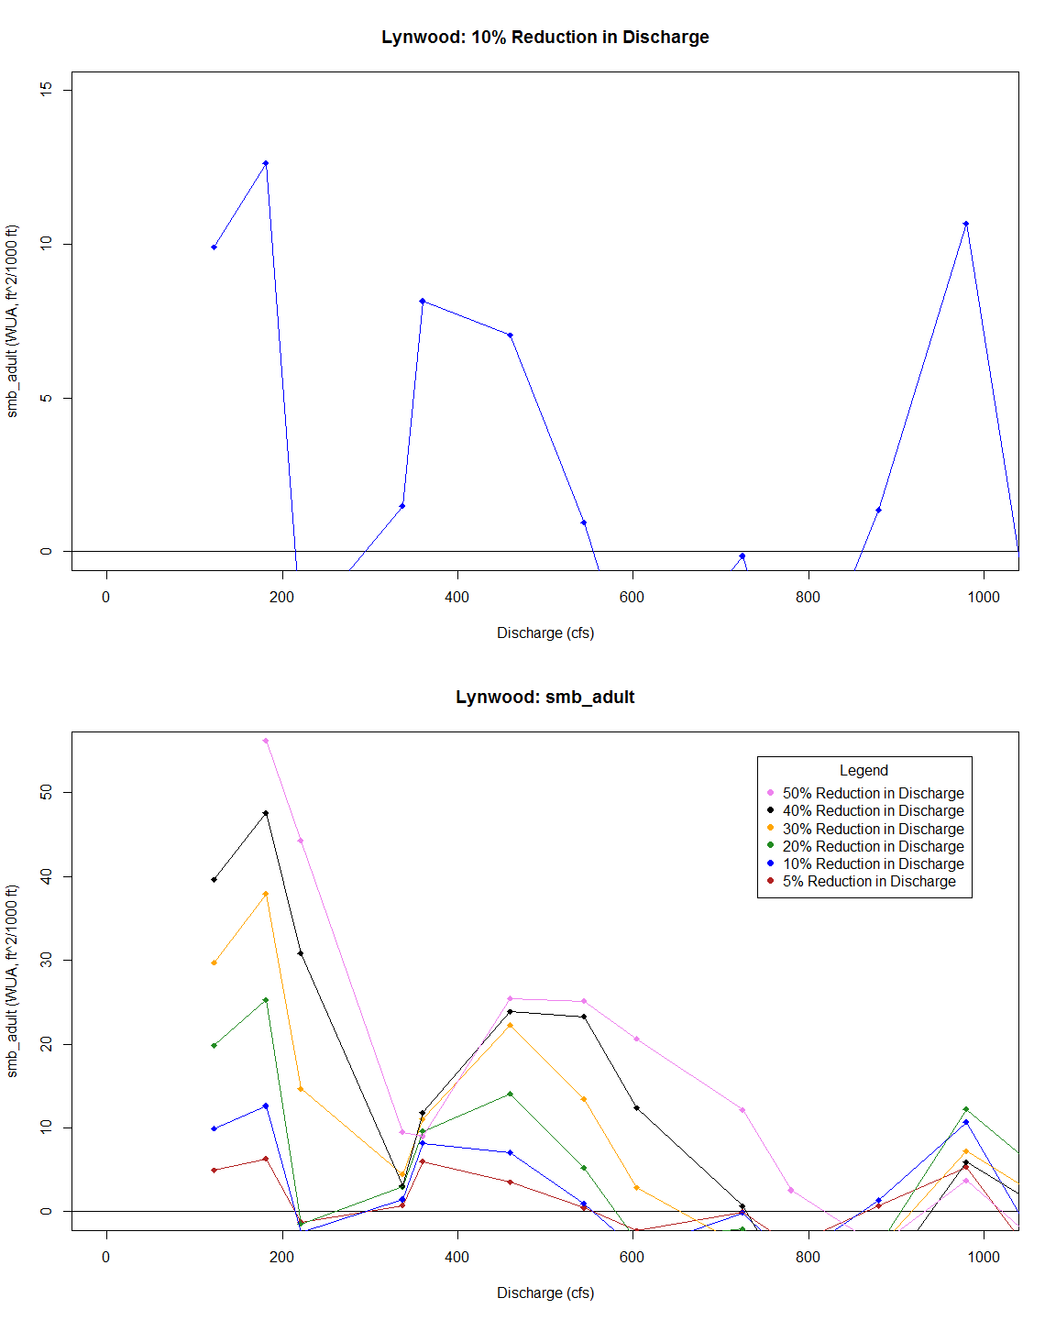

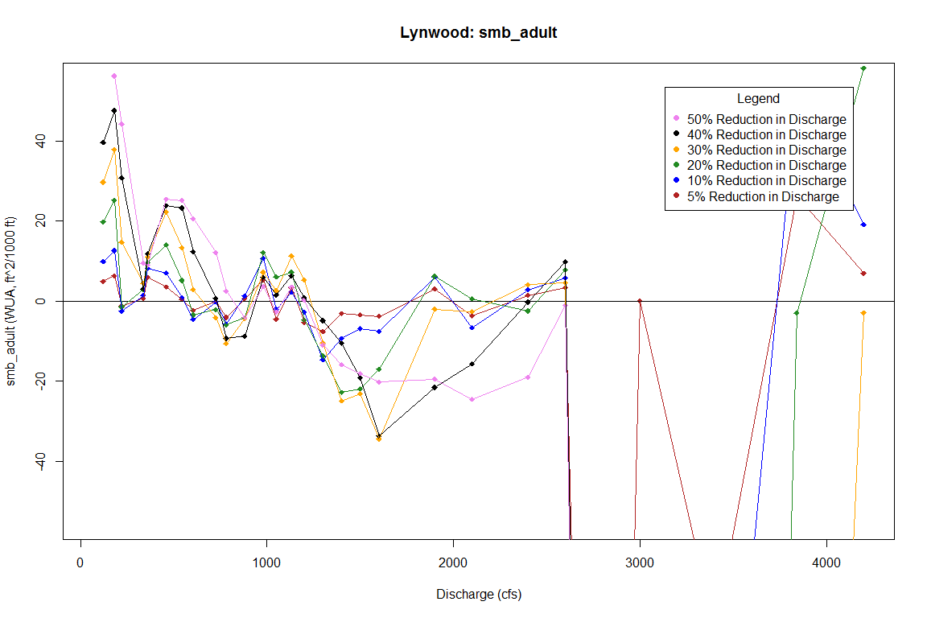

# Habitat Timeseries

### 10% Flow Reduction (Past Year)

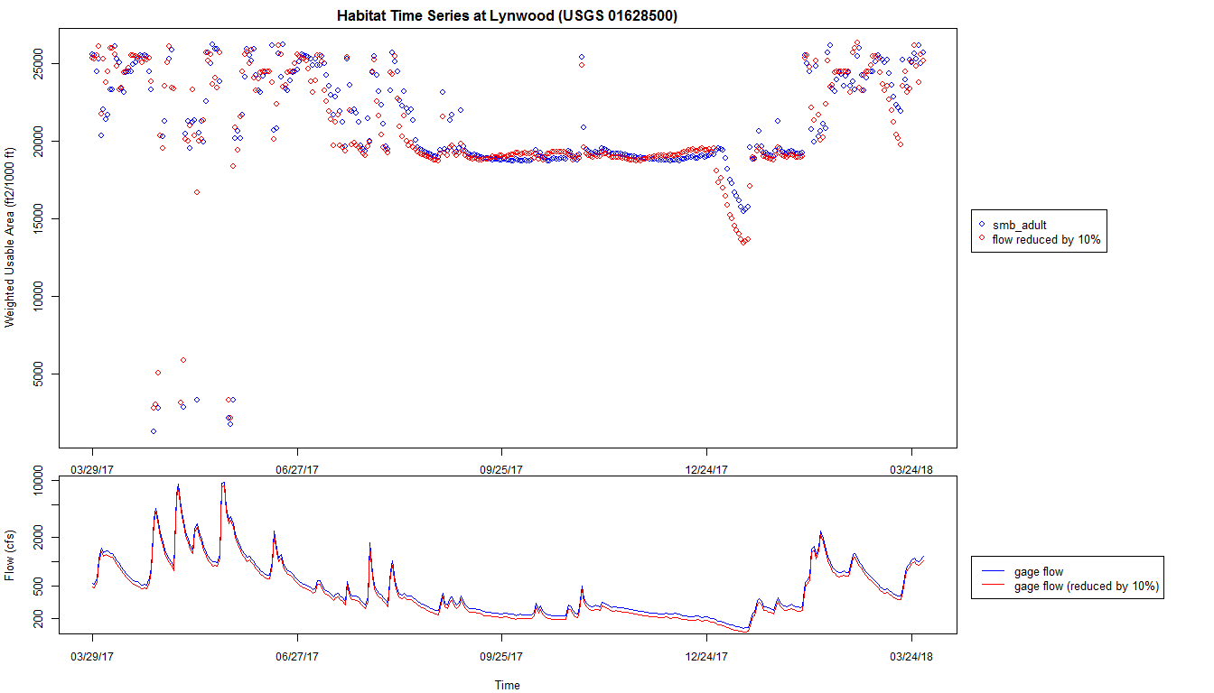

### 10% Flow Reduction (Past 10 Years)

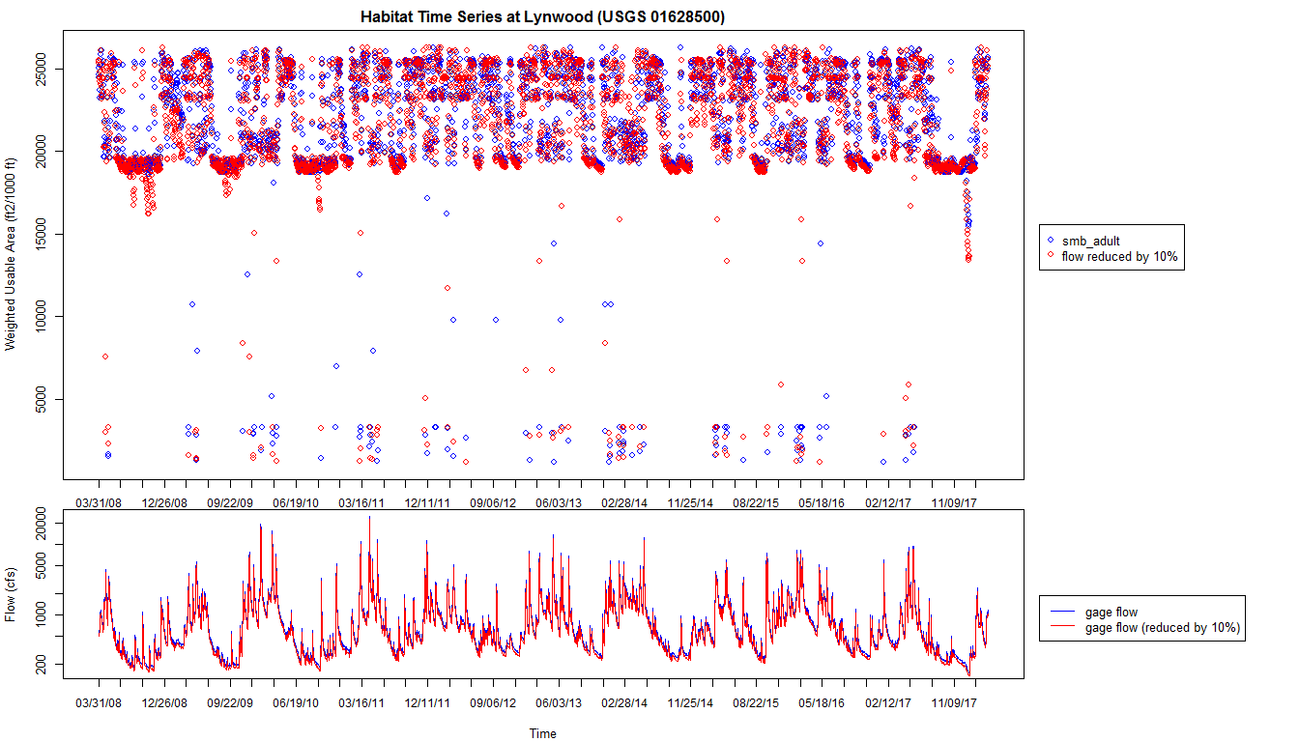

### Varying Flow Reductions (Past Year)

