Watershed Flow Summary

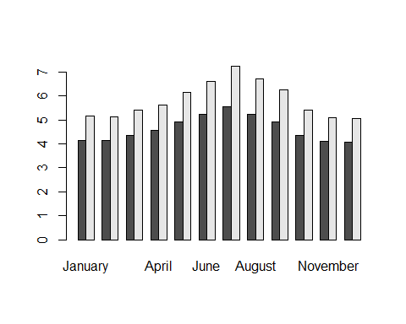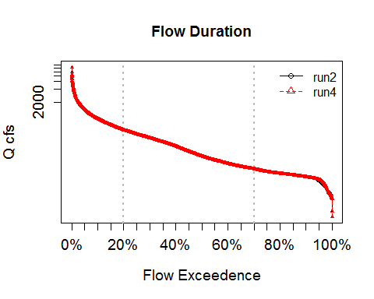 * Location: vahydrosw_wshed_YP3_6700_6670 * Run ID: 4

|  |  |  |  |
| --- | --- | --- | --- |
| Run ID | Segment Name (D. Area) | 7Q10/ALF/LF-90 | WD (mean/max) |
| 2 | North Anna River above Little River near Doswell (NA) | 18.72/65.45/20.9 (2002) | 4.66/5.57 |
| 4 | North Anna River above Little River near Doswell (NA) | 17.77/63.7/18.6 (2002) | 5.85/7.26 |