Brief Model Summary - Philpott

10/20/2021

## Location Maps w/ Facility Locations

River Segment: Philpott Dam

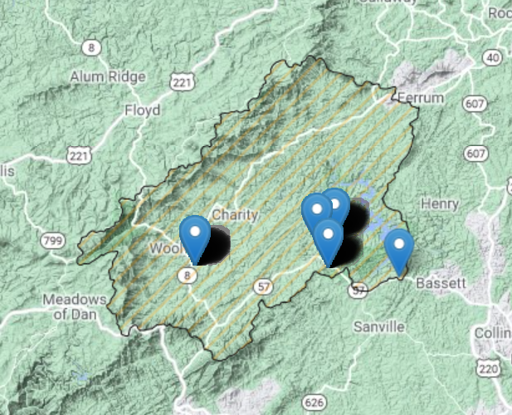

River Segment: Smith River below Philpott

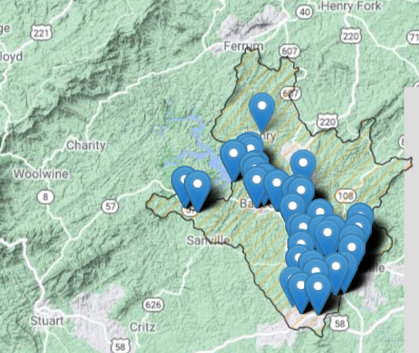

# Cumulative Impact Analysis

The following table summarizes the cumulative impacts to flows, aquatic life, and off-stream demand for the project. The section entitled “River Segment Model Statistics” contains mean flows (Flow Out), and drought flows (30 and 90 Day Low Flow), as well as an estimated Consumptive Use Fraction (See description below) as a result of all withdrawals (Cumulative Withdrawal) and discharges (Cumulative Point Source) in the watershed. There will be one or more columns in this table representing each scenario considered for this analysis.

## Glossary of Cumulative Impact Modeling Terms

* Consumptive Use (CU): This is calculated as a fraction of modeled Flow, so it is CU = 1.0 - (Flow / Flow_Baseline), where Flow_Baseline = (Flow + WD - PS), and WD and PS are the total cumulative withdrawals and point source discharges above the point in the stream. In other words, for calculating baseline flow, we take modeled outflow from the river, add the withdrawals back in, and subtract the point source in order to estimate a baseline flow balance. This almost always ends up being a higher number than the modeled Flow out, so it tells us the fraction of baseline flow that is consumed. Occasionally there are water transfers and point sources from groundwater, or point sources that cross watershed boundaries that can make the CU fraction in some watersheds negative, i.e. Flow > Flow_Baseline.

## Stats Comparison Table:

| **Description** | **2020 “Current”** | **2040** | **Exempt User** |
| --- | --- | --- | --- |
| River Segment Model Statistics: | Philpott Dam | Philpott Dam | Philpott Dam |
| Flow Out (cfs) | 55.19 | 55.19 | 55.18 |
| 30 Day Low Flow (cfs) | 4.78 | 4.78 | 4.7 |
| 90 Day Low Flow (cfs) | 6.29 | 6.29 | 6.2 |
| Consumptive Use Fraction | 0 | 0 | 0.01 |
| Cumulative Withdrawal (mgd) | 0.13 | 0.13 | 0.19 |
| Cumulative Point Source (mgd) | 0 | 0 | 0 |
| River Segment Model Statistics: | Smith River below Philpott | Smith River below Philpott | Smith River below Philpott |
| Flow Out (cfs) | 239.57 | 237.78 | 142.45 |
| 30 Day Low Flow (cfs) | 10.83 | 9.69 | 2.86 |
| 90 Day Low Flow (cfs) | 16.49 | 14.95 | 5.13 |
| Consumptive Use Fraction | 0.05 | 0.06 | 0.44 |
| Cumulative Withdrawal (mgd) | 8.35 | 9.51 | 71.69 |
| Cumulative Point Source (mgd) | 0.24 | 0.24 | 0.29 |

# Ecological Impacts Assessment:

## Elfgen:

In response to a need for better environmental flow metrics, DEQ has developed a new framework for characterizing relations between streamflow and aquatic organism species richness. Part of an evolving approach to managing environmental flows for maintaining aquatic life; this methodology builds on existing minimum instream ow approaches, allowable withdrawals as a percentage of flow, and extensive flow-habitat studies. For the first time this new framework may allow quantification of potential species loss resulting from flow change, and may offer an improved understanding of aquatic life risk variability due to geographic location, stream size and local scale.

This new flow-ecology framework referred to as “elfgen” (*pronounced elf-jen*) derives its name from Ecological Limit Function (ELF) generation (*ELF-gen*). In order to calculate river segment-level richness change, elfgen is first used to produce ELFs, or relations between stream flow and species richness at the HUC 8 scale (See plot below). This is achieved using long term datasets for both ecological and hydrologic data. Ecological data (Fish species richness) is sourced from the VAHydro-EDAS dataset. Hydrologic data (Average Annual Flow) is sourced from the National Hydrography Dataset Plus. The Richness Change values presented in the table below are derived from this flow-ecology relation.

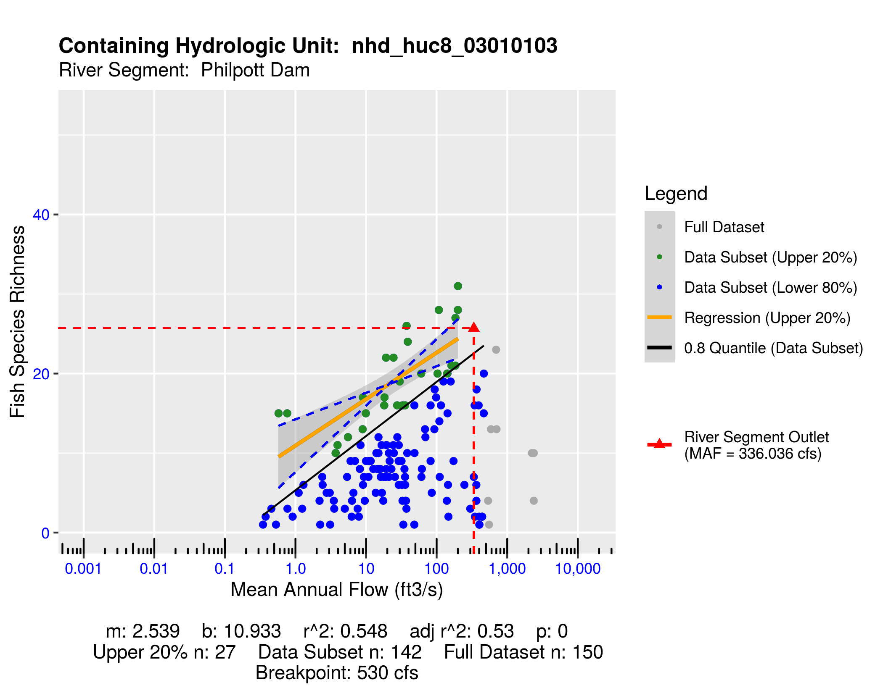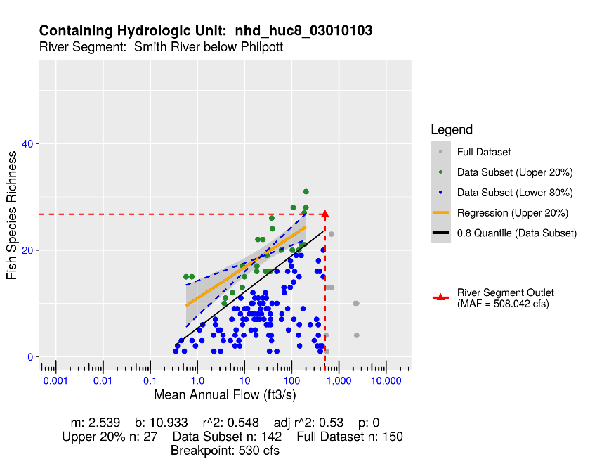

## Richness Change Metric Table:

Estimates for richness change are presented both as an absolute number of species (Richness Change (abs)) and as a percentage of the total number of species present (Richness Change (%)). Richness change calculations are derived from the estimated percent total consumptive use (For additional details on “elfgen” methodology, see <https://onlinelibrary.wiley.com/doi/full/10.1111/1752-1688.12876>).

| **Description** | **2020 “Current”** | **2040** | **Exempt User** |
| --- | --- | --- | --- |
| River Segment Model Statistics: | Philpott Dam | Philpott Dam | Philpott Dam |
| Consumptive Use Fraction | 0 | 0 | 0.01 |
| Cumulative Withdrawal (mgd) | 0.13 | 0.13 | 0.19 |
| Richness Change (abs) | -0.01 | -0.01 | -0.01 |
| Richness Change (%) | -0.04 | -0.04 | -0.05 |
| River Segment Model Statistics: | Smith River below Philpott | Smith River below Philpott | Smith River below Philpott |
| Consumptive Use Fraction | 0.05 | 0.06 | 0.44 |
| Cumulative Withdrawal (mgd) | 8.35 | 9.51 | 71.69 |
| Richness Change (abs) | -0.13 | -0.15 | -1.46 |
| Richness Change (%) | -0.48 | -0.56 | -5.45 |

Notes:

* The river segment “Smith River below Philpott” shows up as the #7 river segment with potential risk of richness loss under the exempt user scenario (See the -5.45% Richness Change in the Draft State Plan *“Table 18: Richness Change (Top 30 River Segments at Risk of Loss).”* Note the 2020 and 2040 predicted richness loss is less severe.
* Text from Draft State Plan: A 10% reduction in L30 (short-term drought) was simulated in the Smith River below Philpott when comparing the 2020 and 2040 demand scenarios. Significant increases in demand from the City of Martinsville and withdrawals from the Smith River below Philpott Dam from the Henry County PSA drive the potential for unmet demands in the river segment. Overall reductions below Philpott Dam in the Smith River is driven by Henry County PSA withdrawals from the Smith River below Philpott Dam and significant demand increases from the City of Martinsville WTP. Unmet demands during the 2040 scenario for both facilities are less than 1 MGD. Simulated reductions of overall flow suggest potential for impacts to aquatic life and species biodiversity in these segments.

| **Facility** | **River Segment** | **2020** | **2030** | **2040** | **Exempt User** |
| --- | --- | --- | --- | --- | --- |
| FAIRY STONE STATE PARK WTP | Philpott Dam | 0 | 0 | 0 | 0.031 |
| Fairystone Wildlife Management Area | Philpott Dam | 0 | 0 | 0 | 0 |
| DALTON FARMS | Philpott Dam | 0 | 0 | 0 | 0 |
| WOOLWINE PLANT | Philpott Dam | 0.134070199 | 0.134070199 | 0.134070199 | 0.158 |
| Henry (Large Self-Supplied User) | Smith River below Philpott | 0.077443226 | 0.077441997 | 0.077439769 | 0.077158783 |
| Henry (Agriculture) | Smith River below Philpott | 1.23162256 | 1.231603012 | 1.231567581 | 1.226502651 |
| Henry (Community Water System) | Smith River below Philpott | 0.152352713 | 0.152350295 | 0.152345913 | 0.15179314 |
| UPPER SMITH RIVER WTP | Smith River below Philpott | 3.295990437 | 3.29543292 | 3.294993356 | 5.11443826 |
| F.C. DUMAINE PLANT WTP | Smith River below Philpott | 0 | 0 | 0 | 2.064439613 |
| STANLEYTOWN PLANT | Smith River below Philpott | 0 | 0 | 0 | 2.57181261 |
| MARTINSVILLE WTP | Smith River below Philpott | 0 | 0 | 0 | 36.99538695 |
| BASSETT PLANT | Smith River below Philpott | 0 | 0 | 0 | 0.677027874 |
| MARTINSVILLE PLANT | Smith River below Philpott | 0.451762822 | 0.451755017 | 0.451740934 | 2.74587234 |
| Heritage Golf Club | Smith River below Philpott | 0 | 0 | 0 | 0 |
| Fieldale Plant | Smith River below Philpott | 1.046645311 | 1.046628752 | 1.046598694 | 2.593228755 |
| MARTINSVILLE WTP | Smith River below Philpott | 1.962106628 | 2.543266696 | 3.123882755 | 16.53391191 |
| BASSETT DIVISION | Smith River below Philpott | 0 | 0 | 0 | 0.747546331 |

# Table of Facility Withdrawals (mgd):

*(Pulled from foundation data metrics_facility_wd_mgd.csv)*