VWP CIA Summary - [INSERT PROJECT NAME HERE]

03/28/2022

# VAHydro Model:

## VAHydro

The comprehensive VAHydro hydrologic model is used by the DEQ Office of Water Supply to evaluate instream and off-stream beneficial uses for non-tidal surface water withdrawals throughout Virginia. This model also simulates streamflow with inputs such as precipitation, climate, land use, and topography, as well as local data collected through DEQ water supply planning and reporting programs, which includes all known withdrawals and discharges, as well as operational rules of Virginia Water Protection (VWP) permits and major hydrologic features such as reservoirs.

The VAHydro model is built on the rainfall-evaporation-runoff (RER) time-series from the Chesapeake Bay Model Phase 6[1]. The VAHydro model simulates conditions from 1984-2014 in the Chesapeake Bay watershed drainage, and 1984-2005 in the rivers flowing outside of the Chesapeake Bay watershed. The VAHydro model features high-resolution hydrologic subsections called “river segments” (over 600 river segments in total), roughly the size of HUC 10 hydrologic units, with additional high-resolution segments added for VWP modeling projects as needed.

## Cumulative Impact Analysis (CIA)

DEQ assesses water supply sustainability through Cumulative Impact Analysis (CIA). CIA is a modeling and analysis approach that takes into account the varied hydrologic processes occurring throughout a river network (including meteorological and human water use). By simulating a daily water balance for every individual river segment within a watershed, DEQ is able to evaluate the potential “cumulative impact” of all streamflow changes occurring upstream and downstream of any location within the river system, as well as the downstream impact of a specific proposed or permitted surface water withdrawal.

The goal of the following analysis is to estimate the potential impacts of the proposed water withdrawal upon existing beneficial uses, including both in-stream and off-stream uses. In addition, cumulative impacts from all existing withdrawals are included in the evaluation.

# Project Introduction

This project consists of an existing water intake constructed in the 1960’s with an upgrade in the early 1980’s. The Town owns and operates the Big Cherry Dam located approximately 3 miles upstream from the intake structure. The Town’s water treatment plant operators control the amount of water discharging the dam into the Powell River and all of the stream by-pass flow to meet the previous permit requirements of 4.0 MOD of maximum withdrawal and 0.50 MGD of by-pass flow. This is always true unless the dam is overflowing exceeding the amount of water required from various rainfall events. Therefore, the existing/proposed maximum withdrawal amounts will not have an impact on the stream in terms of rates, volumes, frequency, etc. This is a daily activity as it serves the existing water treatment plant.

Permit: Big Cherry Dam, 01-0688  
Permit Dates: 2003-08-23 to 2018-08-22

* **Annual Withdrawal Limit** = 1168 MG/yr (3.2 MGD)
  + (historically they withdraw ~2 MGD on average)
* **Daily Withdrawal Limit** = 4 MGD
* **Flow-by** = 0.5 MGD

## Location Map

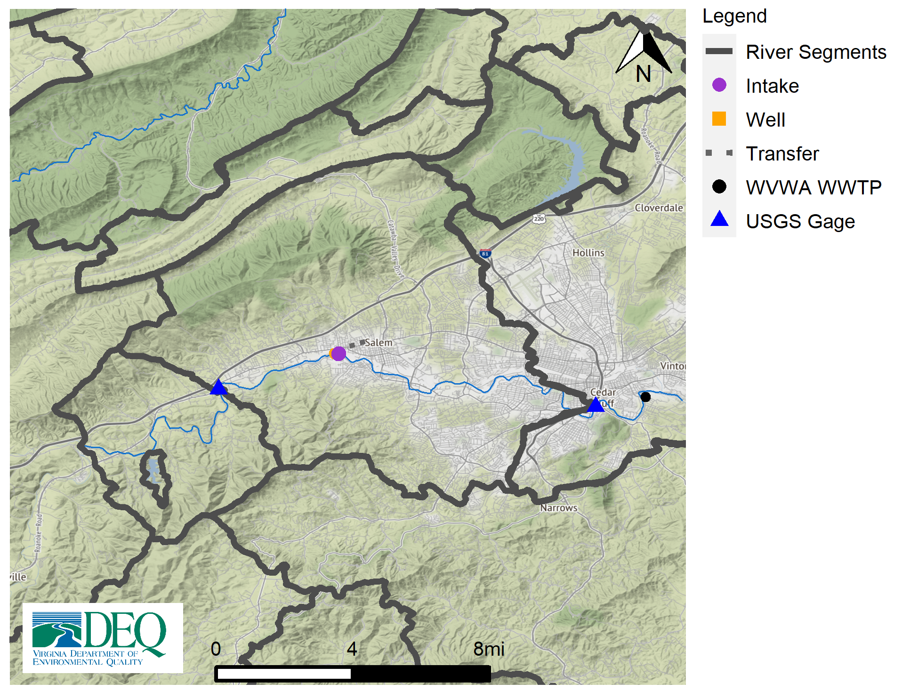

# Model Overview and Scenario Descriptions

**River Model Description** The VAHydro Roanoke River at Salem model segment covers the Roanoke River from just downstream of the USGS gage at Glenvar through the city of Roanoke, ending at the USGS gage 02055000 near the base of Mill Mountain. Model flow calibration at the upstream gage underestimates drought flows during the months of August-November, which will tend to over-estimate unmet demands during drought conditions. A low flow margin of safety of approximately 15 cfs may be added to determine a more realistic water availability during the most extreme drought events, that is, when flows are below the 5% non-exceedance percentile. For example, using a 10% allowable diversion, an additional 1.5 cfs (1.0 mgd) of flow may be available for withdrawal during extreme drought periods than that which is simulated. Model performance is strong at the 25% non-exceedance flow and above.

**Facility & Intake Model Description** The City of Salem operates an intake on the Roanoke River, located downstream of the USGS flow gage 02054530 in Glenvar. DEQ records show withdrawals have increased from 1 MGD in 1982 to approximately 4 mgd in 2021.

The following model scenarios were simulated in order to determine the most effective means of meeting the project need and all other in-stream beneficial uses:

* **Current Conditions Drought Period Run (1998-2002)** (Current (98-02)) - Details about this scenario to be used in the introduction to scenario analyses (but this is *not* the scenario analyses, that happens in scenario_analysis).
* **Total Permitted Conditions Drought Period Run (1998-2002)** (Total Permitted (98-02)) - Details about this scenario to be used in the introduction to scenario analyses (but this is *not* the scenario analyses, that happens in scenario_analysis).
* **Total Permitted Conditions w/ 90% Flowby Drought Period Run (1998-2002)** (Total Permitted w/ 90% Flowby (98-02)) - Details about this scenario to be used in the introduction to scenario analyses (but this is *not* the scenario analyses, that happens in scenario_analysis).

**Historical Intake Flows and Drought Flow Indicators**

The VAHydro model is used to estimate flows at the project intake, including the impact of all cumulative withdrawals, discharges and management rules upstream of the withdrawal location. The models estimates of currently available flows are presented in Table 1. The Virginia Drought Assessment and Response Plan[2] employs non-exceedance flow percentiles as indicators of drought conditions at particular stream-gaging stations used to monitor drought conditions. Representative daily streamflows above the 25th percentile for return flow frequency represent normal conditions with respect to drought. Representative daily streamflows between the 10th and 25th percentiles represent drought watch conditions. Representative daily streamflows between the 5th and 10th percentiles represent drought warning conditions. Representative daily streamflows below the 5th percentile indicate drought emergency conditions.

**Table 1:** Modeled monthly current flow statistics for Roanoke River Salem in cubic feet per second (cfs). Columns show the minimum (Min) and average (Mean) modeled flow, and a range of non-exceedance flow percentiles, that is, the column header indicates the percent of flows that do *not* exceed the given value. For example, the “10%” states that only 10% of flows in the given month are expected to be less than the indicated value, and therefore, 90% of the flows in that month are expected to be greater than the given value. For example, in the table below the 10% column states that 10% of flows within the month of January would be less than 123 cfs.

| **Month** | **Min** | **5%** | **10%** | **25%** | **30%** | **50%** | **Mean** |
| --- | --- | --- | --- | --- | --- | --- | --- |
| Jan | 47 | 106 | 123 | 189 | 219 | 375 | 472 |
| Feb | 92 | 129 | 162 | 273 | 320 | 432 | 594 |
| Mar | 89 | 158 | 204 | 341 | 386 | 533 | 654 |
| Apr | 123 | 159 | 192 | 259 | 281 | 407 | 620 |
| May | 95 | 133 | 159 | 222 | 241 | 332 | 435 |
| Jun | 53 | 89 | 107 | 155 | 173 | 252 | 375 |
| Jul | 26 | 49 | 64 | 106 | 116 | 163 | 228 |
| Aug | 11 | 29 | 40 | 75 | 84 | 131 | 186 |
| Sep | 6 | 23 | 36 | 70 | 81 | 119 | 237 |
| Oct | 9 | 20 | 43 | 75 | 83 | 111 | 228 |
| Nov | 8 | 16 | 50 | 98 | 105 | 144 | 280 |
| Dec | 14 | 68 | 95 | 124 | 138 | 262 | 334 |

# Results

## Summary

Four scenarios are presented below to examine the alternatives for this permit re-issuance. A summary of how permit rules affect available water for this permit, and how this operation may impact instream beneficial uses, and other downstream water withdrawals is presented.

* **Current Conditions Drought Period Run (1998-2002)** - Outcomes from the particular set of operational rules and scenario conditions. Ex: The 90% flow-by scenario results in more flexibility to pump under extremely dry conditions, as compared to the current static MIF permit condition. As a result, the operation is able to meet offstream need during all simulated periods, with a small amount of water remaining during the lowest simulated flow.
* **Total Permitted Conditions Drought Period Run (1998-2002)** - Outcomes from the particular set of operational rules and scenario conditions. Ex: The 90% flow-by scenario results in more flexibility to pump under extremely dry conditions, as compared to the current static MIF permit condition. As a result, the operation is able to meet offstream need during all simulated periods, with a small amount of water remaining during the lowest simulated flow.
* **Total Permitted Conditions w/ 90% Flowby Drought Period Run (1998-2002)** - Outcomes from the particular set of operational rules and scenario conditions. Ex: The 90% flow-by scenario results in more flexibility to pump under extremely dry conditions, as compared to the current static MIF permit condition. As a result, the operation is able to meet offstream need during all simulated periods, with a small amount of water remaining during the lowest simulated flow.

## Conclusion

* **Total Permitted Conditions w/ 90% Flowby Drought Period Run (1985-2005)**  - If this scenario is the preferred scenario, add remarks here for inclusion in final analysis.

## Detailed Cumulative Impact Analysis

The following “Summary of Results” table summarizes the cumulative impacts to flows, aquatic life, and off-stream demand for the project. The section entitled “River Segment Model Statistics” contains mean flows (Flow Out), and drought flows (30 and 90 Day Low Flow), as well as an estimated Consumptive Use Fraction (See description below) as a result of all withdrawals (Cumulative Withdrawal) and discharges (Cumulative Point Source) in the watershed. Minimum Days of Storage Remaining describes the number of days of remaining storage available during the driest period of the model simulation (applicable to impoundment models only). Total Number of Days with Storage < 50% describes the number of days in the simulation in which reservoir levels fall below 50% of full storage. The section entitled “Facility Model Statistics” shows the withdrawals, return flows (Point Source), and the model estimate for potential unmet demand due to demands exceeding the allowable withdrawal at the intake based on the cumulative conditions in the watershed and the flow-by rules in effect. There will be one or more columns in this table representing each scenario considered for this analysis.

### Glossary of Cumulative Impact Modeling Terms

* Consumptive Use Fraction (CU): This is calculated as a fraction of modeled Flow, so it is CU = 1.0 - (Flow / Flow_Baseline), where Flow_Baseline = (Flow + WD - PS), and WD and PS are the total cumulative withdrawals and point source discharges above the point in the stream. In other words, for calculating baseline flow, we take modeled outflow from the river, add the withdrawals back in, and subtract the point source in order to estimate a baseline flow balance. This almost always ends up being a higher number than the modeled Flow out, so it tells us the fraction of baseline flow that is consumed. Occasionally there are water transfers and point sources from groundwater, or point sources that cross watershed boundaries that can make the CU fraction in some watersheds negative, i.e. Flow > Flow_Baseline.
* 30 Day Low Flow: *DESCRIPTION NEEDED
* 90 Day Low Flow: *DESCRIPTION NEEDED
* *Additional DESCRIPTIONS NEEDED for other table metrics that aren’t clearly understood

### Summary of Results:

| **Description** | **Current (98-02)** | **Total Permitted (98-02)** | **Total Permitted w/ 90% Flowby (98-02)** |
| --- | --- | --- | --- |
| River Segment Model Statistics: | Roanoke River (Salem) | Roanoke River (Salem) | Roanoke River (Salem) |
| Flow Out (cfs) - (i.e mean flow) | 201.95 | 194.59 | 196.63 |
| 30 Day Low Flow (cfs) (i.e drought flow) | 15.79 | 10.46 | 18.31 |
| 90 Day Low Flow (cfs) (i.e drought flow) | 42.52 | 35.76 | 42.84 |
| Consumptive Use Fraction | 0.07 | 0.1 | 0.09 |
| Cumulative Withdrawal (MGD) | 9.09 | 13.87 | 12.54 |
| Cumulative Point Source (MGD) | 0 | 0 | 0 |
| Withdrawal (MGD) | 3.02 | 7.8 | 6.48 |
| Point Source (MGD) | 0 | 0 | 0 |
| Facility Model Statistics: | Salem WTP:Roanoke River (Salem) | Salem WTP:Roanoke River (Salem) | Salem WTP:Roanoke River (Salem) |
| Base Demand (MGY) | 1,063.06 | 2,829.17 | 2,829.17 |
| Withdrawal (MGY) | 1,063.06 | 2,807.43 | 2,323.95 |
| Unmet Demand (MGY) | 0 | 21.74 | 505.22 |
| Requested Demand (MGD) | 2.91 | 7.75 | 7.75 |
| Withdrawal Met (MGD) | 2.91 | 7.69 | 6.37 |
| Point Source (MGD) | 3.45 | 7.43 | 6.36 |
| Groundwater Demand (MGD) | 1.25 | 1.25 | 1.25 |
| Maximum 30 day potential unmet demand (MGD) | 0 | 1.7 | 6.75 |

### Analysis of Reservoir Storage:

The following reservoir storage plots depict changes in reservoir storage under each scenario (indicated in black), as well as simulated inflow to the reservoir (blue), simulated outflow from the reservoir (green), and system demand for the given scenario (red). For water supply reservoirs, a minimum of 60 days of remaining storage over the course of the simulation is recommended. System demand varies seasonally.

[1] “No active impoundment found for run id runid_2011” [1] “No active impoundment found for run id runid_4011” [1] “No active impoundment found for run id runid_6011”

### Analysis of Potential Unmet Demand at the River Intake:

Heatmaps are data plotting tools that help visualize data as magnitudes of color intensity. The following heatmaps depict the number of days with unmet demands for each month of the simulation (due to demands exceeding allowable withdrawal at the intake based on the cumulative conditions in the watershed and the flow-by rules in effect). The heatmap cells show the amount of unmet demand for each month [Number of Unmet Days & Amount (MGD)]. Hydrographs are shown for the period of the simulation with greatest unmet demand.

#### Heatmap: Current (98-02)

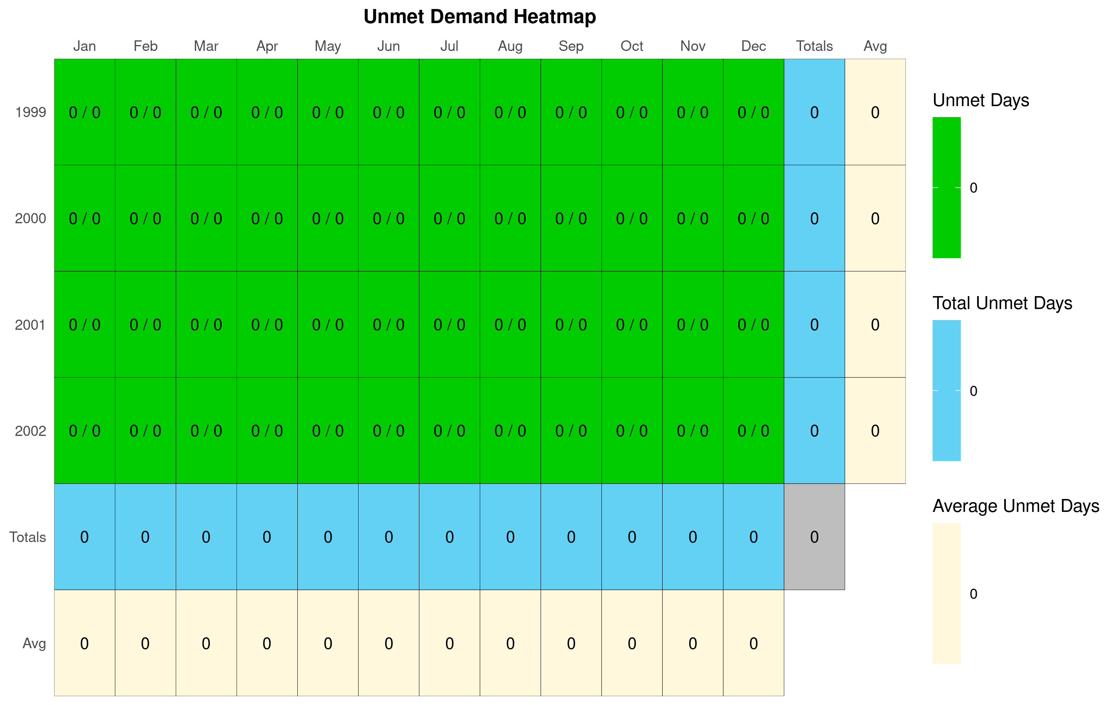

#### Hydrograph: Current (98-02)

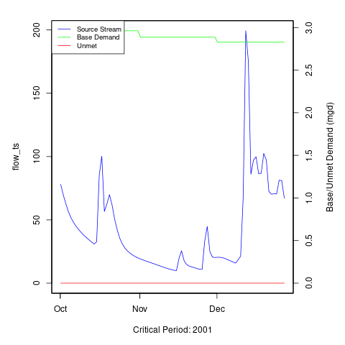 [1] “No local facility impoundment for Current (98-02)”

#### Heatmap: Total Permitted (98-02)

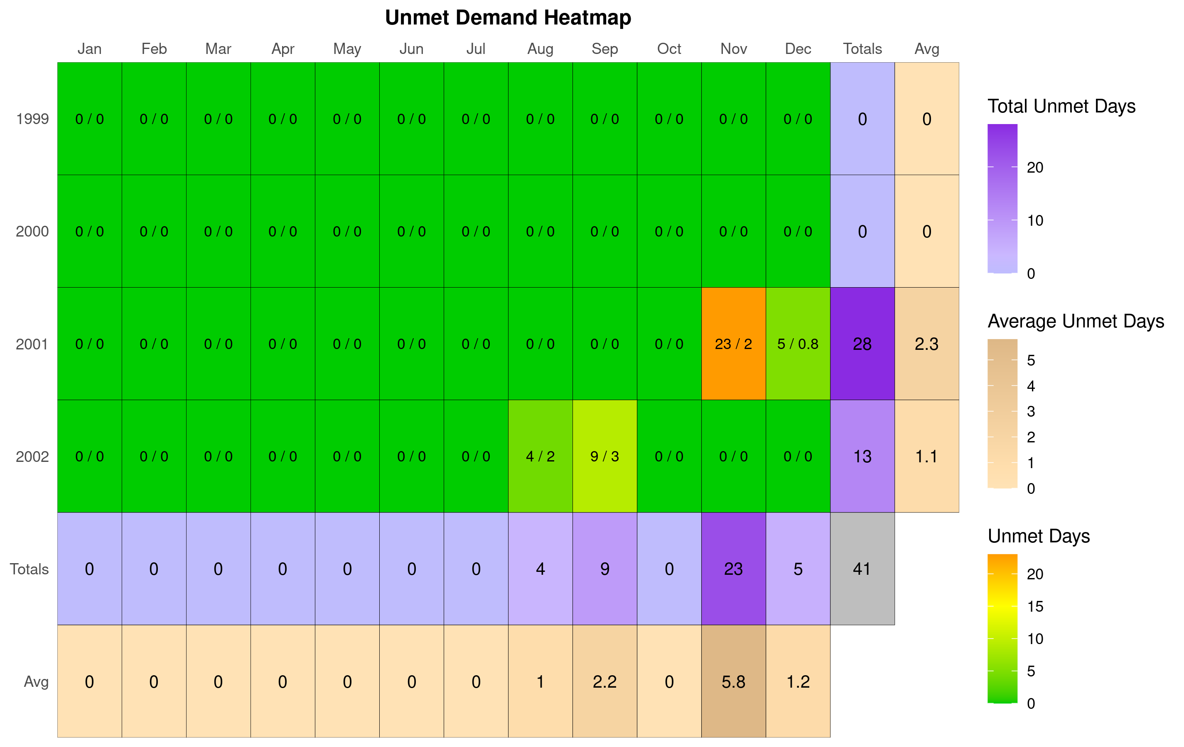

#### Hydrograph: Total Permitted (98-02)

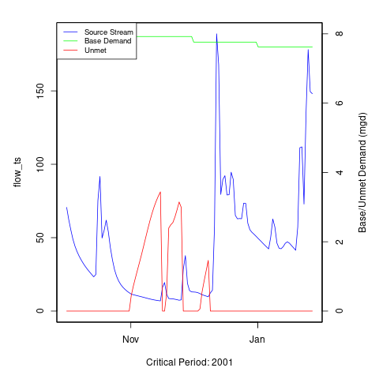 [1] “No local facility impoundment for Total Permitted (98-02)”

#### Heatmap: Total Permitted w/ 90% Flowby (98-02)

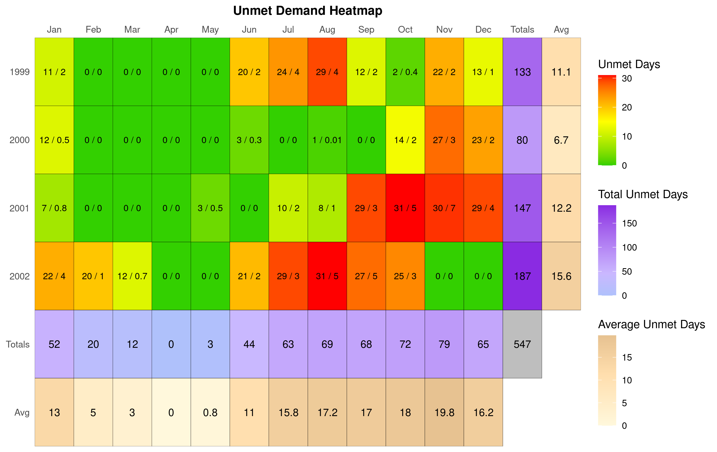

#### Hydrograph: Total Permitted w/ 90% Flowby (98-02)

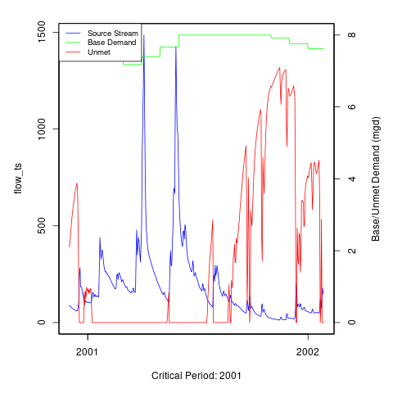 [1] “No local facility impoundment for Total Permitted w/ 90% Flowby (98-02)”

### Additional Model Flow Plots:

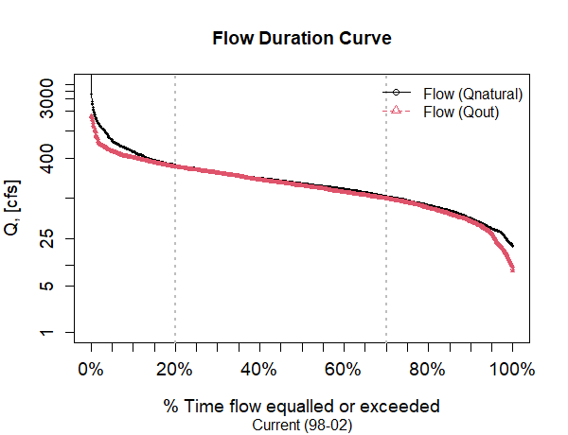

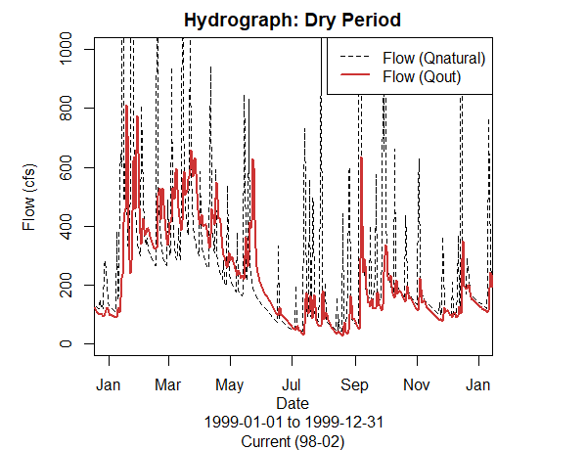

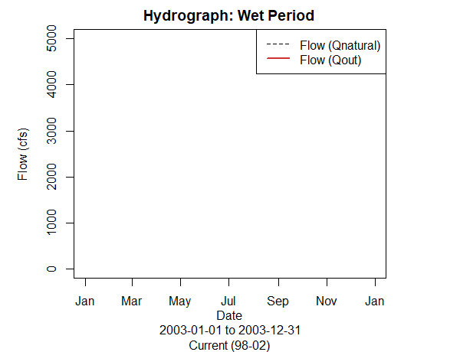

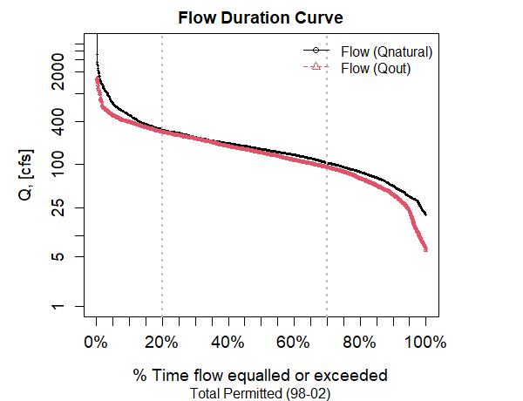

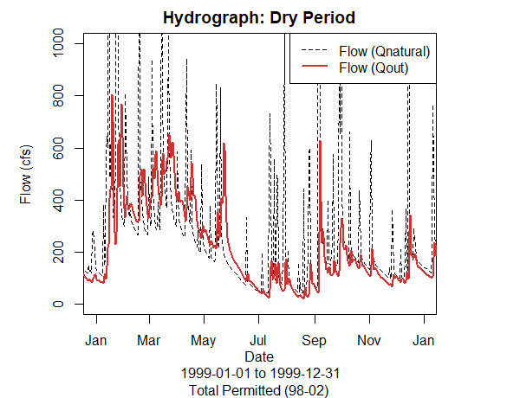

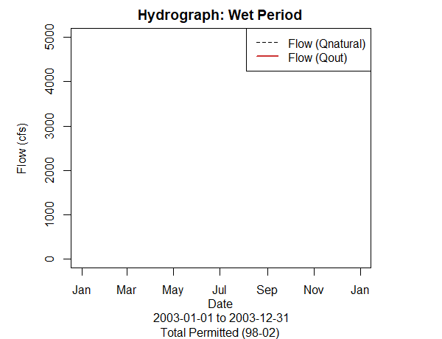

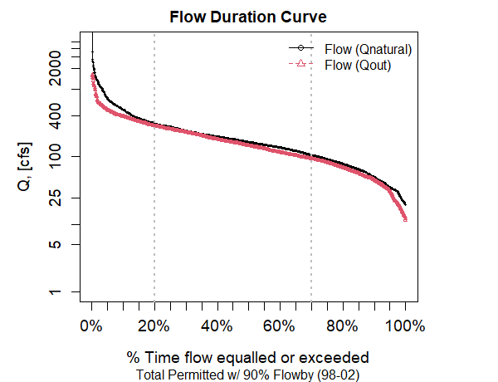

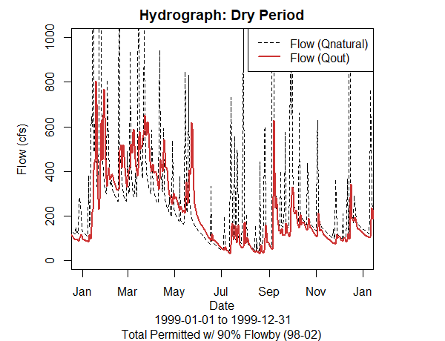

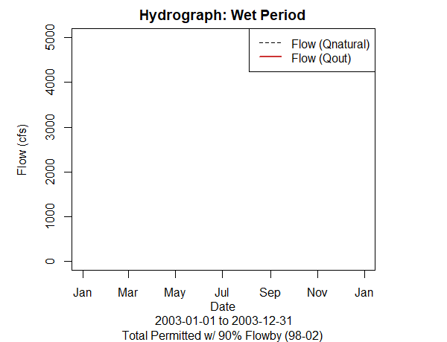

# Appendix A - Ecological Impacts Assessment:

## Elfgen:

In response to a need for better environmental flow metrics, DEQ has developed a new framework for characterizing relations between streamflow and aquatic organism species richness. Part of an evolving approach to managing environmental flows for maintaining aquatic life; this methodology builds on existing minimum instream ow approaches, allowable withdrawals as a percentage of flow, and extensive flow-habitat studies. For the first time this new framework may allow quantification of potential species loss resulting from flow change, and may offer an improved understanding of aquatic life risk variability due to geographic location, stream size and local scale.

This new flow-ecology framework referred to as “elfgen” (*pronounced elf-jen*) derives its name from Ecological Limit Function (ELF) generation (*ELF-gen*). In order to calculate river segment-level richness change, elfgen is first used to produce ELFs, or relations between stream flow and species richness at the HUC 8 scale (See plot below). This is achieved using long term datasets for both ecological and hydrologic data. Ecological data (Fish species richness) is sourced from the VAHydro-EDAS dataset. Hydrologic data (Average Annual Flow) is sourced from the National Hydrography Dataset Plus. The Richness Change values presented in the table below are derived from this flow-ecology relation.

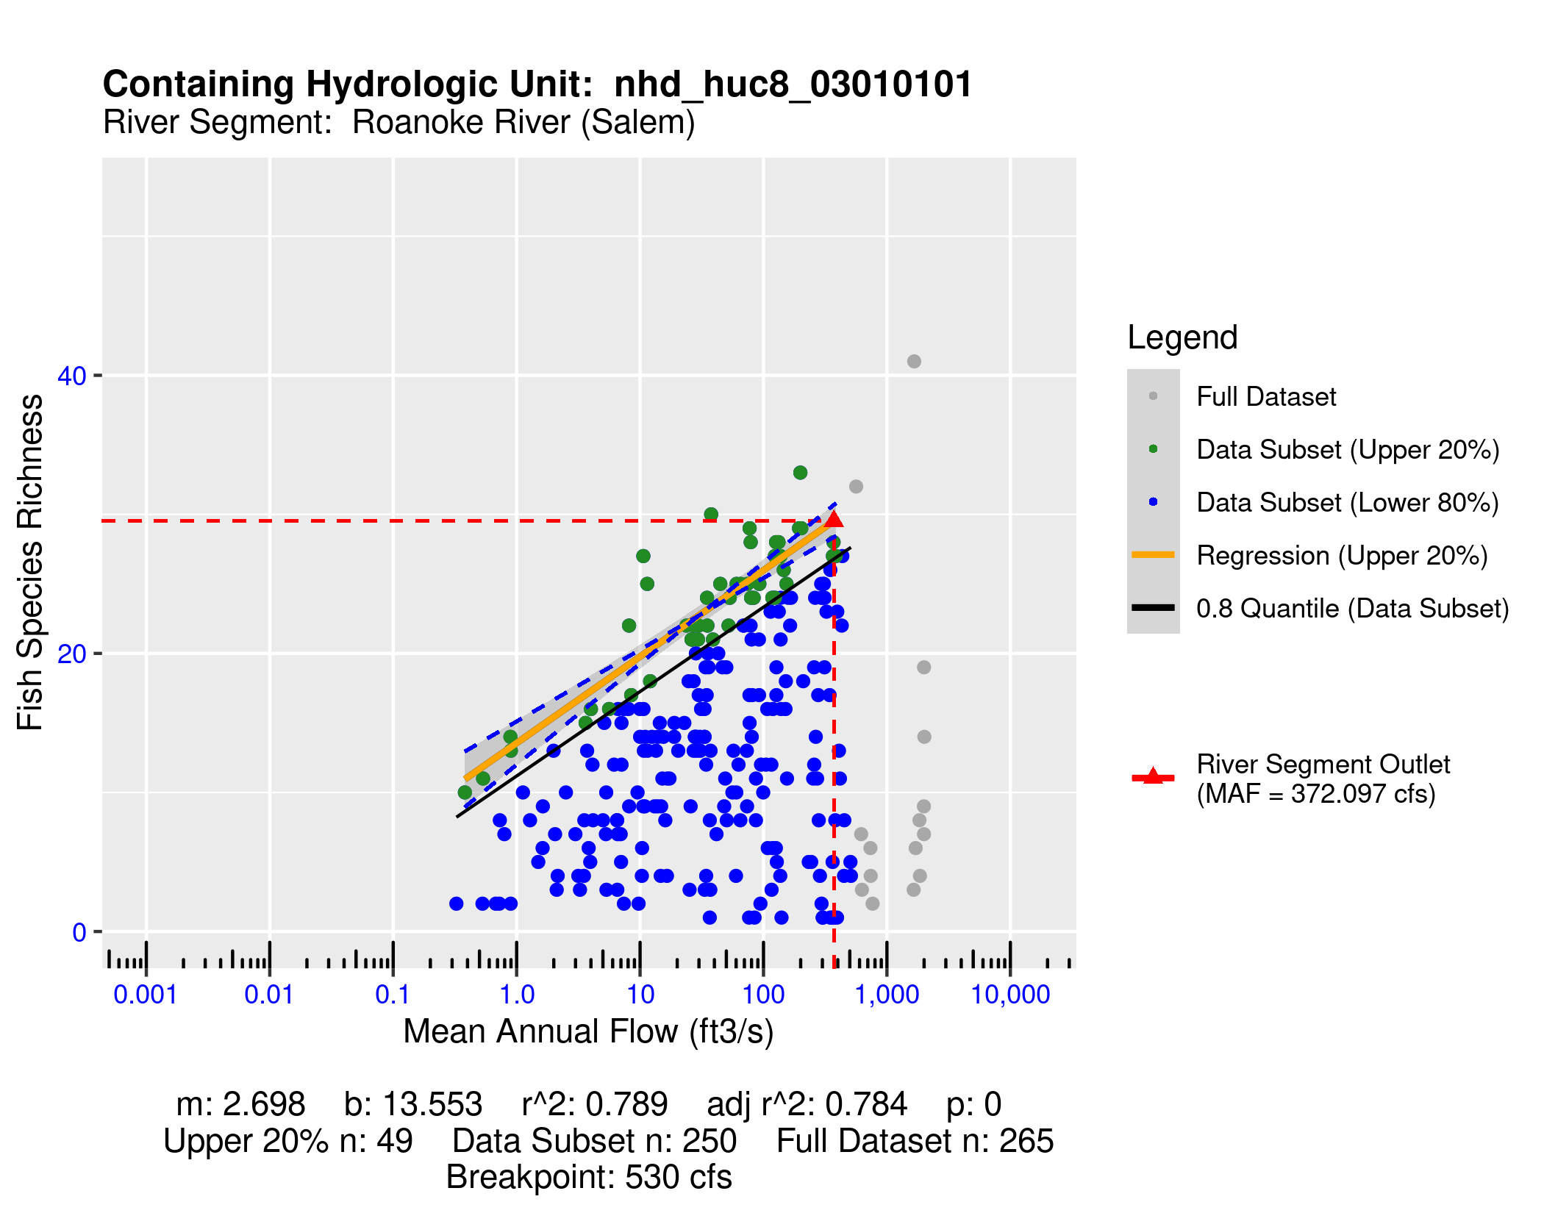

## Richness Change Metric Table:

Estimates for richness change are presented both as an absolute number of species (Richness Change (abs)) and as a percentage of the total number of species present (Richness Change (%)). Richness change calculations are derived from the estimated percent total consumptive use[3]. Note: elfgen methodology only applicable for watersheds < 800 cfs mean annual flow.

| **Description** | **runid_2011** | **runid_4011** | **runid_6011** |
| --- | --- | --- | --- |
| Consumptive Use Fraction | 0.07 | 0.1 | 0.09 |
| Cumulative Withdrawal (MGD) | 9.09 | 13.87 | 12.54 |
| Richness Change (abs) | -0.18 | -0.28 | -0.25 |
| Richness Change (%) | -0.62 | -0.96 | -0.86 |

## Habitat (If Applicable):

# Appendix B - Nearby Users Table:

|  | **Location** | **Sub-Watershed** | **MP Type** | **MP Name** | **MP 5-yr Avg Use (MGY)** | **Facility Name** | **Facility 5-yr Avg Use (MGY)** | **Facility 2040 Use (MGY)** | **runid_6011: base_demand_mgy** |
| --- | --- | --- | --- | --- | --- | --- | --- | --- | --- |
| 1 | Upstream | Roanoke River (Wayside Park) | intake | FROM ROANOKE RIVER | 2,810.41 | SPRING HOLLOW RESERVOIR | 2,810.41 | 0.00 | 2,843.40 |
| 2 | Upstream | Spring Hollow Reservoir, Roanoke River tributary | intake | WD FROM SP HOLLOW RES | 1,726.51 | SPRING HOLLOW WTP | 1,727.21 | 3,183.34 | 1,625.51 |
| 3 | - | Roanoke River (Salem) | intake | ROANOKE RIVER | 1,063.84 | Salem WTP | 1,521.20 | 2,345.65 | 2,829.17 |
| 4 | - | Roanoke River (Salem) | well | WELL #2 | 282.87 | Salem WTP | 1,521.20 | 2,345.65 |  |
| 5 | - | Roanoke River (Salem) | well | WELL #1 | 131.56 | Salem WTP | 1,521.20 | 2,345.65 |  |
| 6 | - | Roanoke River (Salem) | well | WELL #1 | 75.56 | ROANOKE PLANT | 75.56 | 0.00 |  |
| 7 | - | Roanoke River (Salem) | well | WELL #3 | 42.93 | Salem WTP | 1,521.20 | 2,345.65 |  |
| 8 | - | Roanoke River (Salem) | intake | Irrigation Pond | 26.66 | Roanoke Country Club, Inc | 26.66 | 0.00 | 19.92 |
| 9 | - | Roanoke River (Salem) | well | BACK WELL | 23.40 | SALEM PLANT | 23.40 | 0.00 |  |
| 10 | Upstream | North and South Fork (Confluence) Roanoke River | intake | NORTH FORK ROANOKE RIVER | 18.88 | BLACKSBURG COUNTRY CLUB | 18.88 | 0.00 | 15.98 |
| 11 | - | Roanoke River (Salem) | well | #13 WELL | 15.85 | HIDDEN VALLEY COUNTRY CLUB | 15.85 | 26.95 |  |
| 12 | - | Roanoke River (Salem) | intake | IRRIGATION POND | 15.05 | HANGING ROCK GOLF COURSE | 15.05 | 23.62 | 14.96 |
| 13 | Upstream | North and South Fork (Confluence) Roanoke River | intake | SOUTH FORK ROANOKE RIVER #1 | 13.83 | LAVERYs SOD FARM | 29.63 | 36.09 | 1.37 |
| 14 | Upstream | North and South Fork (Confluence) Roanoke River | intake | SOUTH FORK ROANOKE RIVER #1 | 13.83 | LAVERYs SOD FARM | 29.63 | 36.09 | 30.81 |
| 15 | Upstream | South Fork Roanoke River (Headwater) | well | RECOVERY WELL #3 | 6.44 | GW REMEDIATION | 14.20 | 0.00 |  |
| 16 | Upstream | North and South Fork (Confluence) Roanoke River | intake | SOUTH FORK ROANOKE RIVER #2 | 6.32 | LAVERYs SOD FARM | 29.63 | 36.09 | 1.37 |
| 17 | Upstream | North and South Fork (Confluence) Roanoke River | intake | SOUTH FORK ROANOKE RIVER #2 | 6.32 | LAVERYs SOD FARM | 29.63 | 36.09 | 30.81 |
| 18 | Upstream | South Fork Roanoke River (Headwater) | well | RECOVERY WELL #2 | 5.42 | GW REMEDIATION | 14.20 | 0.00 |  |
| 19 | - | Roanoke River (Salem) | well | NORTH LAKES WELL #6 | 5.40 | NORTH LAKES SERVICE AREA | 5.40 | 0.00 |  |
| 20 | Upstream | North and South Fork (Confluence) Roanoke River | intake | SOUTH FORK ROANOKE RIVER #5 | 3.71 | LAVERYs SOD FARM | 29.63 | 36.09 | 1.37 |
| 21 | Upstream | North and South Fork (Confluence) Roanoke River | intake | SOUTH FORK ROANOKE RIVER #5 | 3.71 | LAVERYs SOD FARM | 29.63 | 36.09 | 30.81 |
| 22 | Upstream | South Fork Roanoke River (Headwater) | well | Greear Well | 3.14 | Brann Farms | 4.46 | 0.00 |  |
| 23 | Upstream | North and South Fork (Confluence) Roanoke River | intake | SOUTH FORK ROANOKE RIVER #4 | 2.84 | LAVERYs SOD FARM | 29.63 | 36.09 | 1.37 |
| 24 | Upstream | North and South Fork (Confluence) Roanoke River | intake | SOUTH FORK ROANOKE RIVER #4 | 2.84 | LAVERYs SOD FARM | 29.63 | 36.09 | 30.81 |
| 25 | Upstream | South Fork Roanoke River (Headwater) | well | RECOVERY WELL #1 | 2.34 | GW REMEDIATION | 14.20 | 0.00 |  |
| 26 | Upstream | North and South Fork (Confluence) Roanoke River | intake | NORTH FORK ROANOKE RIVER | 2.29 | LAVERYs SOD FARM | 29.63 | 36.09 | 1.37 |
| 27 | Upstream | North and South Fork (Confluence) Roanoke River | intake | NORTH FORK ROANOKE RIVER | 2.29 | LAVERYs SOD FARM | 29.63 | 36.09 | 30.81 |
| 28 | - | Roanoke River (Salem) | intake | ROANOKE RIVER | 1.71 | GLENVAR PLANT | 1.71 | 8.76 | 4.55 |
| 29 | Upstream | North and South Fork (Confluence) Roanoke River | well | WELL | 1.64 | YAGLE NURSERY INC. | 3.51 | 2.40 |  |
| 30 | Upstream | North and South Fork (Confluence) Roanoke River | intake | SOUTH FORK ROANOKE RIVER | 1.20 | YAGLE NURSERY INC. | 3.51 | 2.40 | 2.02 |
| 31 | Upstream | North and South Fork (Confluence) Roanoke River | intake | SOUTH FORK ROANOKE RIVER | 0.68 | YAGLE NURSERY INC. | 3.51 | 2.40 | 2.02 |
| 32 | - | Roanoke River (Salem) | intake | ROANOKE RIVER | 0.42 | LAVERYs SOD FARM | 29.63 | 36.09 | 1.37 |
| 33 | - | Roanoke River (Salem) | intake | ROANOKE RIVER | 0.42 | LAVERYs SOD FARM | 29.63 | 36.09 | 30.81 |
| 34 | Upstream | North and South Fork (Confluence) Roanoke River | intake | SOUTH FORK ROANOKE RIVER #3 | 0.22 | LAVERYs SOD FARM | 29.63 | 36.09 | 1.37 |
| 35 | Upstream | North and South Fork (Confluence) Roanoke River | intake | SOUTH FORK ROANOKE RIVER #3 | 0.22 | LAVERYs SOD FARM | 29.63 | 36.09 | 30.81 |
| 36 | - | Roanoke River (Salem) | intake | SALEM OLD WTP 1 ROANOKE RIVER | 0.00 | Salem WTP | 1,521.20 | 2,345.65 | 2,829.17 |
| 37 | - | Roanoke River (Salem) | well | WELL #1 BOILER | 0.00 | GLENVAR PLANT | 1.71 | 8.76 |  |
| 38 | - | Roanoke River (Salem) | well | GRISSO WELL - PENN FOREST | 0.00 | PENN FOREST SERVICE AREA | 42.48 | 0.00 |  |
| 39 | - | Roanoke River (Salem) | well | HOMEWOOD WELL #1 | 0.00 | HOMEWOOD SERVICE AREA | 0.00 | 0.00 |  |
| 40 | - | Roanoke River (Salem) | well | WESTERN HILLS WELL | 0.00 | OAK GROVE SERVICE AREA | 0.00 | 0.00 |  |
| 41 | - | Roanoke River (Salem) | well | FARMINGDALE WELL | 0.00 | FARMINGDALE SERVICE AREA | 0.00 | 0.00 |  |
| 42 | - | Roanoke River (Salem) | well | WOODED ACRES WELL | 0.00 | WOODED ACRES SERVICE AREA | 0.00 | 0.00 |  |
| 43 | Upstream | South Fork Roanoke River (Headwater) | well | Greear Well (mp:mp8074) | 0.00 | Brann Farms | 4.46 | 0.00 |  |
| 44 | - | Roanoke River (Salem) | well | ANDREW LEWIS PLACE WELL | 0.00 | ANDREW LEWIS PLACE SERV AREA | 0.00 | 0.00 |  |
| 45 | - | Roanoke River (Salem) | well | HIDDEN VALLEY WELL #9 | 0.00 | HIDDEN VALLEY SERVICE AREA | 0.00 | 0.00 |  |
| 46 | - | Roanoke River (Salem) | well | WYNDALE WELL | 0.00 | OAK GROVE SERVICE AREA | 0.00 | 0.00 |  |
| 47 | - | Roanoke River (Salem) | intake | ROANOKE RIVER | 0.00 | ROANOKE FACILITIES | 0.00 | 0.00 | 0.00 |
| 48 | - | Roanoke River (Salem) | well | BRIDLEWOOD WELL #3 | 0.00 | SOUTH SERVICE AREA | 0.00 | 0.00 |  |
| 49 | - | Roanoke River (Salem) | well | WELL #1 | 0.00 | Emulsion Plant | 0.00 | 0.00 |  |
| 50 | - | Roanoke River (Salem) | intake | ROANOKE RIVER GLENVAR WTP 2 | 0.00 | SALEM GLENVAR WTP 2 | 0.00 | 0.00 | 0.00 |
| 51 | - | Roanoke River (Salem) | well | LONGRIDGE WELL #2 | 0.00 | LONGRIDGE SERVICE AREA | 0.00 | 0.00 |  |
| 52 | - | Roanoke River (Salem) | well | CRESTHILL #1 | 0.00 | OAK GROVE SERVICE AREA | 0.00 | 0.00 |  |
| 53 | Upstream | Roanoke River (Wayside Park) | well | GLEN FOREST WELL | 0.00 | GLEN FOREST SERVICE AREA | 0.00 | 0.00 |  |
| 54 | - | Roanoke River (Salem) | well | WELL #1 | 0.00 | VIRGINIA BAPTIST CHILDREN HOME | 0.00 | 0.00 |  |
| 55 | - | Roanoke River (Salem) | well | CRESTWOOD PARK WELL | 0.00 | CRESTWOOD PARK SERVICE AREA | 0.00 | 0.00 |  |
| 56 | - | Roanoke River (Salem) | well | SOUTHWOODS #2 | 0.00 | OAK GROVE SERVICE AREA | 0.00 | 0.00 |  |
| 57 | - | Roanoke River (Salem) | well | PENN FOREST WELL #1 | 0.00 | PENN FOREST SERVICE AREA | 42.48 | 0.00 |  |
| 58 | Upstream | South Fork Roanoke River (Headwater) | intake | Pond | 0.00 | Auburn Hills Golf Club | 0.00 | 0.00 |  |
| 59 | Upstream | Roanoke River (Wayside Park) | well | CAMPBELL HILLS WELL #2 | 0.00 | CAMPBELL HILLS | 0.00 | 0.00 |  |
| 60 | Upstream | Roanoke River (Wayside Park) | well | CAMPBELL HILLS WELL #3 | 0.00 | CAMPBELL HILLS | 0.00 | 0.00 |  |
| 61 | - | Roanoke River (Salem) | well | CHEROKEE HILLS WELL #1 | 0.00 | CHEROKEE HILLS | 0.00 | 0.00 |  |
| 62 | - | Roanoke River (Salem) | well | CHEROKEE HILLS WELL #4 | 0.00 | CHEROKEE HILLS | 0.00 | 0.00 |  |
| 63 | - | Roanoke River (Salem) | well | LAYMAN LAWN WELL #1 | 0.00 | LAYMAN LAWN SERVICE AREA | 0.00 | 0.00 |  |
| 64 | - | Roanoke River (Salem) | well | NORTH LAKES WELL #2 | 0.00 | NORTH LAKES SERVICE AREA | 5.40 | 0.00 |  |
| 65 | - | Roanoke River (Salem) | well | NORTH LAKES WELL #4 | 0.00 | NORTH LAKES SERVICE AREA | 5.40 | 0.00 |  |
| 66 | - | Roanoke River (Salem) | well | GREEN HAVEN HILLS WELL | 0.00 | GREEN HAVEN HILLS SERVICE AREA | 0.00 | 0.00 |  |
| 67 | - | Roanoke River (Salem) | well | OAK GROVE WELL | 0.00 | OAK GROVE SERVICE AREA | 0.00 | 0.00 |  |
| 68 | - | Roanoke River (Salem) | well | HIGHFIELDS WELL #2 | 0.00 | HIGHFIELDS SERVICE AREA | 0.00 | 0.00 |  |
| 69 | - | Roanoke River (Salem) | well | HIGHFIELDS WELL #1 | 0.00 | HIGHFIELDS SERVICE AREA | 0.00 | 0.00 |  |
| 70 | - | Roanoke River (Salem) | well | NORTH LAKES WELL #3 | 0.00 | NORTH LAKES SERVICE AREA | 5.40 | 0.00 |  |
| 71 | - | Roanoke River (Salem) | well | FRONT WELL | 0.00 | SALEM PLANT | 23.40 | 0.00 |  |
| 72 | - | Roanoke River (Salem) | well | SOUTHWOODS #1 | 0.00 | OAK GROVE SERVICE AREA | 0.00 | 0.00 |  |
| 73 | - | Roanoke River (Salem) | well | BELLE MEADE WELL | 0.00 | BELLE MEADE SERVICE AREA | 0.00 | 0.00 |  |
| 74 | - | Roanoke River (Salem) | well | CHESTERFIELD COURT WELL | 0.00 | CHESTERFIELD CT SERVICE AREA | 0.00 | 0.00 |  |
| 75 | - | Roanoke River (Salem) | well | ARLINGTON HILLS WELL #3 | 0.00 | PENN FOREST SERVICE AREA | 42.48 | 0.00 |  |
| 76 | - | Roanoke River (Salem) | well | NORTH LAKES WELL #1 | 0.00 | NORTH LAKES SERVICE AREA | 5.40 | 0.00 |  |
| 77 | - | Roanoke River (Salem) | well | LONGRIDGE WELL #1 | 0.00 | LONGRIDGE SERVICE AREA | 0.00 | 0.00 |  |
| 78 | - | Roanoke River (Salem) | well | CASTLE ROCK WELL #1 | 0.00 | CASTLE ROCK SERVICE AREA | 0.00 | 0.00 |  |

1. [Chesapeake Bay Program Phase 6 Model](https://www.chesapeakebay.net/documents/Phase_6_Modeling_Tools_1-page_factsheet_12-18-17.pdf).
2. [Virginia Drought Assessment and Response Plan](https://www.deq.virginia.gov/home/showpublisheddocument/5115/637490843054630000), developed by the Drought Response Technical Advisory Committee in response to Executive Order #39, March 28, 2003.
3. Kleiner et al: <https://onlinelibrary.wiley.com/doi/full/10.1111/1752-1688.12876> & Rapp et al: <https://onlinelibrary.wiley.com/doi/full/10.1111/1752-1688.12877>