USGS Gage vs VAHydro Model

02/02/2023

# Appendix X - Model Calibration Analysis:

## Flow Duration Curve Plot:

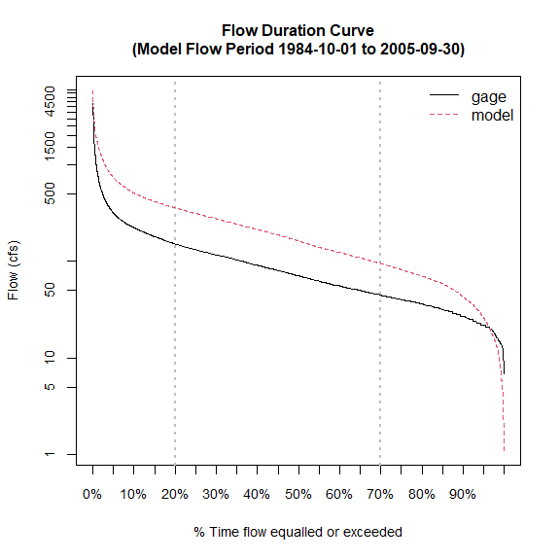

## Scatter Plot USGS vs. Model

## Warning in merge.zoo(x, y, all = FALSE): Index vectors are of  
## different classes: Date POSIXct

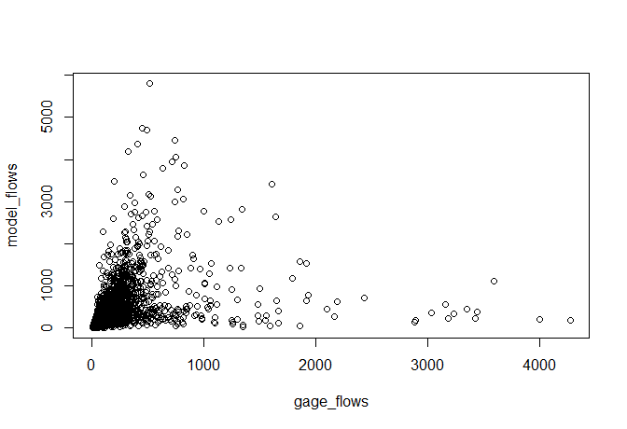

## L90 Model Performance Bar Plot:

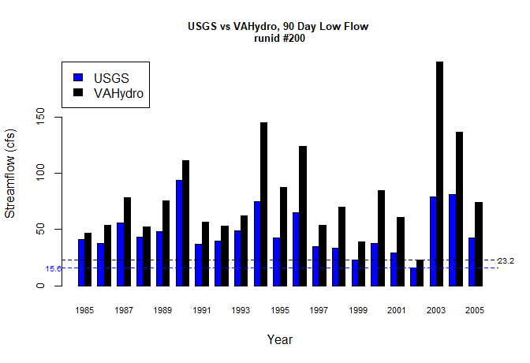

## L30 Model Performance Bar Plot:

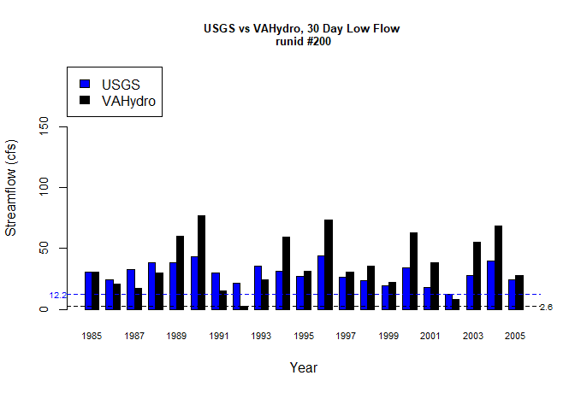

## L7 Model Performance Bar Plot:

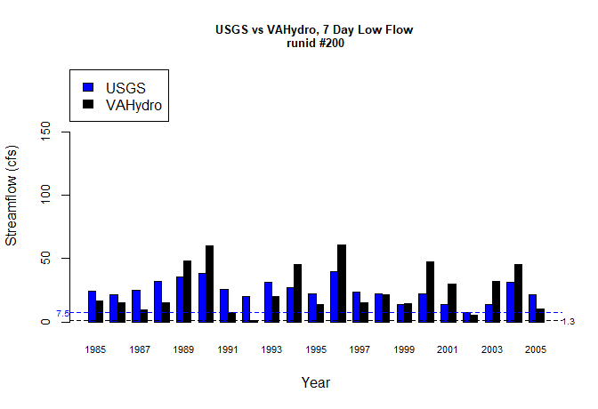

## L1 Model Performance Bar Plot:

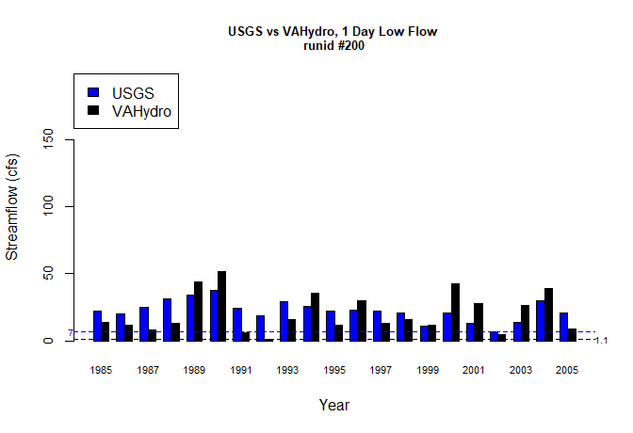

## Model Performance Scatterplots:

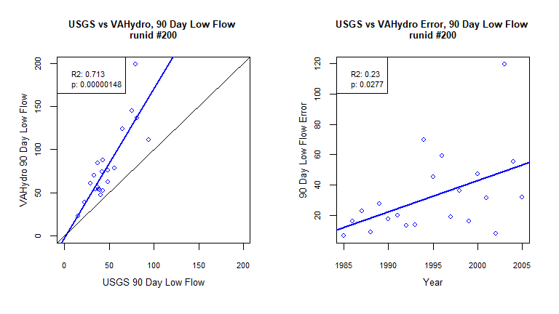

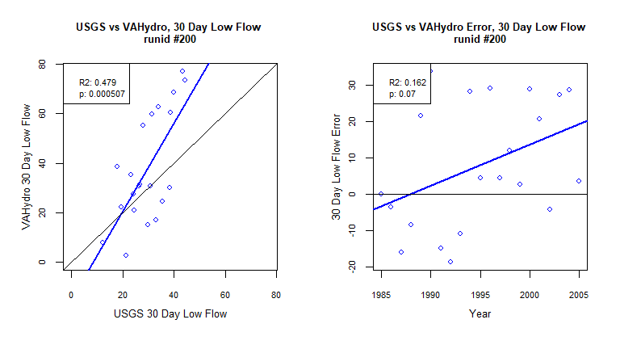

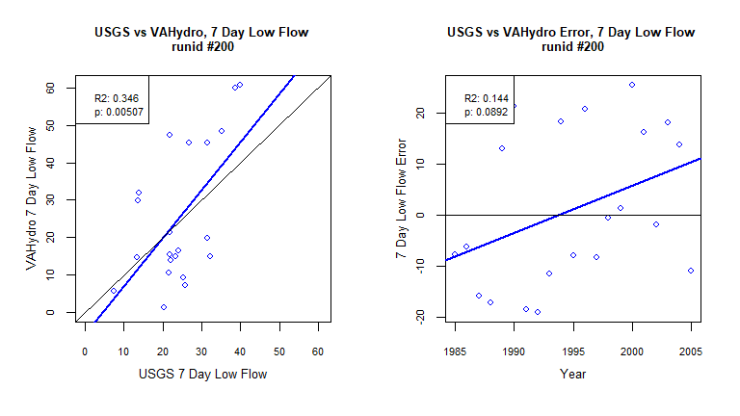

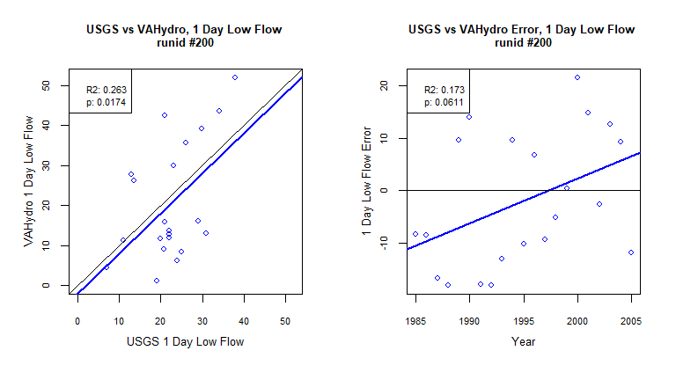

## Metrics Table:

| stat | gage | gage_year | model | model_year |
| --- | --- | --- | --- | --- |
| l90 | 15.62 | 2002 | 23.22 | 2002 |
| l30 | 12.23 | 2002 | 2.59 | 1992 |
| l7 | 7.52 | 2002 | 1.3 | 1992 |
| l1 | 6.95 | 2002 | 1.11 | 1992 |