USGS Gage vs VAHydro Model

02/02/2023

# Appendix X - Model Calibration Analysis:

The following plots provide a comparison of VAHydro model performance for the model segment above the Salem WTP (Roanoke River (Wayside Park)) compared against historic streamflow recorded that USGS 02054530 ROANOKE RIVER AT GLENVAR, VA. This analysis provides additional context to overall model performance.

## Flow Duration Curve Plot:

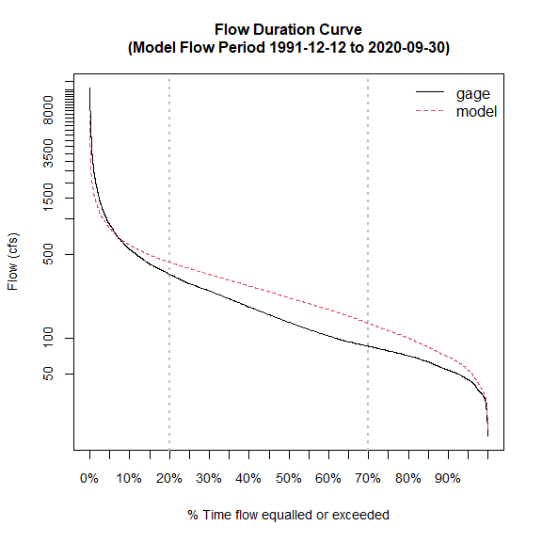

## Scatter Plot USGS vs. Model

## Warning in merge.zoo(x, y, all = FALSE): Index vectors are of  
## different classes: Date POSIXct

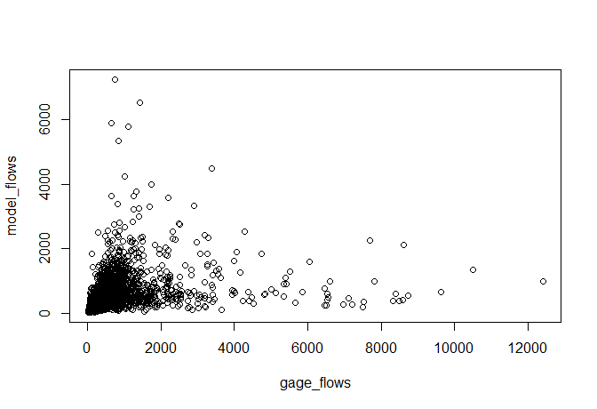

## L90 Model Performance Bar Plot:

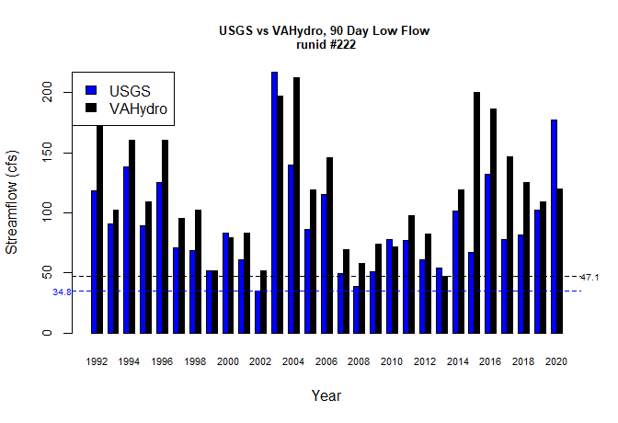

## L30 Model Performance Bar Plot:

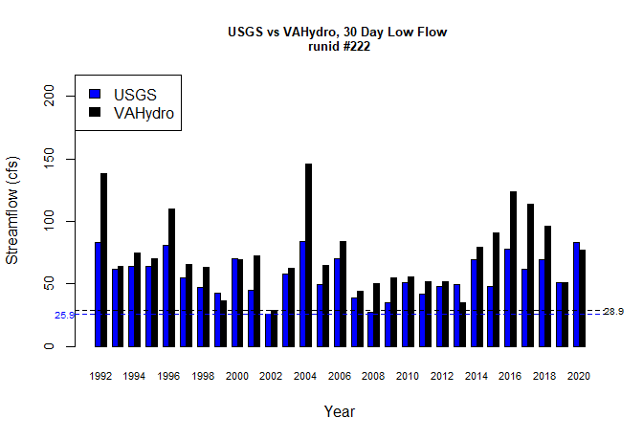

## L7 Model Performance Bar Plot:

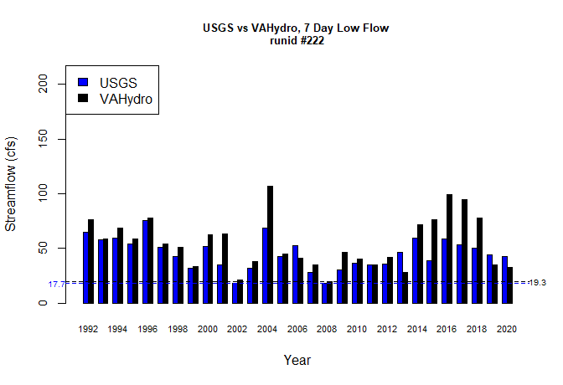

## L1 Model Performance Bar Plot:

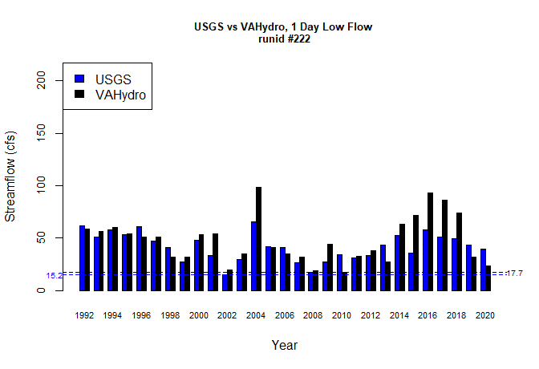

## Model Performance Scatterplots:

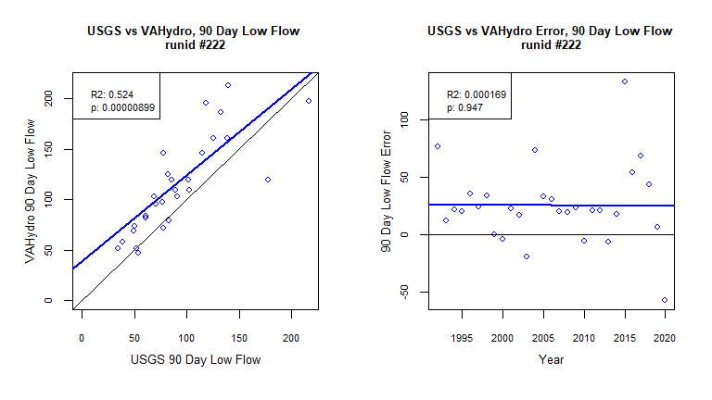

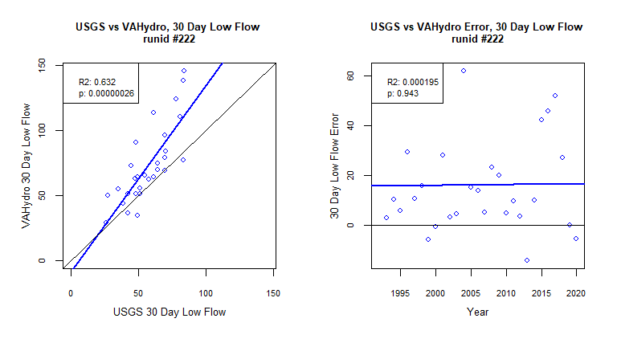

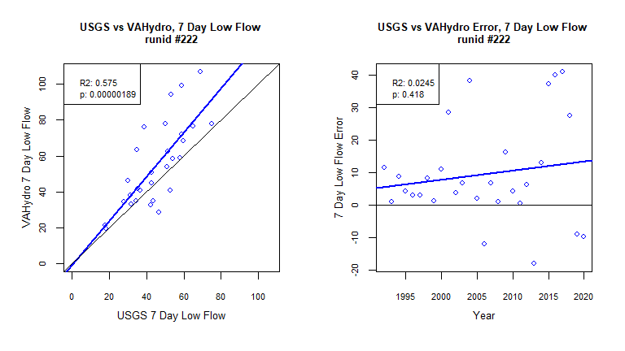

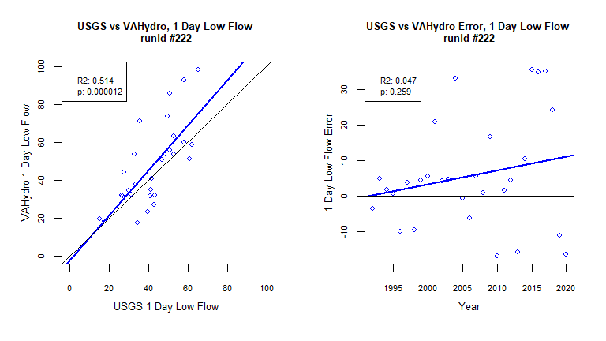

## Metrics Table:

| stat | gage | gage_year | model | model_year |
| --- | --- | --- | --- | --- |
| l90 | 34.84 | 2002 | 47.07 | 2013 |
| l30 | 25.88 | 2002 | 28.89 | 2002 |
| l7 | 17.71 | 2002 | 19.29 | 2008 |
| l1 | 15.2 | 2002 | 17.65 | 2010 |