USGS Gage vs VAHydro Model

01/27/2023

# Appendix X - Model Calibration Plots:

## L90 Model Performance Bar Plot:

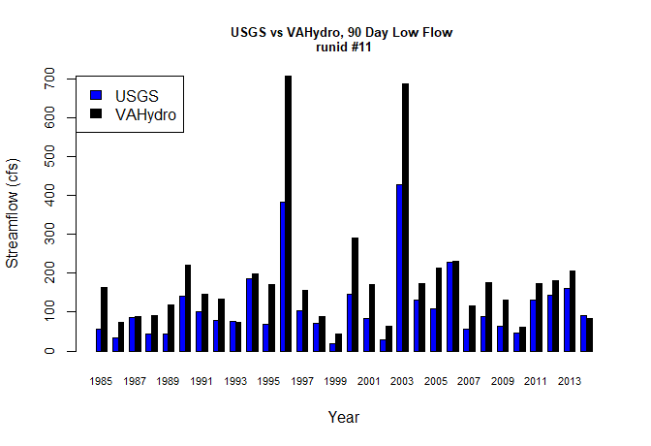

## L30 Model Performance Bar Plot:

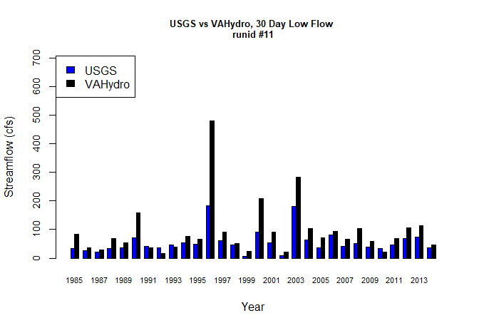

## L7 Model Performance Bar Plot:

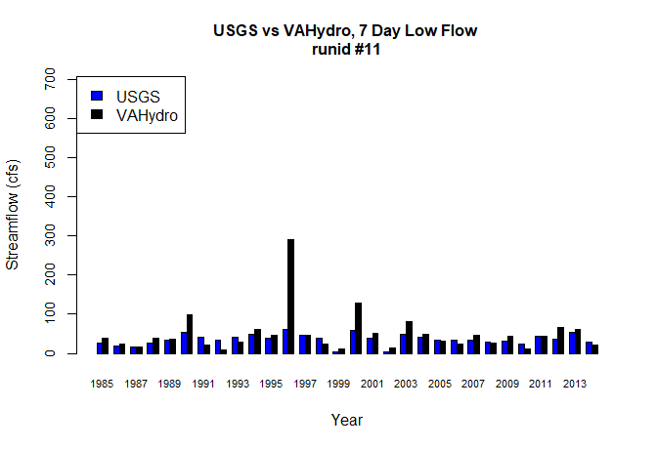

## L1 Model Performance Bar Plot:

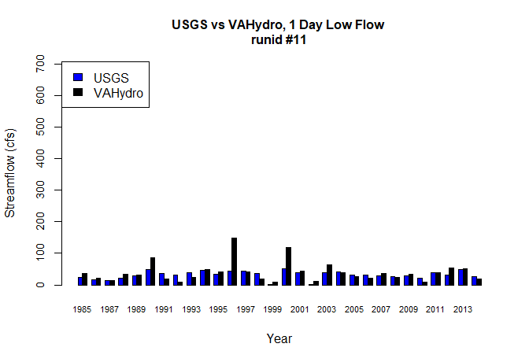

## Model Performance Scatterplots:

