VWP 17-0513: Town of Broadway, North Fork Shenandoah River

01/23/2023

# Project Introduction

Introduction to facility and intake information (non-model specific).

## Location Map

*No location map available for this facility model*

# Model Overview and Scenario Descriptions

**River Model Description** Watershed/river-segment model overview. Descriptive information about the model location, reach length, whether or not it has an impoundment, and how these are represented in the model.

**Facility & Intake Model Description** The town of Broadway operates an intake on the North Fork Shenandoah river. The NF Shenandoah intake is a short distance upstream of the confluence with Linville Creek, therefore, flow-bys are modeled as including the flow from Linville Creek, thereby increasing the available water for the town’s withdrawal (total drainage area of 231 sq.mi.). The treated wastewater discharge is located between 3.5-4.0 miles downstream of the intake (at 291 sq.mi. drainage), and returns treated effluent into the North Fork Shenandoah River. Therefore, a proposed flowby of 25% at the confluence with Linville Creek would equate to approximately 20% flowby at the discharge return point. Other notable withdrawals also exist in between the Town of Broadway withdrawal and discharge return, including the Food Processors Co-Op withdrawal which ranges between 1.0-1.3 mgd during low-flow periods. Combined flow reductions from these withdrawals amounts to approximately 19% of the 7Q10, 18% of the 30-day low flow, and 8% of the 90-day low flow at the Mount Jackson stream gage, approximately 299 square miles drainage area.

The following model scenarios were simulated in order to determine the most effective means of meeting the project need and all other in-stream beneficial uses:

* **runid_11** - Run report information not provided.
* **runid_400** - Run report information not provided.
* **Proposed permit conditions with 75% flowby** (Permit Max w/PoF 75%) - Details about this scenario to be used in the introduction to scenario analyses (but this is *not* the scenario analyses, that happens in scenario_analysis).

## Table of Modeled Demand Limits:

| **Description** | **runid_11** | **runid_400** | **Permit Max w/PoF 75%** |
| --- | --- | --- | --- |
| Average Daily Volume (MGD) | Need to add runid mapping to om_demand_table() | 0.82 | 0.82 |
| Peak Day Volume (MGD) | Need to add runid mapping to om_demand_table() | 1.40 | 1.40 |
| Maximum Annual Volume (MG) | Need to add runid mapping to om_demand_table() | 300.00 | 300.00 |

**Historical Intake Flows and Drought Flow Indicators**

The VAHydro model is used to estimate flows at the project intake, including the impact of all cumulative withdrawals and discharges upstream of the intake location and are presented in Table 1. The Virginia Drought Assessment and Response Plan[1] employs non-exceedance flow percentiles as indicators of drought conditions at particular stream-gaging stations used to monitor drought conditions. Representative daily streamflows above the 25th percentile for return flow frequency represent normal conditions with respect to drought. Representative daily streamflows between the 10th and 25th percentiles represent drought watch conditions. Representative daily streamflows between the 5th and 10th percentiles represent drought warning conditions. Representative daily streamflows below the 5th percentile indicate drought emergency conditions.

| **Month** | **Min** | **5%** | **10%** | **25%** | **30%** | **50%** | **Mean** |
| --- | --- | --- | --- | --- | --- | --- | --- |
| Jan | 39 | 64 | 90 | 145 | 162 | 216 | 314 |
| Feb | 20 | 88 | 113 | 178 | 192 | 241 | 346 |
| Mar | 18 | 88 | 118 | 187 | 204 | 284 | 423 |
| Apr | 43 | 78 | 101 | 161 | 176 | 234 | 358 |
| May | 39 | 66 | 86 | 130 | 145 | 209 | 302 |
| Jun | 18 | 32 | 42 | 61 | 69 | 112 | 208 |
| Jul | 10 | 23 | 28 | 42 | 46 | 68 | 113 |
| Aug | 7 | 19 | 25 | 37 | 43 | 58 | 104 |
| Sep | 9 | 17 | 22 | 34 | 38 | 53 | 205 |
| Oct | 10 | 17 | 23 | 40 | 44 | 87 | 171 |
| Nov | 8 | 19 | 32 | 61 | 73 | 120 | 243 |
| Dec | 10 | 53 | 64 | 122 | 140 | 213 | 302 |

**Table 1:** Modeled monthly current flow statistics for North Fork Shenandoah in cubic feet per second (cfs). Columns show the minimum (Min) and average (Mean) modeled flow, and a range of non-exceedance flow percentiles, that is, the percent of flows that do *not* exceed the given value. For example, the “10%” states that only 10% of flows in the given month are expected to be less than the indicated value, and therefore, 90% of the flows in that month are expected to be greater than the given value. For example, in the table below the 10% column states that 10% of flows within the month of January would be less than 90 cfs.

## Current Facility Base Demand Before Conservation:

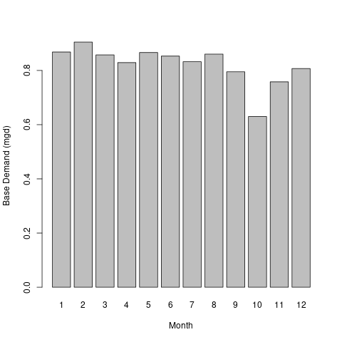

# Results

## Summary

Presented below are 3 scenarios to examine the alternatives for this permit re-issuance. A summary of how permit rules affect available water for this permit, and how this operation may impact instream beneficial uses, and other downstream water withdrawals is presented.

* **runid_11** - Run analysis not provided.
* **runid_400** - Run analysis not provided.
* **Proposed permit conditions with 75% flowby** - The 75% flow-by, with allowance for flows that enter the North Fork Shenandoah from Linville Creek downstream of the intake, results in the full permitted pumping amount during all conditions. While the flow-by was low enough to meet the simulated demands during the most extreme drought simulated without any drought reductions, given the cumulative reduction of flow in the entire river segment above the Broadway STP return flow exceeds 10% under drought warning conditions (10% non-exceedance flow), and exceeds 30% during the most severe drought in the simulation period (see table 3.2.1 columns that show consumptive use percent at “10%” “5%” and “Min” flows), even after considering the additional inflows below the town of Broadway intakes.

| Month | Min | 5% | 10% | 25% | 30% | 50% | Mean |
| --- | --- | --- | --- | --- | --- | --- | --- |
| Jan (Jan%) | 59.8 (-5%) | 105.3 (-2.9%) | 156.6 (-2%) | 262 (-1.2%) | 292.2 (-1.1%) | 391.3 (-0.8%) | 573.7 (-1%) |
| Feb (Feb%) | 34 (-8.7%) | 153.1 (-2.1%) | 202.8 (-1.6%) | 321.6 (-1%) | 352.1 (-0.9%) | 441.9 (-0.7%) | 641.1 (-0.9%) |
| Mar (Mar%) | 29.6 (-9.6%) | 151.8 (-2%) | 206.2 (-1.5%) | 334.7 (-0.9%) | 364 (-0.9%) | 509.2 (-0.6%) | 756.8 (-0.8%) |
| Apr (Apr%) | 80.4 (-3.8%) | 143.8 (-2.2%) | 184.5 (-1.7%) | 289.9 (-1.1%) | 319.1 (-1%) | 424.5 (-0.7%) | 651.2 (-0.9%) |
| May (May%) | 77.2 (-4.1%) | 138.4 (-2.3%) | 171.3 (-1.9%) | 244.6 (-1.3%) | 271.6 (-1.2%) | 392.1 (-0.8%) | 564 (-1%) |
| Jun (Jun%) | 27.5 (-11.6%) | 63.8 (-5.3%) | 87.2 (-4%) | 132.7 (-2.6%) | 149.5 (-2.4%) | 225.8 (-1.6%) | 398.2 (-2%) |
| Jul (Jul%) | 12.6 (-23.2%) | 39 (-8.9%) | 48.6 (-7.3%) | 80 (-4.5%) | 90.1 (-4.1%) | 140.6 (-2.6%) | 216.6 (-3.5%) |
| Aug (Aug%) | 7.3 (-33.9%) | 29.3 (-11.3%) | 39.9 (-8.6%) | 68.8 (-5.1%) | 79.2 (-4.5%) | 115.2 (-3.1%) | 199 (-4.2%) |
| Sep (Sep%) | 8.5 (-28.2%) | 22.5 (-12.9%) | 29.8 (-10%) | 52.4 (-6%) | 58 (-5.4%) | 98.5 (-3.3%) | 375.4 (-4.3%) |
| Oct (Oct%) | 10.9 (-21.3%) | 21.5 (-12%) | 35.6 (-7.6%) | 65.3 (-4.3%) | 77.7 (-3.6%) | 155.5 (-1.9%) | 314.9 (-3.2%) |
| Nov (Nov%) | 7.3 (-28.7%) | 29.2 (-9.2%) | 59.7 (-4.7%) | 105.4 (-2.7%) | 127.6 (-2.3%) | 220.2 (-1.3%) | 437.2 (-2.5%) |
| Dec (Dec%) | 10.4 (-22.5%) | 78.4 (-3.7%) | 108.6 (-2.7%) | 214.8 (-1.4%) | 246.6 (-1.2%) | 387.7 (-0.8%) | 556.8 (-1.3%) |

**Table 3.2.1** Cumulative flow reductions simulated in the North Fork Shenandoah River above the Mount Jackson USGS flow gage, prior to the return of treated effluent from the Broadway Regional WWTP.

## Conclusion

* **Proposed permit conditions with 75% flowby** - If this scenario is the preferred scenario, add remarks here for inclusion in final analysis.

## Facility Base Demand Before Conservation: Proposed permit conditions with 75% flowby



## Detailed Cumulative Impact Analysis

The following “Summary of Results” table summarizes the cumulative impacts to flows, aquatic life, and off-stream demand for the project. The section entitled “River Segment Model Statistics” contains mean flows (Flow Out), and drought flows (30 and 90 Day Low Flow), as well as an estimated Consumptive Use Fraction (See description below) as a result of all withdrawals (Cumulative Withdrawal) and discharges (Cumulative Point Source) in the watershed. Minimum Days of Storage Remaining describes the number of days of remaining storage available during the driest period of the model simulation (applicable to impoundment models only). Total Number of Days with Storage < 50% describes the number of days in the simulation in which reservoir levels fall below 50% of full storage. The section entitled “Facility Model Statistics” shows the withdrawals, return flows (Point Source), and the model estimate for potential unmet demand due to demands exceeding the allowable withdrawal at the intake based on the cumulative conditions in the watershed and the flow-by rules in effect. There will be one or more columns in this table representing each scenario considered for this analysis.

### Summary of Results:

| **Description** | **runid_11** | **runid_400** | **Permit Max w/PoF 75%** |
| --- | --- | --- | --- |
| River Segment Model Statistics: | NF Shenandoah River @ Mount Jackson | NF Shenandoah River @ Mount Jackson | NF Shenandoah River @ Mount Jackson |
| Flow Out (cfs) - (i.e mean flow) | 533.39 | 472.6 | 472.6 |
| Minimum Days of Storage Remaining | NA | NA | NA |
| 30 Day Low Flow (cfs) (i.e drought flow) | 15.86 | 14.29 | 14.29 |
| 90 Day Low Flow (cfs) (i.e drought flow) | 43.12 | 38.41 | 38.41 |
| Consumptive Use Fraction | 0 | 0.01 | 0.01 |
| Cumulative Withdrawal (MGD) | 1.48 | 2.12 | 2.12 |
| Cumulative Point Source (MGD) | 0 | 0 | 0 |
| Withdrawal (MGD) | 1.48 | 2.12 | 2.12 |
| Point Source (MGD) | 0 | 0 | 0 |
| Facility Model Statistics: | BROADWAY WTP:NF Shenandoah River @ Mount Jackson | BROADWAY WTP:NF Shenandoah River @ Mount Jackson | BROADWAY WTP:NF Shenandoah River @ Mount Jackson |
| Base Demand (MGY) | NA | 299.77 | 299.77 |
| Withdrawal (MGY) | NA | 299.77 | 299.77 |
| Unmet Demand (MGY) | NA | 0 | 0 |
| Requested Demand (MGD) | NA | 0.82 | 0.82 |
| Withdrawal Met (MGD) | 0.25 | 0.82 | 0.82 |
| Point Source (MGD) | 0.24 | 0.71 | 0.71 |
| Groundwater Demand (MGD) | 0.03 | 0 | 0 |
| Maximum 30 day potential unmet demand (MGD) | 0 | 0 | 0 |

### Analysis of Reservoir Storage:

The following reservoir storage plots depict changes in reservoir storage under each scenario (indicated in black), as well as simulated inflow to the reservoir (blue), simulated outflow from the reservoir (green), and system demand for the given scenario (red). For water supply reservoirs, a minimum of 60 days of remaining storage over the course of the simulation is recommended. System demand varies seasonally.

[1] “No active impoundment found for run id runid_11” [1] “No active impoundment found for run id runid_400” [1] “No active impoundment found for run id runid_600”

### Analysis of Potential Unmet Demand at the River Intake:

Heatmaps are data plotting tools that help visualize data as magnitudes of color intensity. The following heatmaps depict the number of days with unmet demands for each month of the simulation (due to demands exceeding allowable withdrawal at the intake based on the cumulative conditions in the watershed and the flow-by rules in effect). The heatmap cells show the amount of unmet demand for each month [Number of Unmet Days & Amount (MGD)]. Hydrographs are shown for the period of the simulation with greatest unmet demand.

#### Heatmap: runid_11

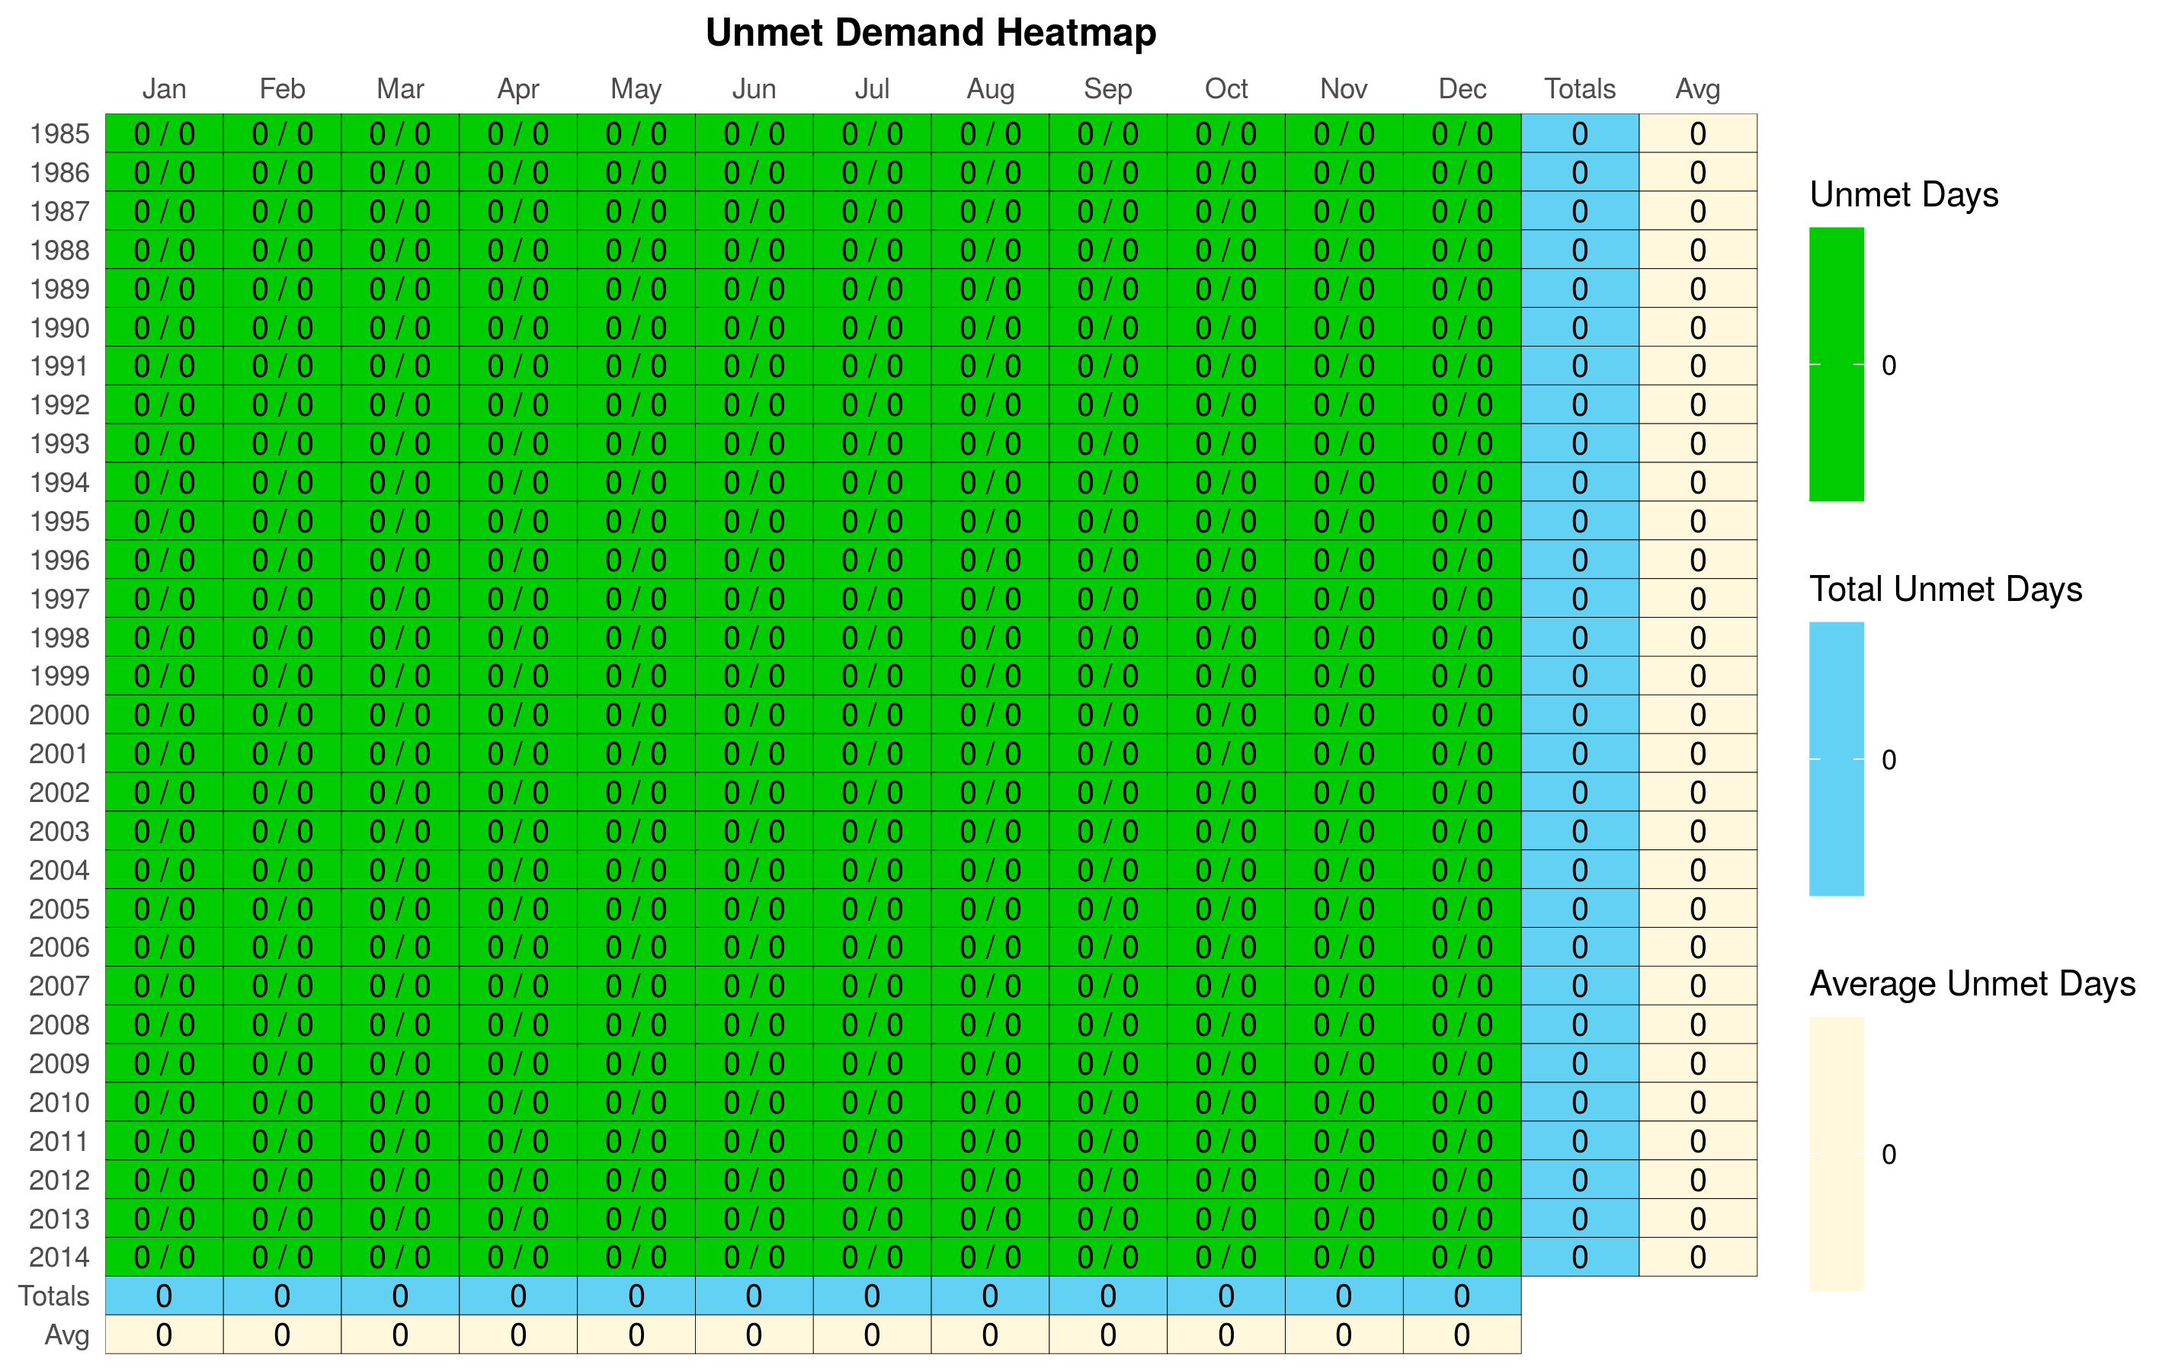

#### Hydrograph: runid_11

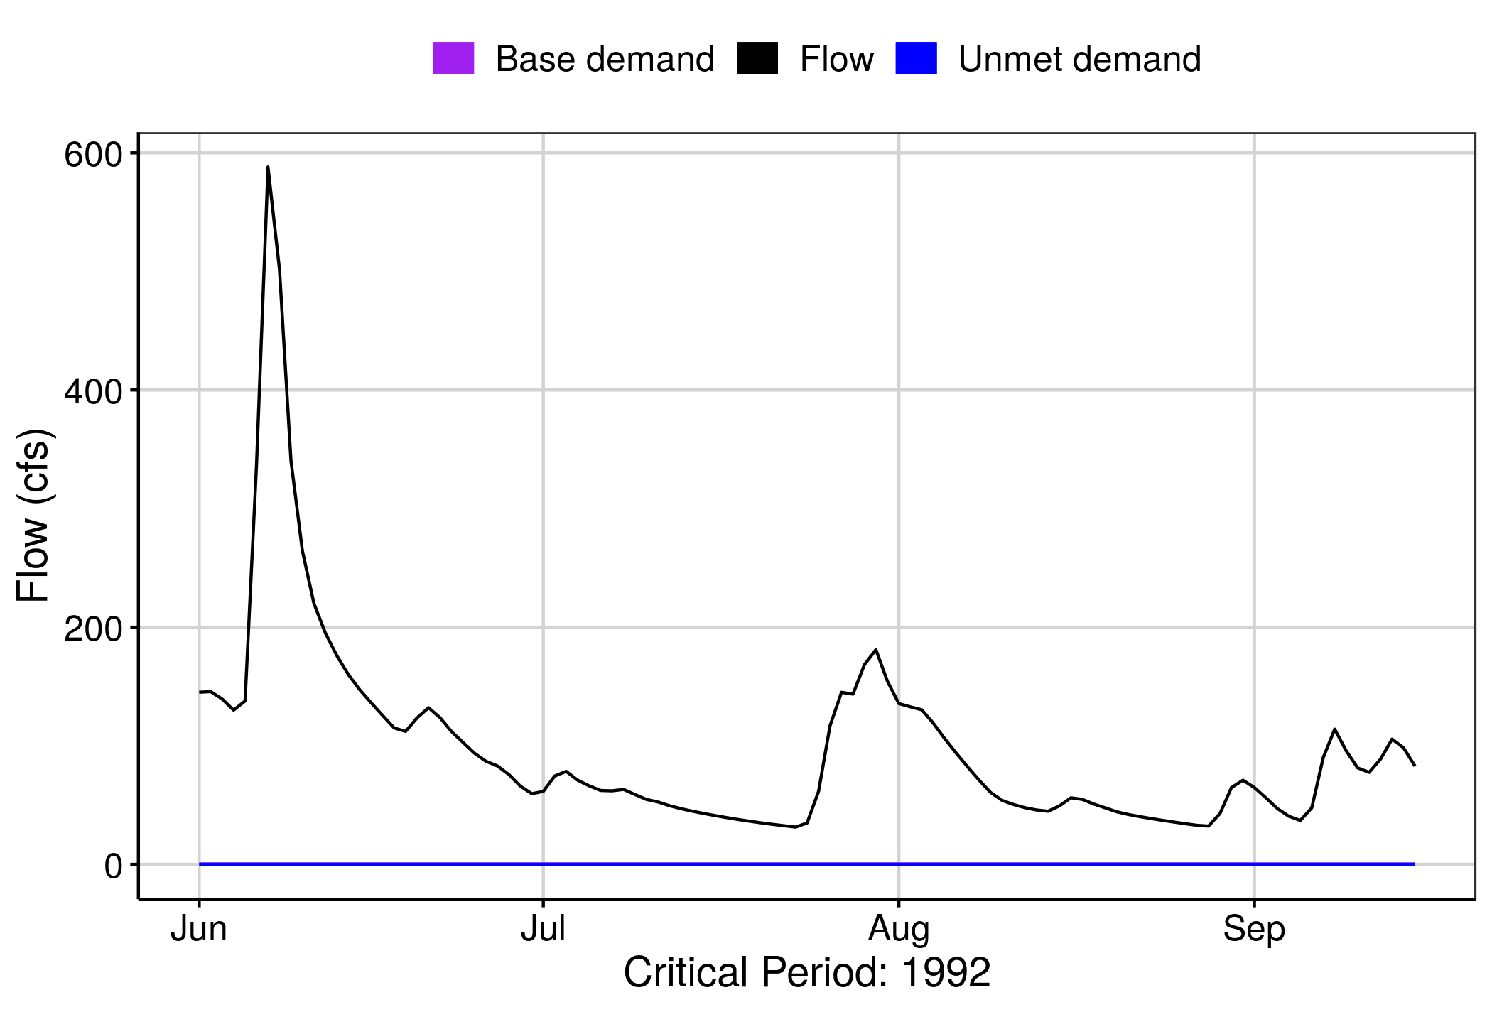 [1] “No local facility impoundment for runid_11”

#### Heatmap: runid_400

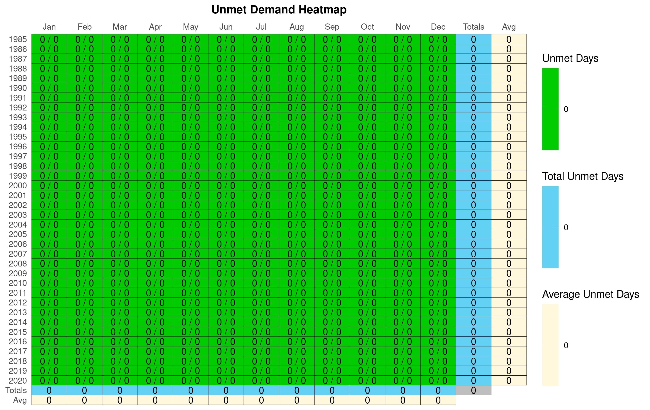

#### Hydrograph: runid_400

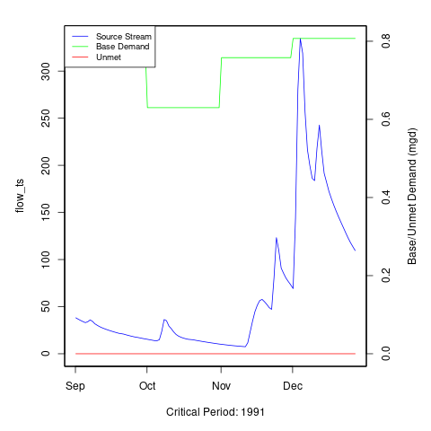 [1] “No local facility impoundment for runid_400”

#### Heatmap: Permit Max w/PoF 75%

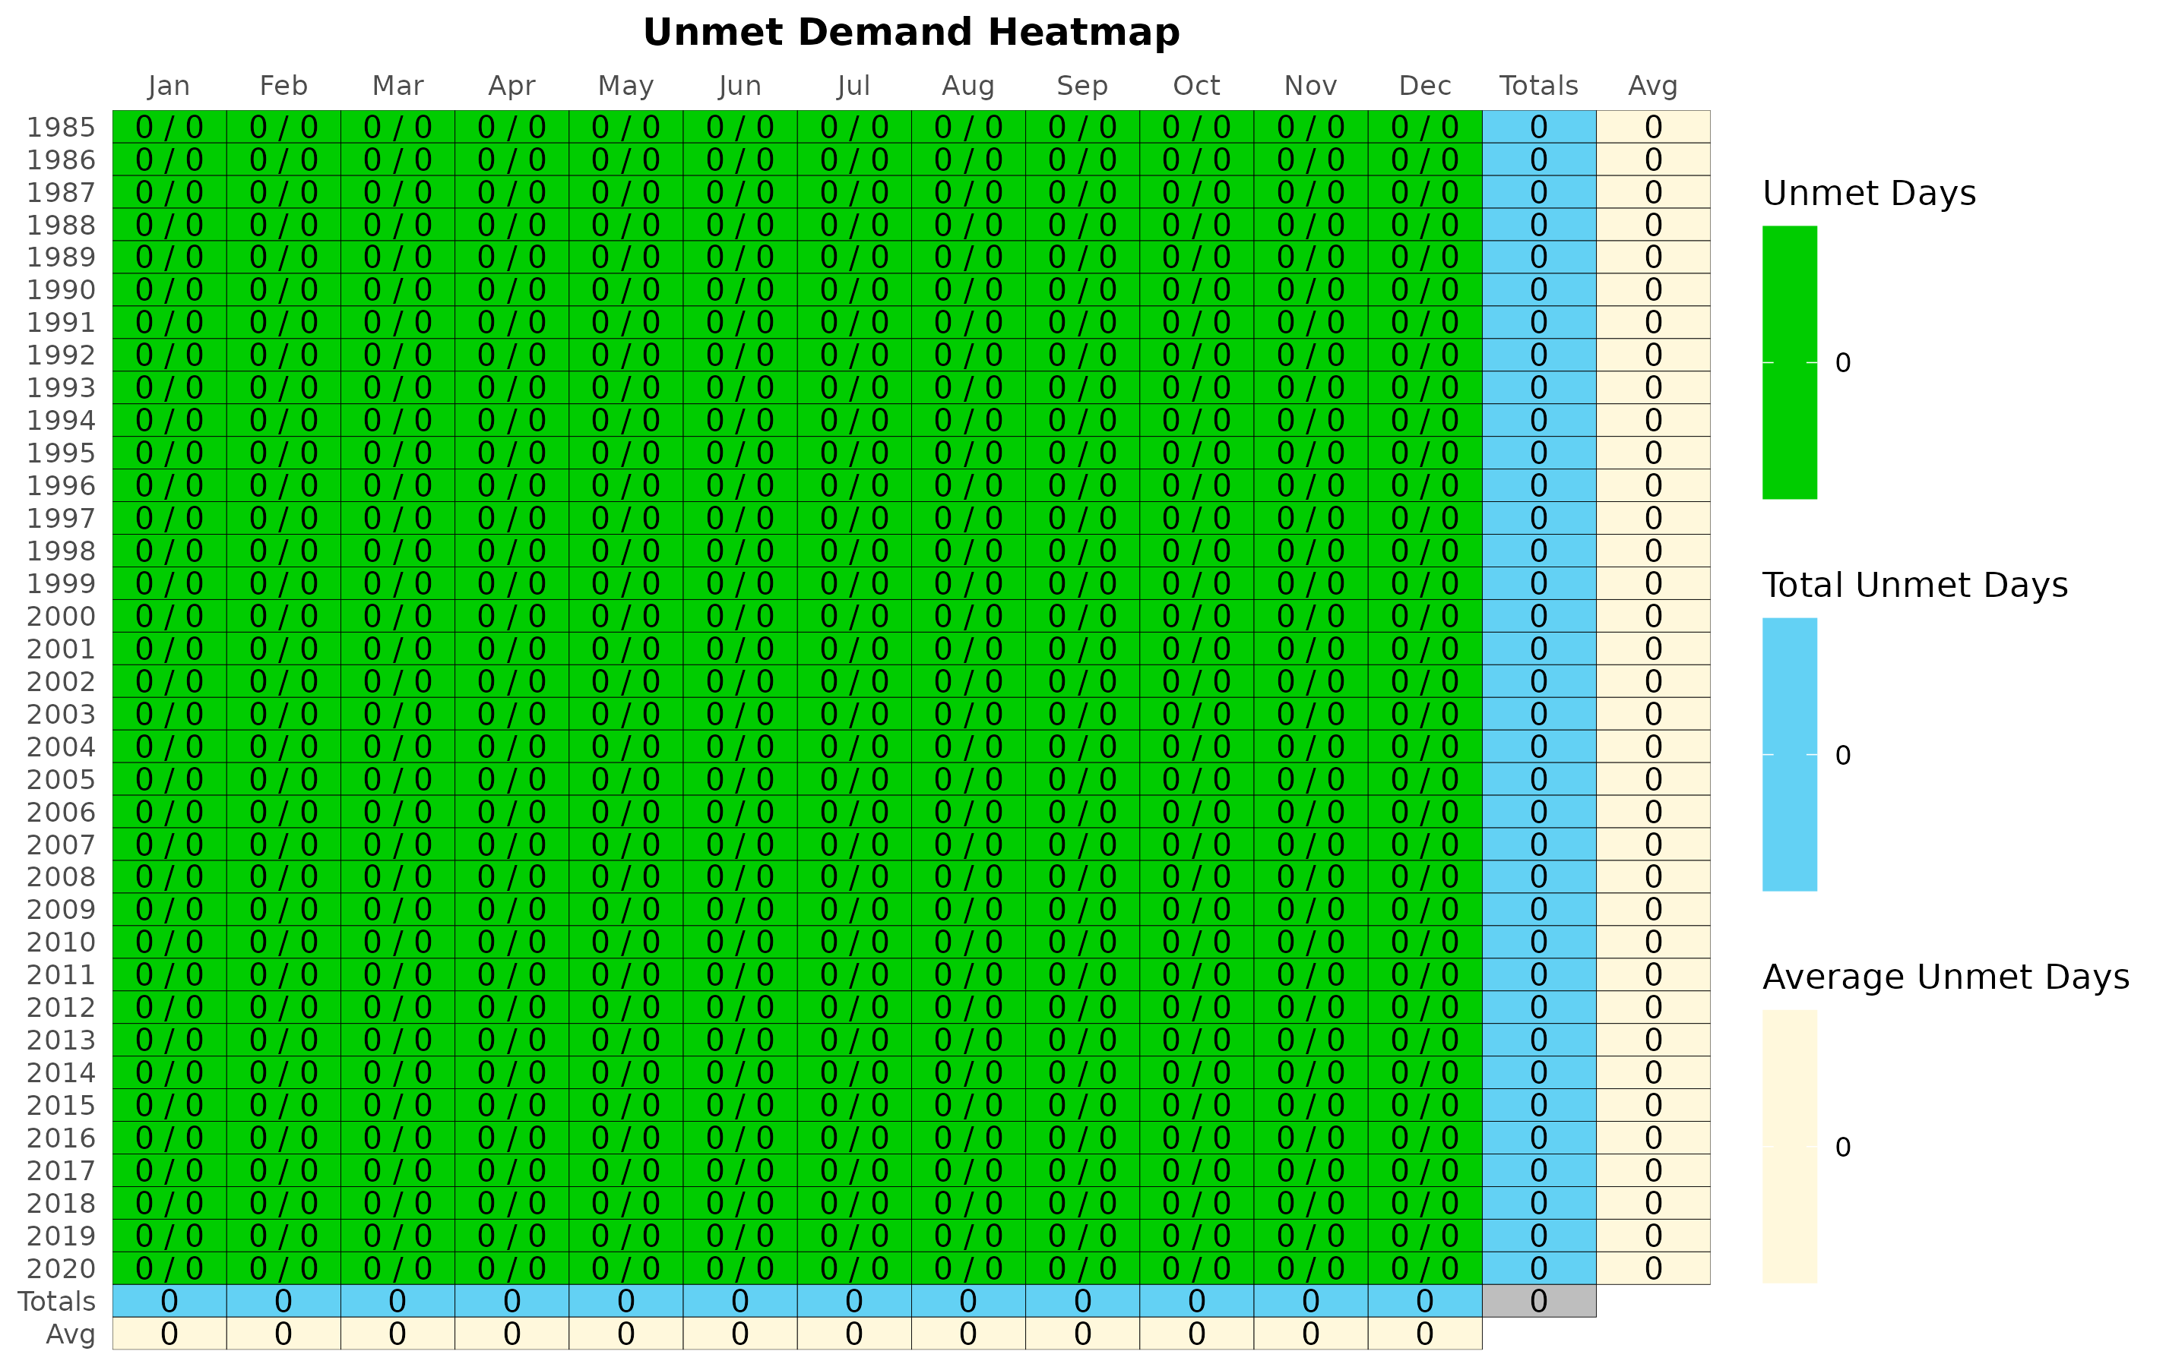

#### Hydrograph: Permit Max w/PoF 75%

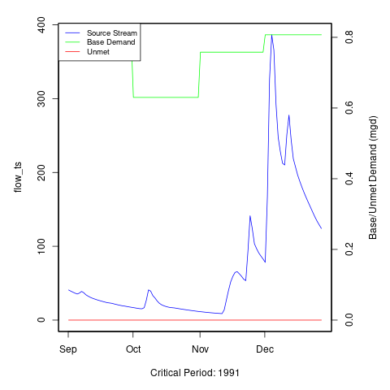 [1] “No local facility impoundment for Permit Max w/PoF 75%”

### Additional Model Flow Plots:

#### runid_400 :

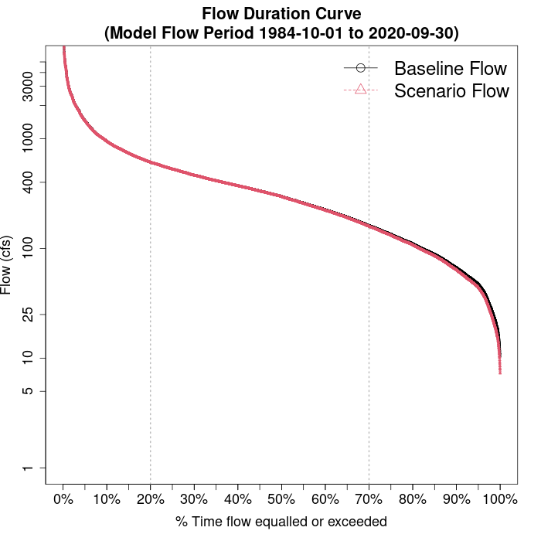

#### runid_400 :

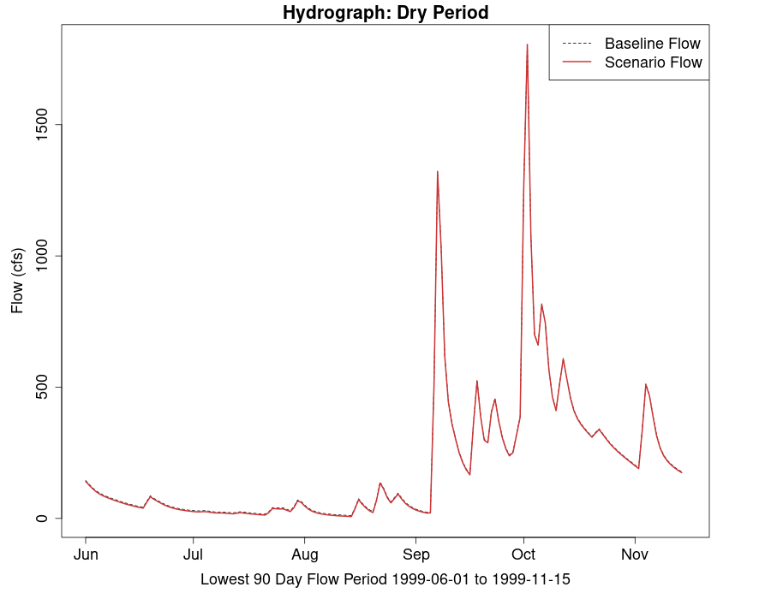

#### Permit Max w/PoF 75% :

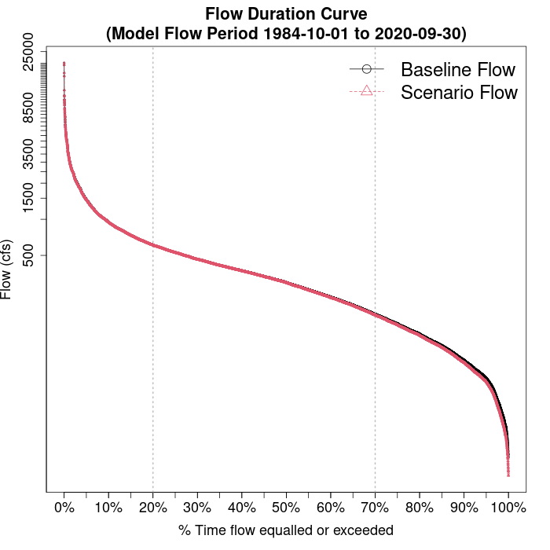

#### Permit Max w/PoF 75% :



# VAHydro Model:

## Appendix B - VAHydro

The comprehensive VAHydro hydrologic model is used by the DEQ Office of Water Supply to evaluate instream and off-stream beneficial uses for non-tidal surface water withdrawals throughout Virginia. This model also simulates streamflow with inputs such as precipitation, climate, land use, and topography, as well as local data collected through DEQ water supply planning and reporting programs, which includes all known withdrawals and discharges, as well as operational rules of Virginia Water Protection (VWP) permits and major hydrologic features such as reservoirs.

The VAHydro model is built on the rainfall-evaporation-runoff (RER) time-series from the Chesapeake Bay Model Phase 6[2]. The VAHydro model simulates conditions from 1984-2014 in the Chesapeake Bay watershed drainage, and 1984-2005 in the rivers flowing outside of the Chesapeake Bay watershed. The VAHydro model features high-resolution hydrologic subsections called “river segments” (over 600 river segments in total), roughly the size of HUC 10 hydrologic units, with additional high-resolution segments added for VWP modeling projects as needed.

## Cumulative Impact Analysis (CIA)

DEQ assesses water supply sustainability through Cumulative Impact Analysis (CIA). CIA is a modeling and analysis approach that takes into account the varied hydrologic processes occurring throughout a river network (including meteorological and human water use). By simulating a daily water balance for every individual river segment within a watershed, DEQ is able to evaluate the potential “cumulative impact” of all streamflow changes occurring upstream and downstream of any location within the river system, as well as the downstream impact of a specific proposed or permitted surface water withdrawal.

The goal of the following analysis is to estimate the potential impacts of the proposed water withdrawal upon existing beneficial uses, including both in-stream and off-stream uses. In addition, cumulative impacts from all existing withdrawals are included in the evaluation.

### Glossary of Cumulative Impact Modeling Terms

* 30 Day Low Flow (l30): Describes the lowest consecutive 30 day average daily streamflow over the simulation period. This metric is a representation of a short-term, or acute drought.
* 90 Day Low Flow (l90): Represents the lowest consecutive 90 day average daily streamflow over the simulation period. This would represent a prolonged drought.
* Base Demand / Requested Demand: The demand simulated for a facility/intake prior to any reductions due to conservation, depleted storage, or adherence to Minimum Instream Flow operational rules (MIF). In this document, *Base Demand* is expressed as *MGY*, and Requested Demand is given in *MGD*.
* CFS: Cubic Feet Per Second, a common unit of measuring stream flow.
* Consumptive Use Fraction (CU): This is calculated as a fraction of modeled Flow, so it is CU = 1.0 - (Flow / Flow_Baseline), where Flow_Baseline = (Flow + WD - PS), and WD and PS are the total cumulative withdrawals and point source discharges above the point in the stream. In other words, for calculating baseline flow, we take modeled outflow from the river, add the withdrawals back in, and subtract the point source in order to estimate a baseline flow balance. This almost always ends up being a higher number than the modeled Flow out, so it tells us the fraction of baseline flow that is consumed. Occasionally there are water transfers and point sources from groundwater, or point sources that cross watershed boundaries that can make the CU fraction in some watersheds negative, i.e. Flow > Flow_Baseline.
* Cumulative Withdrawal: The amount of water withdrawn by all intakes in a given river segment sub-watershed, and all upstream sub-watersheds. See also: *Cumulative Withdrawal*.
* Days of Storage Remaining: For reservoir models, the quotient of the volume of water in a reservoir divided by the daily rate of withdrawal, calculated at each time step of the entire simulation period.
* Maximum 30 day potential unmet demand (MGD): The largest difference between *Requested Demand* and *Withdrawal Met* that results during a continuous 30-day simulation period.
* MGD: Millions of Gallons per Day, a common unit of measuring withdrawal and discharge.
* MGY: Millions of Gallons per Year, a common unit for expressing annual facility demand.
* Minimum Days of Storage Remaining: The minimum simulated *Days of Storage Remaining* in a reservoir.
* Point Source: Water returned to the stream as treated wastewater.
* Withdrawal: The amount of water withdrawn by a single facility, or the total amount of water withdrawn within a single simulated river segment sub-watershed. See also: *Cumulative Withdrawal*.
* Withdrawal Met: The amoiunt of requested demand that was met, on average, throughout the entire simulation period.
* Unmet Demand: The difference between *Base Demand* and *Withdrawal Met*, on average, throughout the entire simulation period.

# Appendix A - Ecological Impacts Assessment:

## Elfgen:

In response to a need for better environmental flow metrics, DEQ has developed a new framework for characterizing relations between streamflow and aquatic organism species richness. Part of an evolving approach to managing environmental flows for maintaining aquatic life; this methodology builds on existing minimum instream ow approaches, allowable withdrawals as a percentage of flow, and extensive flow-habitat studies. For the first time this new framework may allow quantification of potential species loss resulting from flow change, and may offer an improved understanding of aquatic life risk variability due to geographic location, stream size and local scale.

This new flow-ecology framework referred to as “elfgen” (*pronounced elf-jen*) derives its name from Ecological Limit Function (ELF) generation (*ELF-gen*). In order to calculate river segment-level richness change, elfgen is first used to produce ELFs, or relations between stream flow and species richness at the HUC 8 scale (See plot below). This is achieved using long term datasets for both ecological and hydrologic data. Ecological data (Fish species richness) is sourced from the VAHydro-EDAS dataset. Hydrologic data (Average Annual Flow) is sourced from the National Hydrography Dataset Plus. The Richness Change values presented in the table below are derived from this flow-ecology relation.

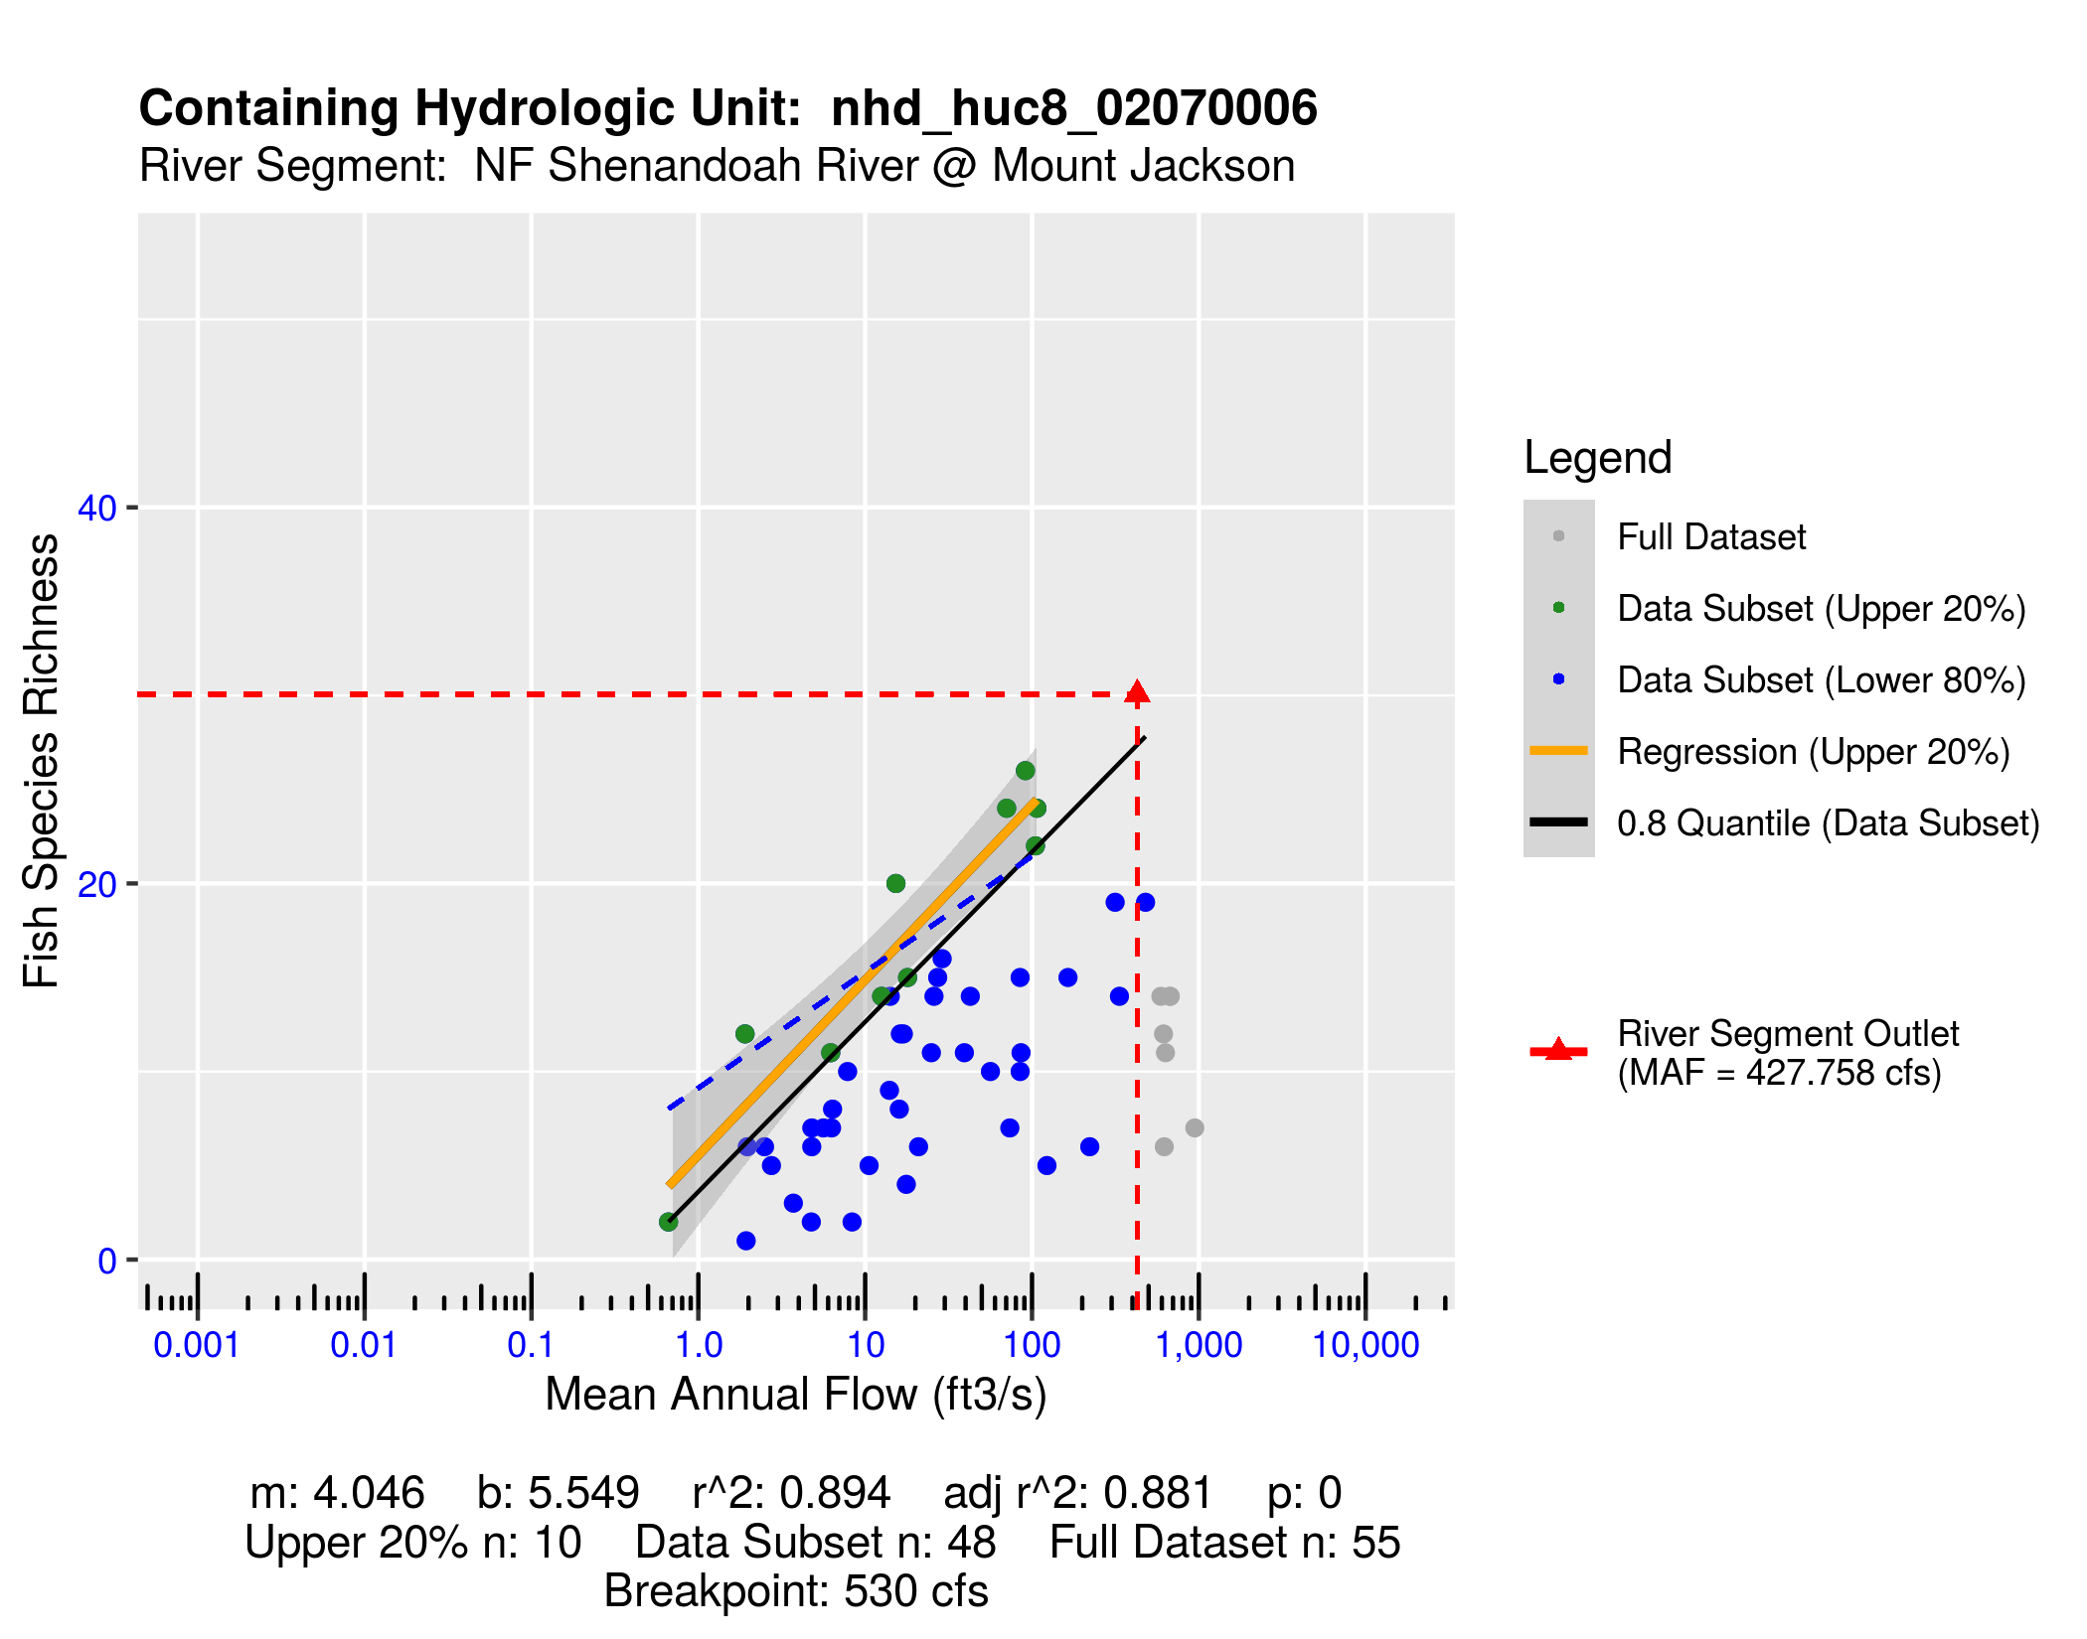

## Richness Change Metric Table:

Estimates for richness change are presented both as an absolute number of species (Richness Change (abs)) and as a percentage of the total number of species present (Richness Change (%)). Richness change calculations are derived from the estimated percent total consumptive use[3]. Note: elfgen methodology only applicable for watersheds < 800 cfs mean annual flow.

| **Description** | **runid_11** | **runid_400** | **Permit Max w/PoF 75%** |
| --- | --- | --- | --- |
| Consumptive Use (%) | 0 | 1 | 1 |
| Consumptive Use Fraction | 0 | 0.01 | 0.01 |
| Cumulative Withdrawal (MGD) | 1.48 | 2.12 | 2.12 |
| Richness Change (abs) | -0.02 | -0.03 | -0.03 |
| Richness Change (%) | -0.06 | -0.09 | -0.09 |

## Habitat (If Applicable):

# Appendix C - Nearby Users Table:

|  | **Location** | **Sub-Watershed** | **MP Type** | **MP Name** | **MP 5-yr Avg Use (MGY)** | **Facility Name** | **Facility 5-yr Avg Use (MGY)** | **Facility 2040 Use (MGY)** | **Permit Max w/PoF 75%: base_demand_mgy** |
| --- | --- | --- | --- | --- | --- | --- | --- | --- | --- |
| 1 | - | NF Shenandoah River @ Mount Jackson | intake | NORTH FORK SHENANDOAH RIVER | 410.37 | Food Processors North Fork Shenandoah WTP | 410.37 | 419.21 | 403.82 |
| 2 | - | NF Shenandoah River @ Mount Jackson | intake | N FORK SHENANDOAH RIVER | 104.86 | BROADWAY WTP | 124.25 | 248.57 | 299.77 |
| 3 | - | NF Shenandoah River @ Mount Jackson | intake | North Fork Shenandoah River | 23.12 | Windcrest Holsteins Inc. | 71.26 | 0.00 | 27.07 |
| 4 | - | NF Shenandoah River @ Mount Jackson | intake | Wehrmann Run/Lake | 8.80 | Windcrest Holsteins Inc. | 71.26 | 0.00 | 27.07 |
| 5 | - | NF Shenandoah River @ Mount Jackson | intake | SMITH CREEK | 21.71 | SHENVALEE LODGE INC | 21.71 | 16.43 | 21.39 |
| 6 | - | NF Shenandoah River @ Mount Jackson | intake | SMITH CREEK | 10.92 | THELMA PHILLIPS | 10.92 | 0.00 | 7.17 |
| 7 | - | NF Shenandoah River @ Mount Jackson | intake | NF SHENANDOAH RIVER HOME | 9.22 | ROGER L & LINDA F MARTIN | 12.45 | 0.00 | 6.54 |
| 8 | - | NF Shenandoah River @ Mount Jackson | intake | NF SHENANDOAH RIVER GOODS | 3.23 | ROGER L & LINDA F MARTIN | 12.45 | 0.00 | 6.54 |
| 9 | - | NF Shenandoah River @ Mount Jackson | intake | NF SHENANDOAH RIVER BAKERS | 0.00 | ROGER L & LINDA F MARTIN | 12.45 | 0.00 | 6.54 |
| 10 | - | NF Shenandoah River @ Mount Jackson | intake | N F SHENANDOAH R - SVA LAND | 3.13 | Center Pivot Irrigation | 3.13 | 8.20 | 3.32 |
| 11 | - | NF Shenandoah River @ Mount Jackson | intake | NORTH FORK SHENANDOAH RIVER | 0.00 | Center Pivot Irrigation | 3.13 | 8.20 | 3.32 |
| 12 | - | NF Shenandoah River @ Mount Jackson | intake | SPRING | 7.32 | TIMBERVILLE SERVICE AREA | 89.98 | 144.27 | 2.80 |
| 13 | - | NF Shenandoah River @ Mount Jackson | intake | SPRING | 2.86 | ROBY JANNEY | 2.86 | 0.00 | 2.30 |
| 14 | - | NF Shenandoah River @ Mount Jackson | intake | SMITH CREEK | 0.00 | NEW MARKET WTP | 0.00 | 0.00 | 0.00 |
| 15 | - | NF Shenandoah River @ Mount Jackson | intake | SMITH CREEK | 0.00 | Wilkins Brothers Dairy LLC | 0.00 | 0.00 | 0.00 |
| 16 | - | NF Shenandoah River @ Mount Jackson | intake | MASSANUTTEN IMPOUNDMENT | 0.00 | NEW MARKET WTP | 0.00 | 0.00 | 0.00 |
| 17 | - | NF Shenandoah River @ Mount Jackson | intake | NORTH FORK SHENANDOAH RIVER | 0.00 | SHADY LANE DAIRY | 0.00 | 0.00 | 0.00 |
| 18 | - | NF Shenandoah River @ Mount Jackson | intake | FARM SPRING | 0.00 | LEON M HEATWOLE | 0.00 | 0.00 | 0.00 |
| 19 | - | NF Shenandoah River @ Mount Jackson | intake | NORTH FORK SHENANDOAH RIVER | 0.00 | ROSELAWN | 0.00 | 0.00 | 0.00 |
| 20 | - | NF Shenandoah River @ Mount Jackson | intake | N.F. SHENANDOAH | 0.00 | LEON M HEATWOLE | 0.00 | 0.00 | 0.00 |
| 21 | - | NF Shenandoah River @ Mount Jackson | intake | NORTH FORK SHENANDOAH RIVER | 0.00 | BROADWAY PLANT COMPLEX | 0.00 | 0.00 | 0.00 |
| 22 | - | NF Shenandoah River @ Mount Jackson | intake | SMITH CREEK | 0.00 | CEDAR BLUFF DAIRY | 0.00 | 0.00 | 0.00 |

1. [Virginia Drought Assessment and Response Plan](https://www.deq.virginia.gov/home/showpublisheddocument/5115/637490843054630000), developed by the Drought Response Technical Advisory Committee in response to Executive Order #39, March 28, 2003.
2. [Chesapeake Bay Program Phase 6 Model](https://www.chesapeakebay.net/documents/Phase_6_Modeling_Tools_1-page_factsheet_12-18-17.pdf).
3. Kleiner et al: <https://onlinelibrary.wiley.com/doi/full/10.1111/1752-1688.12876> & Rapp et al: <https://onlinelibrary.wiley.com/doi/full/10.1111/1752-1688.12877>