VWP CIA Summary - [INSERT PROJECT NAME HERE]

08/22/2022

# VAHydro Model:

## VAHydro

The comprehensive VAHydro hydrologic model is used by the DEQ Office of Water Supply to evaluate instream and off-stream beneficial uses for non-tidal surface water withdrawals throughout Virginia. This model also simulates streamflow with inputs such as precipitation, climate, land use, and topography, as well as local data collected through DEQ water supply planning and reporting programs, which includes all known withdrawals and discharges, as well as operational rules of Virginia Water Protection (VWP) permits and major hydrologic features such as reservoirs.

The VAHydro model is built on the rainfall-evaporation-runoff (RER) time-series from the Chesapeake Bay Model Phase 6[1]. The VAHydro model simulates conditions from 1984-2014 in the Chesapeake Bay watershed drainage, and 1984-2005 in the rivers flowing outside of the Chesapeake Bay watershed. The VAHydro model features high-resolution hydrologic subsections called “river segments” (over 600 river segments in total), roughly the size of HUC 10 hydrologic units, with additional high-resolution segments added for VWP modeling projects as needed.

## Cumulative Impact Analysis (CIA)

DEQ assesses water supply sustainability through Cumulative Impact Analysis (CIA). CIA is a modeling and analysis approach that takes into account the varied hydrologic processes occurring throughout a river network (including meteorological and human water use). By simulating a daily water balance for every individual river segment within a watershed, DEQ is able to evaluate the potential “cumulative impact” of all streamflow changes occurring upstream and downstream of any location within the river system, as well as the downstream impact of a specific proposed or permitted surface water withdrawal.

The goal of the following analysis is to estimate the potential impacts of the proposed water withdrawal upon existing beneficial uses, including both in-stream and off-stream uses. In addition, cumulative impacts from all existing withdrawals are included in the evaluation.

# Project Introduction

General information about facility & intake (non-model specific)

## Location Map

*No location map available for this facility model*

# Model Overview and Scenario Descriptions

**River Model Description** River segment model overview not provided.

**Facility & Intake Model Description** Facility intake model overview not provided.

The following model scenarios were simulated in order to determine the most effective means of meeting the project need and all other in-stream beneficial uses:

* **runid_401** - Run report information not provided.
* **runid_601** - Run report information not provided.

## Table of Modeled Demand Limits:

| **Description** | **runid_401** | **runid_601** |
| --- | --- | --- |
| Average Daily Volume (MGD) | 2.00 | 2.00 |
| Peak Day Volume (MGD) | 4.00 | 4.00 |
| Maximum Annual Volume (MG) | 730.00 | 730.00 |

**Historical Intake Flows and Drought Flow Indicators**

The VAHydro model is used to estimate flows at the project intake, including the impact of all cumulative withdrawals, discharges and management rules upstream of the withdrawal location. The models estimates of currently available flows are presented in Table 1. The Virginia Drought Assessment and Response Plan[2] employs non-exceedance flow percentiles as indicators of drought conditions at particular stream-gaging stations used to monitor drought conditions. Representative daily streamflows above the 25th percentile for return flow frequency represent normal conditions with respect to drought. Representative daily streamflows between the 10th and 25th percentiles represent drought watch conditions. Representative daily streamflows between the 5th and 10th percentiles represent drought warning conditions. Representative daily streamflows below the 5th percentile indicate drought emergency conditions.

**Table 1:** Modeled monthly current flow statistics for un-named intake in cubic feet per second (cfs). Columns show the minimum (Min) and average (Mean) modeled flow, and a range of non-exceedance flow percentiles, that is, the column header indicates the percent of flows that do *not* exceed the given value. For example, the “10%” states that only 10% of flows in the given month are expected to be less than the indicated value, and therefore, 90% of the flows in that month are expected to be greater than the given value. For example, in the table below the 10% column states that 10% of flows within the month of January would be less than 696 cfs.

| **Month** | **Min** | **5%** | **10%** | **25%** | **30%** | **50%** | **Mean** |
| --- | --- | --- | --- | --- | --- | --- | --- |
| Jan | 542 | 652 | 696 | 822 | 858 | 1,119 | 1,820 |
| Feb | 603 | 656 | 712 | 913 | 948 | 1,800 | 2,435 |
| Mar | 590 | 734 | 864 | 1,176 | 1,387 | 2,266 | 2,983 |
| Apr | 670 | 1,039 | 1,172 | 1,260 | 1,284 | 1,599 | 2,962 |
| May | 767 | 1,069 | 1,169 | 1,242 | 1,263 | 1,358 | 2,022 |
| Jun | 576 | 634 | 674 | 754 | 779 | 989 | 1,583 |
| Jul | 476 | 522 | 535 | 572 | 582 | 645 | 1,045 |
| Aug | 444 | 464 | 477 | 502 | 510 | 558 | 853 |
| Sep | 435 | 456 | 462 | 481 | 488 | 511 | 1,232 |
| Oct | 433 | 461 | 472 | 499 | 508 | 542 | 1,290 |
| Nov | 453 | 488 | 512 | 554 | 570 | 633 | 1,290 |
| Dec | 469 | 542 | 562 | 630 | 653 | 831 | 1,410 |

# Results

## Summary

Four scenarios are presented below to examine the alternatives for this permit re-issuance. A summary of how permit rules affect available water for this permit, and how this operation may impact instream beneficial uses, and other downstream water withdrawals is presented.

* **runid_401** - Run analysis not provided.
* **runid_601** - Run analysis not provided.

## Conclusion

* **NULL** - Preferred scenario, runid_600 , conclusions not provided. Conclusions should be stored in [model] -> 600 -> reports -> conclusions

## Detailed Cumulative Impact Analysis

The following “Summary of Results” table summarizes the cumulative impacts to flows, aquatic life, and off-stream demand for the project. The section entitled “River Segment Model Statistics” contains mean flows (Flow Out), and drought flows (30 and 90 Day Low Flow), as well as an estimated Consumptive Use Fraction (See description below) as a result of all withdrawals (Cumulative Withdrawal) and discharges (Cumulative Point Source) in the watershed. Minimum Days of Storage Remaining describes the number of days of remaining storage available during the driest period of the model simulation (applicable to impoundment models only). Total Number of Days with Storage < 50% describes the number of days in the simulation in which reservoir levels fall below 50% of full storage. The section entitled “Facility Model Statistics” shows the withdrawals, return flows (Point Source), and the model estimate for potential unmet demand due to demands exceeding the allowable withdrawal at the intake based on the cumulative conditions in the watershed and the flow-by rules in effect. There will be one or more columns in this table representing each scenario considered for this analysis.

### Glossary of Cumulative Impact Modeling Terms

* 30 Day Low Flow (l30): Describes the lowest consecutive 30 day average daily streamflow over the simulation period. This metric is a representation of a short-term, or acute drought.
* 90 Day Low Flow (l90): Represents the lowest consecutive 90 day average daily streamflow over the simulation period. This would represent a prolonged drought.
* Base Demand / Requested Demand: The demand simulated for a facility/intake prior to any reductions due to conservation, depleted storage, or adherence to Minimum Instream Flow operational rules (MIF). In this document, *Base Demand* is expressed as *MGY*, and Requested Demand is given in *MGD*.
* CFS: Cubic Feet Per Second, a common unit of measuring stream flow.
* Consumptive Use Fraction (CU): This is calculated as a fraction of modeled Flow, so it is CU = 1.0 - (Flow / Flow_Baseline), where Flow_Baseline = (Flow + WD - PS), and WD and PS are the total cumulative withdrawals and point source discharges above the point in the stream. In other words, for calculating baseline flow, we take modeled outflow from the river, add the withdrawals back in, and subtract the point source in order to estimate a baseline flow balance. This almost always ends up being a higher number than the modeled Flow out, so it tells us the fraction of baseline flow that is consumed. Occasionally there are water transfers and point sources from groundwater, or point sources that cross watershed boundaries that can make the CU fraction in some watersheds negative, i.e. Flow > Flow_Baseline.
* Cumulative Withdrawal: The amount of water withdrawn by all intakes in a given river segment sub-watershed, and all upstream sub-watersheds. See also: *Cumulative Withdrawal*.
* Days of Storage Remaining: For reservoir models, the quotient of the volume of water in a reservoir divided by the daily rate of withdrawal, calculated at each time step of the entire simulation period.
* Maximum 30 day potential unmet demand (MGD): The largest difference between *Requested Demand* and *Withdrawal Met* that results during a continuous 30-day simulation period.
* MGD: Millions of Gallons per Day, a common unit of measuring withdrawal and discharge.
* MGY: Millions of Gallons per Year, a common unit for expressing annual facility demand.
* Minimum Days of Storage Remaining: The minimum simulated *Days of Storage Remaining* in a reservoir.
* Point Source: Water returned to the stream as treated wastewater.
* Withdrawal: The amount of water withdrawn by a single facility, or the total amount of water withdrawn within a single simulated river segment sub-watershed. See also: *Cumulative Withdrawal*.
* Withdrawal Met: The amoiunt of requested demand that was met, on average, throughout the entire simulation period.
* Unmet Demand: The difference between *Base Demand* and *Withdrawal Met*, on average, throughout the entire simulation period.

### Summary of Results:

| **Description** | **runid_401** | **runid_601** |
| --- | --- | --- |
| River Segment Model Statistics: | Roanoke River (Altavista) | Roanoke River (Altavista) |
| Flow Out (cfs) - (i.e mean flow) | 597.76 | 598.06 |
| Minimum Days of Storage Remaining | NA | NA |
| 30 Day Low Flow (cfs) (i.e drought flow) | 54.43 | 56.25 |
| 90 Day Low Flow (cfs) (i.e drought flow) | 107.07 | 108.7 |
| Consumptive Use Fraction | -0.01 | -0.01 |
| Cumulative Withdrawal (MGD) | 14.41 | 11.19 |
| Cumulative Point Source (MGD) | 17.4 | 14.16 |
| Withdrawal (MGD) | -14.01 | -13.35 |
| Point Source (MGD) | 0.12 | 0.12 |
| Facility Model Statistics: | Pittsylvania Power Station (formerly HURT FACILITY):Roanoke River (Altavista) | Pittsylvania Power Station (formerly HURT FACILITY):Roanoke River (Altavista) |
| Base Demand (MGY) | 729.41 | 729.41 |
| Withdrawal (MGY) | 42.14 | 224.6 |
| Unmet Demand (MGY) | 687.27 | 504.82 |
| Requested Demand (MGD) | 2 | 2 |
| Withdrawal Met (MGD) | 0.12 | 0.62 |
| Point Source (MGD) | 0.11 | 0.61 |
| Groundwater Demand (MGD) | 0 | 0 |
| Maximum 30 day potential unmet demand (MGD) | 2.74 | 2.74 |

### Analysis of Reservoir Storage:

The following reservoir storage plots depict changes in reservoir storage under each scenario (indicated in black), as well as simulated inflow to the reservoir (blue), simulated outflow from the reservoir (green), and system demand for the given scenario (red). For water supply reservoirs, a minimum of 60 days of remaining storage over the course of the simulation is recommended. System demand varies seasonally.

[1] “No active impoundment found for run id runid_401” [1] “No active impoundment found for run id runid_601”

### Analysis of Potential Unmet Demand at the River Intake:

Heatmaps are data plotting tools that help visualize data as magnitudes of color intensity. The following heatmaps depict the number of days with unmet demands for each month of the simulation (due to demands exceeding allowable withdrawal at the intake based on the cumulative conditions in the watershed and the flow-by rules in effect). The heatmap cells show the amount of unmet demand for each month [Number of Unmet Days & Amount (MGD)]. Hydrographs are shown for the period of the simulation with greatest unmet demand.

#### Heatmap: runid_401

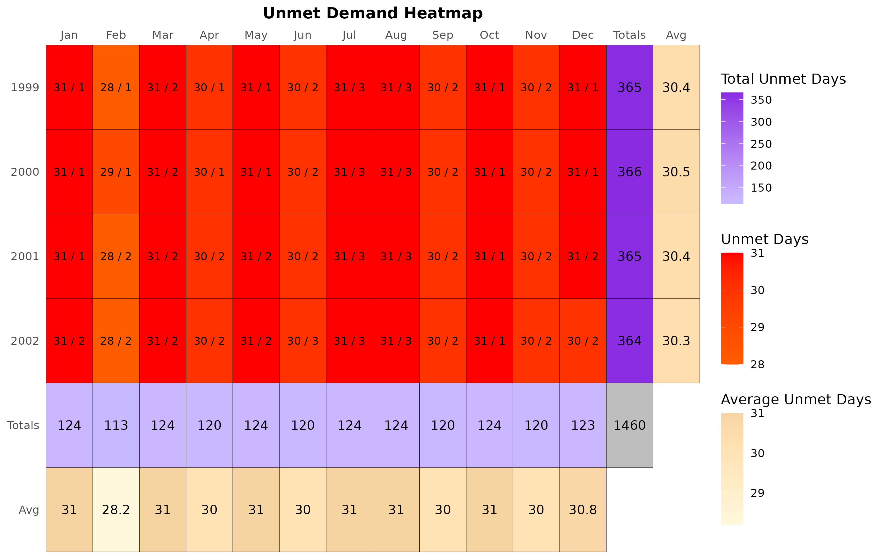

#### Hydrograph: runid_401

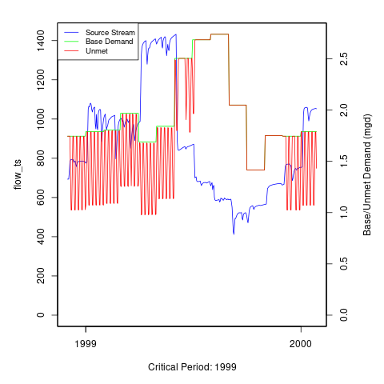

#### Reservoir Storage: runid_401

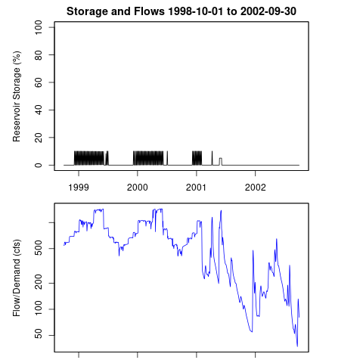

#### Heatmap: runid_601

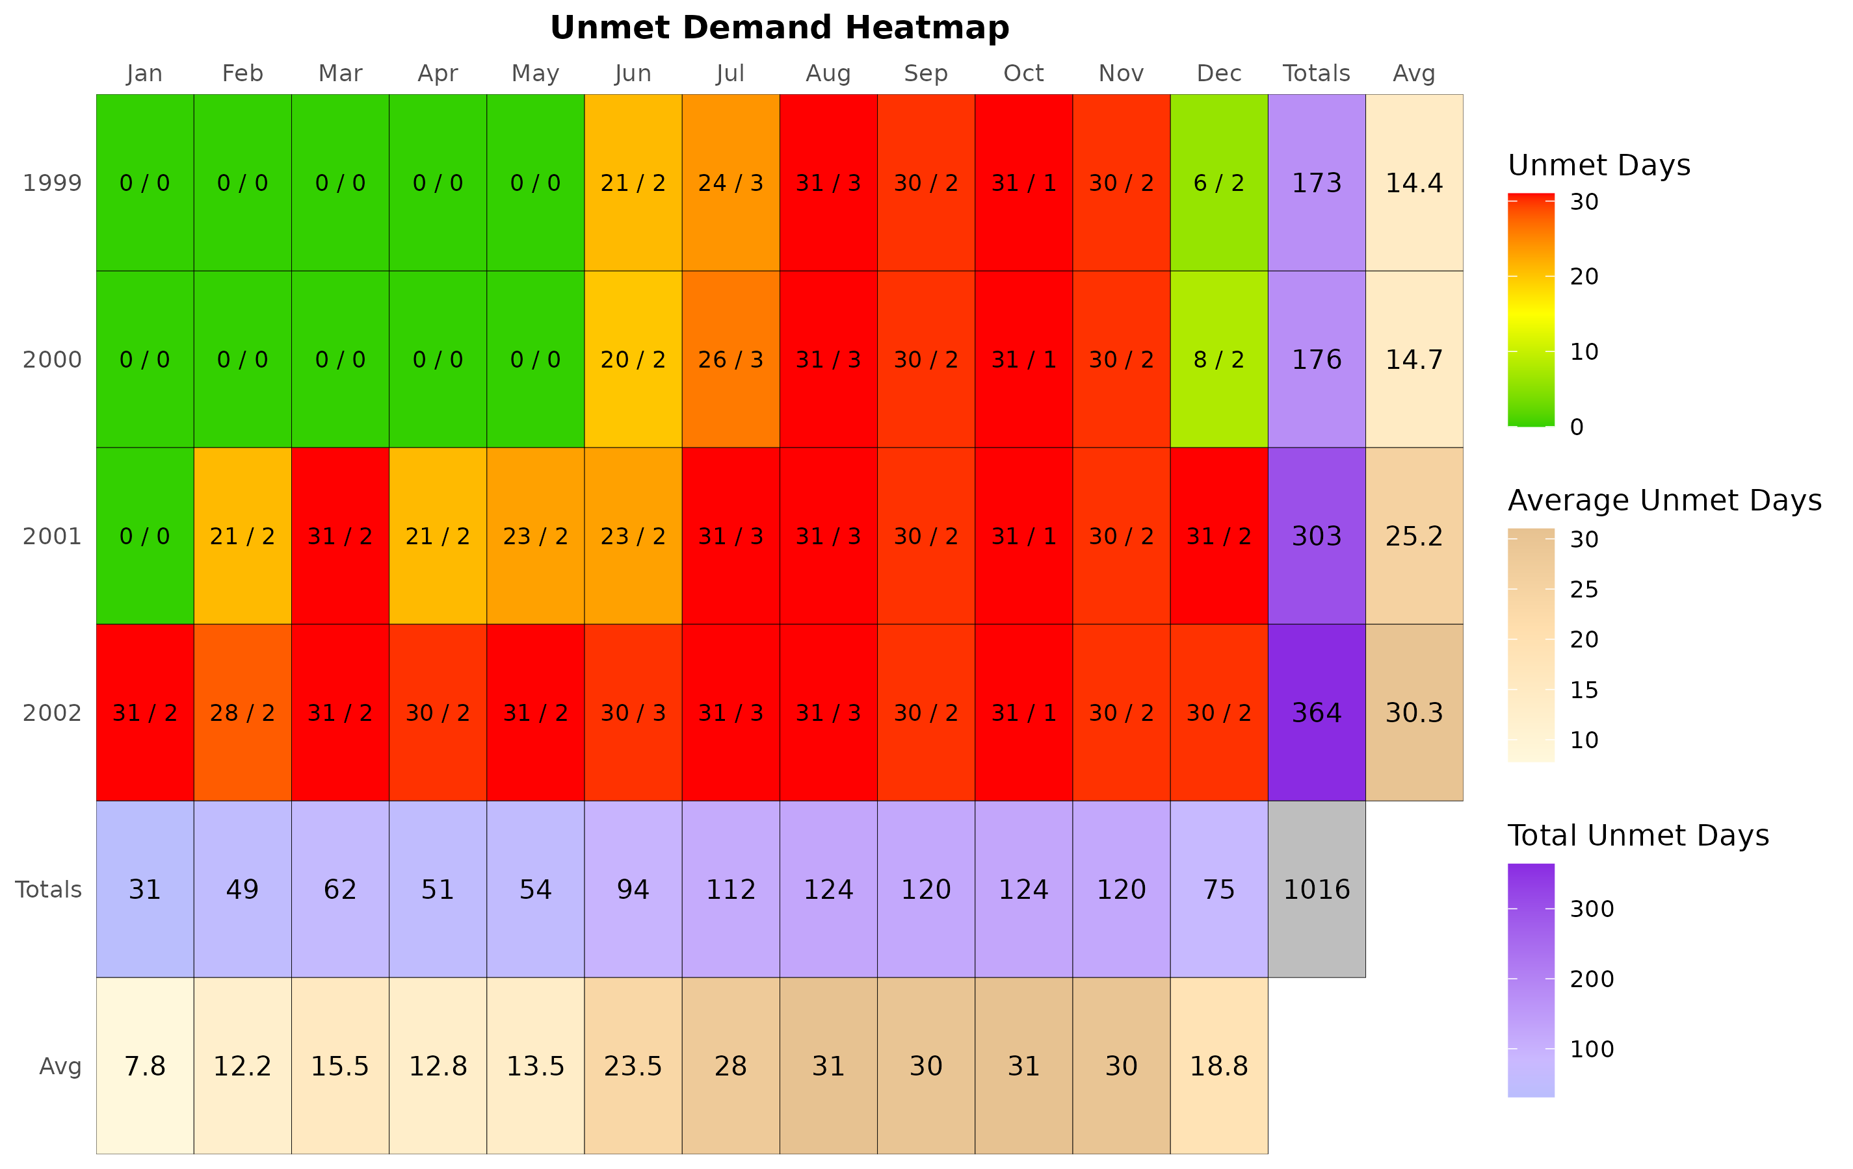

#### Hydrograph: runid_601

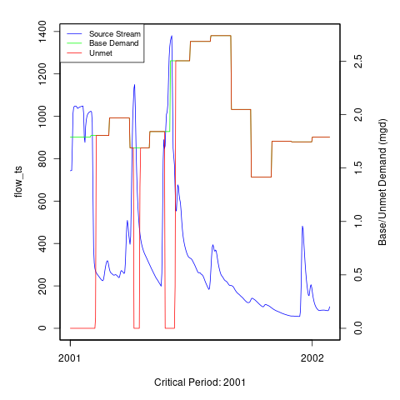

#### Reservoir Storage: runid_601

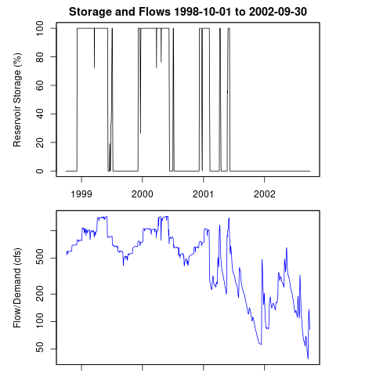

### Additional Model Flow Plots:

# Appendix A - Ecological Impacts Assessment:

## Elfgen:

In response to a need for better environmental flow metrics, DEQ has developed a new framework for characterizing relations between streamflow and aquatic organism species richness. Part of an evolving approach to managing environmental flows for maintaining aquatic life; this methodology builds on existing minimum instream ow approaches, allowable withdrawals as a percentage of flow, and extensive flow-habitat studies. For the first time this new framework may allow quantification of potential species loss resulting from flow change, and may offer an improved understanding of aquatic life risk variability due to geographic location, stream size and local scale.

This new flow-ecology framework referred to as “elfgen” (*pronounced elf-jen*) derives its name from Ecological Limit Function (ELF) generation (*ELF-gen*). In order to calculate river segment-level richness change, elfgen is first used to produce ELFs, or relations between stream flow and species richness at the HUC 8 scale (See plot below). This is achieved using long term datasets for both ecological and hydrologic data. Ecological data (Fish species richness) is sourced from the VAHydro-EDAS dataset. Hydrologic data (Average Annual Flow) is sourced from the National Hydrography Dataset Plus. The Richness Change values presented in the table below are derived from this flow-ecology relation.

*No elfgen plot available for this model*

## Richness Change Metric Table:

Estimates for richness change are presented both as an absolute number of species (Richness Change (abs)) and as a percentage of the total number of species present (Richness Change (%)). Richness change calculations are derived from the estimated percent total consumptive use[3]. Note: elfgen methodology only applicable for watersheds < 800 cfs mean annual flow.

| **Description** | **runid_401** | **runid_601** |
| --- | --- | --- |
| Consumptive Use (%) |  |  |
| Consumptive Use Fraction | -0.01 | -0.01 |
| Cumulative Withdrawal (MGD) | 14.41 | 11.19 |
| Richness Change (abs) | NA | NA |
| Richness Change (%) | NA | NA |

## Habitat (If Applicable):

# Appendix B - Nearby Users Table:

|  | **Location** | **Sub-Watershed** | **MP Type** | **MP Name** | **MP 5-yr Avg Use (MGY)** | **Facility Name** | **Facility 5-yr Avg Use (MGY)** | **Facility 2040 Use (MGY)** | **runid_600: base_demand_mgy** |
| --- | --- | --- | --- | --- | --- | --- | --- | --- | --- |
| 1 | - | Roanoke River (Altavista) | intake | ROANOKE RIVER | 614.12 | ALTAVISTA WTP | 614.47 | 631.12 |  |
| 2 | - | Roanoke River (Altavista) | intake | ROANOKE RIVER | 114.04 | ALTAVISTA POWER STATION | 114.04 | 135.00 |  |
| 3 | - | Roanoke River (Altavista) | intake | MCMINNIS SPRING | 92.35 | ALTAVISTA SERVICE AREA | 189.01 | 152.98 |  |
| 4 | - | Roanoke River (Altavista) | intake | ROANOKE RIVER | 32.11 | Pittsylvania Power Station (formerly HURT FACILITY) | 32.11 | 239.40 |  |
| 5 | - | Roanoke River (Altavista) | intake | REED CREEK | 0.35 | ALTAVISTA WTP | 614.47 | 631.12 |  |
| 6 | - | Roanoke River (Altavista) | intake | ROANOKE RIVER | 0.24 | HURT PLANT WTP | 0.36 | 0.00 |  |
| 7 | - | Roanoke River (Altavista) | well | Well #2 | 0.10 | HURT PLANT WTP | 0.36 | 0.00 |  |
| 8 | - | Roanoke River (Altavista) | well | Well #1 | 0.03 | HURT PLANT WTP | 0.36 | 0.00 |  |
| 9 | - | Roanoke River (Altavista) | well | Well #3 | 0.00 | HURT PLANT WTP | 0.36 | 0.00 |  |
| 10 | - | Roanoke River (Altavista) | well | WELL #1 | 0.00 | ALTAVISTA PLANT | 0.00 | 0.00 |  |
| 11 | - | Roanoke River (Altavista) | well | WELL #2 | 0.00 | ALTAVISTA PLANT | 0.00 | 0.00 |  |
| 12 | - | Roanoke River (Altavista) | well | Well #4 | 0.00 | HURT PLANT WTP | 0.36 | 0.00 |  |
| 13 | - | Roanoke River (Altavista) | intake | SYCAMORE CREEK | 0.00 | ALTAVISTA COUNTRY CLUB | 0.00 | 0.00 |  |
| 14 | - | Roanoke River (Altavista) | intake | ROANOKE RIVER | 0.00 | THE LANE COMPANY, INC. | 0.00 | 0.00 |  |
| 15 | - | Roanoke River (Altavista) | intake | SYCAMORE CREEK | 0.00 | HURT PLANT WTP | 0.36 | 0.00 |  |

1. [Chesapeake Bay Program Phase 6 Model](https://www.chesapeakebay.net/documents/Phase_6_Modeling_Tools_1-page_factsheet_12-18-17.pdf).
2. [Virginia Drought Assessment and Response Plan](https://www.deq.virginia.gov/home/showpublisheddocument/5115/637490843054630000), developed by the Drought Response Technical Advisory Committee in response to Executive Order #39, March 28, 2003.
3. Kleiner et al: <https://onlinelibrary.wiley.com/doi/full/10.1111/1752-1688.12876> & Rapp et al: <https://onlinelibrary.wiley.com/doi/full/10.1111/1752-1688.12877>