Technical Evaluation – VWP 19-2043 Lake Monticello

01/24/2023

# Project Introduction

The Lake Monticello Water treatment plant, operated by Aqua of Virginia, is applying for a renewal of a VWP permit for withdrawal of water from the Rivanna River. Water from this intake is treated and distributed to supply domestic use in the Lake Monticello Subdivision.

## Location Map

*No location map available for this facility model*

# Model Overview and Scenario Descriptions

**River Model Description** The Rivanna river watershed receives flows from approximately 700 square miles of land. Flows are highly regulated by the South Fork Rivanna (SFR) Dam operations, especially during low-flow when mandatory releases from SFR may be as small as 30% of natural inflow in times of extreme drought and low system storage. However, point source discharges from the RWSA wastewater treatment plant replace much of this low-flow decrease, at times even exceeding the natural inflows during drought. Also, the SFR portion of the watershed is less than 40% of the drainage area above the Rivanna confluence with the James river, and natural inflows in the remaining drainage area are far less regulated.

**Facility & Intake Model Description** The Lake Monticello intake on the Rivanna River is modeled as a direct withdrawal, with no storage utilized in Lake Monticello. The flows at the intake are largely controlled by upstream activities at the South Fork Rivanna dam, operated by the Rivanna Water and Sewer Authority, and point source discharges of treated municipal wastewater between the Rivanna dam and the Lake Monticello intake. Water withdrawn from this intake is treated and used, then returns to the Rivanna river as treated wastewater effluent approximately 3 miles downstream of the intake.

The following model scenarios were simulated in order to determine the most effective means of meeting the project need and all other in-stream beneficial uses:

* **Descriptive name for titles, ex: Proposed permit conditions with 90% flowby** (2020 Demand) - This scenario shows the current demand for all facilities as reported in the 2020 state water supply plan. Because of the size of the withdrawals, and amounts of stored water available to the Rivanna Water and Sewer Authority (RWSA) operations, point source effluents can make up a large proportion of low flows in the Rivanna River basin. Point source discharges are proportional to withdrawal, and as a result, low flows in the Rivanna basin can theoretically increase proportionally to increases in demand by RWSA. Therefore, this scenario explores whether current low-flows can expected to be lower than those that would occur under a “full permitted” or “projected future” demand scenarios when demand, and downstream discharges will increase.
* **Current Permit** (Current Permitted) - The current permit provides for a maximum day of 1.1 mgd, and a maximum annual withdrawal of 400 mgy. This is simulated as a near constant demand of 1.1 mgd, although in reality, this facility operates with considerable seasonal variation. There is no minimum instream flow (MIF) in the current permit, so the permitteed would theoretically be allowed to take all of the stream flow in order to meet a daily demand.
* **Proposed Permit** (Proposed Permit) - This scenario includes the same total annual demand as the current permit, however, it uses the historical mean monthly distribution to disaggregate that demand into realistic peak month demands that would be likely to occur in practice if this facility were in fact to require the fill 400 million gallons in a single year. In order to accommodate these more realistic demands, this model run introduces a single day withdrawal limit of 1.25 * the maximum average daily demand. As a result, this will result in higher demands in summer months such as July, August and September. This scenario also introduces a minimum instream flow (MIF), which is set at 90% of the previous days flow at the intake – in other words, allowable withdrawal cannot exceed 10% of the previous days flow.

## Table of Modeled Demand Limits:

| **Description** | **2020 Demand** | **Current Permitted** | **Proposed Permit** |
| --- | --- | --- | --- |
| Average Daily Volume (MGD) | 0.56 | 1.10 | 1.10 |
| Peak Day Volume (MGD) | NA | 2.58 | NA |
| Maximum Annual Volume (MG) | NA | 400.00 | 400.00 |

**Historical Intake Flows and Drought Flow Indicators**

The VAHydro model is used to estimate flows at the project intake, including the impact of all cumulative withdrawals and discharges upstream of the intake location and are presented in Table 1. The Virginia Drought Assessment and Response Plan[1] employs non-exceedance flow percentiles as indicators of drought conditions at particular stream-gaging stations used to monitor drought conditions. Representative daily streamflows above the 25th percentile for return flow frequency represent normal conditions with respect to drought. Representative daily streamflows between the 10th and 25th percentiles represent drought watch conditions. Representative daily streamflows between the 5th and 10th percentiles represent drought warning conditions. Representative daily streamflows below the 5th percentile indicate drought emergency conditions.

| **Month** | **Min** | **5%** | **10%** | **25%** | **30%** | **50%** | **Mean** |
| --- | --- | --- | --- | --- | --- | --- | --- |
| Jan | 29 | 109 | 156 | 296 | 361 | 615 | 854 |
| Feb | 52 | 165 | 233 | 388 | 436 | 660 | 923 |
| Mar | 47 | 145 | 201 | 409 | 472 | 740 | 1,064 |
| Apr | 61 | 148 | 192 | 352 | 398 | 570 | 886 |
| May | 78 | 154 | 197 | 297 | 333 | 502 | 745 |
| Jun | 47 | 77 | 106 | 208 | 235 | 336 | 504 |
| Jul | 38 | 68 | 79 | 116 | 129 | 192 | 308 |
| Aug | 35 | 58 | 69 | 98 | 111 | 172 | 260 |
| Sep | 26 | 50 | 60 | 81 | 91 | 158 | 466 |
| Oct | 8 | 47 | 61 | 97 | 114 | 241 | 485 |
| Nov | 25 | 46 | 65 | 138 | 166 | 313 | 648 |
| Dec | 32 | 50 | 98 | 286 | 338 | 580 | 820 |

**Table 1:** Modeled monthly current flow statistics for Rivanna River in cubic feet per second (cfs). Columns show the minimum (Min) and average (Mean) modeled flow, and a range of non-exceedance flow percentiles, that is, the percent of flows that do *not* exceed the given value. For example, the “10%” states that only 10% of flows in the given month are expected to be less than the indicated value, and therefore, 90% of the flows in that month are expected to be greater than the given value. For example, in the table below the 10% column states that 10% of flows within the month of January would be less than 156 cfs.

## Current Facility Base Demand Before Conservation: Current Permit

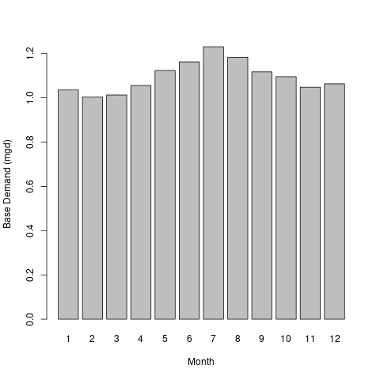

# Results

## Summary

Presented below are 3 scenarios to examine the alternatives for this permit re-issuance. A summary of how permit rules affect available water for this permit, and how this operation may impact instream beneficial uses, and other downstream water withdrawals is presented.

* **Descriptive name for titles, ex: Proposed permit conditions with 90% flowby** - Despite aveage point source discharges decreasing from over 15mgd in the full permit scenarios to less than 10mgd in this current scenario, low flows at the Lake Monticello intake remain very similar. The 90 day low flow at the intake is less than 0.1 cfs different, while the 30-day low flow at the intake decreases approximately 10% from 34 to 31 cfs, which could reduce available water by approximately 0.2 MGD at the intake with a 90% Minimum Instream Flow(MIF).
* **Current Permit** - This scenario shows a minimum daily flow at the intake of 16 cfs, or approximately 10 MGD, which provides for the 1.1 mgd requested demand under all circumstances. The current permit does not have a minimum instream flow (MIF) provision, however, the cumulative impacts analysis suggests that this demand will have a maximum flow reduction of less than 10% during all but a single month of the simulated period.
* **Proposed Permit** - Outcomes from the particular set of operational rules and scenario conditions. Ex: The 90% flow-by scenario results in more flexibility to pump under extremely dry conditions, as compared to the current static MIF permit condition. As a result, the operation is able to meet offstream need during all simulated periods, with a small amount of water remaining during the lowest simulated flow.

## Conclusion

* **Proposed Permit** - If this scenario is the preferred scenario, add remarks here for inclusion in final analysis.

## Facility Base Demand Before Conservation: Proposed Permit



## Detailed Cumulative Impact Analysis

The following “Summary of Results” table summarizes the cumulative impacts to flows, aquatic life, and off-stream demand for the project. The section entitled “River Segment Model Statistics” contains mean flows (Flow Out), and drought flows (30 and 90 Day Low Flow), as well as an estimated Consumptive Use Fraction (See description below) as a result of all withdrawals (Cumulative Withdrawal) and discharges (Cumulative Point Source) in the watershed. Minimum Days of Storage Remaining describes the number of days of remaining storage available during the driest period of the model simulation (applicable to impoundment models only). Total Number of Days with Storage < 50% describes the number of days in the simulation in which reservoir levels fall below 50% of full storage. The section entitled “Facility Model Statistics” shows the withdrawals, return flows (Point Source), and the model estimate for potential unmet demand due to demands exceeding the allowable withdrawal at the intake based on the cumulative conditions in the watershed and the flow-by rules in effect. There will be one or more columns in this table representing each scenario considered for this analysis.

### Summary of Results:

| **Description** | **2020 Demand** | **Current Permitted** | **Proposed Permit** |
| --- | --- | --- | --- |
| River Segment Model Statistics: | Rivanna River | Rivanna River | Rivanna River |
| Flow Out (cfs) - (i.e mean flow) | 663.87 | 662.19 | 662.22 |
| Minimum Days of Storage Remaining | NA | NA | NA |
| 30 Day Low Flow (cfs) (i.e drought flow) | 31.1 | 32.81 | 32.77 |
| 90 Day Low Flow (cfs) (i.e drought flow) | 74.4 | 74.07 | 74.03 |
| Consumptive Use Fraction | 0.01 | 0.02 | 0.02 |
| Cumulative Withdrawal (MGD) | 15.88 | 21.74 | 21.74 |
| Cumulative Point Source (MGD) | 9.49 | 14.43 | 14.31 |
| Withdrawal (MGD) | 0.85 | 1.35 | 1.35 |
| Point Source (MGD) | 9.05 | 13.87 | 13.87 |
| Facility Model Statistics: | LAKE MONTICELLO WTP:Rivanna River | LAKE MONTICELLO WTP:Rivanna River | LAKE MONTICELLO WTP:Rivanna River |
| Base Demand (MGY) | 229.32 | 399.73 | 399.73 |
| Withdrawal (MGY) | 229.32 | 399.73 | 399.7 |
| Unmet Demand (MGY) | 0 | 0 | 0.03 |
| Requested Demand (MGD) | 0.63 | 1.1 | 1.1 |
| Withdrawal Met (MGD) | 0.63 | 1.1 | 1.1 |
| Point Source (MGD) | 0.51 | 0.89 | 0.89 |
| Groundwater Demand (MGD) | 0 | 0 | 0 |
| Maximum 30 day potential unmet demand (MGD) | 0 | 0 | 0.03 |

### Analysis of Reservoir Storage:

The following reservoir storage plots depict changes in reservoir storage under each scenario (indicated in black), as well as simulated inflow to the reservoir (blue), simulated outflow from the reservoir (green), and system demand for the given scenario (red). For water supply reservoirs, a minimum of 60 days of remaining storage over the course of the simulation is recommended. System demand varies seasonally.

[1] “No active impoundment found for run id runid_200” [1] “No active impoundment found for run id runid_400” [1] “No active impoundment found for run id runid_600”

### Analysis of Potential Unmet Demand at the River Intake:

Heatmaps are data plotting tools that help visualize data as magnitudes of color intensity. The following heatmaps depict the number of days with unmet demands for each month of the simulation (due to demands exceeding allowable withdrawal at the intake based on the cumulative conditions in the watershed and the flow-by rules in effect). The heatmap cells show the amount of unmet demand for each month [Number of Unmet Days & Amount (MGD)]. Hydrographs are shown for the period of the simulation with greatest unmet demand.

#### Heatmap: 2020 Demand

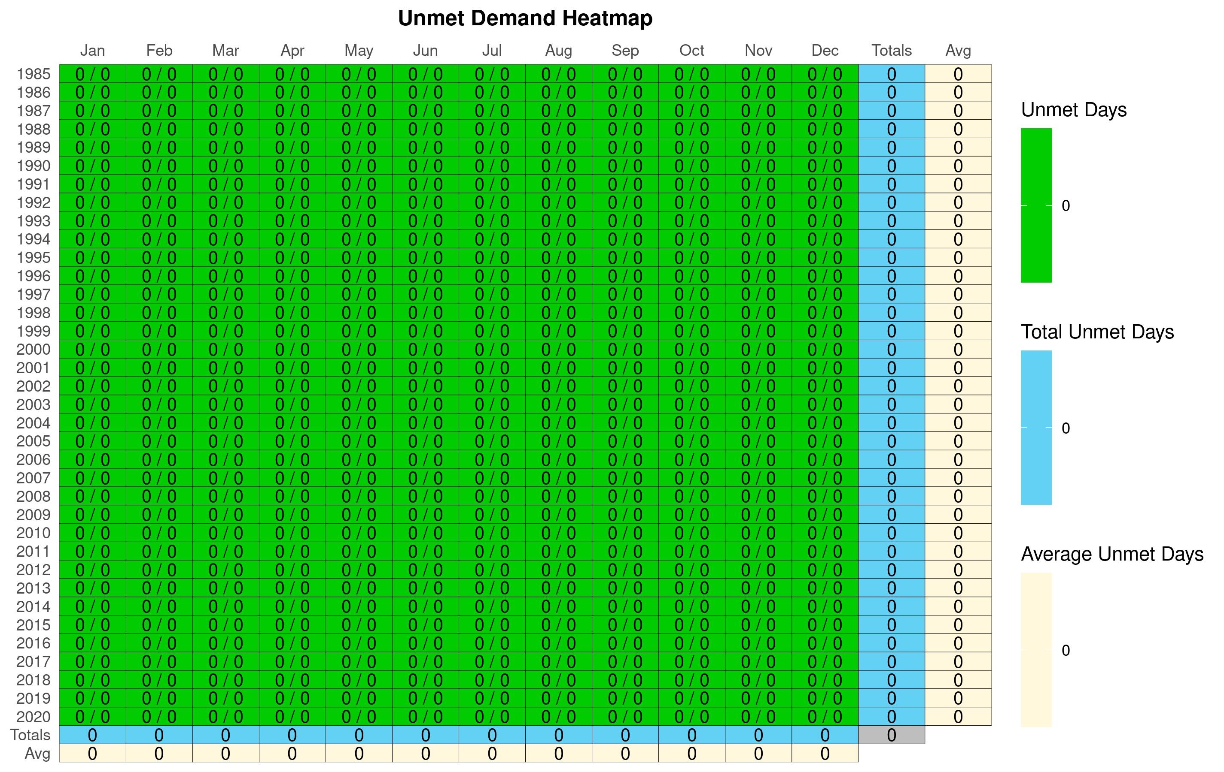

#### Hydrograph: 2020 Demand

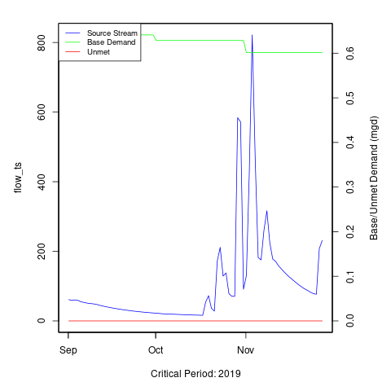 [1] “No local facility impoundment for 2020 Demand”

#### Heatmap: Current Permitted



#### Hydrograph: Current Permitted

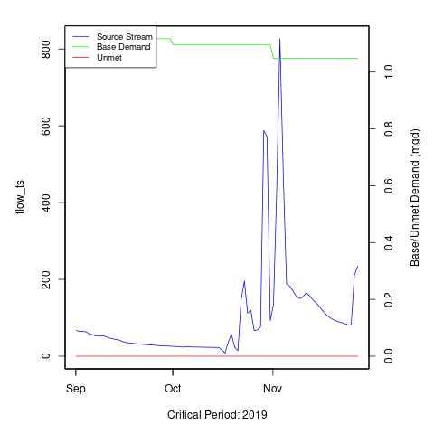 [1] “No local facility impoundment for Current Permitted”

#### Heatmap: Proposed Permit

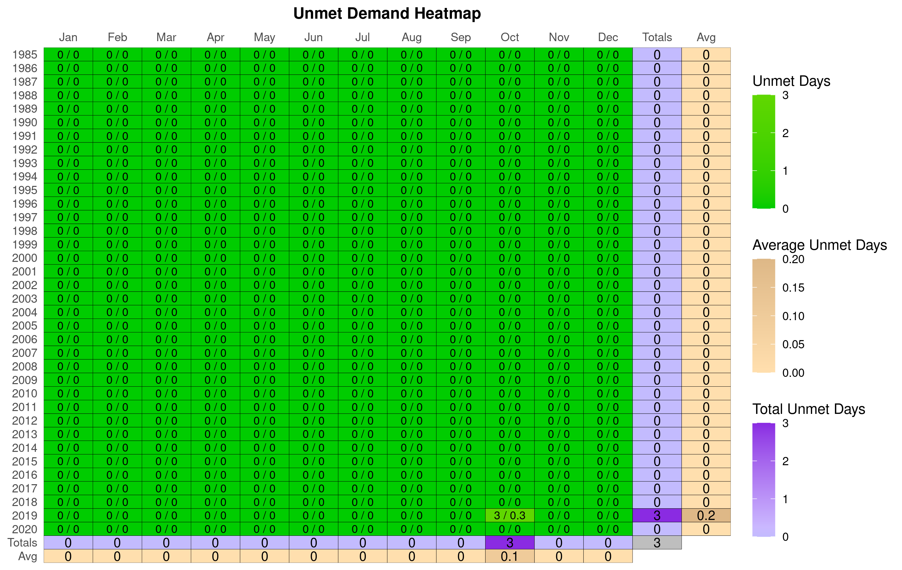

#### Hydrograph: Proposed Permit

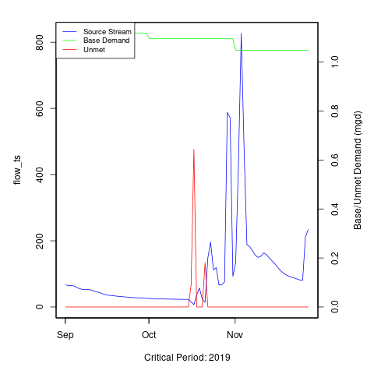 [1] “No local facility impoundment for Proposed Permit”

### Additional Model Flow Plots:

#### 2020 Demand :

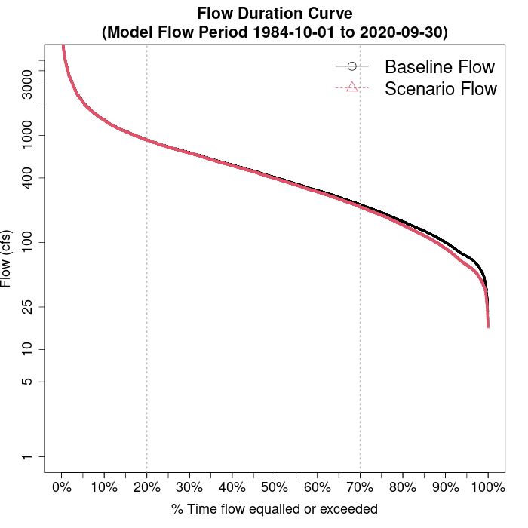

#### 2020 Demand :

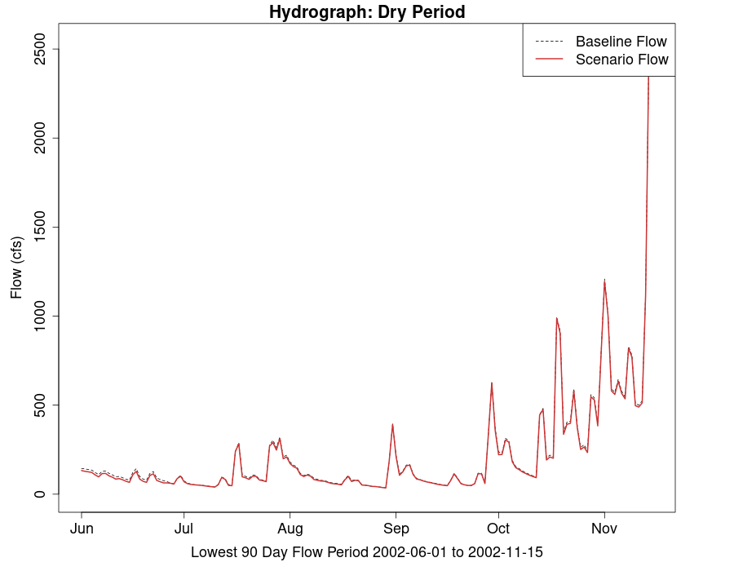

#### Current Permitted :



#### Current Permitted :

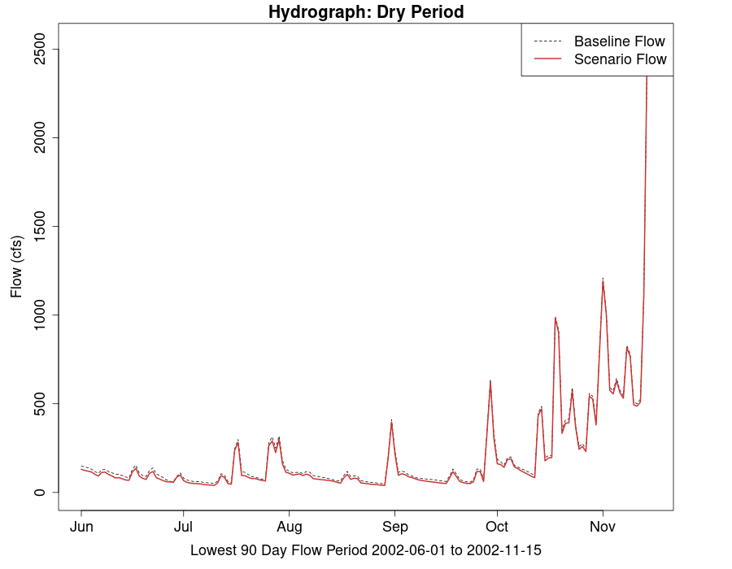

#### Proposed Permit :



#### Proposed Permit :

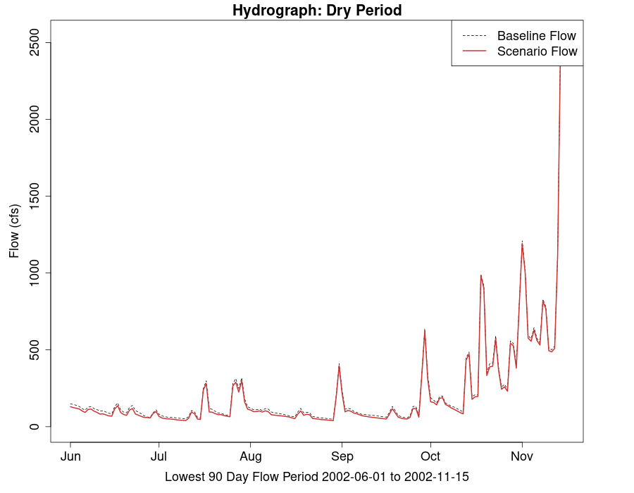

# VAHydro Model:

## Appendix B - VAHydro

The comprehensive VAHydro hydrologic model is used by the DEQ Office of Water Supply to evaluate instream and off-stream beneficial uses for non-tidal surface water withdrawals throughout Virginia. This model also simulates streamflow with inputs such as precipitation, climate, land use, and topography, as well as local data collected through DEQ water supply planning and reporting programs, which includes all known withdrawals and discharges, as well as operational rules of Virginia Water Protection (VWP) permits and major hydrologic features such as reservoirs.

The VAHydro model is built on the rainfall-evaporation-runoff (RER) time-series from the Chesapeake Bay Model Phase 6[2]. The VAHydro model simulates conditions from 1984-2014 in the Chesapeake Bay watershed drainage, and 1984-2005 in the rivers flowing outside of the Chesapeake Bay watershed. The VAHydro model features high-resolution hydrologic subsections called “river segments” (over 600 river segments in total), roughly the size of HUC 10 hydrologic units, with additional high-resolution segments added for VWP modeling projects as needed.

## Cumulative Impact Analysis (CIA)

DEQ assesses water supply sustainability through Cumulative Impact Analysis (CIA). CIA is a modeling and analysis approach that takes into account the varied hydrologic processes occurring throughout a river network (including meteorological and human water use). By simulating a daily water balance for every individual river segment within a watershed, DEQ is able to evaluate the potential “cumulative impact” of all streamflow changes occurring upstream and downstream of any location within the river system, as well as the downstream impact of a specific proposed or permitted surface water withdrawal.

The goal of the following analysis is to estimate the potential impacts of the proposed water withdrawal upon existing beneficial uses, including both in-stream and off-stream uses. In addition, cumulative impacts from all existing withdrawals are included in the evaluation.

### Glossary of Cumulative Impact Modeling Terms

* 30 Day Low Flow (l30): Describes the lowest consecutive 30 day average daily streamflow over the simulation period. This metric is a representation of a short-term, or acute drought.
* 90 Day Low Flow (l90): Represents the lowest consecutive 90 day average daily streamflow over the simulation period. This would represent a prolonged drought.
* Base Demand / Requested Demand: The demand simulated for a facility/intake prior to any reductions due to conservation, depleted storage, or adherence to Minimum Instream Flow operational rules (MIF). In this document, *Base Demand* is expressed as *MGY*, and Requested Demand is given in *MGD*.
* CFS: Cubic Feet Per Second, a common unit of measuring stream flow.
* Consumptive Use Fraction (CU): This is calculated as a fraction of modeled Flow, so it is CU = 1.0 - (Flow / Flow_Baseline), where Flow_Baseline = (Flow + WD - PS), and WD and PS are the total cumulative withdrawals and point source discharges above the point in the stream. In other words, for calculating baseline flow, we take modeled outflow from the river, add the withdrawals back in, and subtract the point source in order to estimate a baseline flow balance. This almost always ends up being a higher number than the modeled Flow out, so it tells us the fraction of baseline flow that is consumed. Occasionally there are water transfers and point sources from groundwater, or point sources that cross watershed boundaries that can make the CU fraction in some watersheds negative, i.e. Flow > Flow_Baseline.
* Cumulative Withdrawal: The amount of water withdrawn by all intakes in a given river segment sub-watershed, and all upstream sub-watersheds. See also: *Cumulative Withdrawal*.
* Days of Storage Remaining: For reservoir models, the quotient of the volume of water in a reservoir divided by the daily rate of withdrawal, calculated at each time step of the entire simulation period.
* Maximum 30 day potential unmet demand (MGD): The largest difference between *Requested Demand* and *Withdrawal Met* that results during a continuous 30-day simulation period.
* MGD: Millions of Gallons per Day, a common unit of measuring withdrawal and discharge.
* MGY: Millions of Gallons per Year, a common unit for expressing annual facility demand.
* Minimum Days of Storage Remaining: The minimum simulated *Days of Storage Remaining* in a reservoir.
* Point Source: Water returned to the stream as treated wastewater.
* Withdrawal: The amount of water withdrawn by a single facility, or the total amount of water withdrawn within a single simulated river segment sub-watershed. See also: *Cumulative Withdrawal*.
* Withdrawal Met: The amoiunt of requested demand that was met, on average, throughout the entire simulation period.
* Unmet Demand: The difference between *Base Demand* and *Withdrawal Met*, on average, throughout the entire simulation period.

# Appendix A - Ecological Impacts Assessment:

## Elfgen:

In response to a need for better environmental flow metrics, DEQ has developed a new framework for characterizing relations between streamflow and aquatic organism species richness. Part of an evolving approach to managing environmental flows for maintaining aquatic life; this methodology builds on existing minimum instream ow approaches, allowable withdrawals as a percentage of flow, and extensive flow-habitat studies. For the first time this new framework may allow quantification of potential species loss resulting from flow change, and may offer an improved understanding of aquatic life risk variability due to geographic location, stream size and local scale.

This new flow-ecology framework referred to as “elfgen” (*pronounced elf-jen*) derives its name from Ecological Limit Function (ELF) generation (*ELF-gen*). In order to calculate river segment-level richness change, elfgen is first used to produce ELFs, or relations between stream flow and species richness at the HUC 8 scale (See plot below). This is achieved using long term datasets for both ecological and hydrologic data. Ecological data (Fish species richness) is sourced from the VAHydro-EDAS dataset. Hydrologic data (Average Annual Flow) is sourced from the National Hydrography Dataset Plus. The Richness Change values presented in the table below are derived from this flow-ecology relation.

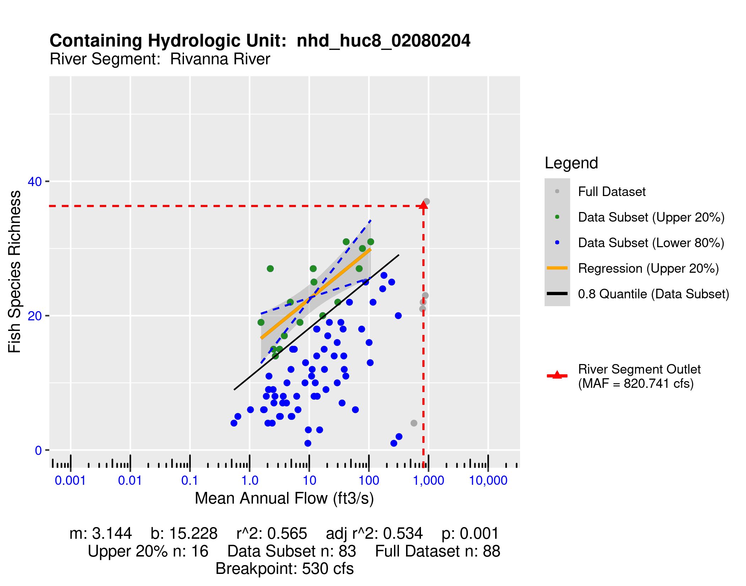

## Richness Change Metric Table:

Estimates for richness change are presented both as an absolute number of species (Richness Change (abs)) and as a percentage of the total number of species present (Richness Change (%)). Richness change calculations are derived from the estimated percent total consumptive use[3]. Note: elfgen methodology only applicable for watersheds < 800 cfs mean annual flow.

| **Description** | **2020 Demand** | **Current Permitted** | **Proposed Permit** |
| --- | --- | --- | --- |
| Consumptive Use (%) | 1 | 2 | 2 |
| Consumptive Use Fraction | 0.01 | 0.02 | 0.02 |
| Cumulative Withdrawal (MGD) | 15.88 | 21.74 | 21.74 |
| Richness Change (abs) | -0.05 | -0.05 | -0.05 |
| Richness Change (%) | -0.13 | -0.15 | -0.15 |

## Habitat (If Applicable):

# Appendix C - Nearby Users Table:

|  | **Location** | **Sub-Watershed** | **MP Type** | **MP Name** | **MP 5-yr Avg Use (MGY)** | **Facility Name** | **Facility 5-yr Avg Use (MGY)** | **Facility 2040 Use (MGY)** | **Proposed Permit: base_demand_mgy** |
| --- | --- | --- | --- | --- | --- | --- | --- | --- | --- |
| 1 | Upstream | South Rivanna River Reservoir | intake | SOUTH FORK RIVANNA RIVER (Reservoir) | 2,657.46 | SOUTH RIVANNA WTP | 2,657.46 | 3,812.23 | 6,201.54 |
| 2 | - | Rivanna River | intake | RIVANNA RIVER | 203.44 | LAKE MONTICELLO WTP | 203.44 | 413.06 | 399.73 |
| 3 | Upstream | Beaver Creek Reservoir | intake | BEAVER CREEK RESERVOIR | 242.86 | CROZET WTP | 242.86 | 282.48 | 192.38 |
| 4 | - | Rivanna River | intake | Morey Creek | 37.85 | Birdwood Golf Course | 37.85 | 0.00 | 37.81 |
| 5 | - | Rivanna River | intake | Paradise | 34.62 | KESWICK HALL & GOLF CLUB | 34.62 | 0.00 | 34.59 |
| 6 | - | Rivanna River | intake | RIVANNA RIVER | 10.70 | MEADOWCREEK GOLF COURSE | 10.70 | 9.49 | 10.69 |
| 7 | - | Rivanna River | intake | GOLF COURSE POND | 10.47 | LAKE MONTICELLO GOLF COURSE | 10.47 | 19.00 | 10.46 |
| 8 | - | Rivanna River | intake | RIVANNA RIVER | 23.61 | GLENMORE COUNTRY CLUB | 23.61 | 26.63 | 0.00 |
| 9 | Upstream | Mechums River at SFR Confluence | intake | MAIN SPRING | 0.00 | MILLER SCHOOL OF ALBEMARLE | 3.98 | 3.98 | 0.00 |
| 10 | Upstream | Mechums River at SFR Confluence | intake | SECOND SPRING | 0.00 | MILLER SCHOOL OF ALBEMARLE | 3.98 | 3.98 | 0.00 |
| 11 | Upstream | Mechums River at SFR Confluence | intake | MILLER SCHOOL DAM | 0.00 | MILLER SCHOOL OF ALBEMARLE | 3.98 | 3.98 | 0.00 |
| 12 | Upstream | South Rivanna River Reservoir | intake | Ivy Creek | 49.61 | FARMINGTON COUNTRY CLUB | 49.61 | 33.21 |  |
| 13 | - | Rivanna River | intake | Mechunk Creek | 48.63 | Fluvanna Correctional Center for Women | 48.63 | 41.61 |  |
| 14 | Upstream | Mechums River at SFR Confluence | intake | #1 Irrigation Pond (pump station location) | 16.35 | OLD TRAIL GOLF CLUB | 16.35 | 0.00 |  |
| 15 | Upstream | Mechums River at SFR Confluence | intake | #5 Pond (Transfer Pump) | 0.00 | OLD TRAIL GOLF CLUB | 16.35 | 0.00 |  |
| 16 | Upstream | South Rivanna River Reservoir | intake | IVY CREEK TRIBUTARY | 0.00 | IVY CREEK GOLF COURSE | 0.00 | 0.00 |  |

1. [Virginia Drought Assessment and Response Plan](https://www.deq.virginia.gov/home/showpublisheddocument/5115/637490843054630000), developed by the Drought Response Technical Advisory Committee in response to Executive Order #39, March 28, 2003.
2. [Chesapeake Bay Program Phase 6 Model](https://www.chesapeakebay.net/documents/Phase_6_Modeling_Tools_1-page_factsheet_12-18-17.pdf).
3. Kleiner et al: <https://onlinelibrary.wiley.com/doi/full/10.1111/1752-1688.12876> & Rapp et al: <https://onlinelibrary.wiley.com/doi/full/10.1111/1752-1688.12877>