WaterSystem

elid = 298522   
Name="Harrisonburg WTP;Dry River & North River"  
runid = 13

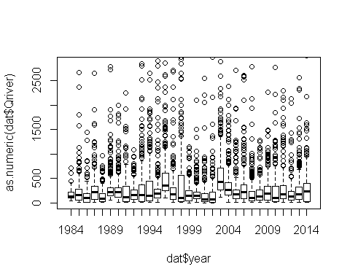

Qriver

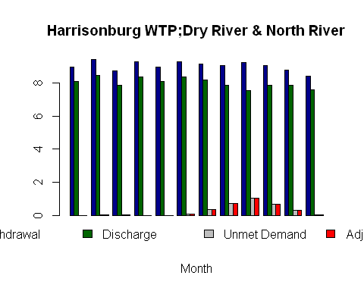

Qriver

Quantiles

|  |  |  |  |  |  |  |  |  |
| --- | --- | --- | --- | --- | --- | --- | --- | --- |
|  | availiable_mgd | Qintake | flowby | base_demand_mgd | adj_demand_mgd | wd_mgd | unmet_demand | drought_adj |
| 1% | 4.253101 | 7.353047 | 0.7735 | 8.463038 | 8.463038 | 4.253101 | 0 | 0 |
| 5% | 7.151348 | 11.836636 | 0.7735 | 8.463038 | 8.463038 | 7.151348 | 0 | 0 |
| 10% | 11.811719 | 19.046231 | 0.7735 | 8.747694 | 8.747694 | 8.463038 | 0 | 0 |
| 20% | 27.812635 | 43.799647 | 0.7735 | 8.966660 | 8.966660 | 8.747694 | 0 | 0 |
| 30% | 52.731497 | 82.349126 | 0.7735 | 8.977608 | 8.977608 | 8.966660 | 0 | 0 |

Rejected Demand

|  |  |
| --- | --- |
|  | Rejected Demand |
| 90% | 0.0000000 |
| 95% | 0.0000000 |
| 97% | 0.0000000 |
| 98% | 0.0000000 |
| 99% | 0.0000000 |
| 100% | 0.1986462 |