VWP CIA Summary (TEMPLATE)
JK
07/28/2021
This is an R Markdown document. This will serve as the template for VWP Project Model Summaries moving forward. For related GitHub issue see https://github.com/HARPgroup/vahydro/issues/317.

VAHydro Model Boilerplate:

VAHydro
The comprehensive VAHydro hydrologic model is used to evaluate surface water supply availability for permitting projects throughout Virginia. The VAHydro model simulates streamflow with inputs such as precipitation, climate, land use, and topography, as well as local data collected through DEQ water supply planning and reporting programs including all known withdrawals and discharges, as well as operational rules of VWP permits and major hydrologic features such as reservoirs.
The VAHydro model is built on rainfall-evaporation-runoff (RER) time-series from the Chesapeake Bay Model Phase 6 which runs from 1984-2014 in the Chesapeake Bay watershed drainage, and 1984-2005 in the rivers flowing outside of the Chesapeake Bay watershed, aka the “southern rivers.” The VAHydro model features high-resolution hydrologic subsections called “river segments” (over 600 river segments in total), roughly the size of HUC 10 hydrologic units, with additional high-resolution segments added for VWP modeling projects as needed.

CIA
DEQ assesses water supply sustainability through Cumulative Impact Analysis (CIA) modeling. CIA is a modeling and analysis approach that takes into account the varied hydrologic process occurring throughout a river network (including meteorology and human water use). By simulating a daily water balance for every individual river segment within a watershed, DEQ is able to evaluate the potential “cumulative impact” of all streamflow changes occurring upstream of any location within the river network, as well as the downstream impact of individual permitted withdrawal operations.
The goal of the folloing analysis was to estimate the potential impacts of the requested water withdrawal upon existing beneficial uses, including both in-stream and off-stream uses.

Project Introduction (To be provided by permit writer)
Lorem ipsum dolor sit amet, consectetur adipiscing elit. Nulla eu pulvinar arcu, quis aliquam dui. In at cursus ante. Vestibulum non sagittis lacus. Duis vitae iaculis dui. Vivamus tempor, nibh ut pretium tempus, enim lorem dignissim quam, at euismod massa magna at magna. Sed facilisis dapibus diam nec volutpat. Maecenas facilisis dapibus egestas. Curabitur dignissim pharetra pulvinar. Nunc bibendum elit sed cursus congue. Curabitur ligula quam, iaculis faucibus orci quis, vestibulum lobortis lectus. Suspendisse fringilla nisl pulvinar, laoreet tellus sed, sollicitudin tortor. Donec consequat congue erat in iaculis. Curabitur luctus tellus ut turpis iaculis, nec laoreet ligula scelerisque.
Curabitur ligula quam, iaculis faucibus orci quis, vestibulum lobortis lectus. Suspendisse fringilla nisl pulvinar, laoreet tellus sed, sollicitudin tortor. Donec consequat congue erat in iaculis. Curabitur luctus tellus ut turpis iaculis, nec laoreet ligula scelerisque.
Lorem ipsum dolor sit amet, consectetur adipiscing elit. Nulla eu pulvinar arcu, quis aliquam dui. In at cursus ante. Vestibulum non sagittis lacus. Duis vitae iaculis dui. Vivamus tempor, nibh ut pretium tempus, enim lorem dignissim quam, at euismod massa magna at magna. Sed facilisis dapibus diam nec volutpat. Maecenas facilisis dapibus egestas. Curabitur dignissim pharetra pulvinar. Nunc bibendum elit sed cursus congue. Curabitur ligula quam, iaculis faucibus orci quis, vestibulum lobortis lectus. Suspendisse fringilla nisl pulvinar, laoreet tellus sed, sollicitudin tortor. Donec consequat congue erat in iaculis. Curabitur luctus tellus ut turpis iaculis, nec laoreet ligula scelerisque.

Location Map
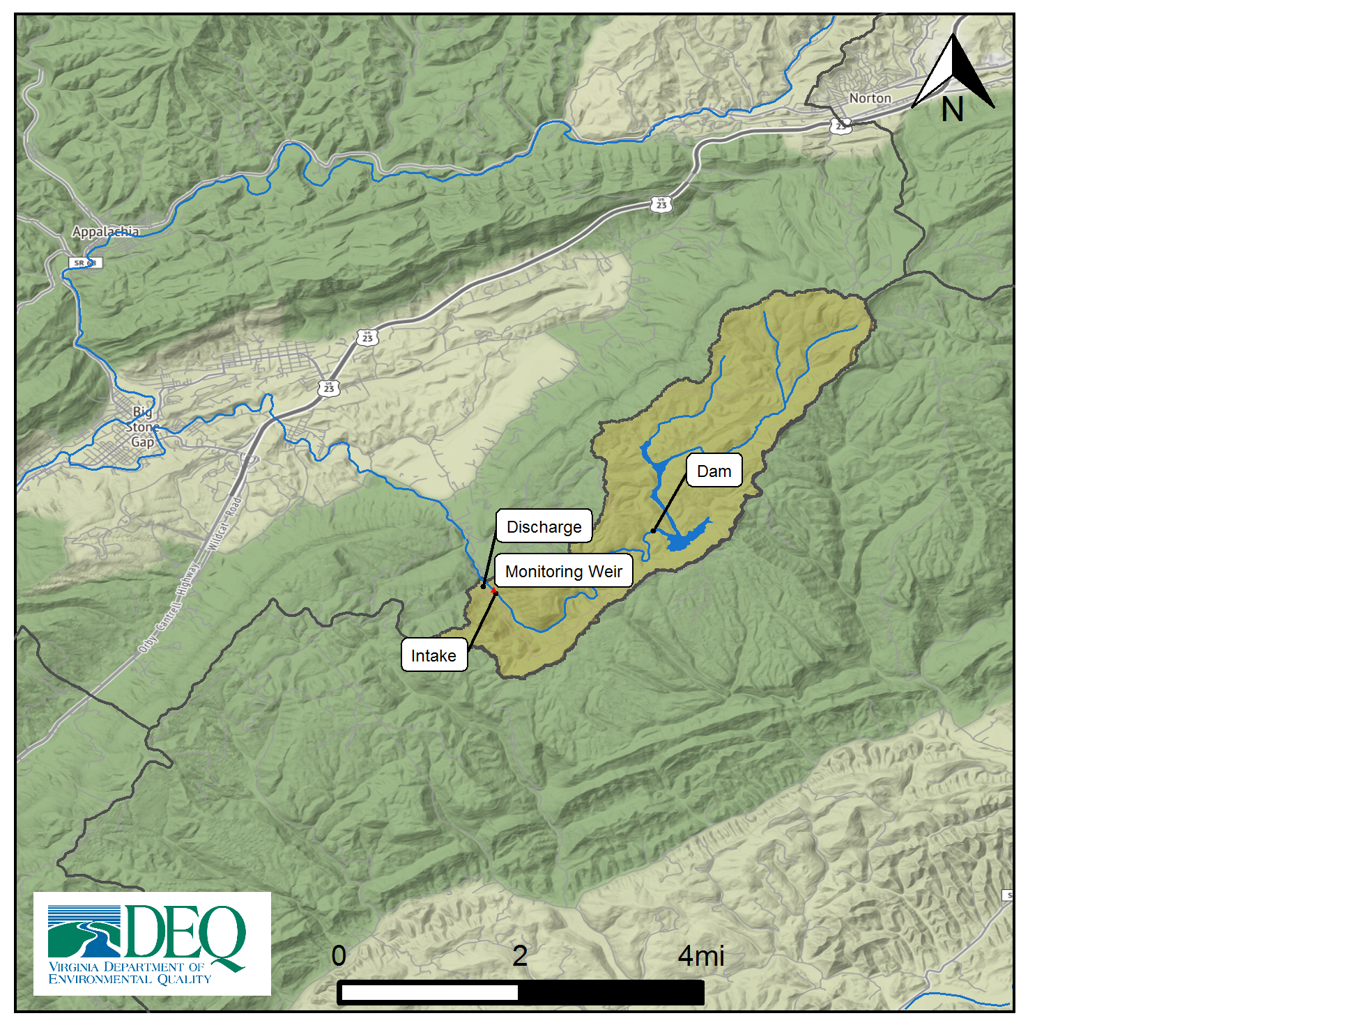

Model Overview and Scenario Descriptions
River Model Description River segment model overview not provided.
Facility & Intake Model Description Big Cherry Dam on the South Fork Powell River is modeled as an on-stream impoundment with an upstream contributing area of XX square miles. The model simulates the stream below Big Cherry Dam including the withdrawal for use by the Big Stone gap water treatment plant, down to the outfall of the wastewater treatment plant return flow. Analysis of cumulative impacts is based on the net diversion after the treated wastewater is discharged back into the stream. The safe yield of the intake is listed as 3.2 mgd from a study published in 2001 (3.2 mgd is equivalent to the permit annual withdrawal limit of 1168 mg/yr). + The data for the study was collected in 1997, which predates the drought period of 1999-2002.
The following model scenarios were simulated in order to determine the most effective means of meeting the project need and all other in-stream beneficial uses:
- Reported Use (Reported Use) - The reported use scenario is modeled withdrawing around 2 mgd/day on average based on current reported withdrawals.
- Total Permitted (Total Permitted) - The total permitted scenario is modeled with an annual withdrawal limit of 1168 mg/yr (3.2 mgd) and a static flowby of 0.5 mgd.
- Draft Alternative #1 (90% Flow-by) - The 90% Flow-by scenario is modeled with an annual withdrawal limit of 1168 mg/yr (3.2 mgd) and a flowby of 90%.
- Draft Alternative #2 (40% Flow-by) - The 40% Flow-by scenario is modeled with an annual withdrawal limit of 1168 mg/yr (3.2 mgd) and a flowby of 40%.

Intake Site Description & Current Estimated Stream Flows

Model Summary Results - Conclusion/Recommendation
- Reported Use - Outcomes from the particular set of operational rules and scenario conditions. Ex: The 90% flow-by scenario results in more flexibility to pump under extremely dry conditions, as compared to the current static MIF permit condition. As a result, the operation is able to meet offstream need during all simulated periods, with a small amount of water remaining during the lowest simulated flow.
- Total Permitted - Outcomes from the particular set of operational rules and scenario conditions. Ex: The 90% flow-by scenario results in more flexibility to pump under extremely dry conditions, as compared to the current static MIF permit condition. As a result, the operation is able to meet offstream need during all simulated periods, with a small amount of water remaining during the lowest simulated flow.
- Draft Alternative #1 - Outcomes from the particular set of operational rules and scenario conditions. Ex: The 90% flow-by scenario results in more flexibility to pump under extremely dry conditions, as compared to the current static MIF permit condition. As a result, the operation is able to meet offstream need during all simulated periods, with a small amount of water remaining during the lowest simulated flow.
- Draft Alternative #2 - Outcomes from the particular set of operational rules and scenario conditions. Ex: The 90% flow-by scenario results in more flexibility to pump under extremely dry conditions, as compared to the current static MIF permit condition. As a result, the operation is able to meet offstream need during all simulated periods, with a small amount of water remaining during the lowest simulated flow.

Stats Comparison Table:
Description | Reported Use | Total Permitted | 90% Flow-by | 40% Flow-by
runid | 201 | 401 | 6011 | 6012
River Segment | TU3_8880_9230_sf_below_big_cherry | TU3_8880_9230_sf_below_big_cherry | TU3_8880_9230_sf_below_big_cherry | TU3_8880_9230_sf_below_big_cherry
River Segment Model Statistics:
Flow Out (cfs) | 8.01 | 7.63 | 8.54 | 7.81
Flow Baseline (cfs) | 8.01 | 8.01 | 8.76 | 8.15
30 Day Low Flow (cfs) | 0.77 | 3.49 | 0.63 | 4.37
90 Day Low Flow (cfs) | 1.28 | 3.71 | 2.56 | 4.87
Consumptive Use Fraction | 0.00 | 0.05 | 0.03 | 0.04
Cumulative Withdrawal (mgd) | 0.00 | 2.47 | 1.45 | 2.18
Cumulative Point Source (mgd) | 0.00 | 2.22 | 1.31 | 1.97
Richness Change (abs) | 0.00 | -0.30 | -0.16 | -0.26
Richness Change (%) | 0.00 | -1.28 | -0.67 | -1.10
Facility Model Statistics:
Withdrawal (mgd) | 0.00 | 2.47 | 1.45 | 2.18
Point Source (mgd) | 0.00 | 2.22 | 1.31 | 1.97
Maximum 30 day potential unmet demand (mgd) | 0.00 | 1.25 | 3.09 | 1.46
Description | 201 | 401 | 6011 | 6012
River Segment | South Fork Powell River - Big Cherry Reservoir | South Fork Powell River - Big Cherry Reservoir | South Fork Powell River - Big Cherry Reservoir | South Fork Powell River - Big Cherry Reservoir
Minimum Days of Storage Remaining | 0.0 | 98.5 | 0.0 | 0.0

Reservoir Storage Plots:
## Number of properties found: 1

Reservoir Storage: run 201
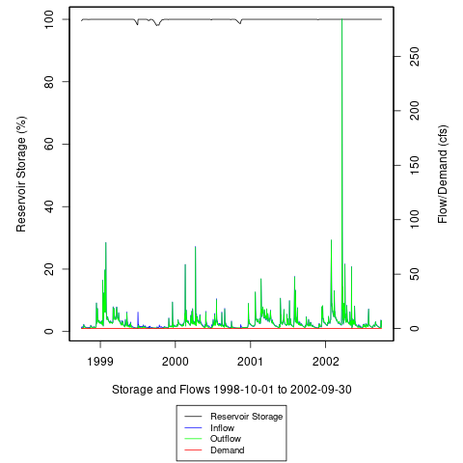

## Number of properties found: 1

Reservoir Storage: run 401
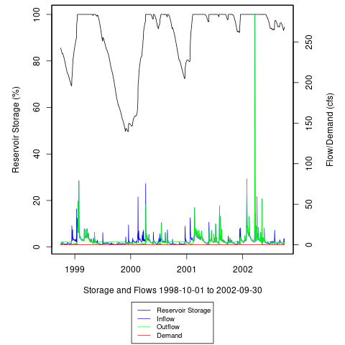

## Number of properties found: 1

Reservoir Storage: run 6011
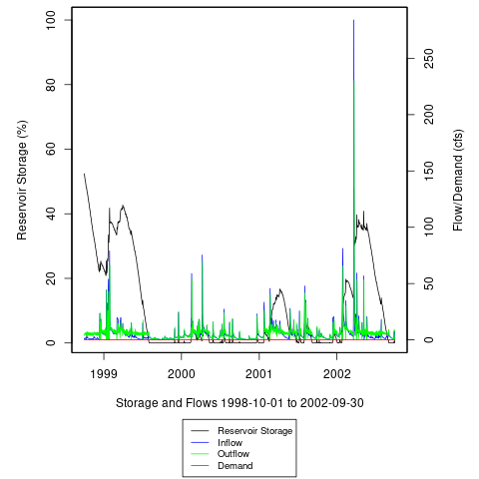

## Number of properties found: 1

Reservoir Storage: run 6012
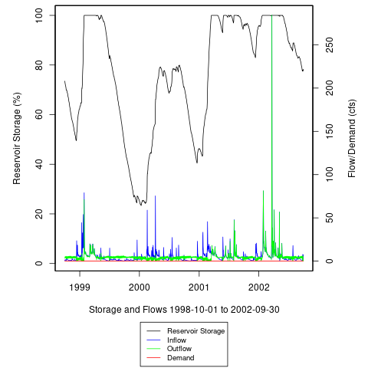

Unmet Demand Heatmaps:
## Number of properties found: 1

Reservoir Storage: run 201
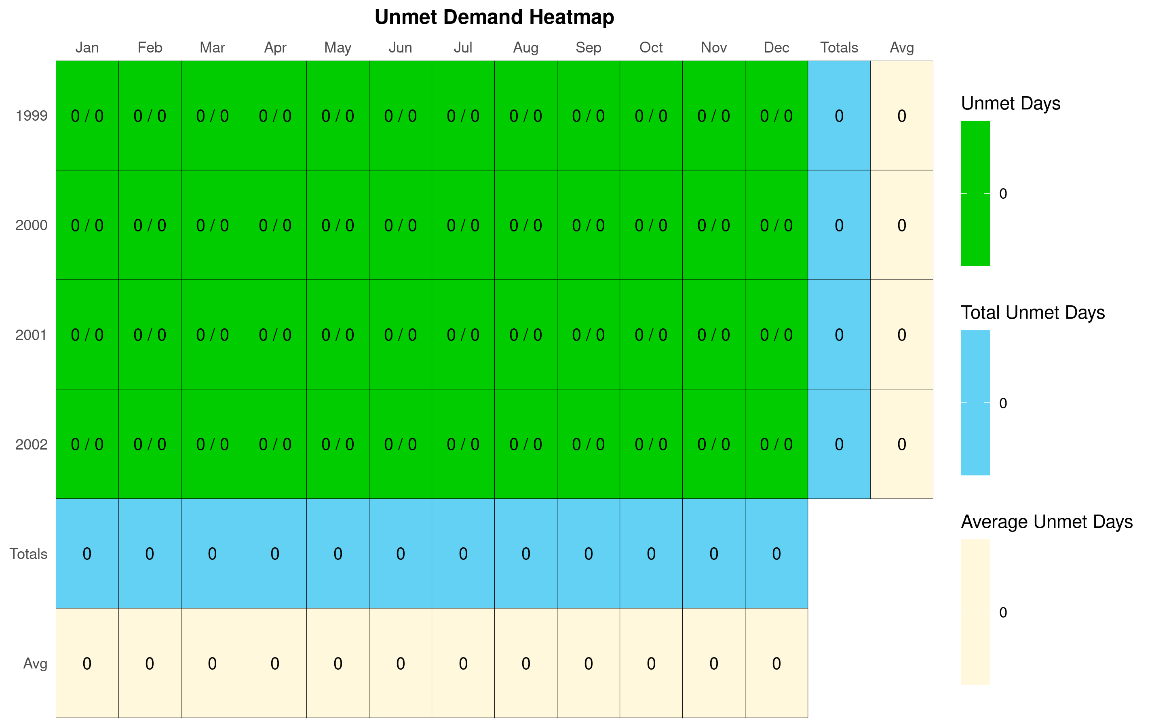
## Number of properties found: 1

Unmet Demand: run 201
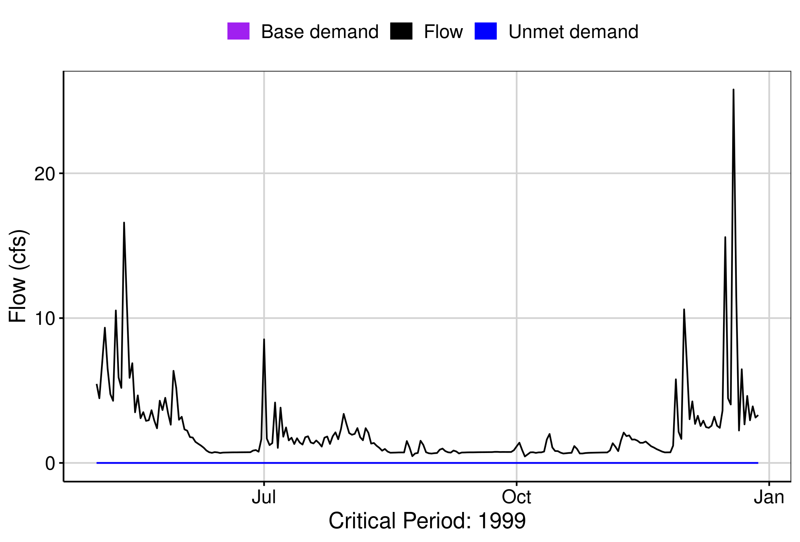

## This property does not exist
[1] “No local facility impoundment for run id 201”

## Number of properties found: 1

Reservoir Storage: run 401
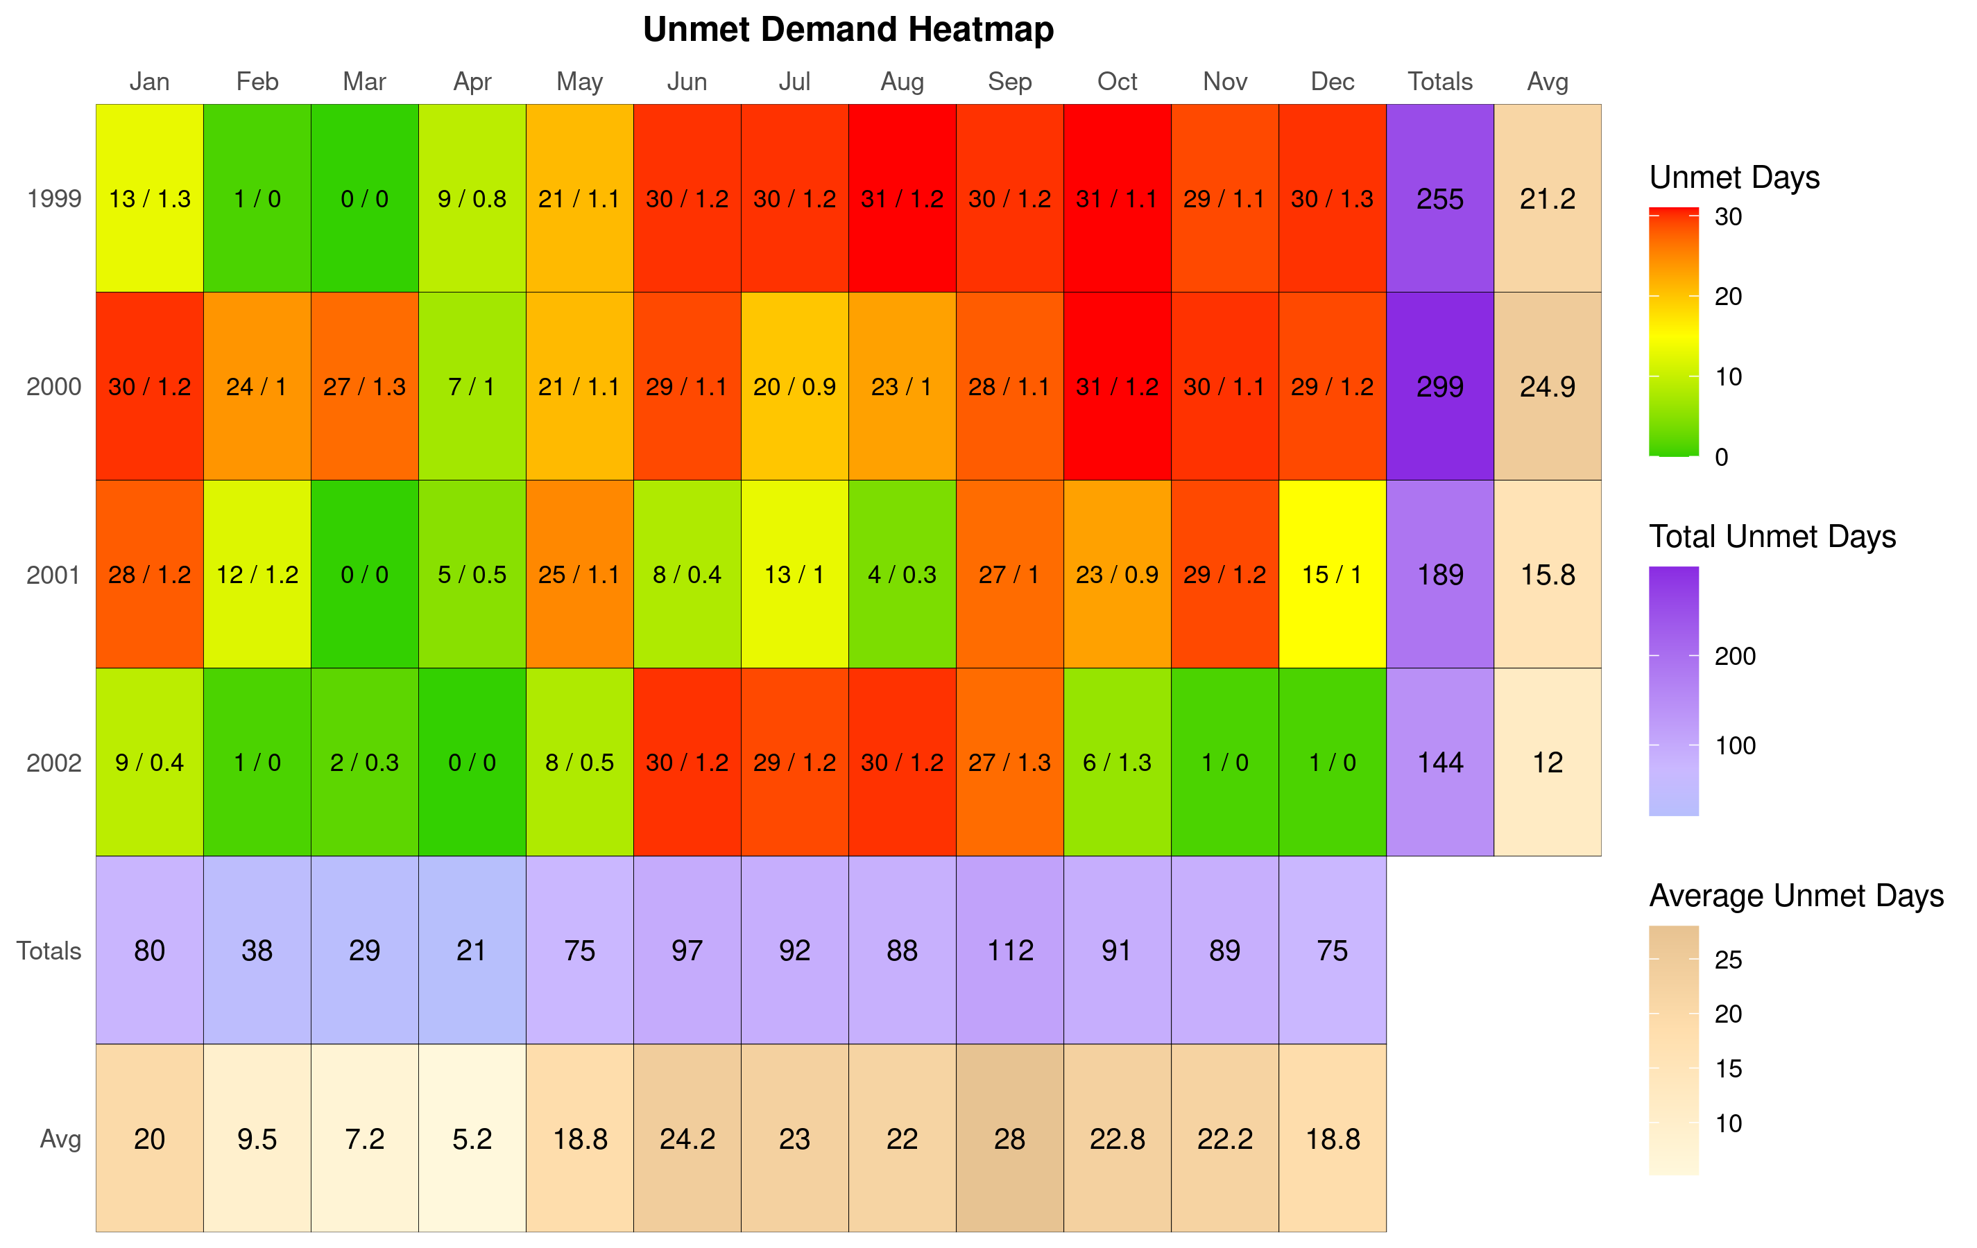
## Number of properties found: 1

Unmet Demand: run 401
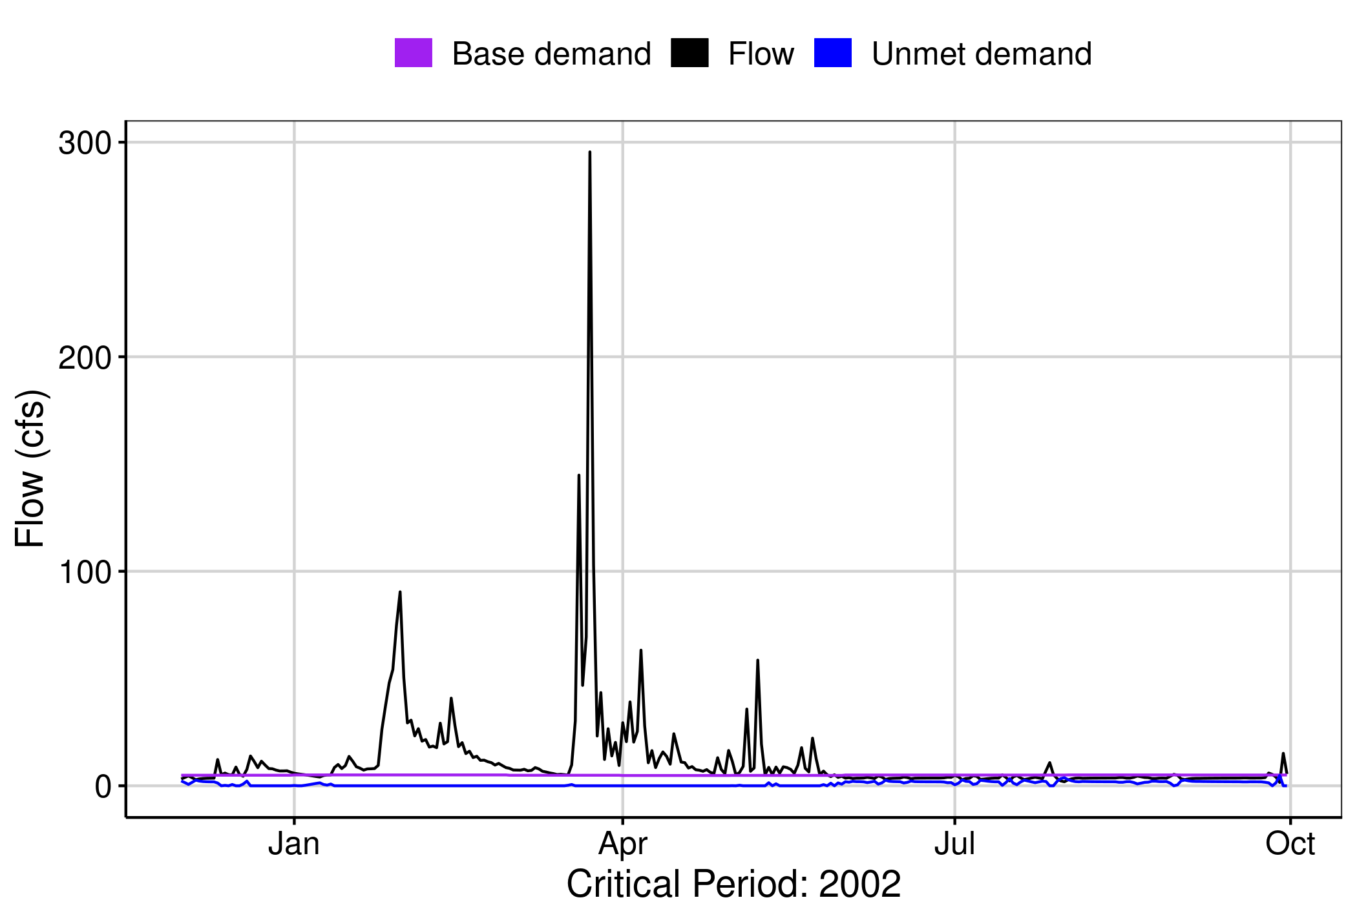

## This property does not exist
[1] “No local facility impoundment for run id 401”

## Number of properties found: 1

Reservoir Storage: run 6011
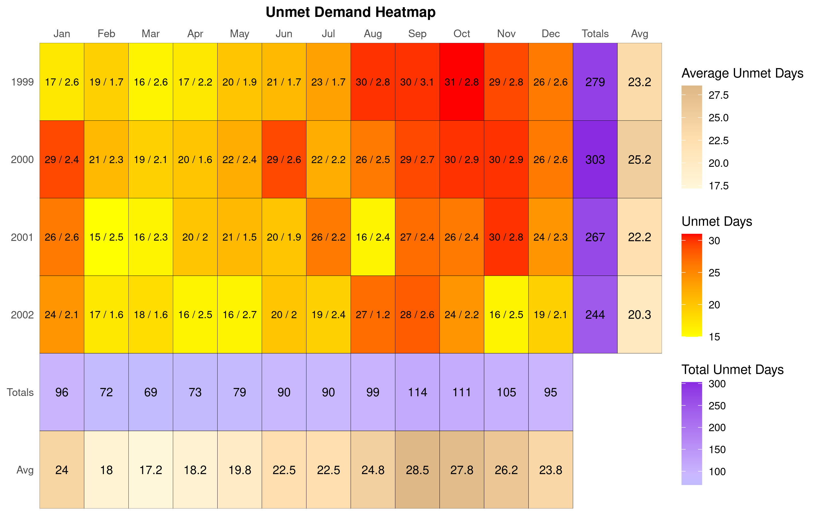
## Number of properties found: 1

Unmet Demand: run 6011
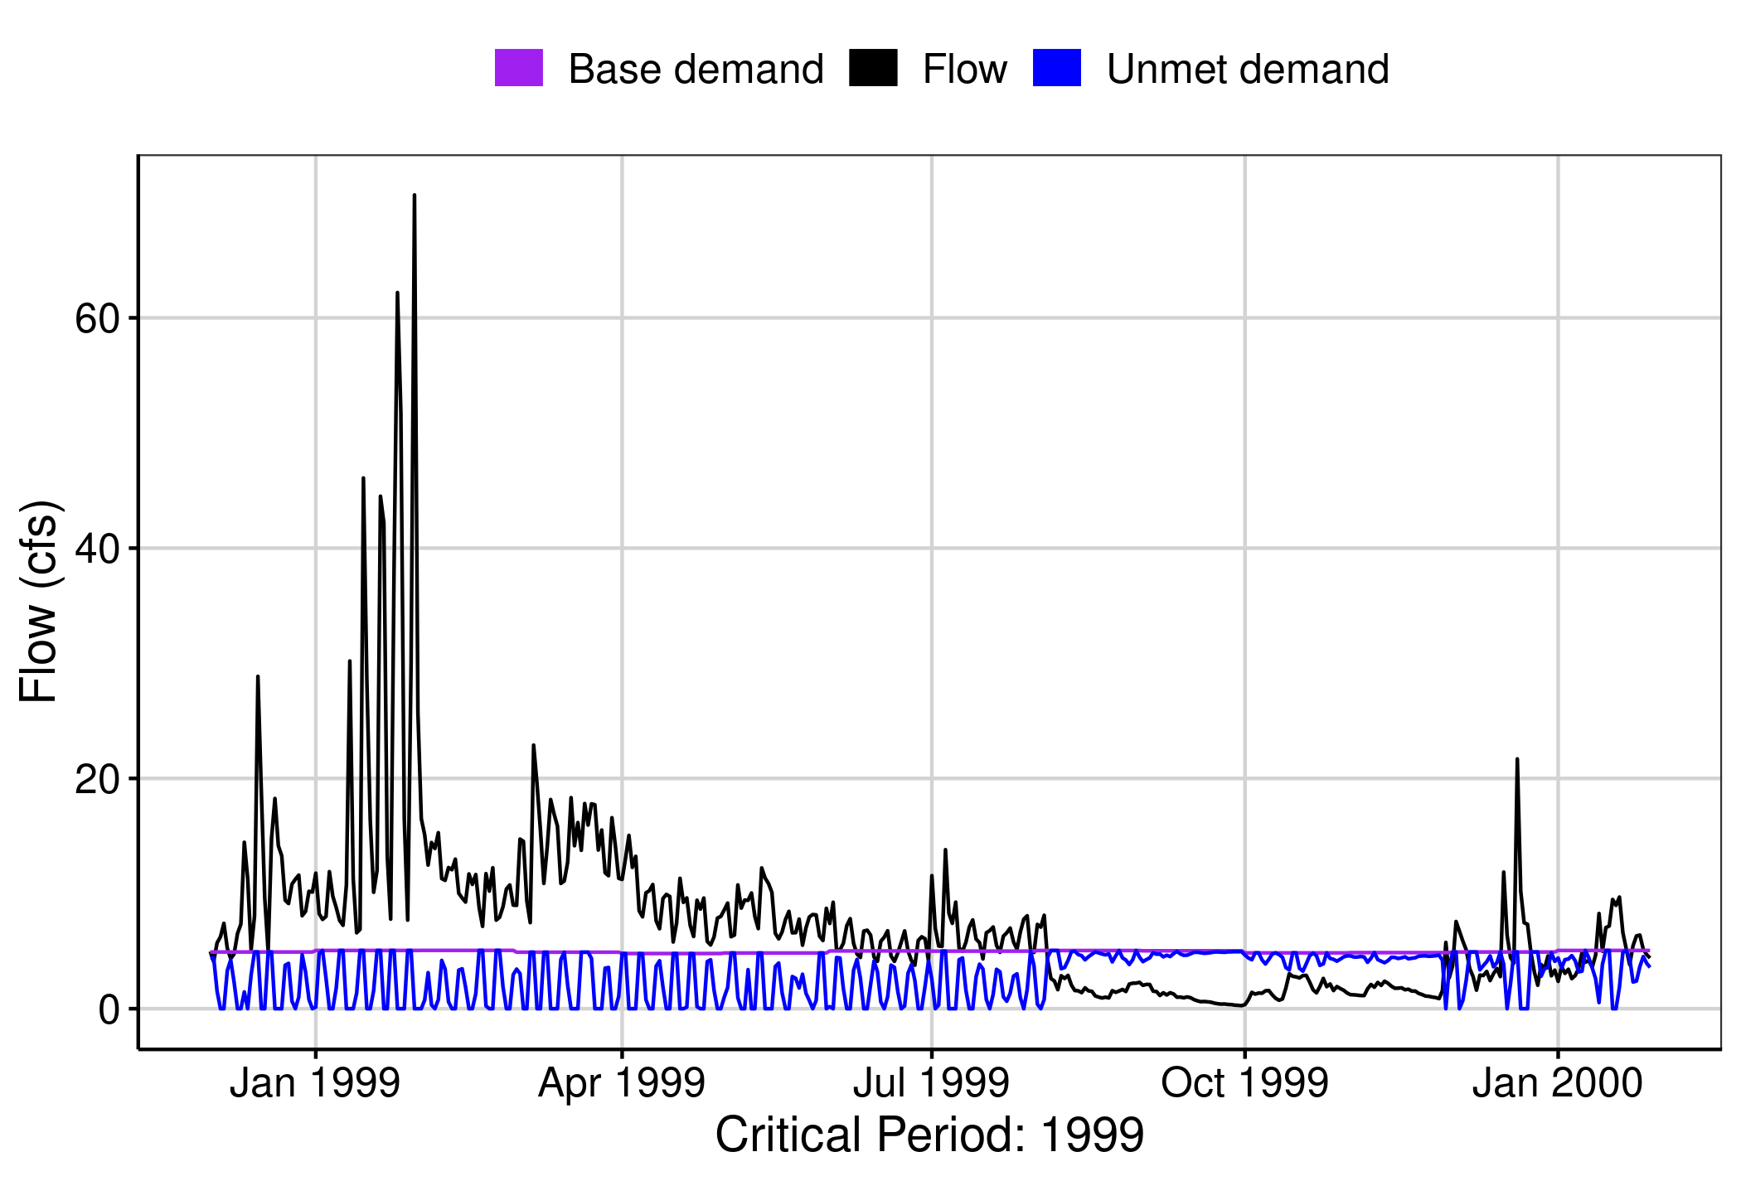

## This property does not exist
[1] “No local facility impoundment for run id 6011”

## Number of properties found: 1

Reservoir Storage: run 6012
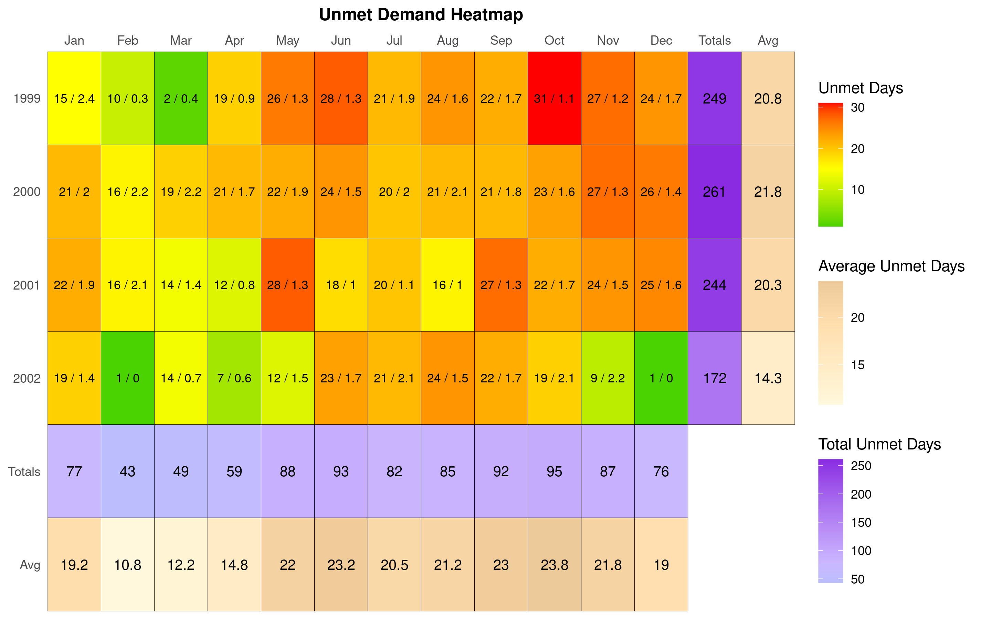
## Number of properties found: 1

Unmet Demand: run 6012
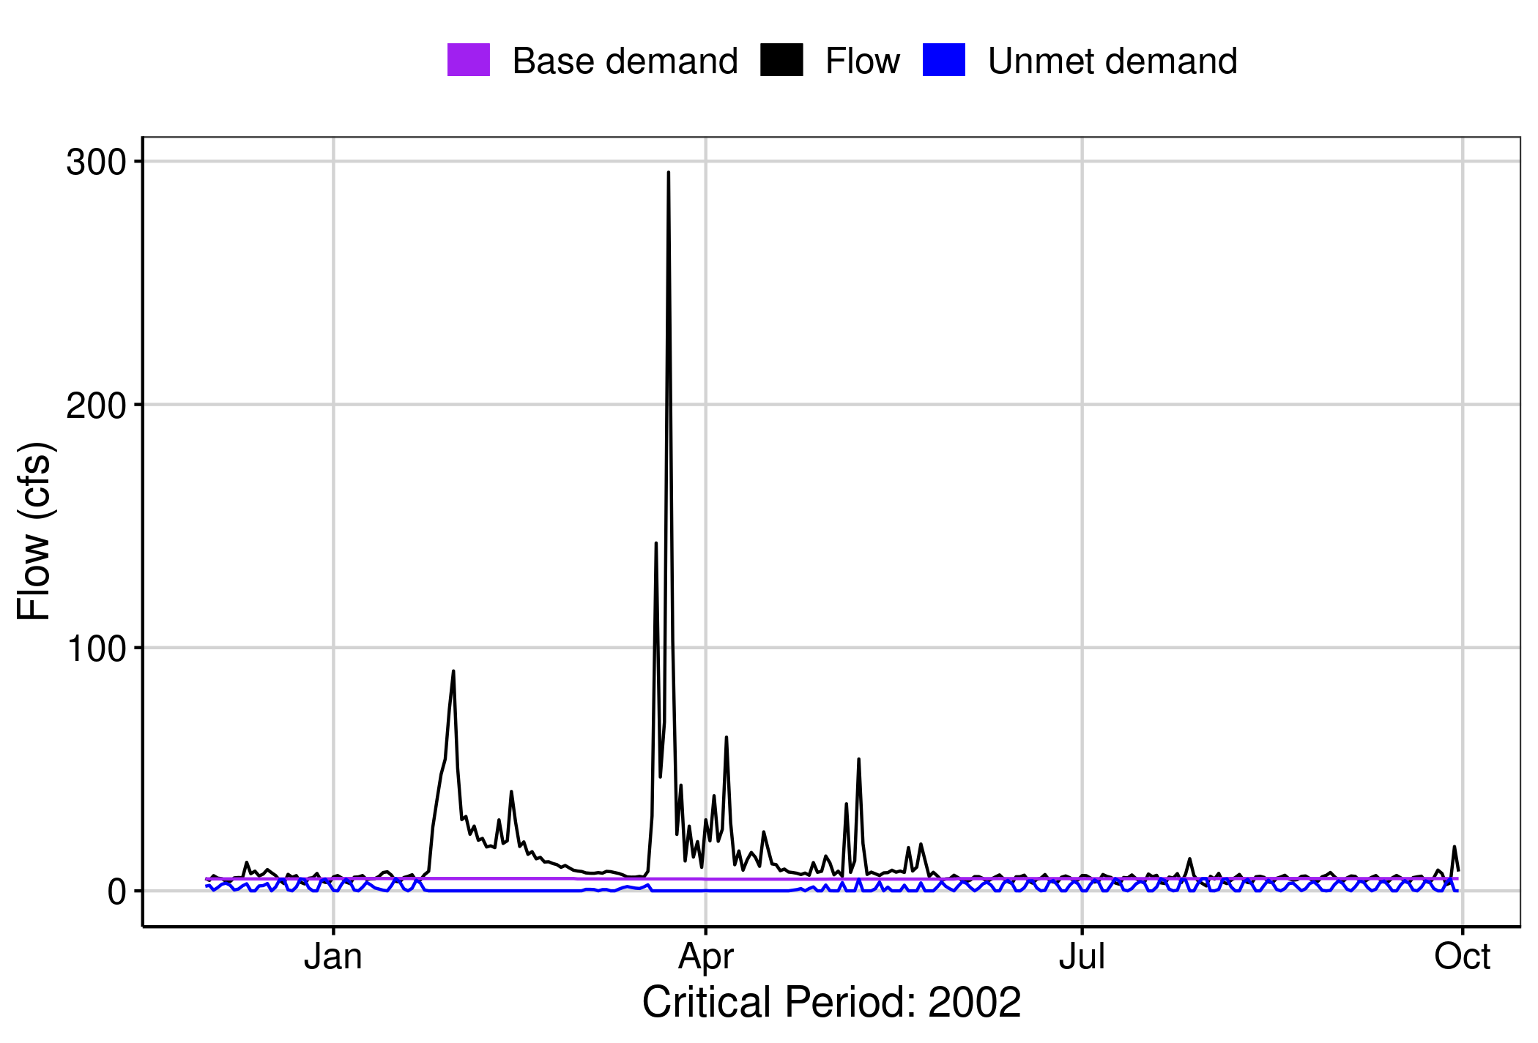

## This property does not exist
[1] “No local facility impoundment for run id 6012”

Ecological Impacts Assessment:

Elfgen:
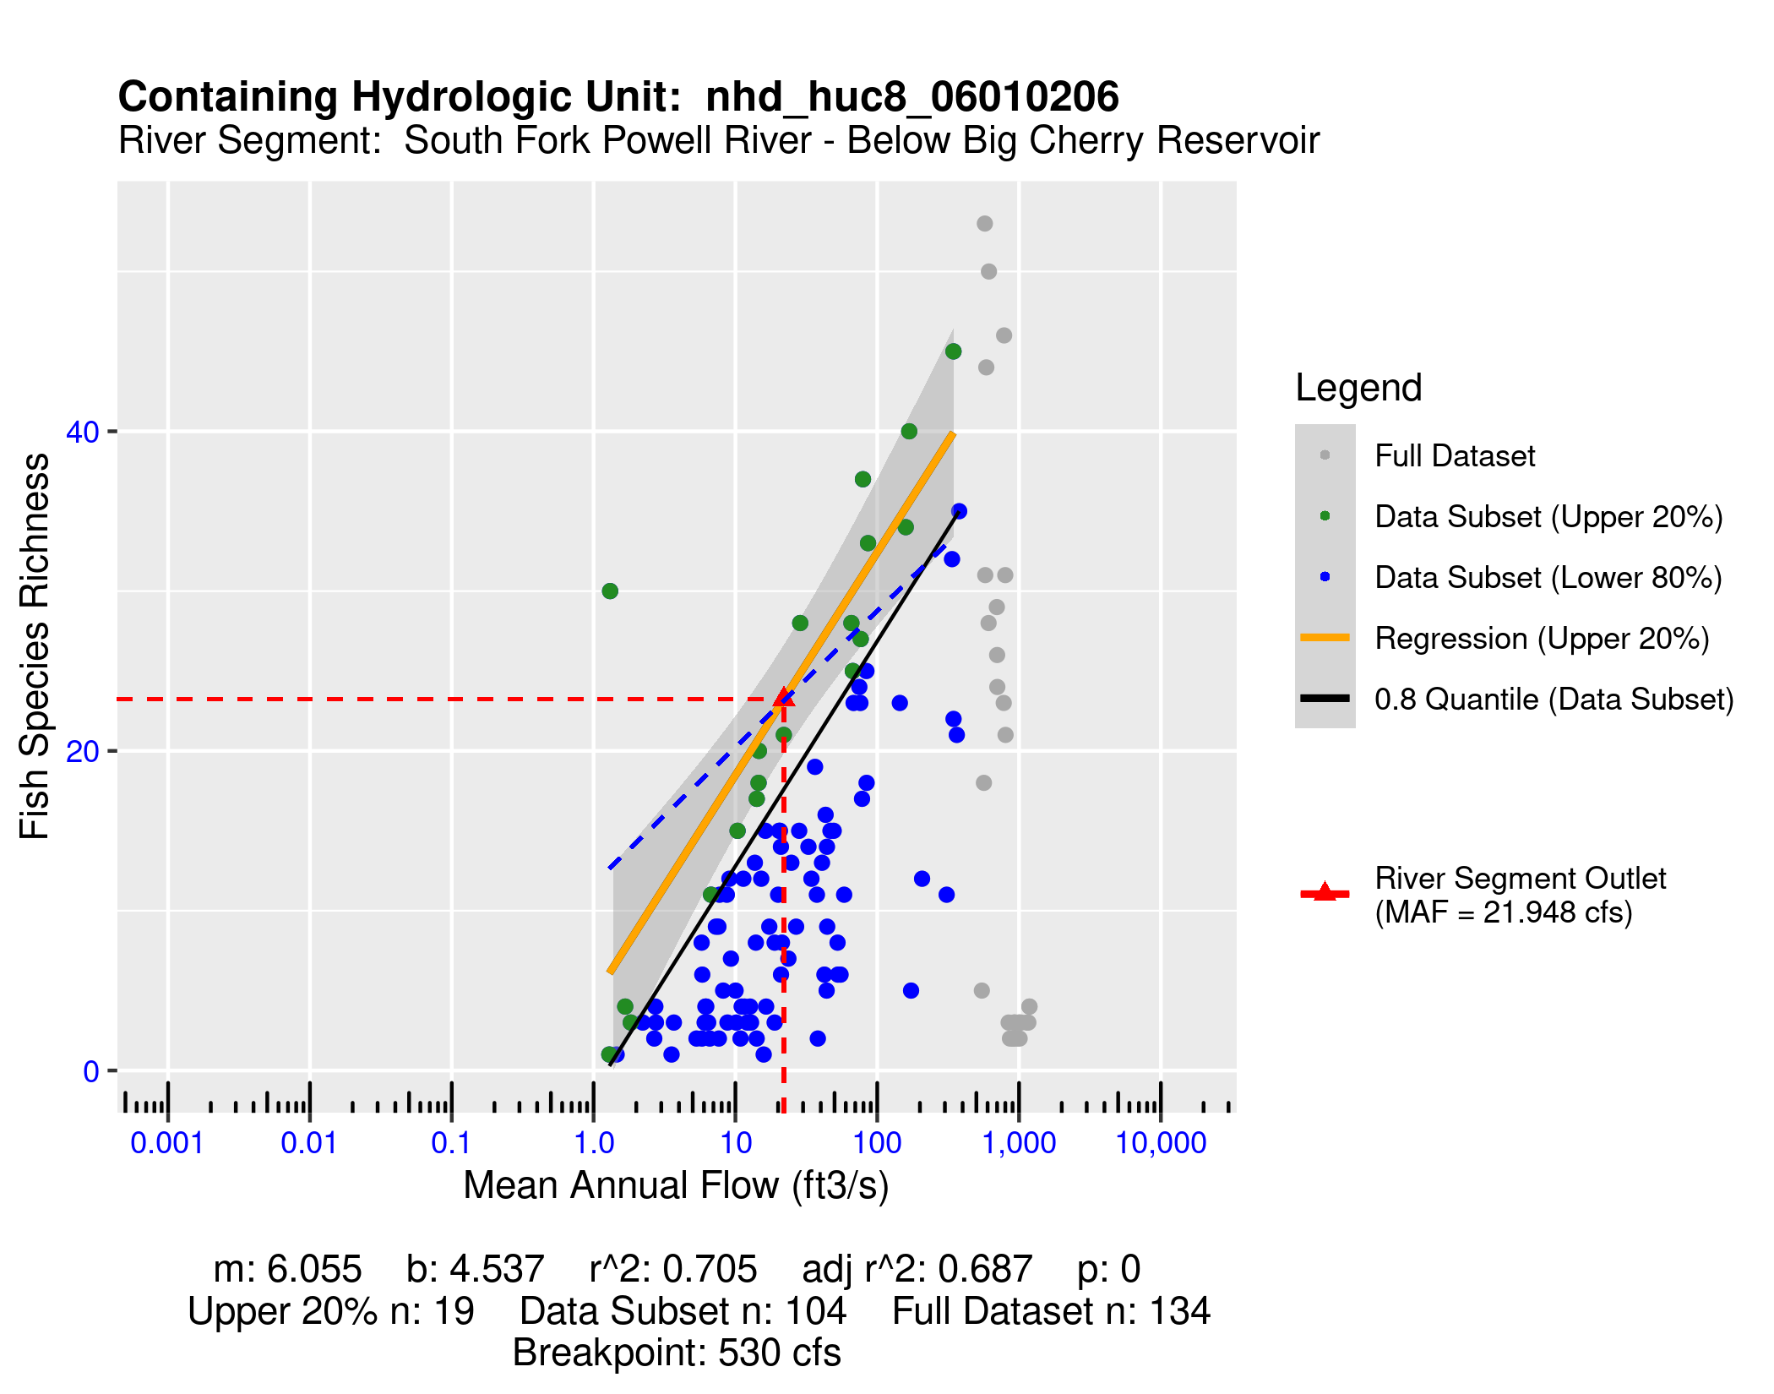

Habitat (If Applicable):

Additional Sections

Lorem ipsum dolor sit amet, consectetur adipiscing elit. Nulla eu pulvinar arcu, quis aliquam dui. In at cursus ante. Vestibulum non sagittis lacus. Duis vitae iaculis dui. Vivamus tempor, nibh ut pretium tempus, enim lorem dignissim quam, at euismod massa magna at magna. Sed facilisis dapibus diam nec volutpat. Maecenas facilisis dapibus egestas. Curabitur dignissim pharetra pulvinar. Nunc bibendum elit sed cursus congue. Curabitur ligula quam, iaculis faucibus orci quis, vestibulum lobortis lectus. Suspendisse fringilla nisl pulvinar, laoreet tellus sed, sollicitudin tortor. Donec consequat congue erat in iaculis. Curabitur luctus tellus ut turpis iaculis, nec laoreet ligula scelerisque.
Curabitur ligula quam, iaculis faucibus orci quis, vestibulum lobortis lectus. Suspendisse fringilla nisl pulvinar, laoreet tellus sed, sollicitudin tortor. Donec consequat congue erat in iaculis. Curabitur luctus tellus ut turpis iaculis, nec laoreet ligula scelerisque.
Lorem ipsum dolor sit amet, consectetur adipiscing elit. Nulla eu pulvinar arcu, quis aliquam dui. In at cursus ante. Vestibulum non sagittis lacus. Duis vitae iaculis dui. Vivamus tempor, nibh ut pretium tempus, enim lorem dignissim quam, at euismod massa magna at magna. Sed facilisis dapibus diam nec volutpat. Maecenas facilisis dapibus egestas. Curabitur dignissim pharetra pulvinar. Nunc bibendum elit sed cursus congue. Curabitur ligula quam, iaculis faucibus orci quis, vestibulum lobortis lectus. Suspendisse fringilla nisl pulvinar, laoreet tellus sed, sollicitudin tortor. Donec consequat congue erat in iaculis. Curabitur luctus tellus ut turpis iaculis, nec laoreet ligula scelerisque.

