Fundamentals of website Development

https://harrisnipes.github.io/DAP416/Assignment/Rehash/index.html

Student No: 19062354

Contents

Introduction 2

Development 2

Method 2

2

Bootstrap: 3

Grid: 3

Choice Summary 3

Design Choices 3

Recommendations 3

Improvements Made 4

Accessibility 6

SEO 6

Future Improvements 6

Summary 7

Bibliography 8

# Introduction

This a report on my process of redevelopment of the [Testemp](http://www.testemp.co.uk/) Site. Comprising: Development, Accessibility, SEO, Future Improvements, & Summary.

# Development

## Method

The site was designed using a combination of flex-box and CSS grid. This was decided upon after a mix of trial and error, also trialling bootstrap.

Figure : Bootstrap attempt

### 

Figure : exclusively html and CSS

### Bootstrap:

Pros:

* Concise,
* Adaptable
* Mobile responsive
* Widely supported

Cons:

* Resource Expensive
* Unknown code
* Restrictive
* Unanticipated result

### Grid:

Pros

* Highly granular control
* Easy to diagnose
* Resource light

Cons

* Not entirely supported
* Code-heavy

### Choice Summary

Unfortunately CSS grid is not as widely supported by older browsers, although the proportion of the market share of browsers that support it (and its features) is roughly [90-94%](https://caniuse.com/#search=grid). Bootstrap, being an external framework to any specific browser (Bootstrap, 2020), is slightly better supported.

The main use case for a site such as this would be an office-based purchasing department, it would likely be visited by computer users, with devices kept up to date and managed by an IT department for legal and security requirements. Therefore, concern for older browsers is an afterthought.

## Design Choices

### Recommendations

Feedback from the senior purchaser for an electronics department remarked the following points about the original site (paraphrased):

* No parametric search (engineers may not always know the components they want, searching for it by feature/specification)
* No part string search (when switching suppliers, it’s good to be able to quickly interrogate parts especially considering copy-exact principles (Neutronics, 2018))
* Stock and lead-time indicators or part availability(manufacturing requires excellent timing and runs off just-in-time principles in order to keep inventory low, the purchaser mentioned he would probably leave the website if this feature wasn’t available).

### Improvements Made

Unfortunately, the implementation of those features is beyond the scope of this module and would require extensive back-end development, although they are critical features of a modern supplier’s website and would be passed on for further development.

The navigation of the site was adapted in three small ways, the logo now has a clickable link to return to the homepage, and a dropdown menu so that product categories can be quickly reached from other pages. The navigation bar is also mobile responsive for optimising screen real estate.

The logo, phone number, email, and fax, are all displayed at the top of the screen as text as opposed to images and they’re categorized respectively so that mobile users and search engines can quickly pick up on contact methods.

Additonally, the entire site is mobile responsive through use of CSS grid, whereas the majority of the layout was controlled through tables. The responsive layout ensures that items on the screen remain a readable an interactable size.

Figure Original site in desktop and mobile screen widths

Figure Updated site, with responsive layout

# Accessibility

In line with [current standards](https://www.w3.org/WAI/tips/developing/) the new website is also navigable by keyboard with clear interactive item selection (chrome). Plus, all images now have alt tags, and text separate from the images for screen readers, and aria labels for font awesome icons. Many errors were picked up on using an [online accessibility checker](https://www.powermapper.com/)

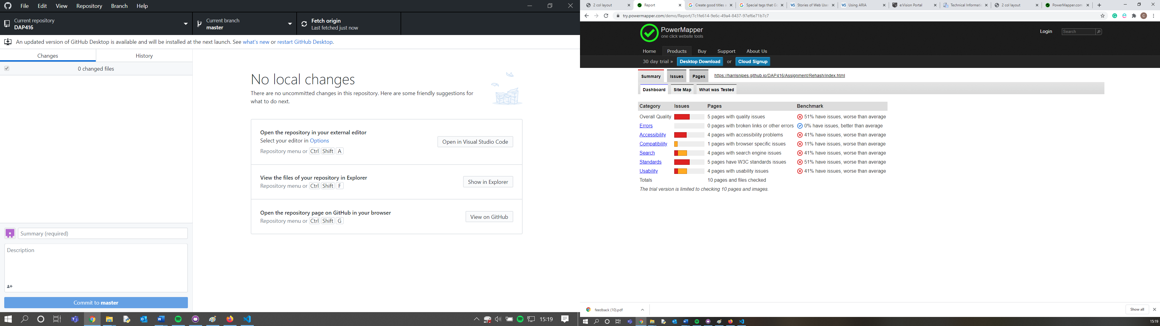

Figure : Before

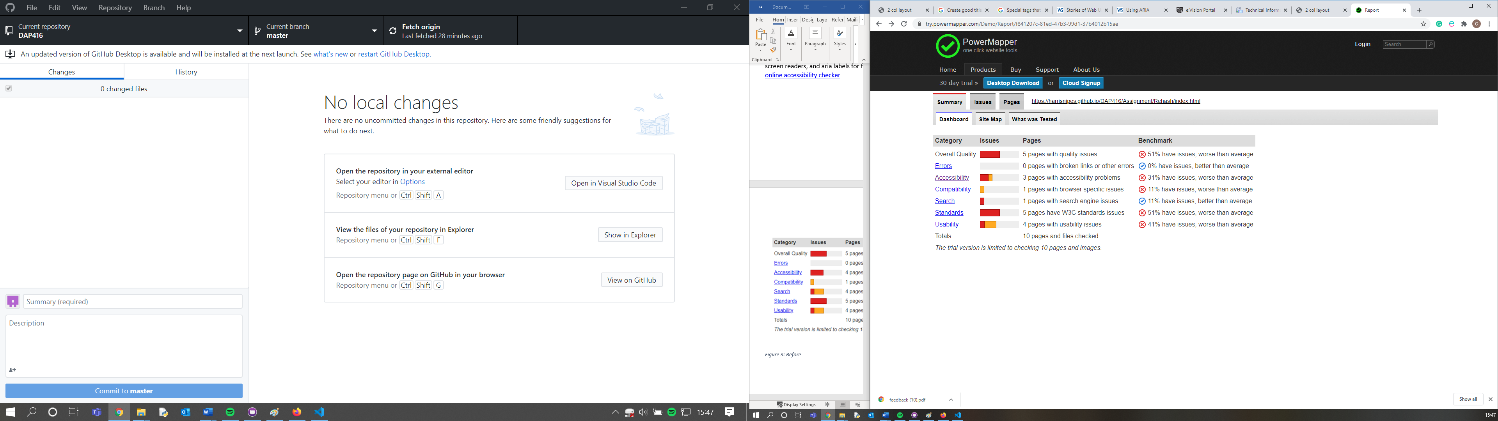

Figure After

I believe the remaining accessibility shortfalls are errors in the checking, since it complains about empty <a> tags where there are font-awesome icons with aria-labels

# SEO

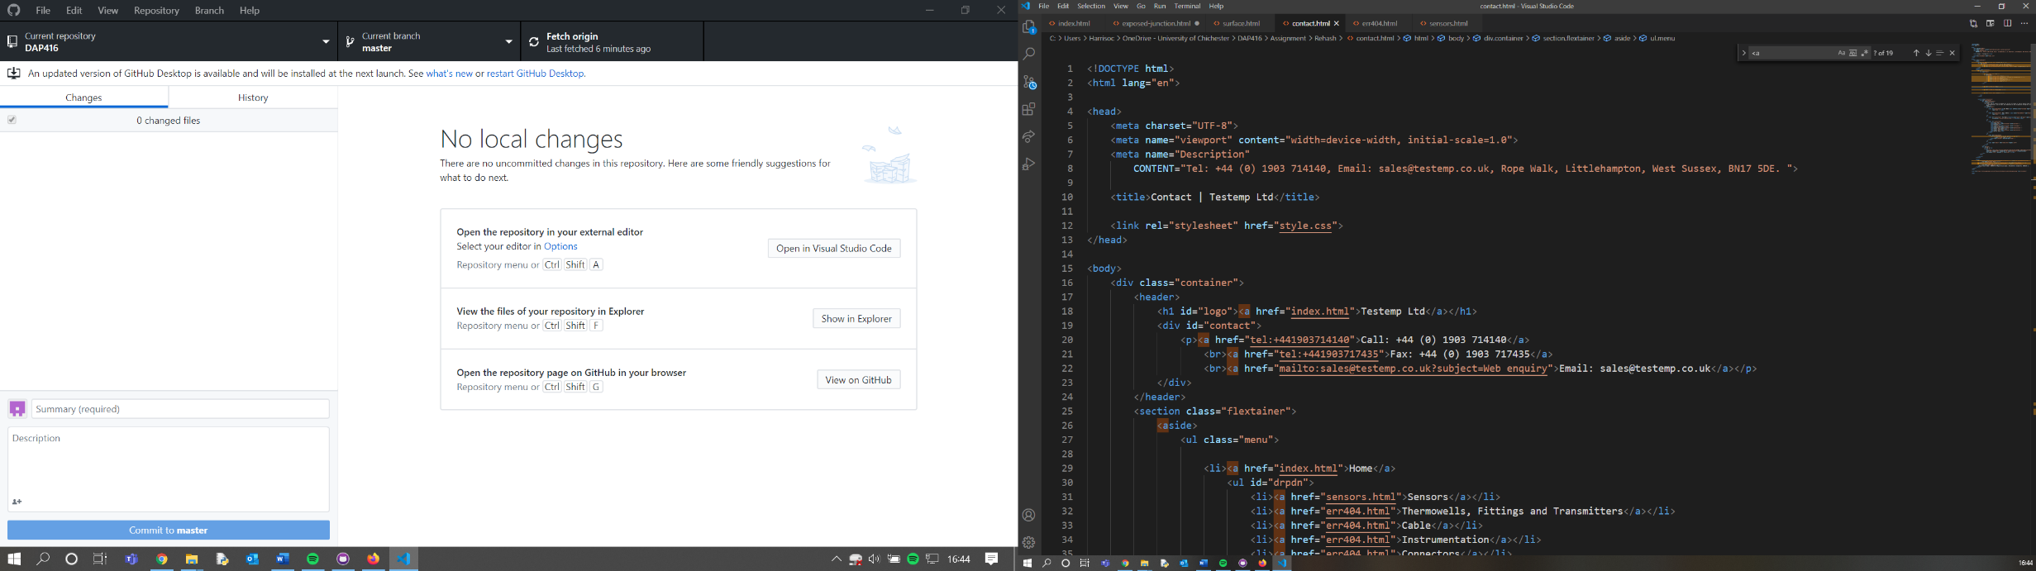A meaningful meta description and title has been provided on each page, and every imaged has been resized to its required resolution to minimise loading times to favour SEO (Google, 2020)

Figure : Meta descriptor

# Future Improvements

As mentioned, there would be a lot of scope to improve this site through back-end features, such as displaying stock, quantities, lead times. Additionally, I would add a sitemap to assist with SEO and accessibility. Finally, due to time constraints it was difficult to cater to smaller mobile display sizes with backgrounds revealing whitespace and content bleeding over borders. I would also research more SEO and accessibility features, as I feel I have only begun to understand how to implement many of them.

# Summary

In reflection, I am surprised at how responsive the webpage is, interactivity, and the animations achievable exclusively with HTML and CSS considering no prior experience, it was also revealing how restrictive the language can be compared to programming an applications GUI interface.

.

# Bibliography

Bootstrap, 2020. *Browsers and Devices.* [Online]   
Available at: https://getbootstrap.com/docs/4.0/getting-started/browsers-devices/#supported-browsers  
[Accessed 13 07 2020].

Google, 2020. *Search appearance.* [Online]   
Available at: https://support.google.com/webmasters/answer/35624#1  
[Accessed 13 7 2020].

Neutronics, 2018. *Copy Exact Resources.* [Online]   
Available at: https://neutronicsinc.com/copy-exact/  
[Accessed 13 7 2020].