FreshBasket Loyalty Churn Prediction: Final Report
FreshBasket Retail
Table of Contents
1. Executive summary 2
2. Problem and scope 2
3. Data and quality audit 2
4. Methodology 4
4.1 Leakage-safe features 4
4.2 Validation design 5
4.3 Models 5
5. Results 5
5.1 Model comparison on the held-out cohort 5
5.2 Out-of-time backtest 6
5.3 Class imbalance 6
5.4 Ablation study 6
6. Drivers of churn 7
6.1 Model attribution (SHAP, validation cohort) 7
6.2 Adjusted associations among active members 8
7. Risk by segment 9
8. Retention scenarios 10
8.1 Model what-if (validation active base, n=592) 10
8.2 Targeting economics (active base, n=1,653, 114 churners) 10
8.3 Forward scores for Jul-Sep 2024 11
8.4 Validation of the forward scores 11
9. Recommendations 12
10. Limitations 12
11. Reproducibility 13

Data window Jan-2023 to Jun-2024; features to Mar-2024, label window Apr-Jun 2024. Code, tables and charts are in the accompanying churn_project folder.

1. Executive summary
FreshBasket wants to know which loyalty members will stop shopping, why, and where retention spend should go. The main findings:
- Most churn is already visible. Of 2,368 members with purchase history, 34.3% churned. The 715 members who had not bought for 2+ months by March 2024 churned 97.8% of the time. A one-line rule (no purchase in 2 months) scores PR-AUC 0.865 on the held-out cohort, but cannot warn about anyone still shopping.
- The real early-warning problem is the 1,653 members who bought in Feb or Mar 2024 (the active base). Only 6.9% of them (114) churned. On this group the rule has zero recall, while the tuned LightGBM model reaches PR-AUC 0.60 against a 7.6% prevalence (about 8x random) and a top-decile lift of 6.0.
- Engagement and purchase behaviour drive the prediction. Demographics alone are no better than chance (PR-AUC 0.24 against 0.22 prevalence). Behavioural features carry about 51% of model attribution and engagement about 44%. Support tickets carry about 4% in the model, but are strongly associated with churn among active members (2.4% churn with no tickets, 18.4% with 2+ in six months).
- Tier, city, age, gender and preferred category do not separate churn risk once activity is accounted for (chi-square p from 0.12 to 0.98 on the active base).
- Targeting beats blanket offers. Under stated assumptions, a blanket offer to all active members earns an ROI of 0.54 at a 20% churn reduction and loses money at 10%. Contacting the top 10% by predicted risk reaches 74% of would-be churners with an ROI of 8.8.
- The forward scoring procedure replays well. Repeated one period earlier, it ranked active members well (PR-AUC 0.637), stayed calibrated (6.3% predicted vs 6.9% observed) and its risk bands separated outcomes (72% / 22.5% / 2.5% churn for High / Medium / Low). The Jul-Sep 2024 scores themselves cannot be checked until those outcomes exist.

2. Problem and scope
The business asked four questions: who will churn in the near term, which behavioural, engagement and support signals precede churn, whether tier, marketing engagement or support experience change risk, and which retention actions are realistic. The target is CHURNED (zero transactions in Apr-Jun 2024 despite earlier purchase history). Predictions are made at member level using only activity up to March 2024.

3. Data and quality audit
Three tables were joined: profile (2,600 members), monthly activity (28,073 rows) and churn label. Row 1 of every sheet is a title banner, so headers start on row 2.
Issue | Count | Treatment
Exact duplicate rows | 8 profile, 5 label, 58 activity (plus 2 conflicting customer-months) | Dropped, first kept
Casing and whitespace | Tier 12 variants to 3; city 40 variants to 10 | Strip and title-case
Missing profile values | Age 78, gender 52, home price tier 130 | Median or ‘Unknown’, plus an age-missing flag
Negative spend | 23 | Rebuilt as average basket x transactions
Zero spend with transactions > 0 | 20 | Rebuilt the same way
Outlier spend (>5x implied; max $3,731 vs 99.9th percentile $680) | 13 | Rebuilt the same way
Zero-transaction months | 2,330 | Kept; valid inactivity and real signal
Missing months inside a member’s history | 2,086 months across 1,644 members | Left as NaN, excluded from averages, counted as a feature
Members whose rows stop before Jun-2024 | 1,040 | Later months treated as zero activity
Members with no purchase on or before Mar-2024 | 232 | Excluded; churn is undefined for them
Official label differs from label re-derived from activity | 4 | Official label kept
Three label-table columns (LAST_PURCHASE_DATE, MONTHS_OBSERVED, INSUFFICIENT_HISTORY_FLAG) are computed using the label window, so they were excluded as leakage. Five members are labelled churned without any purchase in the data window; their history predates January 2023.
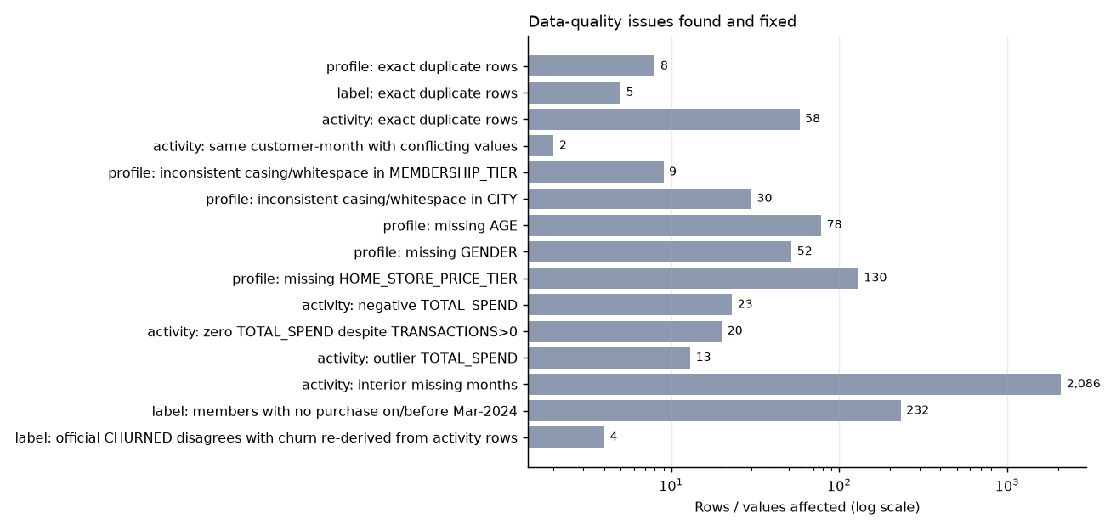
Data-quality issues found and fixed
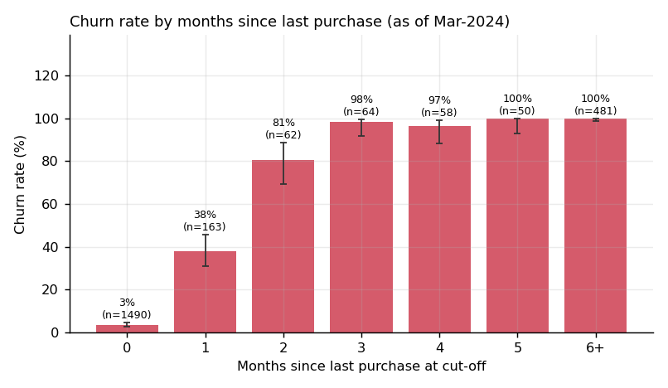
Churn rate by months since last purchase

4. Methodology

4.1 Leakage-safe features
One function builds features relative to a cut-off month and reads only rows up to that month. It produces 49 features in five groups:
- Demographic (8): age, gender, city, tier, marketing opt-in, preferred category, home store price tier, age-missing flag.
- Lifecycle (4): tenure, months of history, short-history flag, missing-month count.
- Behavioural (20): recency, transactions and spend over 3, 6 and 12 months, active months, 3-month vs prior-3-month ratios, slopes, basket size and change, promo share and change.
- Engagement (10): app sessions, emails opened, coupons redeemed (levels and changes), app sessions per transaction.
- Support (7): tickets over 3, 6 and 12 months, complaint months, ticket change, months since last ticket.
The same function builds a Dec-2023 snapshot for a backtest and a Jun-2024 snapshot for forward scoring.

4.2 Validation design
Random splitting was not used for evaluation.
- Cohort split (primary). Members who signed up before 2023-04-01 train (1,657 members, 39.5% churn). Later signups form the held-out validation cohort (711 members, 22.4% churn).
- Tuning. Hyper-parameters, thresholds and calibration use forward-chaining folds over signup quarters.
- Out-of-time backtest. A model trained on a Dec-2023 snapshot is tested on the Mar-2024 snapshot with the official label.

4.3 Models
Four approaches were compared: a rule (no purchase in 2 months), logistic regression (L2, class-weighted), random forest and LightGBM (class-weighted, tuned over 8 configurations). Logistic regression is trained without the lifecycle features: with them, its scores shift on the shorter-tenure validation cohort (mean predicted risk 0.08 against 22% observed) and the tuned threshold collapses to 14.5% recall, although its ranking stays reasonable (PR-AUC 0.917). The final model’s scores are Platt-calibrated on out-of-fold predictions. Isotonic calibration was tried and rejected because it created ties and cut active-base PR-AUC from 0.60 to 0.50.

5. Results

5.1 Model comparison on the held-out cohort
All validation members (n=711, 22.4% churn):
Model | Accuracy | Precision | Recall | F1 | PR-AUC | ROC-AUC
Rule: no purchase in 2 months | 0.930 | 0.958 | 0.717 | 0.820 | 0.865 | 0.929
Logistic regression | 0.927 | 0.902 | 0.755 | 0.822 | 0.850 | 0.958
Random forest | 0.861 | 0.628 | 0.925 | 0.748 | 0.923 | 0.956
LightGBM (tuned) | 0.945 | 0.911 | 0.836 | 0.872 | 0.944 | 0.970
The LightGBM PR-AUC 95% interval is 0.920 to 0.964. Paired bootstrap differences in PR-AUC favour LightGBM over the rule (+0.079, interval 0.051 to 0.113), logistic regression (+0.094, 0.024 to 0.145) and random forest (+0.021, 0.012 to 0.032).
Active base only (bought in Feb or Mar 2024; n=592, 45 churners, 7.6% prevalence):
Model | Precision | Recall | F1 | PR-AUC | ROC-AUC
Rule | 0.000 | 0.000 | 0.000 | 0.278 | 0.757
Logistic regression | 0.455 | 0.222 | 0.299 | 0.351 | 0.876
Random forest | 0.287 | 0.733 | 0.412 | 0.473 | 0.852
LightGBM (tuned) | 0.655 | 0.422 | 0.514 | 0.599 | 0.900
The LightGBM interval here is wide (PR-AUC 0.430 to 0.725) because there are only 45 positives. Paired differences still favour LightGBM over the rule (+0.320, 0.190 to 0.438), logistic regression (+0.247, 0.136 to 0.335) and random forest (+0.126, 0.069 to 0.197).
At the calibrated threshold of 0.41, across all validation members 133 churners are caught, 26 missed and 13 false alarms; in the active base 19 are caught, 26 missed and 10 false alarms. The Brier score is 0.041 against 0.203 for predicting the base rate.
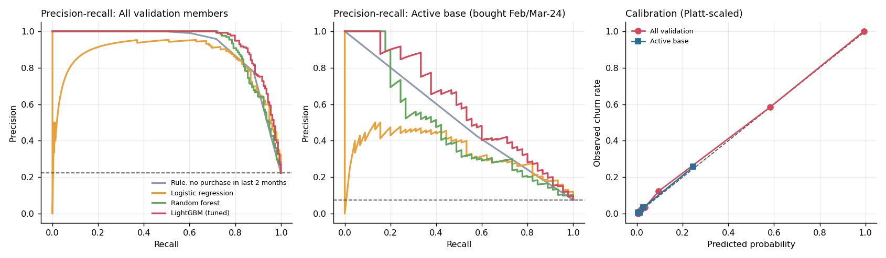
Precision-recall curves and calibration

5.2 Out-of-time backtest
Trained on the Dec-2023 snapshot and scored on the Mar-2024 snapshot, LightGBM reaches PR-AUC 0.985 across all 2,368 eligible members and 0.637 (ROC-AUC 0.922) on the 1,653 active members, against 0.238 for the rule. This agrees with the cohort split. The two checks are not independent, since the same members appear in both snapshots.

5.3 Class imbalance
Churn is 22% to 39% depending on the cohort, so imbalance is moderate. Class weighting made almost no difference to ranking (PR-AUC 0.944 vs 0.942 unweighted). The threshold matters more: at 0.50 the unweighted model has active-base precision 0.74 and recall 0.38, and the tuned threshold gives 0.66 and 0.42. Thresholds are chosen on out-of-fold F1 and should be reset to match campaign capacity.

5.4 Ablation study
LightGBM, same split and parameters. Intervals are 95% bootstrap.
Feature set | PR-AUC (all) | PR-AUC (active base)
Demographics only | 0.240 (0.199-0.294) | 0.075
Demographics + lifecycle | 0.263 | 0.099
+ Behavioural | 0.924 (0.895-0.949) | 0.451 (0.304-0.623)
+ Behavioural + Engagement | 0.935 | 0.567
+ Behavioural + Support | 0.935 | 0.508
All features | 0.944 (0.920-0.964) | 0.599 (0.430-0.725)
All minus behavioural | 0.918 | 0.488
All minus engagement | 0.935 | 0.508
All minus support | 0.935 | 0.567
All minus demographics | 0.943 | 0.599
Engagement only | 0.908 | 0.438
Support only | 0.383 | 0.093
Demographics add nothing. Behavioural and engagement features supply nearly all the signal, and engagement alone gets to 0.908. Removing support costs 0.03 PR-AUC in the active base, and removing engagement costs 0.09, but these intervals overlap, so the incremental value of support is suggestive rather than proven.
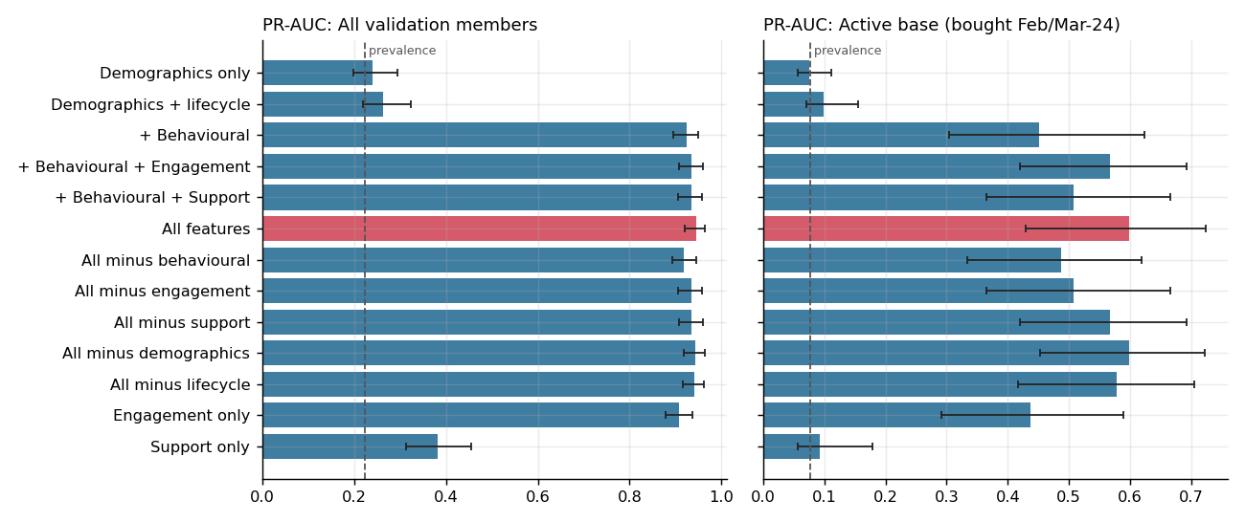
Ablation by feature group

6. Drivers of churn

6.1 Model attribution (SHAP, validation cohort)
By feature group: behavioural 50.7%, engagement 44.0%, support 3.7%, lifecycle 0.8%, demographic 0.8%. The largest single features are app sessions per month over the last 3 months (18.7%), transactions in the last 3 months (13.6%), months since last purchase (11.4%), coupons redeemed in 3 months (8.7%) and emails opened (7.6%). Every validation prediction in churn_predictions_validation_cohort.csv carries its top three drivers in plain language.
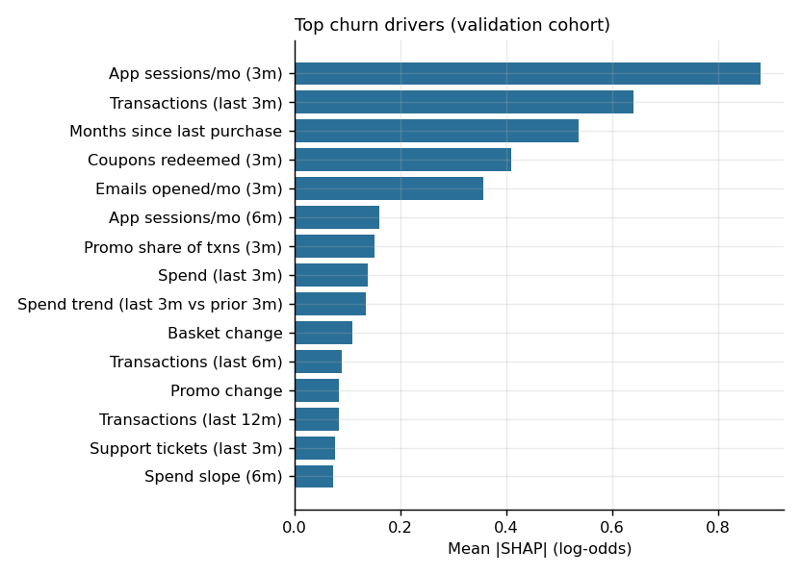
Global SHAP importance
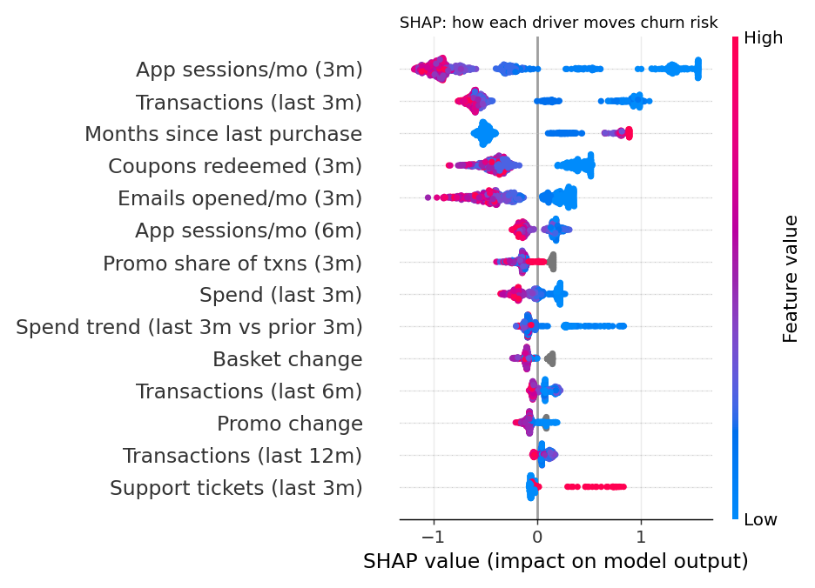
SHAP beeswarm

6.2 Adjusted associations among active members
A multivariable logistic regression on the 1,653 active members (114 churners) gives these adjusted odds ratios:
Factor | Odds ratio (95% CI)
Bought in Feb but not Mar (recency 1 vs 0) | 6.19 (3.63-10.56)
Each support ticket in last 6 months | 2.80 (2.10-3.75)
Each extra app session per month | 0.50 (0.37-0.68)
Each extra email opened per month | 0.39 (0.23-0.68)
Transaction trend ratio (last 3m vs prior 3m) | 0.47 (0.33-0.68)
Each 5 extra transactions in 6 months | 0.76 (0.64-0.89)
Each +10pp promo share of transactions | 1.28 (1.00-1.63)
Marketing opt-in | 1.80 (0.91-3.55)
Gold vs Silver | 0.81 (0.46-1.42)
Platinum vs Silver | 1.15 (0.54-2.47)
These are associations, not causal effects. Complaint months, coupons, age and tenure are not significant after adjustment.
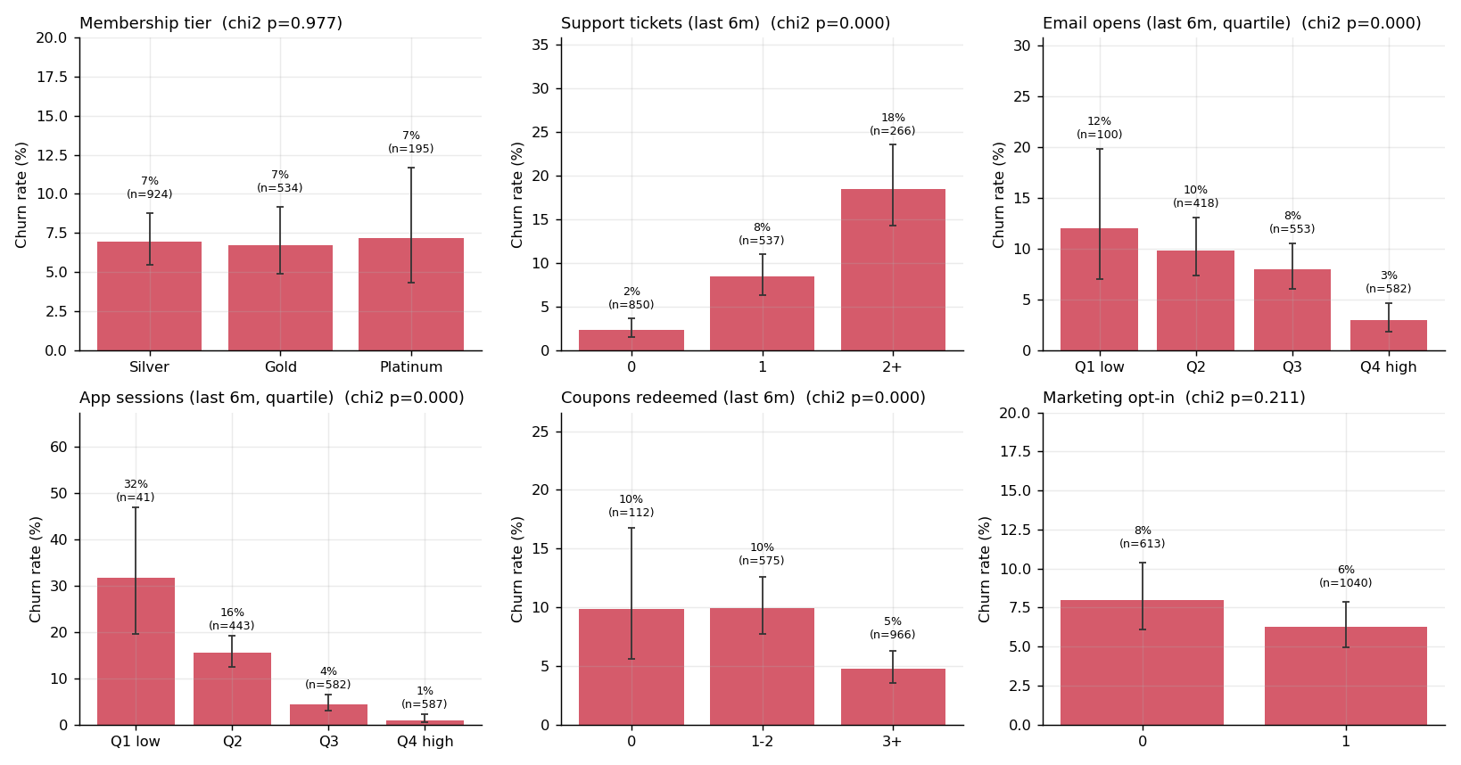
Engagement and support vs churn, active base

7. Risk by segment
- Tier: churn is 35.1% Silver, 33.0% Gold and 33.9% Platinum (p=0.61); among active members 6.9%, 6.7% and 7.2% (p=0.98). Tier is not a useful targeting variable.
- City: 30.7% (Portland) to 40.8% (Austin) overall (p=0.22); 3.7% to 8.8% among active members (p=0.72).
- Signup cohort: churn is 38% to 43% for cohorts from 2021 to 2023-H1 but 20.8% for 2023-H2 and 3.2% for 2024-H1. That reflects less time at risk, not better members; among active members cohorts range 3.2% to 8.7% (p=0.26). The model over-predicts the newest cohort (2024-Q1: 10.3% predicted vs 3.2% observed).
- Marketing opt-in: opted-in members churn less overall (32.1% vs 37.8%, p=0.005) but not significantly among active members (6.2% vs 8.0%, p=0.21).
- Support tickets: among active members, 2.4% churn with no tickets, 8.4% with one and 18.4% with two or more (p<0.001). Across all members the pattern reverses because lapsed members generate no tickets, so the all-member view should not be read as ‘tickets protect against churn’.
- Engagement: active members in the lowest quartile of app use churn at 31.7% (n=41) against 1.0% in the top quartile; the lowest email-open quartile churns at 12% against 3%.
Per-segment model quality is stable (PR-AUC 0.81 to 0.99 across tiers and cities). It is weakest for the newest cohorts (2023-Q4 0.83, 2024-Q1 0.80), for Portland (0.81) and for Platinum recall (0.70), all of which have few churners.
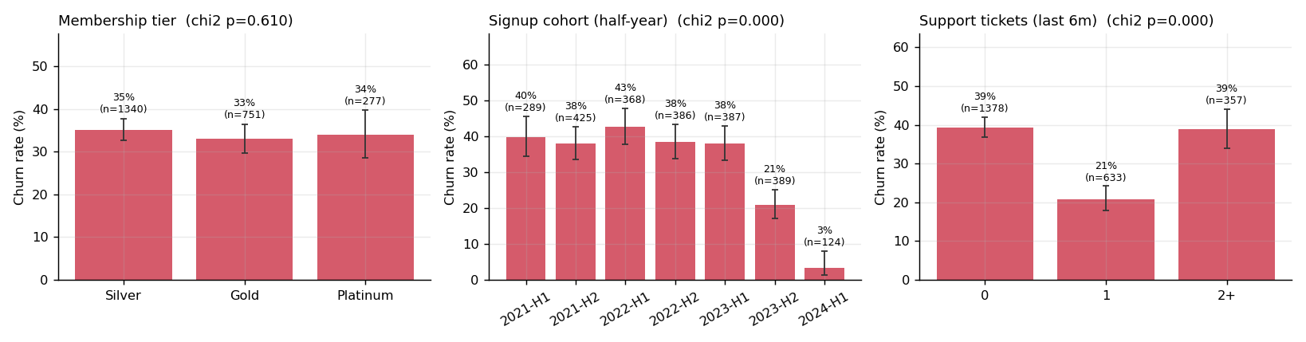
Churn by tier, signup cohort and tickets (all members)

8. Retention scenarios
The data contain no randomised intervention, so both scenarios are simulations, not causal estimates.

8.1 Model what-if (validation active base, n=592)
Scenario | Members targeted | Mean risk before to after
Proactive service recovery (clear tickets and complaints) | 164 (28%) | 12.6% to 10.9% (-1.7pp; about 3 churners avoided)
Engagement nudge (+1 coupon, +1 email, +1 app session per month) | 270 (46%) | 10.4% to 2.7% (-7.7pp; about 21 churners avoided)
The engagement result is implausibly large. It shows that the model leans heavily on app and email activity, not that a nudge will cut churn by 74%. Real effects must be measured in a test.

8.2 Targeting economics (active base, n=1,653, 114 churners)
Assumptions, editable in config.py: $2 per contact, 25% margin, 12-month value horizon, and a relative churn reduction among contacted would-be churners of 10%, 20% or 30%. Risk scores are cross-fitted (each member scored by a model that never saw them). Results at 20%:
Policy | Contacted | Churners reached | Net benefit | ROI
Blanket (all active) | 1,653 | 100% | $1,769 | 0.54
Top 10% by risk | 165 | 74% | $2,898 | 8.8
Top 20% by risk | 331 | 85% | $3,239 | 4.9
Top 30% by risk | 496 | 91% | $3,470 | 3.5
At least 1 ticket in last 3 months | 507 | 68% | $2,495 | 2.5
Random 20% (expected) | 331 | 20% | $354 | 0.54
At a 10% reduction the blanket campaign loses $768 while the top-10% policy still earns $1,284 (ROI 3.9). At 30% the top 30% policy nets $5,700 against $4,307 for blanket.
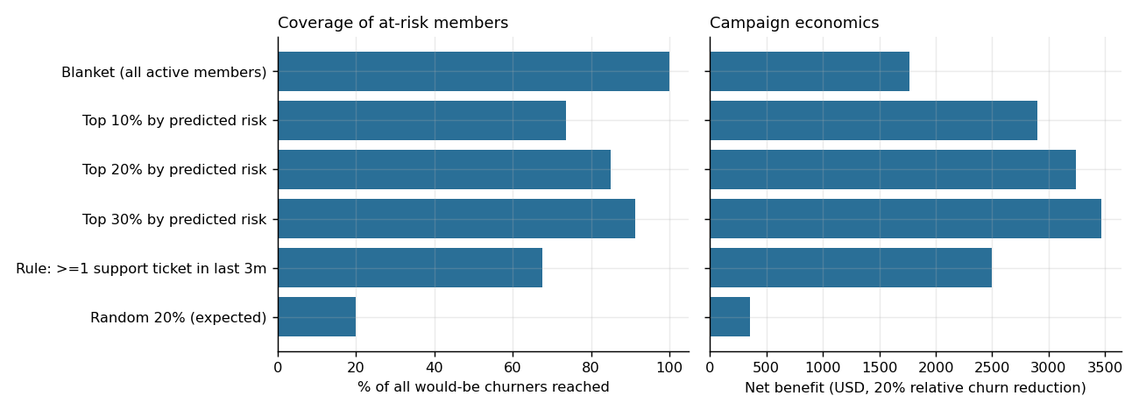
Targeting policies

8.3 Forward scores for Jul-Sep 2024
Refitting on all labelled members and scoring at a Jun-2024 cut-off gives 2,474 members, of whom 1,594 are still active. Of these, 77 are high risk and 87 medium risk. A further 880 members have already lapsed for 2+ months (875 high risk). Scoring features are clipped to the range seen in training.

8.4 Validation of the forward scores
No outcome exists yet for Jul-Sep 2024, so the scores cannot be scored directly. Two substitutes were run (src/validate_forward.py).
Protocol replay. The same procedure was repeated one period earlier using only information available then: labels derived from activity up to Mar-2024, calibrator and threshold from out-of-fold scores, and scoring of the Mar-2024 snapshot against the official Apr-Jun 2024 label.
Population | n | Observed churn | Mean predicted | Brier | PR-AUC | ROC-AUC | Precision | Recall
All eligible | 2,368 | 34.3% | 33.9% | 0.029 | 0.985 | 0.988 | 0.959 | 0.932
Active base | 1,653 | 6.9% | 6.3% | 0.037 | 0.637 | 0.922 | 0.720 | 0.518
Among active members the risk bands behaved as intended:
Band | Members | Observed churn
High | 82 | 72.0%
Medium | 80 | 22.5%
Low | 1,491 | 2.5%
Drift check. Comparing the Jun-2024 scoring data with the Mar-2024 training data, no feature has a population stability index above 0.25 (largest 0.12, months with a purchase). The exception is expected: 67% of Jun-2024 members have more months of history than any training member (up to 18 against 15). These lifecycle features carry under 1% of model attribution, and clipping scoring features to the training range changed no member’s risk band. The mean predicted churn of active members in the forward file (6.2%) matches the replay (6.3%).
What this does and does not show. The procedure ranks and calibrates well on a known outcome and the new data looks like the old. It does not prove accuracy for Jul-Sep 2024; compare the scores with actual purchases once that quarter closes. The replay overlaps the earlier backtest, so it is a consistency check, not an independent test.

9. Recommendations
- Stop spending standard retention offers on lapsed members. The 715 members lapsed 2+ months at the cut-off churned at 97.8%. Use a separate, low-cost win-back programme and measure it independently.
- Run retention on the active base using the risk score. Start with the top 10% to 30%, about 165 to 500 members per cycle, rather than a blanket offer.
- Act on early warning signs: no app sessions in the last 3 months, falling transaction trend, a missed month after steady purchasing, and zero email opens.
- Fix service before offering discounts. Members with 2+ tickets in six months churn at 18%. Route them to proactive service recovery.
- Do not segment retention by tier, city, age or gender. None separates risk.
- Test before scaling. Run a randomised holdout on the first campaign to replace the assumed 10% to 30% reduction with a measured uplift, and re-run section 8.2 with it.
- Operationalise. Score monthly, review calibration quarterly, and reset the threshold to campaign capacity.
- Capture better data: offer history, contact history, support resolution outcomes and repeated churn labels.

10. Limitations
- One label window. Seasonality of churn cannot be learned, and the backtest and replay overlap the same members.
- Small positive counts where it matters. The active-base validation set has 45 churners, so its intervals are wide.
- Cohort shift. Validation members have shorter history. Tree models handle this, the linear baseline does not, and the model over-predicts the newest cohort.
- Association, not causation. Odds ratios and what-if shifts do not estimate intervention effects. Reverse causation is possible, for example members preparing to leave contacting support.
- Scenario inputs are assumptions and drive the ROI conclusions.
- Imputations and repairs (spend rebuilds, zero-fill of trailing months) are reasonable but unverifiable. Only 4 of 2,368 official labels disagree with a re-derived label.
- Data appear synthetic and unusually clean in places (very strong recency signal), so real-world performance may be lower.

11. Reproducibility
Run python src/run_pipeline.py after pip install -r requirements.txt; it takes about 45 seconds, uses a fixed seed (42) and regenerates every table and chart. python src/validate_forward.py re-runs the forward-score validation, and build_notebook.py re-executes the EDA notebook. The README describes the layout, assumptions and outputs.

