| Experiment No. 4 |
| --- |
| Topic : To implement midpoint Ellipse algorithm |
| Name: Saurabh Vishwakarma |
| Roll Number: 61 |
| Date of Performance: |
| Date of Submission: |

**Experiment No. 4**

**Aim**-To implement midpoint Ellipse algorithm

**Objective:**

Draw the ellipse using Mid-point Ellipse algorithm in computer graphics. Midpoint ellipse

algorithm plots (finds) points of an ellipse on the first quadrant by dividing the quadrant into

two regions.

**Theory:**

Midpoint ellipse algorithm uses four way symmetry of the ellipse to generate it. Figure shows

the 4-way symmetry of the ellipse.

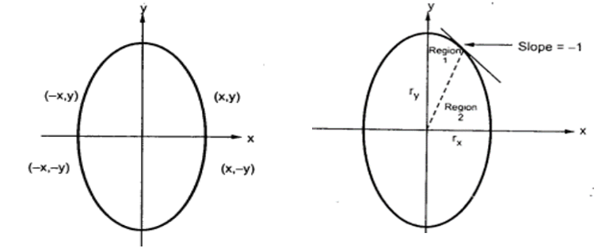

Here the quadrant of the ellipse is divided into two regions as shown in the fig. Fig. shows the

division of first quadrant according to the slope of an ellipse with rx &lt; ry. As ellipse is drawn

from 90 0 to 0 0 , x moves in positive direction and y moves in negative direction and ellipse

passes through two regions 1 and 2.

The equation of ellipse with center at (xc, yc) is given as -

[(x – xc) / rx] 2 + [(y – yc) / ry] 2 = 1

Therefore, the equation of ellipse with center at origin is given as -

[x / rx] 2 + [y / ry] 2 = 1

i.e. x 2 ry 2 + y 2 rx 2 = rx 2 ry 2

Let, f ellipse (x, y) = x2 ry2 + y2 rx2 - rx2 ry2

**Algorithm:**

**Program**

#include<stdio.h>

#include<conio.h>

#include<graphics.h>

void pixel(int x,int y,int xc,int yc)

{

putpixel(x+xc,y+yc,BLUE);

putpixel(x+xc,-y+yc,BLUE);

putpixel(-x+xc,y+yc,BLUE);

putpixel(-x+xc,-y+yc,BLUE);

putpixel(y+xc,x+yc,BLUE);

putpixel(y+xc,-x+yc,BLUE);

putpixel(-y+xc,x+yc,BLUE);

putpixel(-y+xc,-x+yc,BLUE);

}

main()

{

int gd=DETECT,gm=0,r,xc,yc,x,y;

float p;

//detectgraph(&gd,&gm);

initgraph(&gd,&gm," ");

printf(“\n ********* MID POINT ELLIPSE ALGORITHM ********* ”)

printf("\n Enter the radius of the circle:");

scanf("%d",&r);

printf("\n Enter the center of the circle:");

scanf("%d %d",&xc,&yc);

y=r;

x=0;

p=(5/4)-r;

while(x<y)

{

if(p<0)

{

x=x+1;

y=y;

p=p+2*x+3;

}

else

{

x=x+1;

y=y-1;

p=p+2*x-2*y+5;

}

pixel(x,y,xc,yc);

}

getch();

closegraph();

}

**Output:**

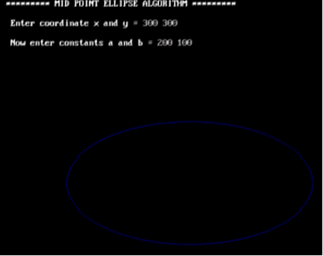

**Conclusion**: Comment on

1. Slow or fast

2. Difference with circle

3. Importance of object

**Speed:** The midpoint ellipse algorithm is relatively faster compared to other algorithms for drawing ellipses. It efficiently utilizes incremental calculations, which helps in reducing computational overhead, making it suitable for real-time graphics applications.

**Differences with circles:** The midpoint ellipse algorithm differs from the midpoint circle algorithm in terms of the decision parameters and the way points are plotted. While both algorithms utilize the concept of symmetry and incremental calculations, the parameters and equations for ellipses are different from those for circles due to the variation in the geometry of these two shapes.

**Importance of the object:** The significance of the object being drawn lies in the context of the application. Ellipses are fundamental geometric shapes used in various computer graphics applications, including drawing, modeling, and image processing. They are essential for representing various objects such as orbits, paths, shapes, and boundaries in computer graphics. The midpoint ellipse algorithm provides an efficient and accurate way to render ellipses, which is crucial for generating complex graphics and accurately representing objects in a wide range of applications.