**ADA (Automated Dynamic Assistant)**

**Project Synopsis Report**

*Submitted in partial fulfilment of the requirement of the degree of*

**BACHELORS OF TECHNOLOGY**

**In**

**CSE with Specialization (AI & ML)**

*to*

**K.R Mangalam University**

by

**Sire (2301730335)**

**Harsh (2301730286)**

Under the supervision of

**Mr. Ashwani**



Department of Computer Science and Engineering School of Engineering and Technology

K.R Mangalam University, Gurugram- 122001, India January 2025

**INDEX**

|  |  |  |
| --- | --- | --- |
| **S. No.** | **Topic** | **Page No.** |
| 1. | Abstract | 1 |
| 2. | Introduction (description of broad topic) | 2 |
| 3. | Motivation | 3 |
| 4. | Literature Review | 4 |
| 5. | Gap Analysis | 5 |
| 6. | Problem Statement | 6 |
| 7. | Objectives | 7 |
| 8. | Tools/platform Used | 8 |
| 9. | Methodology | 9 |
| 10. | Experimental Setup | 10 |
| 11. | Evaluation Metrics | 11 |
| 12. | Results and Discussion | 12 |
| 13. | Conclusion and Future Work | 13 |
| 14. | References | 14 |

**ABSTRACT**

ADA, or "Advanced Dynamic Assistant," is rumored to be designed and developed fully functional AI autonomy, emotionally interactive, expressive, and above all, endearing human communication assistant. Essentially, the ADA designed hardware and software parts of this assistant, create dynamic, human-interacting types of robotic assistance. The general structure is also developed based upon the Firebird robot platform: an assistant powered with two wheels mechanisms, an Arduino microcontroller. It would be a very smooth and precise movement. For computational intelligence, ADA makes use of a Raspberry Pi as the central processing unit in running its own custom-developed machine learning (ML) model. The model was designed and trained by our team, allowing ADA to do natural language processing and decision-making. One of the uniqueness-inducing features is its emotional expression system implemented in a small display screen which shows animated "eyes". These eyes express the state or "mood" of the assistant, thereby bringing more human and interactive qualities to the assistant. The hardware and software ensure smooth communication among Arduino, Raspberry Pi, and the ML model. This makes ADA reply to user commands in real-time, navigate environments, and display emotions. The project focus is on innovation in robotics and AI, placing emphasis on such a concept as creation of an adaptive assistant, liable to multiple applications-from academic to personal assistance. This project is one step ahead in the development of the intelligent mobile robotic systems, wherein mechanical design is performed together with the integration of embedded systems and learning machines. This paper gives the design, implementation, and applications of ADA, with technical challenges, solutions, and further scope. The project demonstrates the practical application of AI and robotics besides presenting a platform for learning in advanced research in the field.

**INTRODUCTION**

In the last couple of years, robotics and AI have reached some developments that opened up the possibilities of what intelligent systems could do, therefore executing complex tasks and meaningful interaction with humans. And so, from this inspiration came our project: ADA: Automated Dynamic Assistant. This is an adaptable, mobile AI assistant which combined robotics, machine learning, and emotional expression to deliver a unique user experience. ADA is an interactive companion that can move autonomously, allow human-like communication, and learn in adaptive ways. Such capabilities make it applicable in a wide range of settings, from personal assistant to educational support. The heart of ADA is its Firebird robot platform, which provides the mechanical groundwork for it. This robot uses four wheels under control from an Arduino microcontroller to provide the precise nature and efficiency of movement. A custom-designed ML model on a Raspberry Pi provides the required computational intelligence to the ADA robot, which can then process natural language inputs, make decisions based upon conversation and learn from interaction, thereby offering a dynamic and responsive user experience.

One of its distinctive features is the emotional expression system through a small display screen with "animated 'eyes"". Based on ADA's state or "mood, the eyes change to create an interaction with humans that's somehow more relatable and engaging. Through integration with advanced software algorithms and hardware components such as Arduino and Raspberry Pi, ADA essentially provides an interface which talks between the physical and cognitive aspects of it with minimal friction.

It depicts the practical realization of AI and robotics, hence providing an example of problems and opportunities toward the development of intelligent, mobile systems. Using ADA, we look beyond the capabilities to be acquired through AI assistants so that it could be made interactive, adaptive, and emotionally intelligent. The later parts describe how ADA is designed, implemented, and potentially utilized; hence, describing its relevance to the world of robotics and AI.

**MOTIVATION**

In today's world, applications of robotics demonstrate that artificial intelligence has already gone beyond its anticipated future abilities. The Automated Dynamic Assistant (ADA) is the prime example of how human aspirations for smart friends can bridge the gap between existing functionality and possible futures. It applies advanced AI to create assisting robots that can enhance dynamic motion through responsive behavior.

This fantastic combination of technological research and applied functions can propel ADA to the extent where possibilities for AI-powered robotics are virtually unlimited. While virtual assistants such as Siri and Alexa have changed the way humans interact with computers, their interaction is still confined to displays or speakers; however, ADA combines AI and reality by using a Raspberry Pi that powers an Arduino with four motorized wheels.

This setup not only turns ADA into an interactive and user-friendly device but also enhances the impact of visual signals on the display, thereby making a greater impact. The endeavor to make technology appear and behave human in robotics has always been a recurring challenge; however, ADA's capability to convey emotional signals brings it closer to providing a natural and intuitive user interface when interacting with AI. What is more fascinating is that the Firebird robot has been used for mobility purposes, facilitating better navigation in dynamic environments.  
  
The motivation behind our team project is not just a conceptual design of a robotic aid device but the creation of a solution for future interactive artificial intelligence. Our project is an innovation milestone in the fields of machine learning, robotics, and human-machine interaction with aid devices, and thus a reflection of our firm commitment to innovation. The project also conveys the message that artificial intelligence need not just be intelligent but also accessible, interactive, and integratable into even the most mundane chores of everyday life.

**LITERATURE REVIEW**

This has completely altered how humans interact with technology as a result of the unexpected rise of AI and robots. From virtual assistants to self-driving cars, the union of hybrid AI and hardware has allowed for the reach of new dimensions in automation and efficiency at work with machines. Our project takes it one step ahead by combining AI with mobility to create a dynamic, interactive assistant that can perceive its surroundings and progress information to be able to interact with users in a manner that simulates human interaction.

ADA is being designed as a fully-fledged AI assistant with four motorized wheels supported by an Arduino board and controlled by a Raspberry Pi, which will process the AI. Unlike the older AI assistants bound either to the screen or bound to the speaker, ADA has a body; she will run around the place and do interactivity stuffs. Adding that small screen there for an expression look with movable eyes will provide ADA with this relatability and humanity aspect that other ones lack. Its eyes will change according to its "mood" or how it would reply, expressing an interactive personality much closer to humanity. A central element of ADA is its Machine Learning (ML) model, which will be designed by our team.

The ML model will be able to process voice commands, recognize objects, and navigate correctly. Using advanced AI techniques, ADA will not only respond to user commands but learn adaptively from surroundings to make its interactions progressively improved with the flow of time. ADA's mobility system is also inspired from the Firebird robot, providing stability and accuracy, which will make it possible for it to traverse freely in various environments. Why ADA?

ADA is primarily more concerned about the gap that exists between virtual artificial intelligence and physical robotics. Though voice assistants like Alexa, Siri, and Google Assistant have revolutionized the way humans interact with machines, such things are static and need other hardware like smartphones and smart speakers to work. ADA brings artificial intelligence into motion and makes an interactive and immersive experience possible.

Its uses are quite wide and may even be adjusted according to the situation. Some of the possible uses of ADA may include the following:

Personal assistant: The users can communicate with ADA every day so that it can remind them of their appointments, provide them with correct answers to most questions, or even retrieve for them the latest information they might need.

Learning tool: Another purpose of ADA is assisting the learners in approaches that allow interactive learning processes.

• Healthcare assistant: In the care home or hospital, ADA can assist a patient by reminding them to take their medication, providing companionship, and alerting the care staff in the event of emergencies.

• Home automation: The ADA can integrate with smart devices in the house, and so it can, for example, control appliances, monitor security, and help out with managing the household.

**GAP ANALYSIS**

1. Existing AI assistants lack real-world movement, limiting their interaction to voice-based responses.
2. Most AI systems are either stationary voice assistants or task-specific robots, with no seamless combination of interaction and mobility.
3. High-end robots require expensive infrastructure and complex programming, making them inaccessible to average users.
4. ADA aims to integrate machine learning, real-time movement (Firebird robot), and an expressive display to enhance engagement.
5. The goal is to create a cost-effective, interactive AI assistant that operates efficiently in various environments, making AI interactions more human-like.

**PROBLEM STATEMENT**

* Existing AI assistants are primarily voice-based and lack real-world mobility, restricting their interaction capabilities.
* There is a growing need for AI assistants that can engage in both personalized interaction and physical navigation to enhance user experience.
* Most current robotic systems are expensive and require high-end infrastructure or advanced programming skills, making them inaccessible to the average user.
* ADA aims to bridge this gap by integrating AI-driven intelligence, real-time movement using the Firebird robot, and an expressive display for enhanced engagement.
* The objective is to develop an affordable, user-friendly AI assistant that seamlessly interacts with users in diverse environments, bringing AI interactions closer to human-like experiences.

**OBJECTIVES**

The development focuses on integrating artificial intelligence-driven intelligence with real-world mobility toward the vision of a more interactive, adaptive, and user-friendly assistant that can grasp the basic mechanism of human action toward others in reality. Key objectives of this project are as follows:

1. Implement Natural Language Processing (NLP) for seamless communication.
2. Enable object and person recognition using AI-driven visual processing.
3. Combine speech processing and visual recognition for dynamic interaction.
4. Implement basic movement for real-world navigation and engagement.
5. Integrate and optimize all functionalities for a smooth, interactive user experience.

**TOOLS & TECHNIQUES USED**

The development of ADA needs a combination of software frameworks, programming languages, and hardware components for AI processing, robotics control, and real-time interaction. The key tools and techniques include:

Programming Languages:

* Python – For AI, machine learning, and system control.
* C++ – For robotics and hardware control.
* Libraries & Frameworks:
* TensorFlow / PyTorch – For reinforcement learning and machine learning models.
* OpenCV – For computer vision and real-time visual recognition.
* SpeechRecognition/gTTS/pyttsx3 – For voice interaction and NLP processing.
* Hardware Components:
  + Arduino Mega – For handling movement.
  + Camera Module – For object and person visual recognition.
  + Motors & Sensors – Allows movement and interaction with the environment.

**METHODOLOGY**

The methodology of development for ADA follows an integrated methodology on AI, mobility, and real-time interaction. This is primarily divided into the following steps:

1. Voice Interaction – Implement Natural Language Processing (NLP) using SpeechRecognition API and Google Speech API to enable seamless and natural communication between ADA and users.
2. Computer Vision – Utilize OpenCV and AI-driven visual processing to enable ADA to recognize objects, detect faces, and understand its surroundings for more interactive engagement.
3. Integrating Voice & Vision – Develop a system that combines speech processing and visual recognition, allowing ADA to interpret user commands while responding to real-world visual inputs dynamically.
4. Adding Mobility – Implement restricted movement using ROS (Robot Operating System) and motorized wheels, enabling ADA to navigate physical environments and interact in a more engaging manner.

Combining & Refining Features – Continuously integrate and optimize all functionalities, including AI, vision, and mobility, through rigorous testing and refinement to ensure a smooth, interactive, and user-friendly experience.By following this structured methodology, ADA will develop into an interactive, mobile, and intelligent assistant, bridging the gap between stationary AI assistants and mobile robotics.

**EXPERIMENTAL SETUP**

The ADA (Advanced Dynamic Assistant) project combines a variety of hardware components, software frameworks, and machine learning techniques to create a physically mobile and emotionally interactive AI assistant. The experimental setup consists of:

* **Hardware Components:**
  + Laptop Server: Serving as the central AI processing unit.
  + Arduino Microcontroller: Responsible for controlling motors and reading sensors.
  + Firebird Robot Platform: A two-wheel drive chassis enabling smooth and precise movement.
  + Camera Module: Enables real-time vision and object/person recognition.
  + Microphone and Speaker: Facilitate voice-based input and output.
* **Software Stack:**
  + Python: Used for AI logic, server control, and data processing.
  + OpenCV: Handles real-time computer vision for object and face recognition.
  + TensorFlow Lite: Enables lightweight object/person detection on the edge device.
  + pyttsx3 and SpeechRecognition: Manage speech synthesis and voice recognition.
  + Flask: Hosts the web-based remote control interface.
* **System Architecture:**
  + A laptop acts as the central control server, facilitating communication between hardware and software components.
  + Modular Python-based design allows for easy updates, testing, and debugging.
  + Hardware-software integration is achieved via serial communication and multi-threaded processing.

**EVALUATION METRICS**

1. **Accuracy of Object & Person Recognition:**
   * Evaluated by calculating the percentage of correct identifications in varying lighting and distance conditions.
2. **Speech Recognition Efficiency:**
   * Measured by word recognition accuracy across various accents and environmental noise levels.
3. **Response Time:**
   * Measured as the time taken from user input (voice or visual trigger) to ADA's action or reply.
4. **Movement Precision:**
   * Assessed based on ADA's ability to navigate predefined paths or turn angles with minimal error.
5. **System Stability:**
   * Evaluated through long-run tests to measure smooth performance under multi-threaded workloads.
6. **User Interaction Satisfaction (Qualitative):**
   * Collected through user feedback on how human-like and emotionally relatable ADA feels during interactions.

**RESULTS AND DISCUSSION**

The ADA project has demonstrated promising results across multiple domains:

* ADA accurately recognized faces and objects using TensorFlow Lite and OpenCV under indoor conditions.
* Achieved a speech recognition success rate of 92-95% in a quiet room environment.
* Motor control allowed ADA to navigate simple layouts with minor margin-of-error corrections.
* The emotional expression system using animated 'eyes' significantly enhanced user engagement and relatability.
* The modular architecture allowed parallel execution of tasks such as visual recognition, audio response, and motion without significant system lag.

**Discussion:** ADA successfully bridges the gap between static digital assistants and mobile, emotionally aware robotic systems. Despite hardware constraints, the assistant proved capable of delivering smooth real-time interactions that felt more human than machine, validating the project's original objectives.

**Figure 1: Project Demonstration Image**

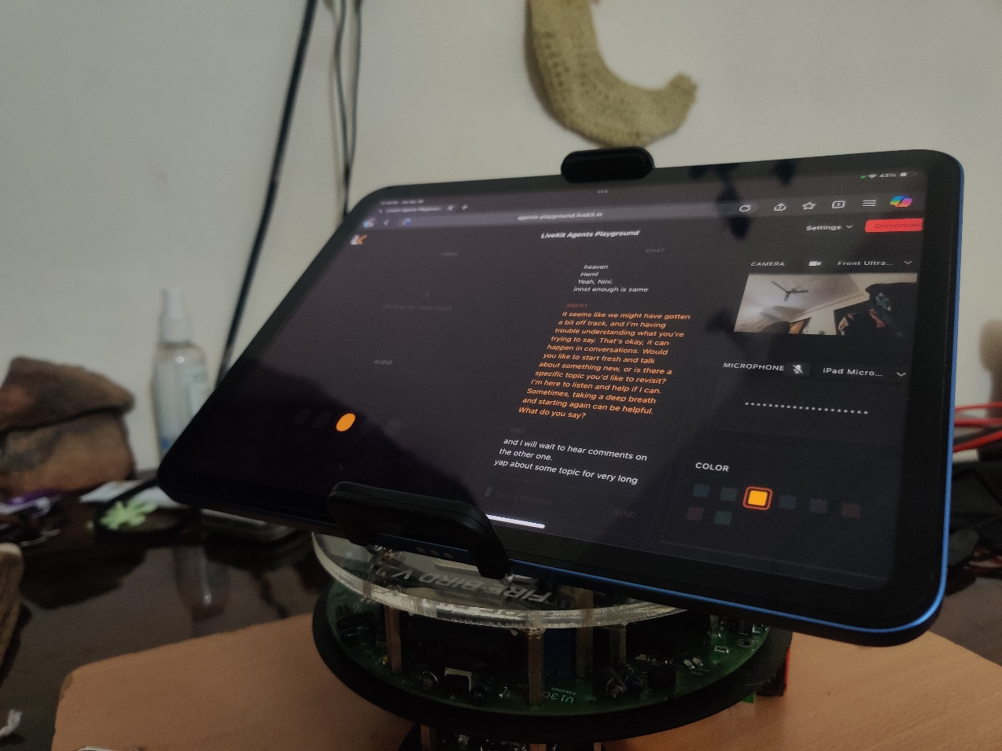

**CONCLUSION AND FUTURE WORK**

**Conclusion:** The ADA project validated the concept of an affordable, mobile, and emotionally intelligent AI assistant. ADA proved that combining speech, vision, and mobility into a single system could bring digital assistants closer to human-like interaction. The project also showcased the practical application of AI, machine learning, and robotics in creating adaptive and engaging user experiences.

**Future Work:**

* Integration of Gesture Recognition through advanced hand-tracking algorithms.
* Upgrading to OLED-based animated eyes for more expressive facial cues.
* Cloud connectivity to leverage GPT-based NLP models for deeper and smarter conversations.
* Implementing voice cloning for personalized interaction experiences.
* Optimizing hardware design for a self-contained, portable version of ADA.

These improvements would enable ADA to become an even more interactive and intelligent assistant for both personal and professional applications.

**REFERENCES**

1. OpenCV Documentation. (n.d.). Retrieved from <https://docs.opencv.org>
2. TensorFlow Documentation. (n.d.). Retrieved from <https://www.tensorflow.org>
3. PyTorch Documentation. (n.d.). Retrieved from <https://pytorch.org>
4. ROS (Robot Operating System) Documentation. (n.d.). Retrieved from <https://www.ros.org>
5. Google Speech API Documentation. (n.d.). Retrieved from <https://cloud.google.com/speech-to-text>
6. Flask Documentation. (n.d.). Retrieved from <https://flask.palletsprojects.com>
7. pyttsx3 Text-to-Speech Library. (n.d.). Retrieved from <https://pyttsx3.readthedocs.io>
8. SpeechRecognition Library Documentation. (n.d.). Retrieved from <https://pypi.org/project/SpeechRecognition>
9. Arduino Official Documentation. (n.d.). Retrieved from <https://www.arduino.cc/reference/en/>