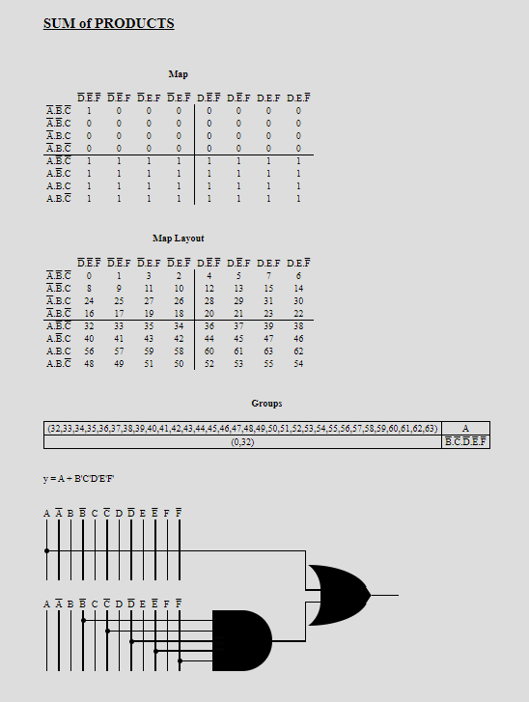

We have to initialize addresses from 0400 to 7FFF (hexadecimal). For this we use k-maps to find our logic equation to connect the output of the pin to the chip enable. We do not want our addresses to be below 0x0400 and above 0x7FFF hence we select the input as required. This result means that output will be on if either of A or B/C/D/E/F/ are 1.



Sdcc settings to include the precise linker flags enabled the program to successfully which did not run as expected.

PCA provides more timing capabilities with less CPU intervention than the standard timer/counter. Its advantages include reduced software overhead and improved accuracy. The PCA consists of a dedicated timer/counter which serves as the time base for an array of five compare/capture modules.

Pwm in PCA generates a trigger when set in idle mode, where the source opf greatest power consumption is reduced and all the interrupts, timer and peripherals work normally and retains the value for the rest of the interval. Ale and psen go high in idle mode.In power down mode, microcontroller turns its internal oscillator to reduce power consumption. For more about idle mode check and power down mode check pdf.

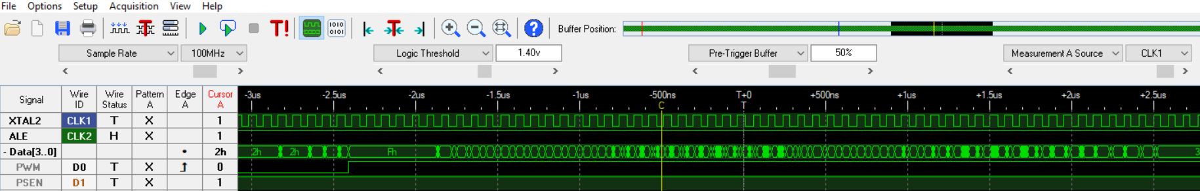

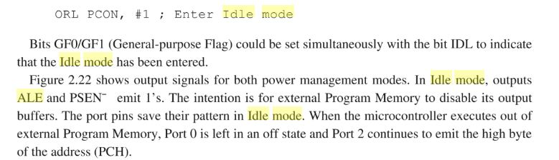

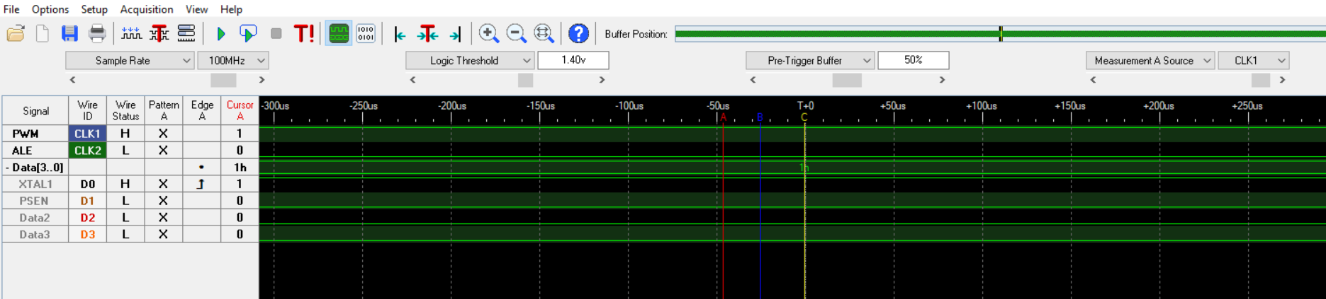

SUBMISSION QUESTIONS

1. What operating system (including revision) did you use for your code development?

Ans. WINDOWS OS

1. What compiler (including revision) did you use?

Ans. SDCC 3.9.0

1. What exactly (include name/revision if appropriate) did you use to build your code (what IDE, make/makefile, or command line)?

Ans. Code Blocks

1. Did you install and use any other software tools to complete your lab assignment?

Ans. No

1. Did you experience any problems with any of the software tools? If so, describe the problems

Ans Yes, Sometimes it showed errors where errors did not exist like in case of syntax errors.