Machine Learning Operations (MLOps) — AIMLZG523
Assignment 1
End-to-End Heart Disease Risk Prediction: Model Development, CI/CD and Production Deployment
Name: R Harsh Sai Kumar
BITS ID: 2025AE05662
Code repository: https://github.com/HARSH4411/mlops05662
October 2026

Contents

1. Introduction
The goal of this assignment is to build a classifier that predicts the presence of heart disease from routine clinical measurements, and to take it through the full MLOps lifecycle: reproducible data acquisition, exploratory analysis, model selection with cross-validation, experiment tracking, packaging, automated testing and CI/CD, containerisation, deployment to Kubernetes, and runtime monitoring.
The design principle throughout was that every artefact should be reproducible from a clean checkout with a single command per stage, and that the same preprocessing code is used in training and in serving, so that there is no training/serving skew.

1.1 Dataset
The UCI Heart Disease dataset (Cleveland subset) contains 303 patients and 13 attributes: age, sex, chest-pain type (cp), resting blood pressure (trestbps), cholesterol (chol), fasting blood sugar (fbs), resting ECG (restecg), maximum heart rate (thalach), exercise-induced angina (exang), ST depression (oldpeak), ST slope (slope), number of major vessels (ca) and thalassemia (thal). The original target num is a 0–4 severity score; following the problem statement it is converted to a binary label (0 = no disease, 1 = disease present).

1.2 Architecture
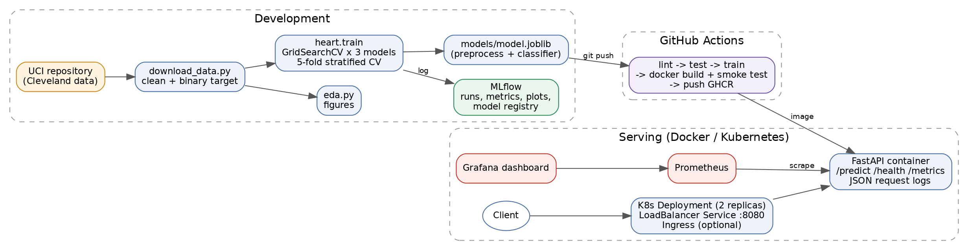
Figure 1. System architecture
Data flows from the UCI repository through a download/cleaning script into a versioned CSV. The training module runs a grid search over three model families and logs every run to MLflow; the best pipeline is serialised and committed. GitHub Actions re-runs the whole chain on every push, builds a Docker image with the freshly trained model, smoke-tests it and publishes it to GitHub Container Registry. The image is deployed to Kubernetes behind a LoadBalancer service, and Prometheus scrapes the /metrics endpoint for a Grafana dashboard.

2. Setup and Installation
Requirements: Python 3.10+, Git, Docker Desktop (with Kubernetes enabled) or Minikube. All Python dependencies are pinned in requirements.txt (full environment) and requirements-serve.txt (minimal runtime used by the container).
git clone https://github.com/HARSH4411/mlops05662.git && cd mlops05662
python -m venv .venv && .venv\Scripts\activate # Linux: source .venv/bin/activate
pip install -r requirements.txt
$env:PYTHONPATH="src;." # Linux: export PYTHONPATH=src:.
python scripts/download_data.py # data
python scripts/eda.py # EDA figures
python -m heart.train # training + MLflow
pytest -v # tests
docker build -t heart-api:latest . # container
kubectl apply -f k8s/ # deployment

Folder / file | Contents
scripts/ | download_data.py, eda.py, load_test.py
src/heart/ | config, data cleaning, feature pipeline, training, prediction
api/ | FastAPI application and request/response schemas
tests/ | 24 pytest unit tests (data, features, models, API)
.github/workflows/ci.yml | CI/CD pipeline
Dockerfile, docker-compose.yml | Serving image; local stack with Prometheus + Grafana
k8s/ | Namespace, Deployment, Service, Ingress, in-cluster Prometheus
monitoring/ | Prometheus config, Grafana datasource and dashboard
models/ | model.joblib (full pipeline) + model.json (metadata)

3. Data Acquisition and EDA

3.1 Acquisition and cleaning
scripts/download_data.py downloads processed.cleveland.data directly from the UCI archive (idempotent: it skips the download if the file exists) and writes data/processed/heart_clean.csv. Cleaning steps:
- Missing values are encoded as "?" in the raw file and parsed as NaN. Six cells are missing (4 in ca, 2 in thal).
- Category codes outside the UCI data dictionary are set to NaN, so a corrupted row cannot silently create a new category.
- Exact duplicate rows are dropped (none in this file, but the step guards future data).
- The 0–4 target num is mapped to a binary target (num > 0).
Imputation is deliberately not done in the cleaning script. It is learned inside the sklearn pipeline on the training folds only, which avoids leaking test-set statistics into training.

3.2 Findings
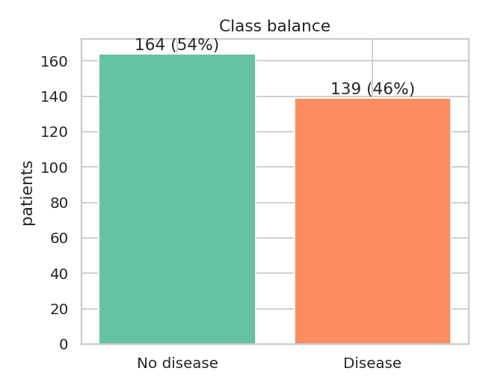
Figure 2. Class balance: 164 no disease (54%) vs 139 disease (46%)
The classes are close to balanced, so accuracy is meaningful, but recall on the disease class is still the priority because a missed diagnosis is the costlier error. Stratified splits are used everywhere to keep the ratio stable.
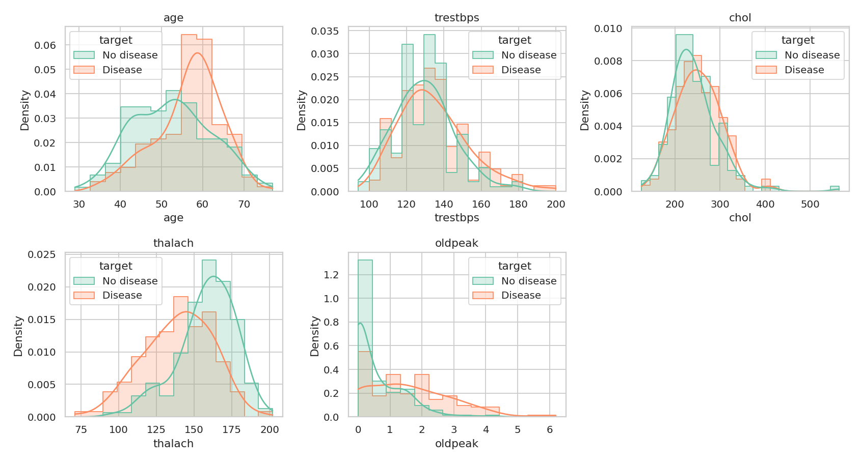
Figure 3. Distribution of numeric features by class
Patients with disease reach a clearly lower maximum heart rate (thalach) and show higher ST depression (oldpeak). They are also older on average. Cholesterol and resting blood pressure overlap heavily between the classes and are weak predictors on their own.
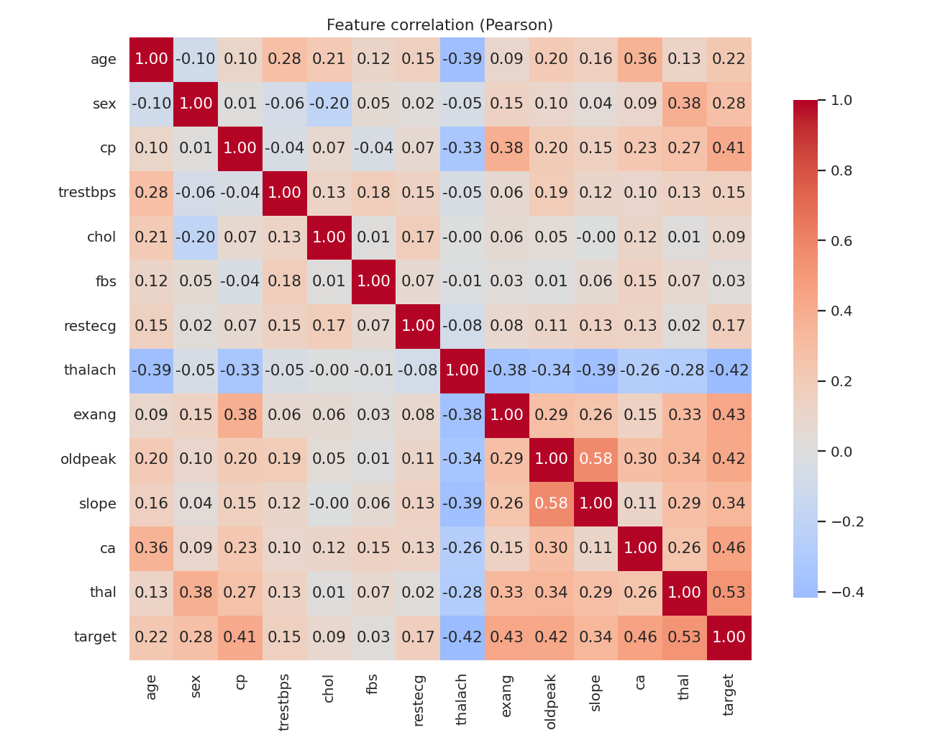
Figure 4. Pearson correlation matrix
The strongest linear associations with the target are thal (0.53), ca (0.46), exang (0.43), oldpeak (0.42), cp (0.41) and thalach (−0.42). No pair of features is so strongly correlated that one should be dropped, so all 13 features are retained.
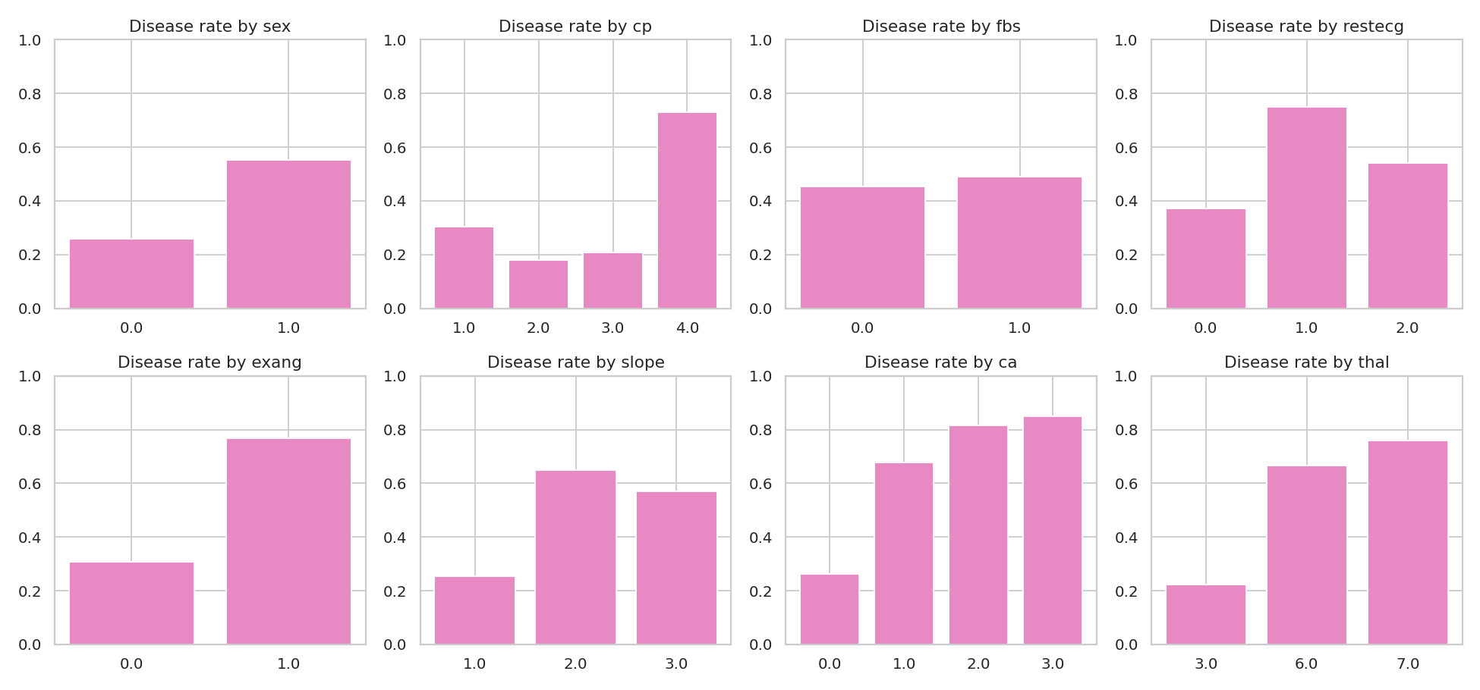
Figure 5. Disease rate for each level of the categorical features
Asymptomatic chest pain (cp = 4), reversible thalassemia defect (thal = 7), exercise angina and one or more coloured vessels each push the disease rate far above the 46% baseline. These are nominal codes rather than ordered quantities, which motivates one-hot encoding cp, restecg, slope and thal rather than treating them as numbers.

4. Feature Engineering and Model Development

4.1 Preprocessing pipeline
A single ColumnTransformer (src/heart/features.py) is fitted as the first step of every model pipeline:
Group | Columns | Transform
Numeric | age, trestbps, chol, thalach, oldpeak, ca | median imputation → StandardScaler
Binary | sex, fbs, exang | most-frequent imputation
Categorical | cp, restecg, slope, thal | most-frequent imputation → OneHotEncoder(handle_unknown="ignore")

ca is kept numeric because it is a count (0–3) with a monotone relationship to risk. handle_unknown="ignore" makes the API robust to an unseen category instead of crashing.

4.2 Models and tuning
Data is split 80/20 (stratified, seed 42). On the training split, each model family is tuned with GridSearchCV using 5-fold stratified cross-validation. All five metrics (accuracy, precision, recall, F1, ROC-AUC) are computed per fold, and ROC-AUC is used for refitting because it is threshold-independent.
Model | Search space | Best parameters
Logistic Regression | C ∈ {0.01…5}, L1/L2, class_weight | C:0.5,class_weight:balanced,penalty:l2
Random Forest | n_estimators, max_depth, min_samples_leaf, max_features (72 combos) | n_estimators=400, max_depth=8, min_samples_leaf=3, max_features=sqrt
Gradient Boosting | n_estimators, learning_rate, max_depth, subsample (16 combos) | n_estimators=100, lr=0.03, max_depth=2, subsample=0.8

4.3 Results
Model | CV ROC-AUC (±sd) | CV recall | Test acc. | Test prec. | Test recall | Test F1 | Test ROC-AUC
Logistic Regression | 0.908 ± 0.019 | 0.810 | 0.869 | 0.813 | 0.929 | 0.867 | 0.959
Random Forest | 0.901 ± 0.024 | 0.773 | 0.885 | 0.839 | 0.929 | 0.881 | 0.952
Gradient Boosting | 0.884 ± 0.027 | 0.756 | 0.902 | 0.867 | 0.929 | 0.897 | 0.960

All three models perform similarly; the differences on a 61-patient test set are within noise. Model selection therefore uses the mean cross-validated ROC-AUC, which is the more stable estimate. Logistic Regression is selected (CV ROC-AUC 0.908). It has the highest CV recall, its coefficients are directly interpretable for a clinical setting, and it is also the smallest and fastest model to serve. The balanced class weight chosen by the search trades a little precision for recall, which matches the cost asymmetry of the problem.
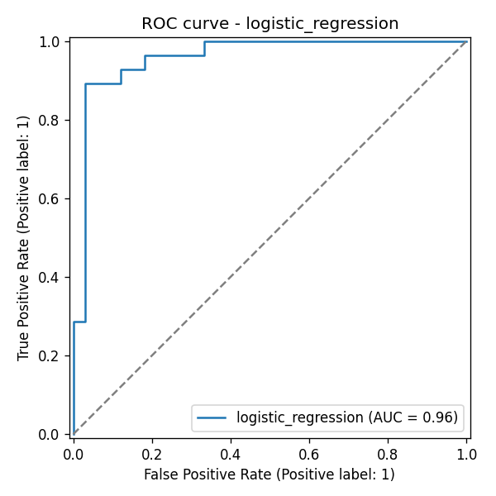
Figure 6. ROC curve of the selected model on the held-out test set
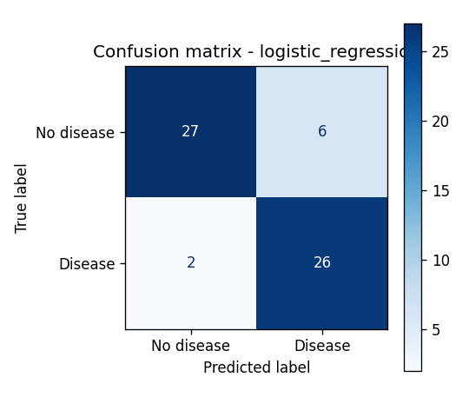
Figure 7. Confusion matrix of the selected model (threshold 0.5)
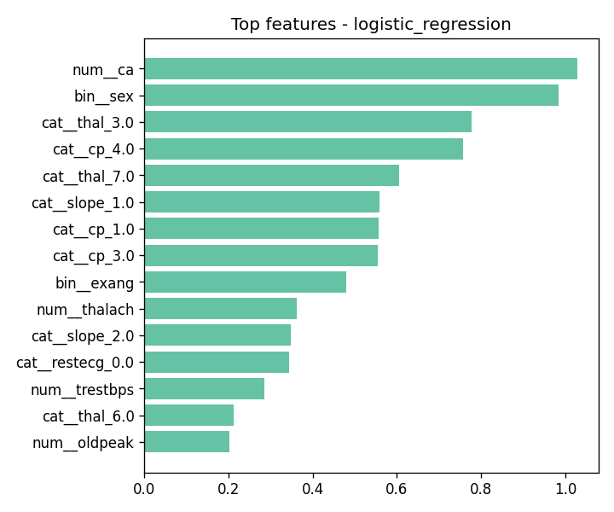
Figure 8. Largest absolute coefficients of the selected model

5. Experiment Tracking
MLflow (SQLite backend, local artifact store) records one run per model family under the experiment "heart-disease". Each run logs:
- Parameters: the best hyper-parameters plus split size, number of folds, seed and sample counts.
- Metrics: the mean and standard deviation of each CV metric, all held-out test metrics, and training time.
- Artifacts: ROC curve, confusion matrix and feature-importance plots, and the fitted sklearn pipeline with an input example and inferred signature.
- Tags: model family and grid size.
The best run is registered as heart-disease-classifier in the MLflow Model Registry, so every deployed model can be traced back to the run, parameters and data that produced it. The UI is launched with: mlflow ui --backend-store-uri sqlite:///mlflow.db.
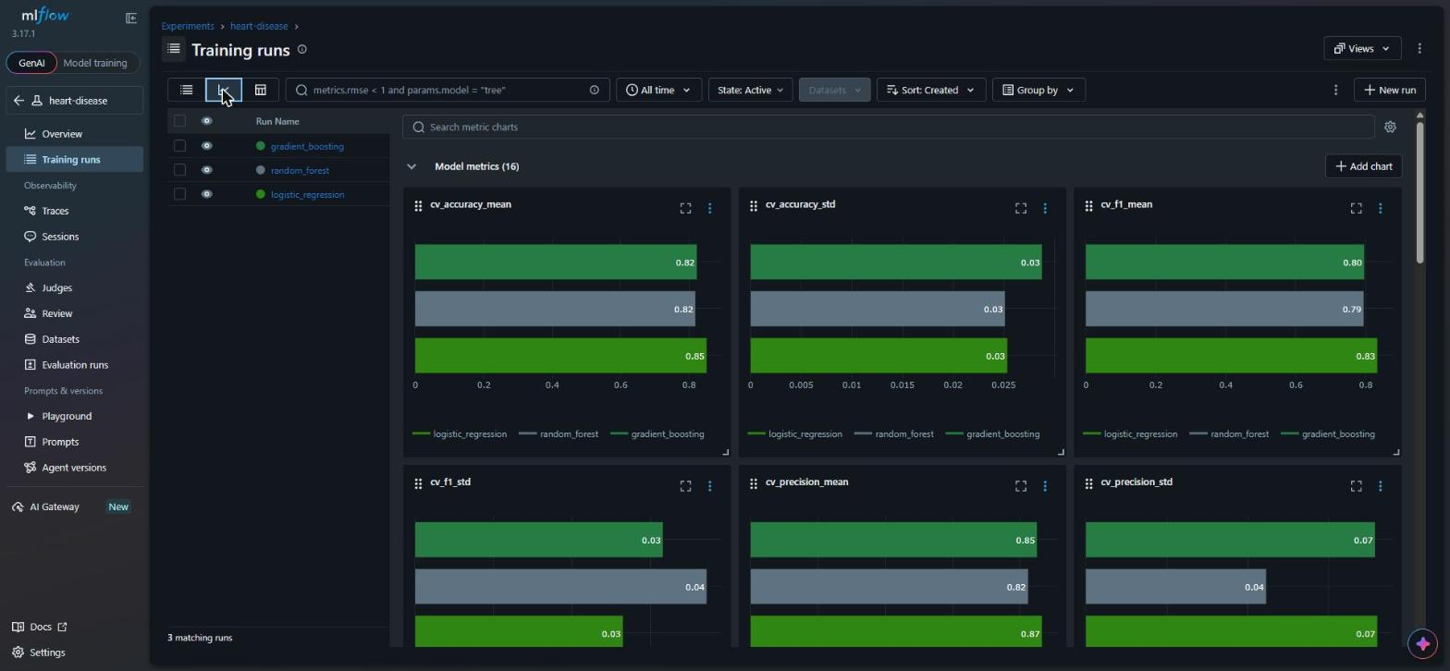
Figure 9. MLflow experiment comparing the three runs

6. Model Packaging and Reproducibility
- The full Pipeline (preprocessing + classifier) is saved with joblib to models/model.joblib, so serving needs no separate preprocessing code.
- A models/model.json sidecar stores the model name, hyper-parameters, all metrics, feature order, sklearn version, training timestamp and MLflow run id. The API reports this metadata.
- The model is also logged in MLflow format, so it can be loaded with mlflow.pyfunc.
- All dependencies are pinned to exact versions. The serving image installs only the 8 runtime packages, which keeps it small.
- A fixed random seed (42) is used for splitting, CV folds and models, so re-running training gives identical results.

7. CI/CD Pipeline and Automated Testing

7.1 Unit tests
tests/ contains 24 pytest tests, which run in under 2 seconds against synthetic fixtures, so CI does not depend on the network:
- Data: binary target creation, invalid codes are nulled, missing values are preserved for the pipeline, duplicates are dropped, and "?" is parsed as missing.
- Features and models: the preprocessor output contains no NaNs, unseen categories are handled, each model family fits and returns valid probabilities, and predict_records returns the expected output shape.
- Quality gate: the trained artefact must reach a test ROC-AUC of at least 0.80.
- API: /health, /predict (including null ca/thal), rejection of invalid inputs with 422, batch prediction, and the Prometheus metrics endpoint.

7.2 GitHub Actions workflow
Job | Steps | Fails when
lint | flake8 (max line 120) | any style or syntax error
test | pytest with coverage; JUnit and coverage XML uploaded as artifacts | any test fails
train | download data → EDA → train with MLflow → quality gate; model, MLflow DB and figures uploaded | training error or ROC-AUC < 0.80
docker | build image with the CI-trained model, run it, curl /health and /predict, print logs; push to GHCR on main | build error or failed smoke test

The jobs are chained with needs:, so a failure stops the pipeline early, and each step's output is visible in the Actions log.
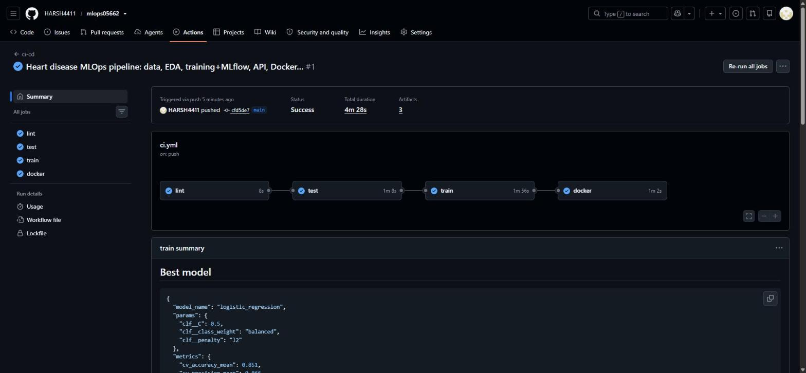
Figure 10. Successful GitHub Actions run

8. Model Containerisation
The FastAPI service (api/app.py) loads the pipeline once at start-up and exposes:
Endpoint | Description
POST /predict | One patient (JSON) → prediction, label, risk_probability, confidence, model name/version, request id
POST /predict/batch | Up to 500 patients
GET /health | Liveness and readiness check; returns 503 if the model is not loaded
GET /metrics | Prometheus exposition format
GET /docs | Interactive Swagger UI

Input is validated by a Pydantic schema with types, ranges and allowed codes taken from the UCI data dictionary. ca and thal may be null and are imputed by the pipeline. Confidence is the probability of the predicted class.
The Dockerfile uses python:3.12-slim, installs dependencies in a separate layer for caching, runs as a non-root user, and defines a HEALTHCHECK. It runs a single uvicorn worker because Prometheus metrics are kept in-process; scaling is done with replicas.
> curl -X POST localhost:8000/predict -H "Content-Type: application/json" -d @sample_request.json
{"prediction":1,"label":"disease","risk_probability":0.9947,"confidence":0.9947,
"model_name":"logistic_regression","model_version":"2026-10-19T14:34:39+00:00","request_id":"d1c72857920a"}

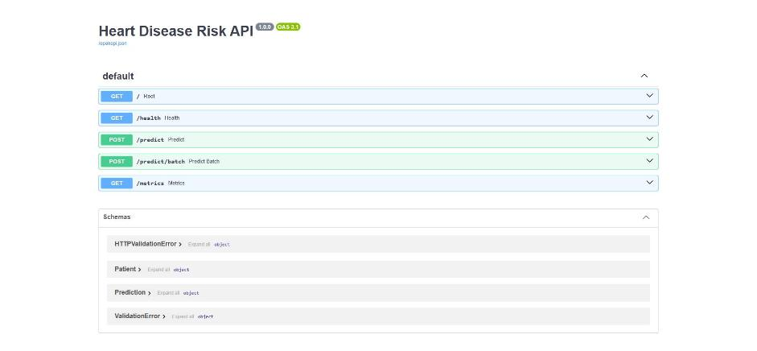
Figure 11. Swagger UI of the running container

9. Production Deployment
The image is deployed to the Kubernetes cluster built into Docker Desktop (v1.36). The k8s/ directory contains:
- deployment.yaml: 2 replicas, a RollingUpdate strategy with maxUnavailable 0, CPU and memory requests and limits, readiness and liveness probes on /health, and prometheus.io annotations.
- service.yaml: a LoadBalancer on port 8080 → 8000. Docker Desktop exposes it on localhost; on GKE, EKS or AKS a cloud load balancer IP is assigned.
- ingress.yaml: optional nginx ingress for host heart.local.
- monitoring.yaml: an in-cluster Prometheus with RBAC that discovers the API pods through their annotations.
> kubectl -n heart get pods,svc
NAME READY STATUS RESTARTS AGE
pod/heart-api-657df84c85-6zz8s 1/1 Running 0 12s
pod/heart-api-657df84c85-tq8md 1/1 Running 0 12s
pod/prometheus-7476c4cc5f-6zdsh 1/1 Running 0 12s
NAME TYPE CLUSTER-IP EXTERNAL-IP PORT(S)
service/heart-api LoadBalancer 10.96.194.11 172.22.0.5 8080:31226/TCP
service/prometheus ClusterIP 10.96.213.218 <none> 9090/TCP
> curl localhost:8080/health
{"status":"ok","model":"logistic_regression","test_roc_auc":0.9589}

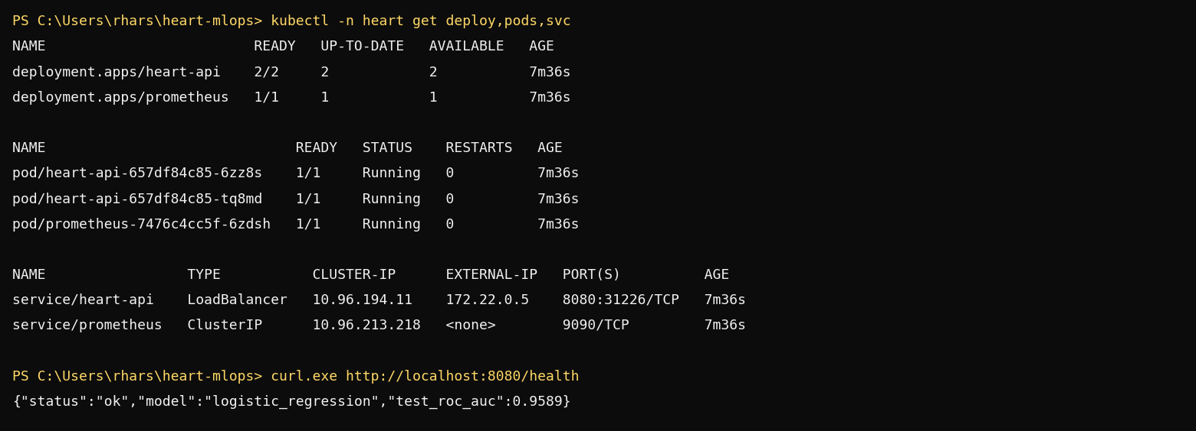
Figure 12. Kubernetes pods and service

10. Monitoring and Logging
- Logging: every request is written to stdout as one JSON line containing request_id, method, path, status and latency_ms. Every prediction also logs its label. The request id is returned in the x-request-id header, so a client error can be traced in the logs (kubectl logs or docker logs).
- Metrics, exposed through prometheus_client: request count by path and status, a latency histogram, predictions by class, a histogram of predicted risk (useful for spotting drift), and a model-loaded gauge.
- Dashboard: docker compose starts the API, Prometheus and Grafana. The provisioned dashboard shows requests per second, p95 latency, the class mix, mean predicted risk, model status and error rate. scripts/load_test.py generates traffic that includes deliberately invalid requests, so the error panel has data.
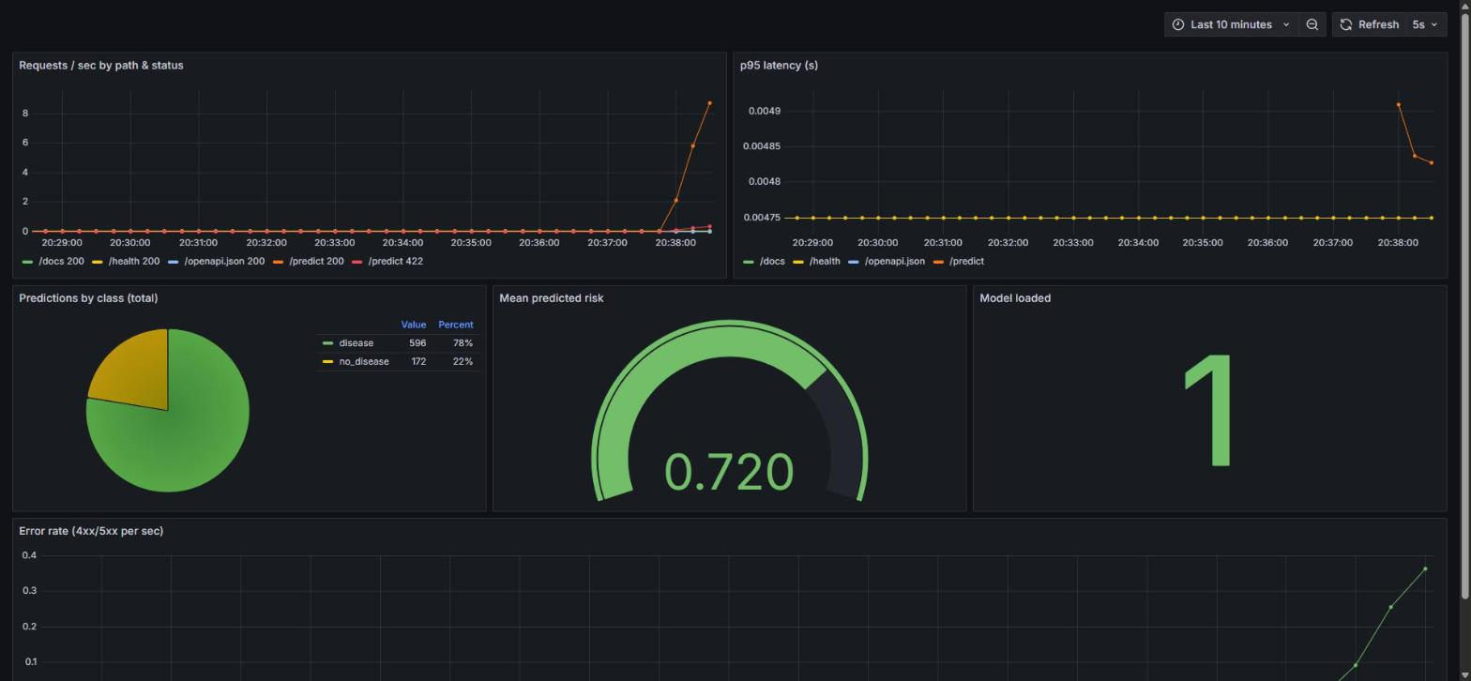
Figure 13. Grafana dashboard under load

11. Conclusion and Future Work
The project delivers a reproducible pipeline from raw UCI data to a monitored, containerised API on Kubernetes, rebuilt and verified automatically on every commit. The selected Logistic Regression model reaches a cross-validated ROC-AUC of about 0.91 and a held-out recall of 0.93.
Possible extensions:
- Data versioning with DVC.
- Probability calibration, and tuning the decision threshold to a target recall.
- Drift alerts on the risk histogram.
- Canary releases driven by the MLflow registry stages.
- Validation on the other UCI sites (Hungary, Switzerland, VA) to test generalisation.

Deliverables
- Code repository: https://github.com/HARSH4411/mlops05662
- Local access: http://localhost:8000/docs (Docker) and http://localhost:8080 (Kubernetes); see README sections 5–7.
- Screenshots: the screenshots/ folder. Pipeline video: submitted separately.

Use of AI tools
AI assistance (Anthropic Claude) was used to help scaffold code and draft parts of this report. I reviewed, ran and verified every component on my own machine, and the design choices described above are explained in my own understanding.

