ASG Airlines
End-to-End Data Engineering Case Study
Technical Documentation & Solution Walkthrough
Prepared for: NeoStats
Technology Stack: Azure Data Lake Storage Gen2 · Python (pandas + deltalake) · Databricks Unity Catalog · Power BI Desktop

Table of Contents
1. Problem Statement Summary
2. Solution Architecture
3. Workflow Walkthrough
4. Data Flow & Data Model
5. Dataset Description
6. Assumptions
7. Data Cleaning Logic & Strategy
8. Transformation Logic (Duration & Overnight Handling)
9. Error Handling & Logging
10. PII Masking Strategy
11. Business KPIs & Metrics
12. Power BI Dashboard Walkthrough
13. Privacy & Access Control
14. Technology Notes: Deviations from the Planned Architecture
15. Limitations & Future Enhancements

1. Problem Statement Summary
ASG Airlines collects operational flight data from booking platforms, scheduling systems, and airport logs. Inconsistencies in this data — corrupted or colliding flight identifiers, inconsistent time formats, missing values, and unhandled overnight (cross-day) flights — make it difficult to calculate accurate flight durations, analyse route-wise traffic, identify anomalies, and support reliable operational reporting.
This document describes the end-to-end pipeline built to address that: ingesting the raw source data, profiling it to find real data-quality issues rather than assuming them up front, cleaning and standardising it, protecting passenger PII, and transforming it into a reliable analytical layer that powers a 5-page interactive Power BI dashboard covering flight duration, route traffic, anomaly detection, and airline distribution.

2. Solution Architecture
The pipeline is built on Azure Data Lake Storage Gen2 (account stasgairlines01) using a medallion structure of raw, bronze, silver, and gold containers. Data is ingested from a single source Excel workbook containing four sheets (flights, bookings, passengers, payments) and processed through Python (pandas, plus the deltalake / delta-rs library) into ACID-compliant Delta tables at each layer. The gold layer is registered as external Unity Catalog tables in Databricks so that Power BI Desktop can connect to it directly, using a Managed Identity storage credential and an external location (gold_location) pointing at the gold container.
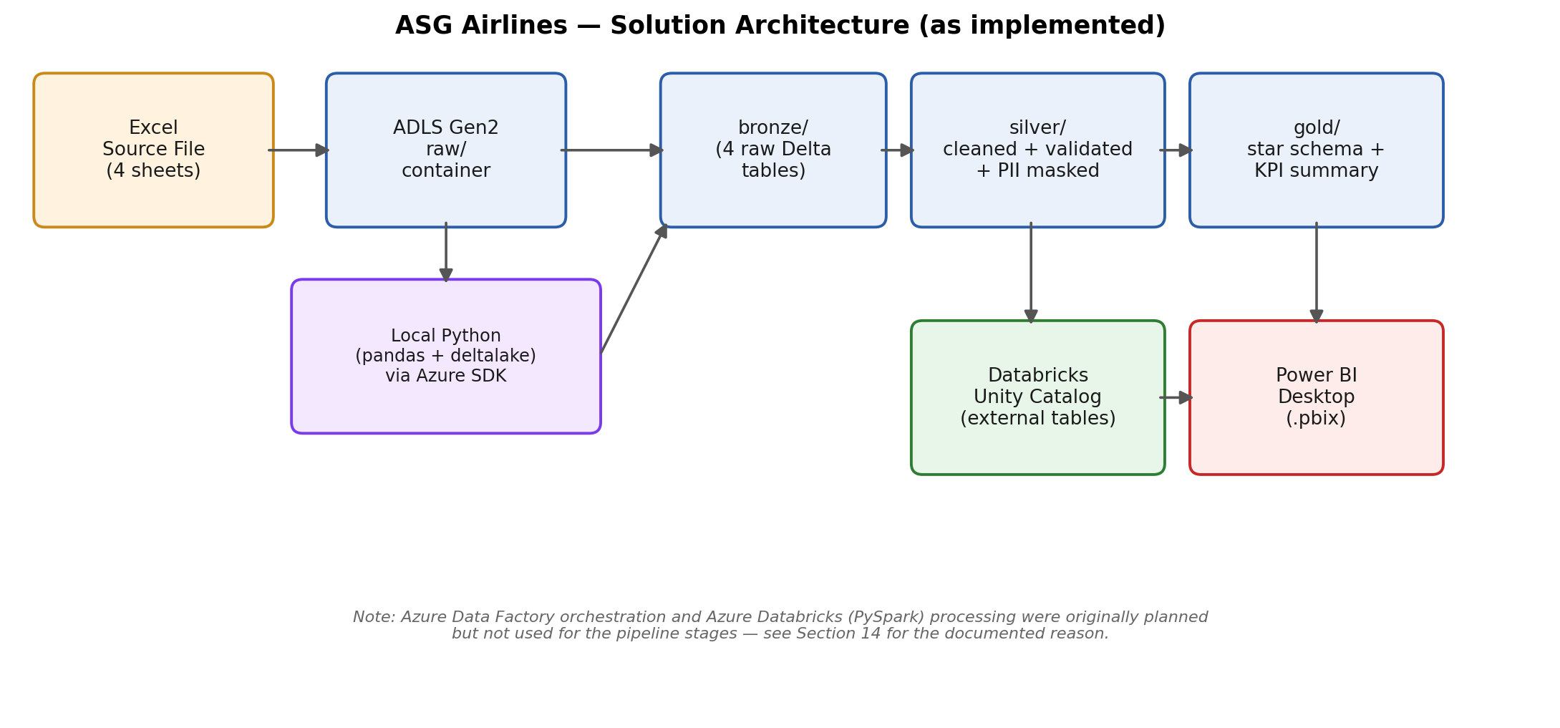

Pipeline Stages
- Ingestion (Raw → Bronze): the source Excel workbook is read locally and written as four separate Bronze Delta tables (flights, bookings, passengers, payments), with a data-quality profiling pass (null counts, duplicate counts, dtype summary) run immediately, before any data is changed.
- Cleaning & Transformation (Bronze → Silver): duplicate and conflicting records are resolved or quarantined, missing values are flagged rather than silently dropped, duration and overnight-flight logic is recomputed from raw timestamps, and passenger/booking PII is masked.
- Modelling & KPIs (Silver → Gold): a flight-only star schema and a pre-aggregated KPI summary table are built to directly support the four required business KPIs.
- Serving: the Gold Delta tables are registered as external Unity Catalog tables and connected to Power BI Desktop in Import mode.
- Reporting: a 5-page interactive Power BI dashboard visualises flight duration, route traffic, airline distribution, and anomaly insights.
Note: Azure Databricks (PySpark) processing and Azure Data Factory orchestration were part of the original architecture but were not used for the implemented pipeline. Section 14 documents exactly why, and what was used instead.

3. Workflow Walkthrough
This section describes what actually happened during the build, in the order it happened, rather than the idealised stage list above.
Work began by loading the four source sheets into Bronze and profiling them before making any changes. That profiling pass found concrete, specific problems rather than assumed ones: the flights table's airline column was missing or placeholder in roughly 7% of rows; the flight_id column, while structurally clean (no whitespace or case issues), contained 15 fully-duplicated flight_id values (30 rows) and one flight_id (6F250) that appeared twice with genuinely conflicting route/time data; and the raw duration column in the source file turned out to be a corrupted Excel time-serialisation artefact rather than a usable duration figure.
From there, each flight's two- or three-character flight_id prefix was found to map cleanly onto a single airline, so that mapping was used to repair missing/placeholder airline values instead of dropping those rows. The 15 exact-duplicate flight_id rows were deduplicated (kept the first occurrence); the one genuine flight_id conflict was quarantined into a separate rejected-records table rather than merged or arbitrarily resolved, since there was no way to determine which of the two conflicting rows was correct. Duration was recalculated directly from the full departure and arrival timestamps rather than trusting the unreliable raw duration column, and one record (SJ192) stood out where the recalculated duration was negative — clearly a data-quality problem rather than a normal overnight flight — so it was flagged as an anomaly and retained, not silently corrected or deleted.
Missing values elsewhere (bookings.status, payments.amount, passengers.last_name) were profiled per column and handled with a consistent flag-and-retain strategy: set to a placeholder value plus a boolean indicator column, never dropped, since the rest of the row typically still carries valid information. The bookings and passengers tables' row counts (1,000 and 1,039 respectively) were unchanged from Bronze through Silver, confirming that, unlike the flights table, no duplicate or corrupted records were found in those two tables during profiling.
Once Silver was in a trustworthy state, PII fields across passengers and bookings were irreversibly hashed or partially masked (Section 10), a flight-only Gold star schema and KPI summary table were built (Section 4), and the Gold layer was registered in Databricks Unity Catalog and connected to Power BI Desktop to build the five-page dashboard described in Section 12.

4. Data Flow & Data Model
Four source tables exist through the Bronze and Silver layers: flights, bookings, passengers, and payments, related via flight_id, passenger_id, and booking_id respectively. However, none of the four required KPIs (Average Flight Duration, Route-wise Traffic, Delays/Anomalies, Airline Distribution) require passenger- or booking-level data — so, by design, the Gold layer and the Power BI dashboard are flight-only. No passenger or booking data of any kind, masked or otherwise, is present past Silver. This is a stronger privacy guarantee than masking alone (see Section 13).
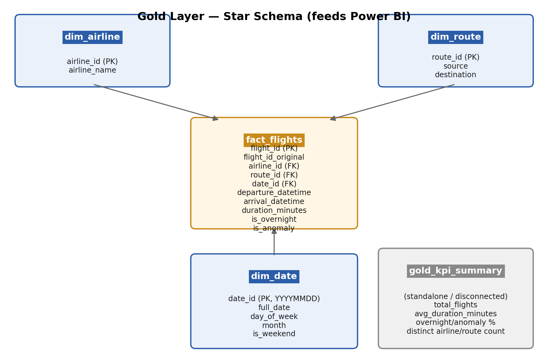
fact_flights is the single fact table, at one row per flight, joined to three dimensions (dim_airline, dim_route, dim_date). gold_kpi_summary is an intentionally disconnected single-row table holding unfiltered, global totals — kept separate from the star schema so it always reflects the true overall numbers regardless of any slicer state applied elsewhere in the report.

5. Dataset Description

flights (1,020 raw records → 1,003 in Silver/Gold)
Column | Description
flight_id | Flight identifier; structurally clean 2–3 character alphabetic prefix + numeric suffix
airline | Airline name — ~7% missing/placeholder in raw data, repaired via flight_id prefix mapping
source / destination | Departure / arrival city code
departure_time / arrival_time | Full date-time timestamps
duration | Raw duration field — found unreliable (Excel time-serialisation artefact); dropped and recomputed

bookings (1,000 records, unchanged Bronze → Silver)
Column | Description
booking_id, passenger_id, flight_id | Identifiers linking to passengers and flights
booking_date, status | Booking metadata; status had ~4.5% missing values, flagged not dropped
passport_number*, emergency_contact_name*, emergency_contact_phone* | PII fields — masked in Silver (Section 10)
seat_number | Assigned seat

passengers (1,039 records, unchanged Bronze → Silver)
Column | Description
passenger_id | Passenger identifier
first_name, last_name, age, gender, date_of_birth | Demographic details; last_name had ~1% missing values
email*, phone*, aadhaar_id* | PII fields — masked in Silver (Section 10)

payments (1,000 records)
Column | Description
payment_id, booking_id | Identifiers
amount | Payment amount — ~4.8% missing values, flagged via is_amount_missing, not imputed
payment_method | Payment channel

6. Assumptions
- Each flight_id's alphabetic prefix maps one-to-one to a specific airline, and was treated as the authoritative source for repairing missing/placeholder airline values rather than dropping those rows.
- Because departure_time and arrival_time are full date-time values (not time-only), a later absolute arrival timestamp correctly represents a genuine overnight flight without requiring separate day-rollover logic — duration is simply arrival minus departure.
- A record where the recalculated duration is negative (arrival before departure even after accounting for a genuine overnight flight) is treated as a data-quality anomaly, not a valid flight, and is flagged (is_anomaly = true) rather than corrected or deleted — this is the one case found in the dataset (SJ192).
- Where two rows share a flight_id but disagree on other fields (the single 6F250 conflict), neither row is assumed correct; both are quarantined into a separate rejected-records table rather than merged or arbitrarily kept.
- No scheduled-time field exists in the source data, so a traditional delay metric (actual vs. scheduled) cannot be honestly computed. Rather than fabricate one, the existing duration-anomaly flag is used as the closest available, defensible proxy for "Delays/Anomalies" in the required KPI set — this was an explicit, recorded design decision, not an oversight.
- Missing values are flagged and retained (a boolean indicator column plus a placeholder value), never dropped, on the basis that the rest of a row typically still carries valid, usable information.
- Missing payment amounts are not imputed, since fabricating a financial figure would misrepresent revenue; they are flagged via is_amount_missing and excluded from any amount-based aggregation.

7. Data Cleaning Logic & Strategy

7.1 Airline Repair (flights)
Missing or placeholder airline values (~7% of rows) were repaired by mapping each row's flight_id prefix to the single airline that prefix consistently represents elsewhere in the dataset, rather than dropping the affected rows or guessing.

7.2 Duplicate & Conflicting flight_id Records
Duplicate detection used an exact full-row match across all original source fields, not just flight_id — this is what distinguishes a true duplicate from a genuine data conflict:
- 15 flight_id values were found as fully identical duplicate rows (30 rows total). One occurrence of each was kept, the other 15 dropped.
- 1 flight_id (6F250) appeared twice with genuinely different data (different routes/times). Since neither row could be confirmed correct, both were quarantined into silver/rejected_flights_id_conflicts with a rejection_reason and quarantine_timestamp, and excluded from the main Silver flights table.
Net effect: 1,020 raw rows − 15 duplicates − 2 quarantined = 1,003 clean flights, which matches the final Silver/Gold row count exactly.

7.3 Raw Duration Column
The pre-existing raw duration field was found to be inconsistently formatted: 97.25% in HH:MM:SS format, 2.65% with fractional microseconds appended, and one row as a corrupted Excel-epoch timestamp. Rather than attempt to parse three inconsistent formats, the column was dropped entirely and duration was recomputed from the full departure and arrival timestamps (Section 8).

7.4 Missing Values
Column | Table | Issue | Strategy
airline | flights | 41 null + 26 literal 'UNKNOWN' (67 total) | Set to 'Unknown', flag column airline_is_missing = true, row kept
status | bookings | 45 missing | Set to 'Unknown', flag column status_is_missing = true, row kept
last_name | passengers | 10 missing | Set to 'Unknown', flag column last_name_is_missing = true, row kept
amount | payments | 48 null + 30 'INVALID' (78 total) | Cast to numeric; unparseable set to null, flag column amount_is_invalid = true, row kept
No rows were dropped anywhere for missing values — the strategy throughout was flag-and-retain.

8. Transformation Logic — Duration & Overnight Handling
Duration is calculated as the full-datetime difference between arrival_time and departure_time (not a time-only subtraction), which is what allows overnight flights to be handled correctly without any special day-rollover logic — because both fields already carry a full date component, a flight that arrives the next calendar day simply produces a duration greater than 24 hours minus the same-day case, with no additional adjustment needed.
Anomaly detection: a record whose calculated duration is zero or negative — i.e. arrival appears to predate departure even after correctly accounting for a genuine overnight flight — is treated as corrupted data (see Section 7.2 / 6.3) rather than a valid duration, and is flagged is_anomaly = true. It remains in the dataset (unlike the quarantined flight_id conflicts) so it can be surfaced and inspected on the dashboard's Delay & Anomaly Insights page, rather than being silently hidden.
Result: 1,003 clean flight records, of which 122 (12.2%) are genuine overnight flights and 1 (0.1%, flight SJ192, route HYD→BOM) is the flagged duration anomaly. Average flight duration overall is 163.2 minutes.

9. Error Handling & Logging
- Every cleaning rule printed a before/after row-count and affected-row-count summary to console at each pipeline stage, so any unexpected change in row count was caught immediately during development rather than propagating silently downstream.
- Records that fail validation are not deleted outright: the one genuine flight_id conflict was quarantined into a separate table (silver/rejected_flights_id_conflicts) with a rejection_reason and quarantine_timestamp column, and other issues are flagged with boolean indicator columns (airline_is_missing, status_is_missing, last_name_is_missing, amount_is_invalid, is_overnight, is_anomaly) so every exclusion or adjustment is traceable and reversible if a business rule changes later.
- PII masking (Section 10) included its own explicit validation step: hash-uniqueness counts and unmasked-column-removal checks were run and confirmed before the masked Silver tables were accepted as final.
Limitation: no persistent, structured logging system (e.g. a log file or logging table) was built — cleaning reports exist only as console output at the time each stage was run. This is called out again as a future enhancement in Section 15.

10. PII Masking Strategy
The passengers and bookings tables contain personally identifiable information. The following irreversible protections were applied in Silver, before the data was made available to any downstream layer:
Field | Table | Masking Technique
aadhaar_id | passengers | SHA-256 one-way hash, salted (column dropped, replaced by aadhaar_id_hash)
passport_number | bookings | SHA-256 one-way hash, salted (column dropped, replaced by passport_number_hash)
email | passengers | Partial mask: {first_char}***@{domain} (column dropped, replaced by email_masked)
phone / emergency_contact_phone | passengers / bookings | Partial mask: country code + last 2 digits visible, middle masked
emergency_contact_name | bookings | Masked to first initial + "***"
first_name, last_name, date_of_birth | passengers | Kept unchanged in Silver only, for internal joins; not present in Gold at all
The salt used for hashing is generated once and stored as an environment variable (PII_SALT), never hardcoded or committed to source control (confirmed excluded via .gitignore). SHA-256 hashing was chosen over encryption because the masked values only need to support equality comparisons (e.g. detecting the same passenger across records), not reversal to the original value — a one-way hash is the more conservative and appropriate control.
Validated: distinct aadhaar_id_hash values equal the distinct raw aadhaar_id count (1,039 of 1,039 — no collisions or duplicate raw IDs); distinct passport_number_hash values equal the distinct raw passport_number count (1,000 of 1,000). Row counts (passengers 1,039, bookings 1,000) were confirmed unchanged by the masking step.
Gold goes further than masking: no passenger- or booking-level column, masked or otherwise, exists anywhere in the Gold layer or the Power BI dashboard (see Section 4). This was an explicit design decision, since the four required KPIs are all flight-grain and do not need passenger or booking data — eliminating an entire category of risk at the reporting layer rather than relying on masking alone.

11. Business KPIs & Metrics
KPI | Result
Average Flight Duration (overall) | 163.2 minutes
Overnight Flights | 122 of 1,003 (12.2%)
Duration Anomalies (Delays/Anomalies KPI) | 1 flight (0.1%) — SJ192, HYD → BOM
Distinct Routes | 30
Distinct Airlines | 5 (IndiGo, SpiceJet, Air India, Vistara, Unknown)
Airline Distribution | IndiGo 24.8% · SpiceJet 23.5% · Air India 23.2% · Vistara 21.7% · Unknown 6.7%
Route-wise Traffic | Visualised directly as flight count per route (source → destination) on the Route Performance page
Note on "delays": the source data has no scheduled departure/arrival time, only actuals, so a traditional delay metric (actual vs. scheduled) could not be computed. The duration-based anomaly flag (Section 8) is used as the closest defensible proxy for operational irregularities, and this is stated explicitly on the dashboard's Delay & Anomaly Insights page rather than left implicit.

12. Power BI Dashboard Walkthrough
The dashboard is built in Power BI Desktop (Import mode, connected to the Gold Unity Catalog tables) and organised into 5 pages, matching the case study's suggested structure:
Page | Contents
Overview | KPI cards (Total Flights, Avg Duration, Overnight Flights, Overnight %, Anomaly Flights, Anomaly %); Flights by Airline, Avg Duration by Airline, Route Flight Count by Source; Select Airline slicer
Duration Analysis | Avg Flight Duration KPI card; Avg Duration by Airline; Avg Duration by Source
Route Performance | Select Airline slicer; Flights by Destination; Flights by Source; Flights by Route (source → destination pairs, sorted by volume)
Airline Trends | Select Airline slicer; Flight Share by Airline (donut); Avg Flight Duration by Airline
Delay & Anomaly Insights | KPI cards (Overnight Flights, Overnight Rate, Anomaly Flights, Anomaly Rate); Anomalies by Airline chart; anomaly detail table (flight_id, airline, route, duration, filtered to is_anomaly = true) showing the one flagged record (SJ192) for direct inspection
All DAX KPI measures (Total Flights, Average Flight Duration, Anomaly Flights/%, Overnight Flights/%, Airline Flight Share %) are built directly on fact_flights, which makes every card and chart respond correctly to the Select Airline slicer. The standalone gold_kpi_summary table is not used by any visual, by design — since it holds an unfiltered global snapshot rather than slicer-responsive figures, it was deliberately kept separate from the interactive measures rather than duplicating the Total Flights card.
An optional "All-Time Baseline (Unfiltered)" section on the Overview page, sourced from gold_kpi_summary, was designed as an enhancement but deferred and not yet built into the current .pbix — see Section 15.
Cross-filtering is enabled through the star-schema relationships and the Select Airline slicer present on 4 of the 5 pages, so selecting an airline updates every related visual on that page.

13. Privacy & Access Control
The dataset contains passenger PII (contact details, government ID numbers, travel documents) at the Bronze and Silver layers only. The following controls govern access:
- Raw and Bronze layers (unmasked source data) are stored in dedicated ADLS Gen2 containers (raw, bronze) and are intended to be restricted to authorised data engineers only, via Azure RBAC (e.g. Storage Blob Data Contributor scoped to those containers).
- Silver retains masked/hashed PII only (raw PII columns are dropped, not just hidden), for internal pipeline integrity checks such as detecting the same passenger across records.
- Gold contains zero passenger- or booking-level fields of any kind — not masked, simply absent. This means the Power BI dashboard and the Unity Catalog external tables it connects to cannot leak PII even if broadly shared, by construction rather than by relying on a masking or access-control layer holding correctly.
- Databricks Unity Catalog provides table-level governance for the external Gold tables; in a production deployment, access to the underlying raw/bronze ADLS containers would be granted only to a data-engineering role, while Gold/Power BI access could be granted more broadly to analytics and operations users.
- Per the case study's literal submission requirement (a .pbix file and a screenshot), this project intentionally does not publish to Power BI Service or use an organisational Microsoft Entra identity — the .pbix is shared directly. In a production or Service-published setting, the recommended control would be a secured workspace with row-level security and Azure AD authentication rather than broad distribution of the raw .pbix file.

14. Technology Notes: Deviations from the Planned Architecture
The original architecture, aligned with the case study's preferred technology recommendation, was: Azure Databricks (PySpark) for processing, Azure Data Factory (ADF) for orchestration, ADLS Gen2 for storage, and Power BI for reporting. The processing and orchestration layers changed during implementation, for the reasons documented below — this section exists so the deviation is understood as a deliberate, recorded response to a real infrastructure blocker, not an unexplained shortcut.

14.1 What Was Attempted
Azure Databricks cluster (compute) provisioning was attempted and failed repeatedly, across multiple Azure regions and VM sizes:
- centralindia: cluster repeatedly stuck in PENDING ("Finding instances for new nodes, acquiring more instances if necessary") across Standard_DS3_v2, Standard_D4s_v3, and Standard_D4s_v4 — confirmed as an Azure regional capacity/stockout issue, not a quota problem (quota was available: 6 regional vCPUs, 4 per family).
- uaenorth: cluster creation reached a TERMINATED state with error INVALID_WORKER_ENVIRONMENT: WORKER_ENVIRONMENT_NOT_FOUND.
- koreacentral: cluster creation failed with "Current organization ... does not have any associated worker environments."
- A manual workaround (opening the workspace once via the Azure Portal "Launch Workspace" action, to trigger backend activation) was tried on the centralindia workspace; the same PENDING/stockout behaviour persisted afterwards.

14.2 Decision Made
Databricks compute was abandoned for the ingestion/cleaning/transformation pipeline. ADLS Gen2 was kept as the storage layer exactly as planned, and all pipeline stages were instead executed locally: Python (pandas, plus the deltalake / delta-rs library) reading and writing Delta tables directly to ADLS Gen2 via the Azure DataLakeServiceClient SDK. This is an explicitly documented architectural deviation, and is consistent with the case study's own stated allowance for a local Python/SQL alternative to Azure Databricks.
Azure Data Factory orchestration was never attempted, for a related reason: ADF was intended to orchestrate Databricks notebook execution, and the pipeline never got past establishing working Databricks compute in the first place — once Databricks was abandoned for processing, there was no compute layer left for ADF to orchestrate. All pipeline stages were instead run as discrete, independently-validated Python scripts, each checked (row counts, sample output, validation queries) before proceeding to the next stage.

14.3 Where Databricks Was Still Used
Databricks was still used, but only downstream, as a query/serving layer rather than a processing layer: once the Gold Delta files existed on ADLS Gen2, they were registered as external Unity Catalog tables (via a new Azure Managed Identity storage credential and an external location, gold_location) so that Power BI Desktop could connect to them through a Databricks SQL Warehouse. This required granting the Unity Catalog access connector's managed identity the Storage Blob Data Contributor role on the storage account, since the workspace's default storage credential was restricted to Databricks-managed storage and could not reach the project's own storage account.

14.4 Cost/Safety Note
Because Databricks compute was never successfully provisioned for processing, no meaningful compute cost was incurred there. The only Databricks cost exposure in this project is the SQL Warehouse used transiently to serve the Gold tables to Power BI.

15. Limitations & Future Enhancements
- No scheduled-time field exists in the source data, limiting true delay analysis to the duration-based anomaly proxy described in Section 8/11.
- The one genuine flight_id conflict (6F250) could not be resolved to a single "correct" record without an external source of truth, and remains quarantined rather than guessed at.
- No persistent, structured logging system was built; cleaning reports currently exist only as console output captured at run time. A production version would add structured logging (e.g. to a log file or logging table) for auditability after the fact.
- Azure Data Factory orchestration was not implemented, for the infrastructure reasons documented in Section 14. A production deployment would either resolve the Databricks capacity issue directly with Azure support, or build the pipeline as native ADF activities (e.g. Mapping Data Flows or Azure Functions) that do not depend on Databricks compute.
- Power BI Desktop currently connects to the Gold Unity Catalog tables in Import mode; a production version would use scheduled refresh or DirectQuery against a live SQL Warehouse for up-to-date figures without a manual refresh step.
- The optional "All-Time Baseline (Unfiltered)" KPI section on the Overview page, sourced from the standalone gold_kpi_summary table, was designed but not yet built into the current .pbix.
- Power BI Service publishing (workspace, organisational sign-in, online sharing) was intentionally out of scope for this submission, consistent with the case study's literal deliverable requirement of a .pbix file and a screenshot. Publishing to Service with a proper Microsoft Entra ID-backed account is a documented, low-cost enhancement path if a fully online, collaborative version is required later.
— End of Document —

