**PRIMAL RESEARCH IDEAS IN SCIENCE AND MANAGEMENT**

**PRISM – 2022**

**IDEA PROPOSAL APPLICATION**

**Early Detection of Sleep Deprivation: Impact on Cognitive Performance**

|  |  |
| --- | --- |
| **Harsha K.G.** | **PG Scholar (Master in Data Science) Department of Statistics and Data Science**  **CHRIST (Deemed to be University), Bangalore** |
| **7593974960** | **harsha.kg@msds.christuniversity.in** |
| **M. Madiha Farhana** | **PG Scholar (Master in Data Science) Department of Statistics and Data Science**  **CHRIST (Deemed to be University), Bangalore** |
| **8555963051** | **m.farhana@msds.christuniversity.in** |
| **Joan Jose M** | **PG Scholar (Master in Data Science) Department of Statistics and Data Science**  **CHRIST (Deemed to be University), Bangalore** |
| **9645276142** | **joan.m@msds.christuniversity.in** |
| **Aiswarya Antony** | **PG Scholar (Master in Data Science) Department of Statistics and Data Science**  **CHRIST (Deemed to be University), Bangalore** |
| **8086676496** | **aiswarya.antony@msds.christuniversity.in** |
| **Keerthana R** | **PG Scholar (Master in Data Science) Department of Statistics and Data Science**  **CHRIST (Deemed to be University), Bangalore** |
| **9384960246** | **9384960246** |

|  |  |
| --- | --- |
| **Sibu Cyriac** | **Senior Programme Manager Centre of Digital Innovation**  **CHRIST (Deemed to be University), Bangalore** |
| **Amala Ann K A** | **amala.ann@res.christuniversity.in** |

**INTRODUCTION**

**Dr Matthew Walker,** Founder and Director of the Centre for Human sleep science, **remarks. “The best bridge between despair and hope is a good night’s sleep”.** Sleep is an active and regulated process with an essential restorative function for physical and mental health [1]. The quantity and quality of sleep have a significant impact on health and quality of life. According to Walker, by 70 years old, there’s only about five percent of deep sleep left that was there when an individual was young and healthy. By 80 years, any of these deep sleep brain waves won’t be able to detect anymore. The impact of acute sleep deprivation (SD) on performance is critical in several domains. [2] People also have a tendency to overwork themselves and jeopardize their nightly sleep, which results in chronic sleep deprivation.

Decision-making falls under the broader category of executive functions, often called cognitive performances, including working memory, learning and implementation, automatic responses, and probabilistic assessment. Performing these day-to-day tasks can be a challenge for people with sleep deprivation. A standard theory suggests that attention is the only cognitive function affected by sleep deprivation, but cognitive impairments can also be mediated through alertness during sleep, slowed responses, and wake-state instability.

 Our study includes:

To build a classification model that helps understand the variation of ECG, EOG, EMG signals in non-healthy subjects who have exhibited Insomnia and other cognitive-related disorders with respect to Healthy subjects.

1. To identify the distribution statistics of NREM and REM sleep stages of subjects who suffer from Diagnosis and Other problems
2. To analyse the abnormalities in Heart Rate and the amount of haemoglobin saturated with oxygen during the episode and examine how it is associated with cognitive changes.

This study examines the changes during sleep deprivation that can provide critical information on the brain’s ability to perform decision-making tasks to reveal significant cognitive consequences.

* **Polysomnography (sleep study)**

Polysomnography, also called a sleep study, is a comprehensive test used to diagnose sleep disorders. During a polysomnography study, your eye and leg movements, blood oxygen levels, heart rate, respiration, and brain waves are all recorded. Polysomnography (PSG) offers a multifaceted methodology for identifying the type and root causes of various sleep problems. It monitors whether, when, and why your sleep patterns are disrupted and also tracks your sleep cycles and phases.  The comprehensiveness of PSG   enables accurate inferences to be drawn about the causes of sleep disruption. The PSG report is a valuable diagnostic tool for more complicated health conditions with social or personal roots.

The AASM manual's guidelines were followed when recording the PSG signals. There are 19 channels of signals in each recording. All EEG, EOG, and chin EMG signals were recorded using standard EDF+ data formats with .REC extensions and sampled at 200 Hz. According to the recommendations of the AASM, all recordings in the dataset were segmented into epochs of 30 s and visually assessed by two distinct sleep specialists at CHUC, with the stages of waking, NREM (N1, N2, and N3), and REM sleep.

* **The stages of sleep**

Non-rapid eye movement (NREM) and rapid eye movement (REM) sleep are the two main categories of human sleep. Every 90 minutes or so, REM and NREM sleep alternate. Sleep exhibits an ultradian rhythm, which has a frequency of around 90 minutes. A very distinctive aspect of human sleep is this cycle of REM and NREM sleep.

**Stage W**

Relatively high tonic EMG activity defines stage W. It is frequently observed that at least 50% of this period has alpha activity. Active wakefulness is characterized by a low-voltage (10–30 V) mixed-frequency EEG profile with open eyes. Contrast this with peaceful wakefulness with closed eyelids when the alpha activity starts to show in the parieto-occipital region. It is frequently observed that at least 50% of this period has alpha activity.

**Stage N1**

Stage N1 is distinguished by low-voltage, mixed-frequency EEG activity, with the 2–7 Hz band exhibiting the maximum amplitude. It's possible to see sharp vertical waves, whose amplitude can be as high as 200 V. Additionally, stage N1 is characterized by a stop of blinking and a lack of saccadic eye movements. SEMs, often known as sluggish and oscillating eye movements, start to occur.

**Stage N2**

It's a common belief that the true start of sleep occurs when stage N2 first manifests. Wave patterns, the lack of slow waves, sporadic K-complex occurrences, and one or more trains of sleep spindles are the characteristics of stage N2. High tonic submental EMG levels, which result in no bodily movements, define stage N2.

**Sleep spindles and K-complexes**

The K-complex (KC) is a thalamic-generated series of spindles that is followed by a cycle of sluggish cortical oscillation. The KC typically consists of three waves and lasts for at least one second in scalp EEG recordings (positive–negative–positive). Sleep spindles occur between 12 and 14 Hz.

**Stage 3**

The deepest NREM sleep stages are denoted by Stage N3. In stage N3, waves in the 0.5-2 Hz range are present in 20–50% of the EEG record's epoch (measured over frontal areas). This phase may also include sleep spindles.

**Stage R**

Similar to stage 1 of EEG, stage R is characterised by low voltage, mixed frequencies, and a sawtooth wave pattern. EMG activity reaches its lowest point, and episodic REMs start to happen during stage R. The final portion of the night is when REM sleep predominates, and REM sleep is when dreams are most likely to happen.

* **Background**

Based on the R&K (Rechtschaffen & Kales) standards, the American Academy of Sleep Medicine (AASM) defined new criteria for sleep scoring [3]. Adults' sleep-wake cycles are divided into three stages: awake, non-rapid eye movement (NREM), and rapid eye movement (REM). Three levels further split NREM sleep: N1 (drowsiness/transitional sleep), N2 (light sleep) and N3(deep sleep), the last of which is also called delta sleep or slow wave sleep (SWS). The 2007 AASM visual scoring rules recommend a frontal electrode for best-detecting K-complexes, a central electrode for spindles, and an occipital electrode for alpha waves. Based on both scoring rule sets (R&K and AASM), epochs of 30 s (more rarely 20 s) are defined for the PSG signals scoring.

The recorded PSG signals have a poor signal-to-noise ratio (SNR); preprocessing is used to improve the signal quality. For example, some channels of the recorded signals are filtered to remove background EEG noise and unwanted noise, with the goal of improving the PSG signal quality and SNR. The first step in the filtering process is a notch filter to remove electrical noise at 50 Hz; the second step is a bandpass Butterworth filter with lower cutoff frequencies of 0.3 Hz and higher cutoff frequencies of 35 Hz for the EEG and EOG channels and lower cutoff frequencies of 10 Hz and higher cutoff frequencies of 70 Hz for the EMG channels.

Low delta 0.3-1 Hz, delta 1-4 Hz, theta 4-8 Hz, alpha 8-12 Hz, sigma 12-15 Hz, and beta 15-30 Hz are the main EEG frequency ranges. Different stages of sleep are characterized by different EEG waves (alpha, beta, sigma, delta, and theta). The REM stage is characterised by low amplitude, mixed EEG frequency, saw-tooth pattern, and high-level Electrooculogram (EOG) signals from both eyes. The EEG signal in stage N1 contains alpha waves and waves with high amplitudes and a frequency range of 2–7 Hz. Regarding N1, the EMG level is lower than it is during the waking state. During N2, sleep spindles (12–14 Hz) and K-complexes are seen. N3 (deep sleep) comprises 2-4 Hz low-frequency, high-amplitude waves**.**

* **Effect of sleep-related disorders on sleep stage pattern**

The most typical sleep condition seen in sleep medicine clinics is sleep apnea. Repeated episodes of upper airway blockage that happen while you're sleeping and are typically accompanied by a drop in blood oxygen saturation are what the syndrome is known for. Brief awakenings during sleep brought on by these nocturnal respiratory disorders encourage fragmented sleep, which often affects sleep architecture by reducing or even eliminating REM and N3 sleep. The syndrome is characterised by an increase in arousals of various lengths and an increase in sleep stage transitions. Because of this sleep fragmentation, which prevents brain synchronization, there are fewer slow wave sequences during deep sleep [3]. On the other hand, transient experimental hypoxia-induced abnormal posterior resting state delta and alpha rhythms in healthy volunteers, and EEG slowing during awake with an increase in relative theta and delta power in occipital, temporal, and parietal areas was observed in sleep apnea subjects, which can be correlated with sleepiness in these individuals. Additionally, in the frontal and parietal regions, moderate obstructive sleep apnea (OSA) patients had a smaller percentage of slow spindles with deceleration than mild OSA or regular groups, which may indicate a disturbance of the thalamocortical loops that produce spindle oscillations. Collectively, these results suggest that in patients with sleep apnea, considerable discrepancies in agreement across different raters of sleep investigations can occur.

Sleep-EEG alterations can be brought on by affective disorders (depression/anxiety disorders). Depression is characterized by an increase in sleep latency, an increase in sleep fragmentation brought on by arousals or irregular awakenings, and an increase in early-morning awakenings. In all age groups, a shortened REM latency, including sleep onset REM periods (REM latency 20 min), prolonged first REM periods, and increased REM density, are frequently observed. NREM-sleep changes in younger patients include a decrease in SWS, an increase in stage N2 sleep, and a shift in EEG-delta power from the first to the second sleep cycle [4]. The only noticeable differences between generalized anxiety disorder (GAD) patients and control subjects in SWS and REM sleep are insomnia-like symptoms [5].

The hyperarousal paradigm of primary insomnia (psychophysiological insomnia) postulates that a lack of reduced arousal during sleep may cause non-restorative sleep. The EEG beta (cortical arousal) and sigma (spindle) frequency bands during the N2 sleep stage have been demonstrated to have higher spectral power values in these patients, with no abnormalities in the other frequency bands [6]. This rise in cortical arousal and a measure of sleep-protective mechanisms (spindles) may support the idea that primary insomnia patients experience non-restorative sleep due to the simultaneous activation of wake-promoting and sleep-protective brain activity patterns.

**METHODS**

**ISRUC-Sleep Dataset**

Each study team gathers its test data, investing time and money to evaluate the effectiveness of sleep pattern analysis methodologies. These databases, primarily utilized for their research, frequently need essential information on their acquisition and the clinical states of the subjects (neural, cardiorespiratory, and medication effects). Some of these datasets only record a few PSG channels and lack statistical significance. As a result, accurately comparing and evaluating these approaches' performances with new methods is impossible.

The dataset includes information gathered from polysomnography (PSG) recordings made during an 8-hour night. Each recording was chosen randomly from among the PSG recordings that the Sleep Medicine Centre of the Hospital of Coimbra University (CHUC) collected between 2009 and 2013. Data collection involved non-invasive sensors and bio signal acquisition equipment (a multi-channel ambulatory recording device called the SomnoStar Pro sleep system).

The subject sleeps in a bed in a patient's room as part of the arrangements, while the specialists and technicians are housed in a different room. All patients who had been referred underwent an initial briefing while being supported by an informed consent form. The CHUC ethics committee approved using the referred patients' anonymized data for research purposes.

The American Academy of Sleep Medicine (AASM) manual's guidelines were followed when recording the PSG signals. Each recording comprises signals from six different channels, as shown in Table. All EEG, EOG, and chin EMG signals were recorded using standard EDF+ data formats with the ‘.REC’ extension and sampled at 200 Hz. According to the recommendations of the AASM, all recordings from the dataset were segmented into epochs of 30 s and visually assessed by two distinct sleep specialists at CHUC, with the stages of waking, NREM (N1, N2, and N3), and REM sleep. The results of calculating Cohen's kappa index between two experts over the subgroups' topics are as follows: overall kappa index of 0.87 ± 0.09 for subgroup-I and 0.9 ± 0.06 for subgroup-III. The labels are saved in a standard text file format, where each line represents a single epoch. In addition, the header of each text contains information about the gender, height, weight, age, and date of recording of the test subjects.

Table : Details of recorded signals of ISRUC-Sleep dataset 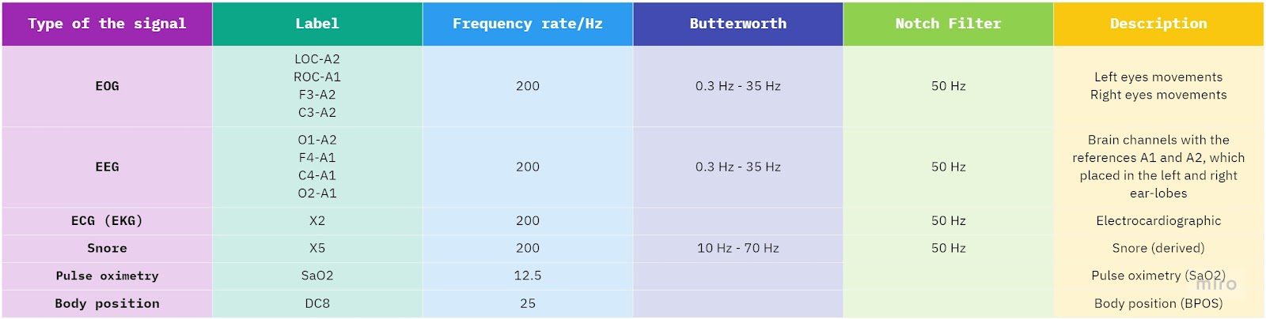

Additional analysis includes percentages of each participant's sleep stage, sleep events, sleep-related disorders, other illnesses, sleep pathology, and consumed drugs. According to the figure, the ISRUC-Sleep dataset consists of subgroups I and III.

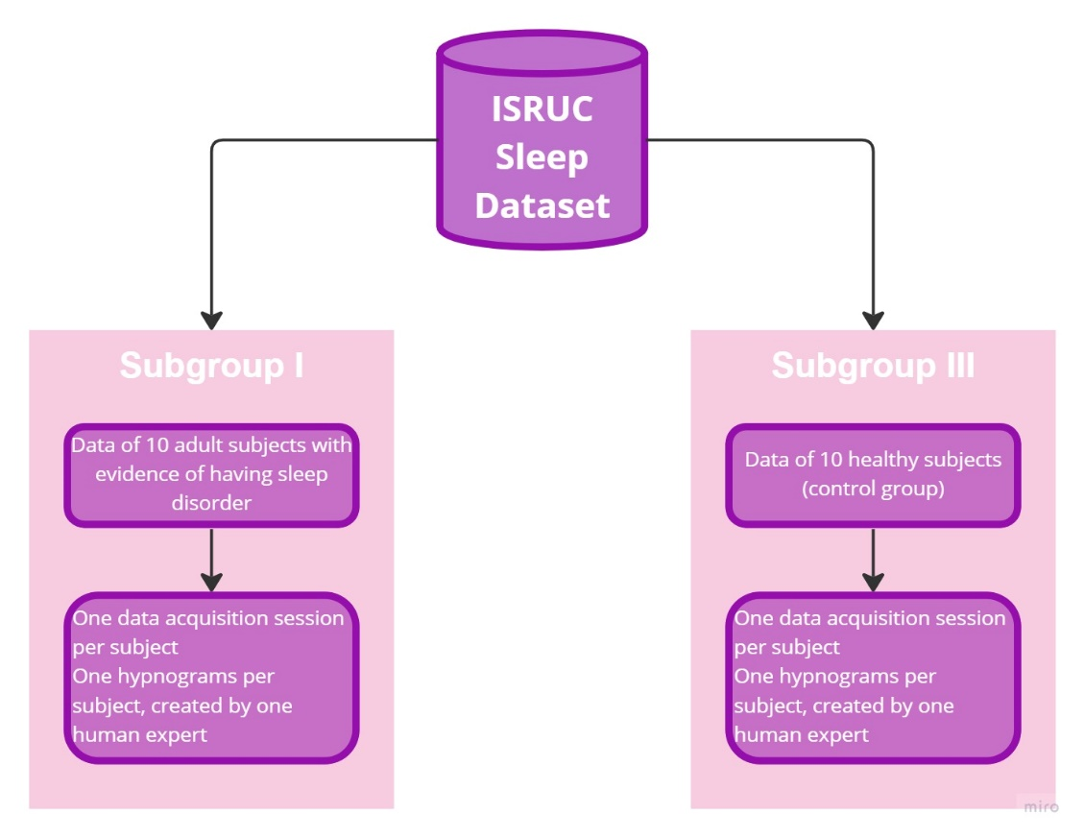

Fig.: Details of ISRUC-Sleep dataset

Table: Variable description

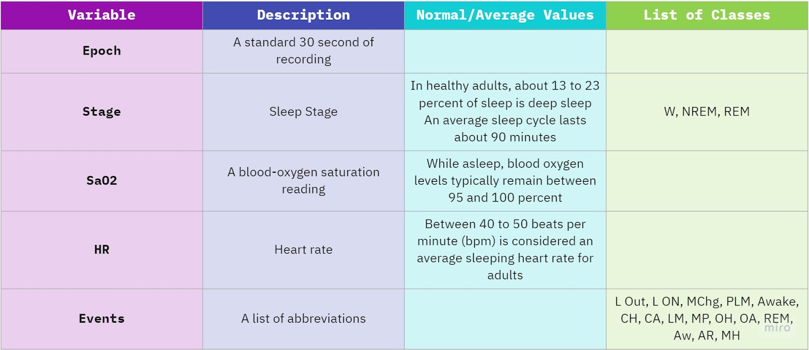

The AASM established a standard for scoring sleep based on the R&K principles. Human sleep intervals typically last 90 minutes or less. The stages of the sleep-wake cycle in adults are as follows:

i.                 W: Awake

ii.               NREM: Non-Rapid Eye Movement

iii.             REM: Rapid Eye Movement

The three stages of NREM sleep are N1, N2, and N3, with the third stage often known as delta sleep or slow wave sleep (SWS). These stages advance in a cyclical order: N1 → N2 → N3 → N2 → REM. The cycles occur four to six times throughout a whole night's sleep. Each night, the early sleep cycles feature relatively long deep sleep cycles and short REM cycles, but later in the night, REM cycles extend, and deep sleep cycles shorten. The table provides an overview of the specified features for each stage of sleep centred on the frequency, amplitude, and shape of the polysomnographic (PSG) signals.

Table: Summary of EEG, EOG and EMG patterns for different sleep stages

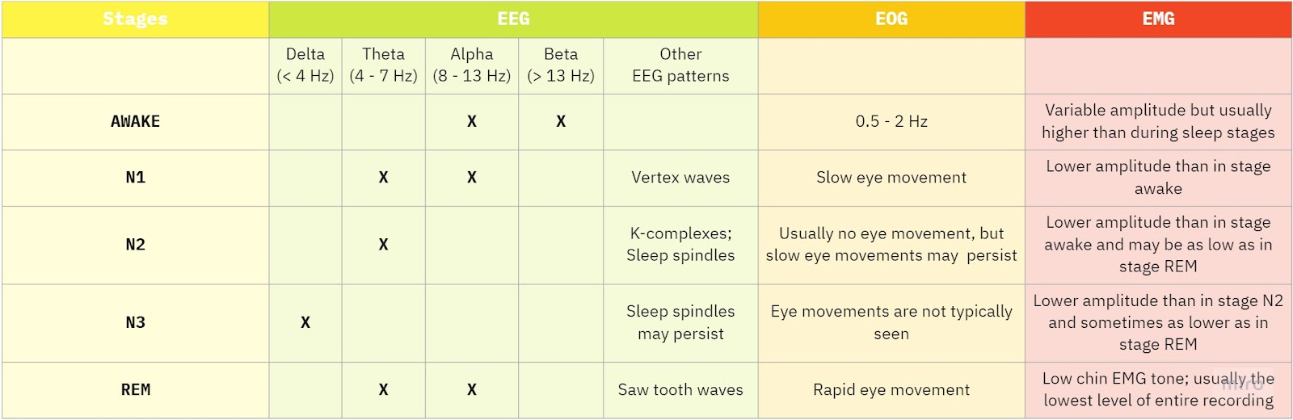

A blood-oxygen saturation (SaO2) reading reveals the proportion of oxygen-saturated hemoglobin molecules in arterial blood. The result is known as SaO2. An oximeter uses specific light wavelengths to measure oxyhaemoglobin saturation non-invasively and estimates arterial oxyhaemoglobin saturation (SaO2).

The Events consist of the following abbreviations:

i.                 L Out: Lights turn off

ii.               L ON: Lights turn on

iii.             MChg: Montage Change

iv.        PLM: Periodic Leg Movement is a motion that recurs over and over, and the period required for each recurrence remains the same

v.               Awake: Awakening

vi.             CH: Central Hypopnea

**Sleep Parameters**

**Arousal Index**

Arousals are sleep pauses that last three to fifteen seconds. It can happen on its own or as a result of other sleep disorders, such as sleep-disordered breathing. You return to a lighter state of sleep with each arousal. An arousal turns into an awakening if it lasts for more than 15 seconds.

**Electrodes (channels)**

These channels are utilised to determine whether you are awake or sleeping as well as the many stages of sleep you experience. Typically, electrodes are affixed to your scalp around the frontal, occipital, and central portions of your brain. EEG or brain waves: Usually, a water-soluble putty or glue is used to connect 6 electrodes to your scalp. You don't have your hair cropped or shaved. There are no needles used. After your study session is done, the glue is removed.

**Hypnogram**

A hypnogram is a diagram that shows the stages of sleep in relation to time. Full polysomnography in a sleep lab is necessary, with EEG, EMG, and simultaneous eye movement recording. Various abnormalities of your sleep phases can be diagnosed by sleep disorders specialists using both qualitative and quantitative methods. Sleep architecture is represented by a hypnogram.

**Number of REM episodes**

Usually, there are three to five REM cycles each night, with each episode growing longer as the night goes on. The final one may go on for an hour or so. Aiming to spend 20–25% of your sleep duration in the REM state is a desirable objective for healthy individuals. Around 90 minutes of your 7-8 hours of sleep should be REM.

**Parameters monitored for Polysomnography test**

**EEG Recording**

Electroencephalography (EEG) is the recording of electrical activity along the scalp. It studies the brain's neuronal function and neurophysiological properties. Electrodes are used to record signals from the scalp that represent brain activity. Electrodes are generally positioned over several scalp regions during EEG recordings. The electrodes are attached to detectors and recorders that pick up, amplify, and capture brain electrical activity.

**EOG Recording**

The horizontal and vertical eye movements are recorded on two EOG recording channels. On the horizontal eye axis, electrodes are positioned at the right and left outer canthi. About 1 cm above and out from the right eye's outer canthus, the right outer canthus electrode (ROC) is attached. About 1 cm below and out from the left eye's outer canthus, the left outer canthus electrode (LOC) is attached. These electrodes detect the natural voltage present in the eye; the retina is negatively charged, and the cornea is positively charged**.**

**ECG Recording**

During PSG recording, a single electrocardiography (ECG or EKG) channel is usually sufficient. Two self-stick EKG electrodes are often used: one at the lateral chest position and the other at the rostral sternum. There are two reasons for recording EKG activity. The monitoring of cardiac activity during overnight sleep recording is possible to start with. The severity of some cardiorespiratory dysfunctions, such as sleep apnea, can be evaluated, for instance, using an EKG. Second, locating the cardiac artefact on the EEG channels is helpful. For typical sleep patients, it might be less of an issue than for PSG performed on an epileptic patient, though**.**

**Pulse Oximetry**

An initial screening procedure for sleep apnea is an overnight pulse oximeter test. A pulse oximeter detects the level of oxygen in your blood. The blood carries oxygen to your brain, and if the blood oxygen content is consistently above 94% while you sleep, your brain is receiving the oxygen it requires, and you are likely to wake up feeling refreshed. May have symptoms of sleep apnea, such as morning headache, excessive daytime sleepiness, insomnia, snoring, gasping for air while sleeping, dry mouth, etc., if the brain does not receive regular oxygen throughout sleep.

**Snore**

Snoring is currently not adequately recorded and analyzed by Sleep Medicine. The use of a standardized method to record and analyze snoring is needed in order to compare studies of OSA and snoring and to advance this field. Snoring recording is also a promising, inexpensive, and noninvasive method for OSA diagnosis.

**DESIGN / PROTOTYPE**

From the data collected through the ISRUC sleep study, we categorize the subjects into two subgroups, i.e., one subgroup of subjects having a medical history of sleep disorders or are suffering from sleep disorders and the other subgroup of subjects who are healthy and do not have any medical history as such.

The first subgroup is subjects with problems like depression, insomnia, and shift work. Most were diagnosed with SAOS (Obstructive Sleep Apnea Syndrome) and REM (Rapid Eye Movement) sleep behavior disorder. Since the objective of this test is to identify the signs of cognitive impairment concerned with sleep depression, sleep apnea, insomnia, and shift work, which define how their cognitive performance is being affected due to the disorders and that are compared with the healthy subjects.

The signal recording, which includes EEG, EMG, ECG, etc., is converted to EDF files, and then for analysis, all the extracted data are converted to .csv format for all the data to be in the same format.

Using the details of the subgroup of healthy and unhealthy

* Analyse the % of each sleep stage and how it affects Diagnosis and other medical conditions
* Identify what is the percentage of each sleep stage for people who suffer from insomnia and other condition related our study

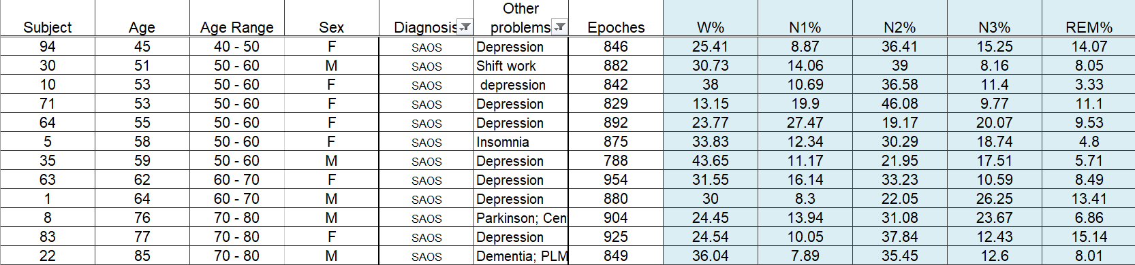

Fig : With Sleep Disorder Dataset (Subgroup-I)

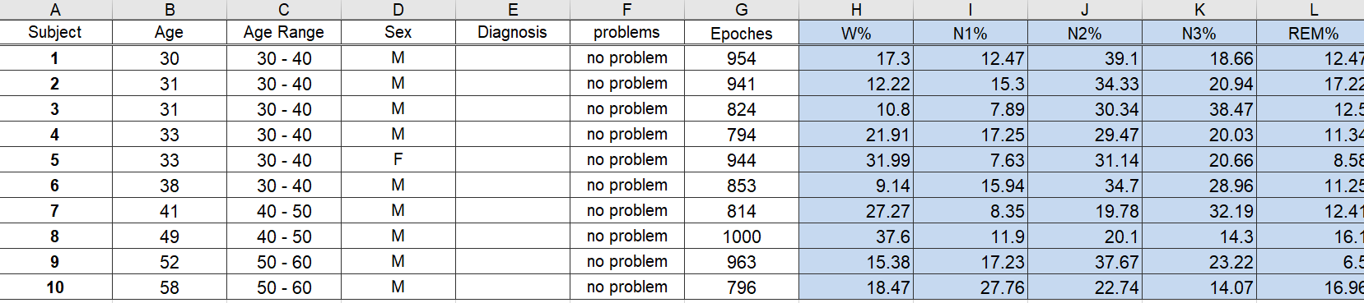

Fig : WithOUT Sleep Disorder Dataset (Subgroup-III)

Now filter out 5 subjects from Subgroups 1, and 3 with Insomnia, Depression, Dementia, Parkinson etc. (any disorder that is related to the brain you can consider) and look at the contextual information containing excel files of these subjects.

Now understand how their Heart rate, SaO2 etc varies

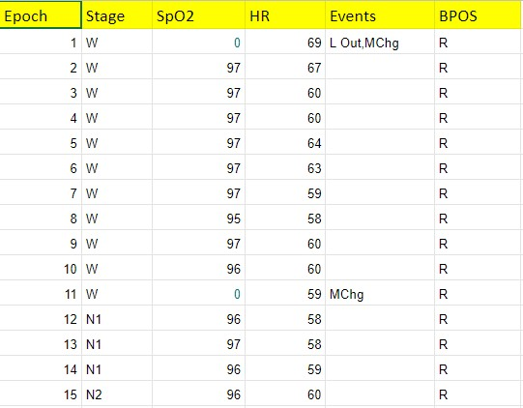 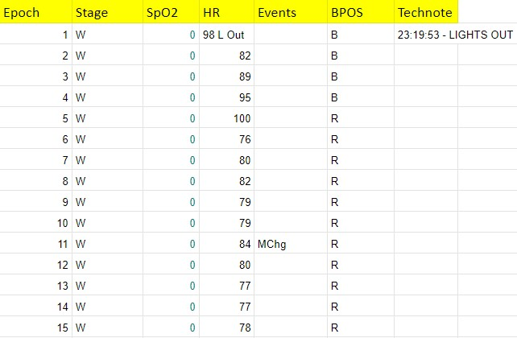

Fig: With Sleep Disorder Dataset (Subgroup-I) Fig: Without Sleep Disorder Dataset (Subgroup-III)

* Perform correlation to understand how the parameter varies in each subject if he/she is diagnosed with insomnia or other condition
* Combine the extracted signal data using the EDF browser with contextual information data either using subject id or epoch and perform model building.

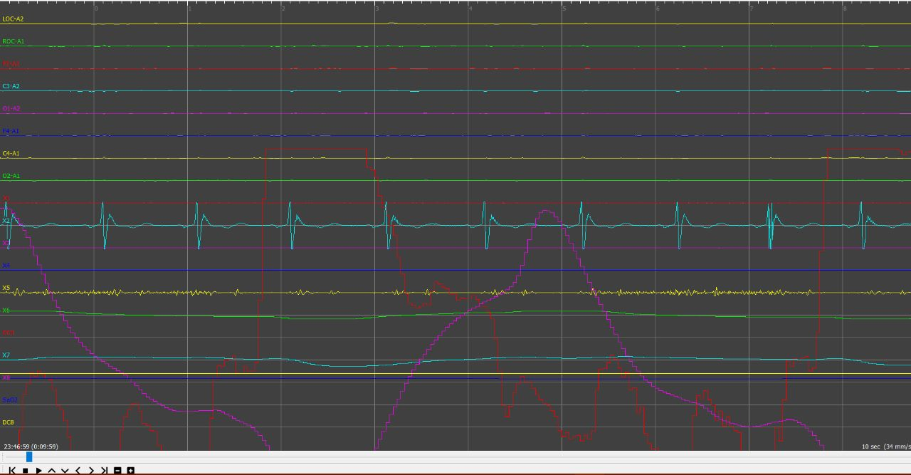

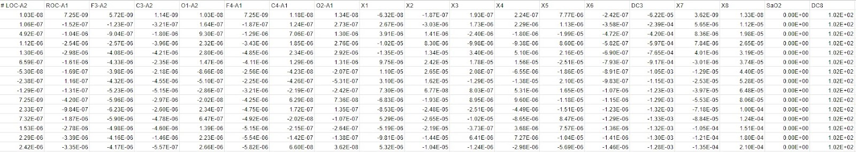

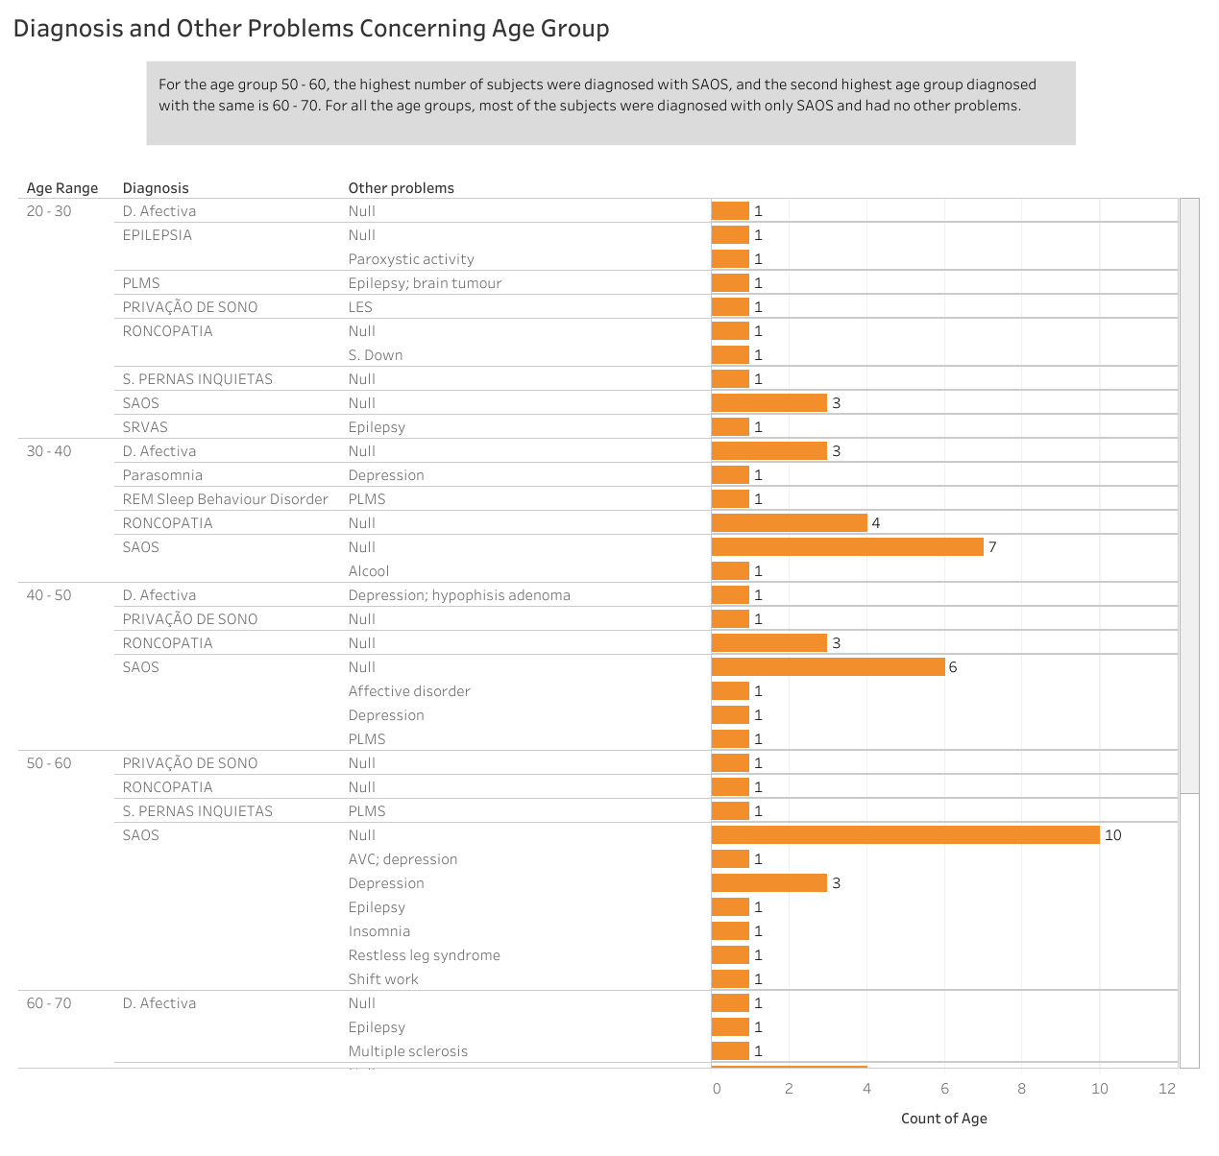

Fig. Diagnosis and Other Problems Concerning Age Groups

The above figure represents the count of the subjects in respective age group who were diagnosed with sleep disorders and have other problems including depression, insomnia, etc.

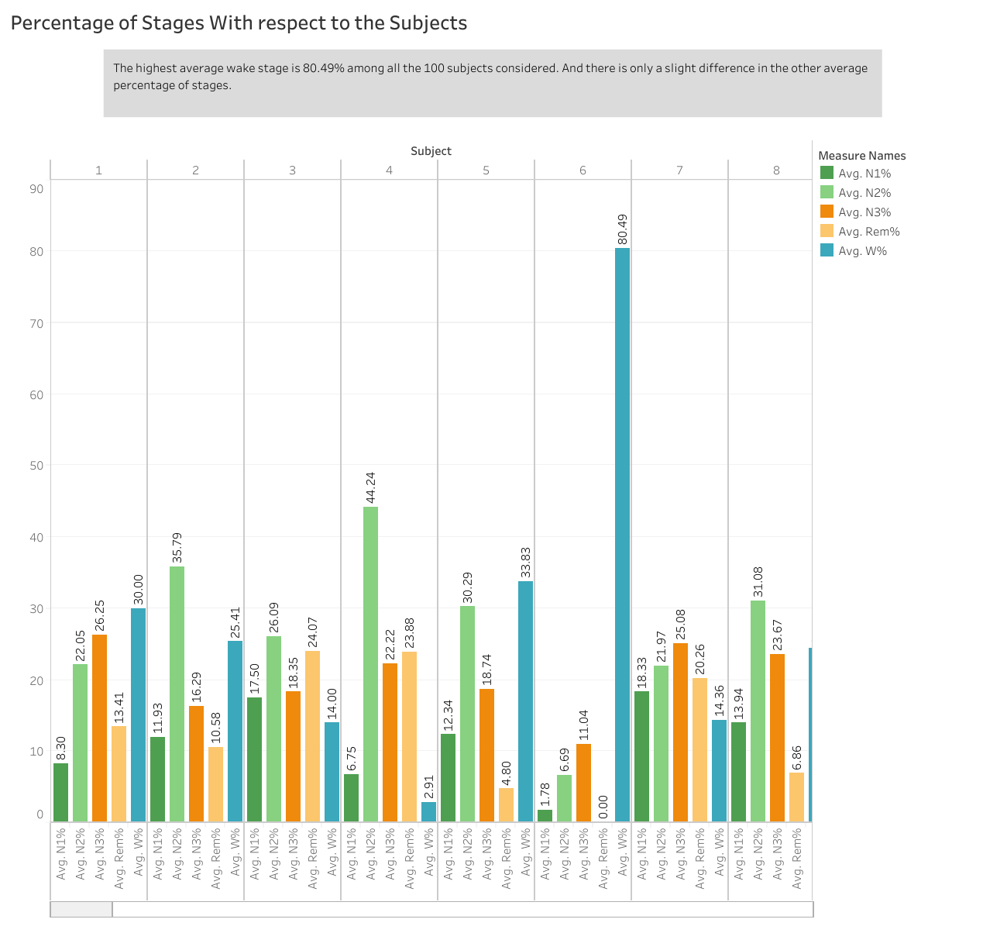

Fig. Percentage values of the Stages with respect to the subjects

The above graph represents the average percentage value of each i.e.ge i.e W, N1, N2, N3 ,and REM concerning to the subject.

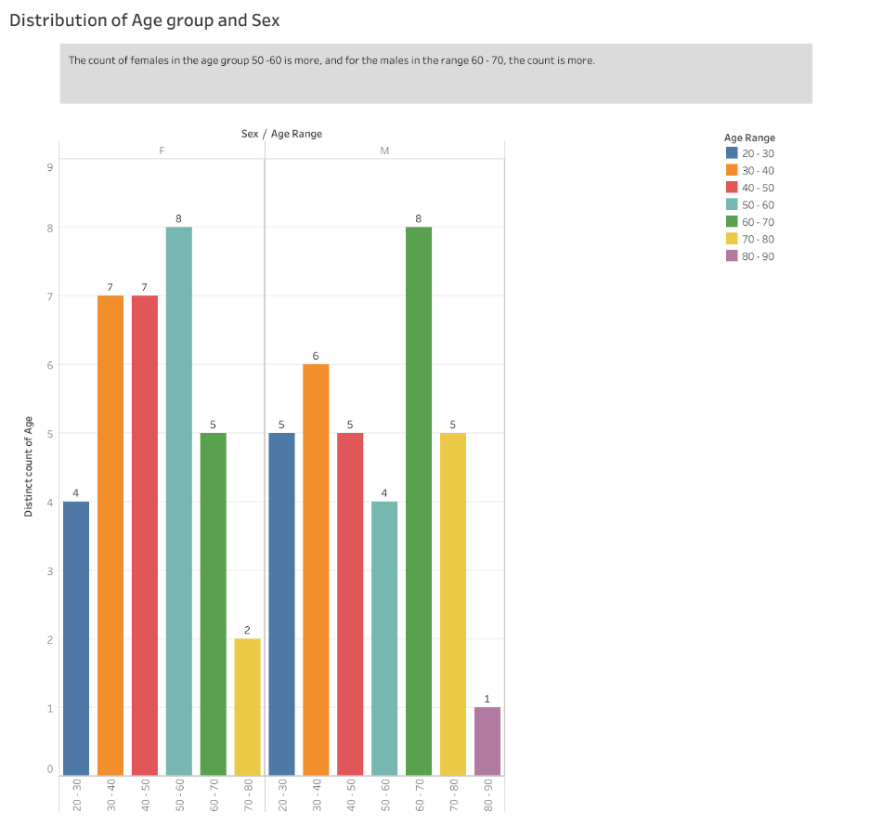

Fig. Distribution of age group and sex of the subjects

The above graph depicts the distribution of male and female subjects from each age group taken for the study.

Limitation

* Lack of availability of specific parameters for merging different forms of dataset

Scope of Study

* The future scope of the study will include modelling for better accuracy on real-time data that is not confined to a single race.

# References

|  |  |
| --- | --- |
| [1] | S. C. L. B. C. Lukáš Zoubek, "Feature selection for sleep/wake stages classification using data driven methods," *ScienceDirect,* vol. 2, no. 3, pp. 171-179, 3 July 2007. |
| [2] | M. R. K. M. M. K. A. C. M. M. J. L. M. P. Kannan Ramar, "Sleep is essential to health: an American Academy of Sleep Medicine position statement," *Journal of Clinical sleep of Medicine,* vol. 17, no. 10, 2021. |
| [3] | Y. S. E. K. S. S. K. I. S. U. K. M. K. T. K. Y. T. M. K. F. N. F. T. Hori, " Sleep ComputingCommittee of the Japanese Society of Sleep Research,Proposed supplements and amendments to ‘a manual ofstandardized terminology, techniques and the Rechtschaffen &Kales (1968) standard," *Psychiatry Clin. Neurosci. ,* vol. 55, no. 3, pp. 305-310, 2001. |
| [4] | A. J. J. V. S.L. Himanen, "Visual assessment ofselected high amplitude frontopolar slow waves of sleep:differences between healthy subjects and apnea patients," *Clin. EEG Neurosci. ,* vol. 35, no. 3, pp. 125-131, 2004. |
| [5] | D. R. M. W. M. B. C.J. Lauer, "From early tolate adulthood – changes in EEG sleep of depressed-patientsand healthy-volunteers," *Biol. Psychiatry ,* vol. 29, no. 0, 1991. |
| [6] | R. Armitage, "Sleep and circadian rhythms in mooddisorders," *Acta Psychiatr. Scand.,* p. 104–115, 2007. |
| [7] | W. R. B. F. J. H. H. P. C. D. R. C. N. K. Spiegelhalder, " Increased EEG sigma andbeta power during NREM sleep in primary insomnia,," *Biol.Psychol.,* p. 329–333, 2012. |