Department of Computer Science and Engineering
B.Tech III Semester
Academic Year 2026-2027
Data Analysis Essentials(2501AI06)
Corner Stone Project Documentation

ADITYA UNIVERSITY
Surampalem, Kakinada District
Andhra Pradesh-533437


SCHOOL OF COMPUTING
Department of Computer Science and Engineering
DATA ANALYSIS ESSENTIALS
CERTIFICATE
This is to certify that the Cornerstone project work entitled “STREAMING DATA ANALYSIS AND VISUALIZATION” is submitted by
N. HARSHA VARDHAN (25B11CS243)
P. CHANDRAKANTH (25B11CS715)
M.N. ANVESH (25B11CS057)
C.K. KAMAL BASHA (25B11CS148)
in partial fulfilment of the requirements for the award of the B.Tech. degree in Computer Science and Engineering for the academic year 2026-2027.
Project Guide  Mrs K. Vydehi, MTech., (Ph.D.)  Assistant Professor,  Department of CSE | Head of the Department  Dr. Phani Sridhar Addepalli, Ph.D.  Assistant Professor,  Department of CSE

DECLARATION

We hereby declare that the project entitled “STREAMING DATA ANALYSIS AND VISUALIZATION” is our original work and is submitted to ADITYA UNIVERSITY, Surampalem, in partial fulfillment of the requirements for the award of the B.Tech. degree in Computer Science and Engineering.
We further declare that this project has not been submitted, either in full or in part, for the award of any degree or diploma in this or any other institution. We also confirm that this work has been carried out with academic honesty and complies with the Institutional Academic Integrity and AI Usage Policy.
Place: Surampalem
Date: 01-10-2026
BY
N. HARSHA VARDHAN (25B11CS243)
P. CHANDRAKANTH (25B11CS715)
M.N. ANVESH (25B11CS057)
C.K. KAMAL BASHA (25B11CS148)

ACKNOWLEDGEMENT

It is with immense pleasure that we express our sincere gratitude to our Cornerstone Project Guide, K. Vydehi, Assistant Professor, who has guided us throughout the project. Her valuable support, encouragement, and guidance have greatly contributed to the successful completion of this work.
We would like to thank our Deputy Heads of the Department, Dr. Chandra Sekhar Kolli, Associate Professor, Dr, Hari Jyothula, Associate Professor, Dr. Pennada Siva Satya Prasad, Assistant Professor, Department of CSE for their support and valuable suggestions.
Our deepest thanks to our Head of Department, Dr. Phani Sridhar Addepalli, Assistant Professor for his inspiration and for providing all the necessary facilities and resources required for this project.
We also extend our sincere thanks to Dr. M.V. Rajesh, Associate Dean, School of Computing, for his encouragement and support during our project.
We would like to express our sincere gratitude to Dr. G. Suresh, Registrar; Dr. A. Ramesh, Pro Vice-Chancellor (Engineering & Sciences); Dr. S. Rama Sree, Pro Vice-Chancellor (Academics); Dr. M.B. Srinivas, Vice-Chancellor; and Dr. M. Sreenivasa Reddy, Deputy Pro Chancellor and Management, Aditya University, for providing excellent infrastructure and state-of-the-art laboratories.
Finally, we would like to thank the faculty members, lab technicians, non-teaching staff, and our friends who have directly or indirectly supported us in completing this Cornerstone project successfully.

ABSTRACT
STREAMING DATA ANALYSIS AND VISUALIZATION

Streaming Data Analysis and Visualization is the process of collecting, processing, analyzing, and displaying data continuously as it is generated from various sources such as Internet of Things (IoT) devices, social media platforms, financial transactions, sensors, and web applications. Unlike traditional batch processing, streaming analytics enables organizations to gain real-time insights, detect anomalies, and make immediate data-driven decisions.This project focuses on analyzing household energy consumption data by simulating a continuous data stream and extracting meaningful insights from it. The system utilizes Python, Pandas, and NumPy for data cleaning, statistical analysis, streaming simulation, running and moving averages, anomaly detection, and peak consumption identification. Matplotlib is used to create time-based and statistical visualizations including line charts, bar charts, histograms, and box plots.Effective visualization helps users identify trends, patterns, and unusual events quickly, improving operational efficiency and decision-making. By automating the analysis of energy consumption patterns, the Streaming Data Analysis and Visualization system reduces manual effort, increases the accuracy of anomaly detection, and enhances understanding of household energy usage for better energy management.

Table of contents
S.No. | Contents | Pages
1 | Title Page | 1
2 | Certificate | 2
3 | Declaration | 3
4 | Acknowledgement | 4
5 | Abstract | 5
6 | Table of Contents | 6
7 | List of Figures | 8
8 | List of Tables | 9
Chapter 1 | Introduction | 10
1.1 | Introduction to the Project | 10
1.2 | Problem Statement | 10
1.3 | Objectives of the Project | 10
1.4 | Scope of the Project | 11
Chapter 2 | Dataset Description and Understanding | 12
2.1 | Dataset Source | 12
2.2 | Dataset Description | 12
2.3 | Features / Attributes | 12
2.4 | Target Variable, if applicable | 13
2.5 | Dataset Statistics / Initial Exploration | 13
Chapter 3 | Data Preprocessing | 14
3.1 | Data Collection / Loading | 14
3.2 | Date-Time Construction and Numeric Conversion | 14
3.3 | Handling Missing and Duplicate Records | 14
3.4 | Other Project-Specific Preprocessing | 15
Chapter 4 | System Design and Methodology | 16
4.1 | Proposed Methodology | 16
4.2 | System Workflow / Architecture | 16
4.3 | Flowchart | 16
4.4 | Tools and Technologies Used | 17
4.5 | Algorithm / Analysis Method | 17
Chapter 5 | Implementation | 18
5.1 | Development Environment | 18
5.2 | Dataset Loading and Exploration | 18
5.3 | Preprocessing Implementation | 18
5.4 | Exploratory Data Analysis (EDA) | 18
5.5 | Model / Analysis Implementation | 19
5.6 | Important Code Explanation | 21
Chapter 6 | Data Visualization and Results | 23
6.1 | Bar Graph – Daily Average Consumption | 23
6.2 | Line Chart – Hourly Consumption | 23
6.3 | Anomaly Visualization | 24
6.4 | Histogram | 25
6.5 | Box Plot | 26
6.6 | Project-Specific Visualizations | 27
6.7 | Interpretation of Visualizations | 27
Chapter 7 | Analysis of Results | 29
7.1 | Evaluation Metrics | 29
7.2 | Experimental Results | 29
7.3 | Result Interpretation | 29
7.4 | Discussion | 29
Chapter 8 | Output Screenshots | 31
8.1 | Input / Dataset Screenshots | 31
8.2 | Preprocessing and Analysis Outputs | 31
8.3 | Visualization Outputs | 32
Chapter 9 | Conclusion and Future Enhancements | 34
9.1 | Conclusion | 34
9.2 | Limitations | 34
9.3 | Future Enhancements | 34
10 | References | 35
11 | Appendix – Source Code | 36

List of Figures
Figures | Figure Names | pages
1 | Flowchart of the implemented analysis process | 16
2 | Cleaned data displayed using head() | 15
3 | Statistical analysis output | 19
4 | Streaming simulation output | 19
5 | Anomaly analysis output | 20
6 | Peak consumption output | 21
7 | Daily average household appliance energy consumption (Bar Chart) | 23
8 | Average energy consumption by hour (Line Chart) | 24
9 | Energy consumption with potential anomalies | 25
10 | Distribution of appliance energy consumption (Histogram) | 26
11 | Box plot of household appliance energy consumption | 27
12 | Cleaned data and dataset input in Google Colab | 31
13 | Complete implementation console output | 31
14 | Daily average energy visualization | 32
15 | Hourly average energy visualization | 32
16 | Potential anomaly visualization | 32
17 | Histogram of appliance energy consumption | 33
18 | Box plot of appliance energy consumption | 33

List of Tables
Tables | Table Name | Pages
1 | Abbreviations | 11
2 | Dataset fields used in the implementation | 12
3 | Initial dataset statistics shown in the implementation output | 13
4 | Tools and technologies used | 17
5 | Statistical measures shown in the implementation output | 21
6 | Evaluation summary of analytical measures | 29

Chapter 1
Introduction

1.1 Introduction to the Project
Streaming data is continuously generated data that can be analyzed to identify patterns, trends, and unusual activities. The project “Streaming Data Analysis and Visualization” applies this concept to household energy consumption data by simulating a continuous data stream and extracting useful insights from appliance energy readings.
The project uses Python as the programming language and Pandas, NumPy, and Matplotlib as the main libraries. The implementation loads a household energy CSV file, combines date and time into a DateTime field, converts appliance readings to numeric values, removes incomplete and duplicate records, and sorts the data chronologically. It then uses operations such as head(), fillna-style cleaning with dropna(), sorting, rolling averages, and groupby statistics to interpret consumption behaviour.

1.2 Problem Statement
Household energy consumption is recorded as a sequence of readings that can contain missing values, duplicate records, inconsistent data types, and unusually high readings. Inspecting such data manually makes it difficult to understand consumption trends, identify peak periods, and detect potentially abnormal energy usage. Therefore, the project aims to clean, analyse, and visualize household energy data using Pandas, NumPy, and Matplotlib to obtain meaningful insights into consumption behaviour.

1.3 Objectives of the Project
- To load and organize household energy consumption data using Python and Pandas.
- To combine date and time information into a usable DateTime field.
- To clean the dataset by removing records with missing DateTime or Appliances values and removing duplicate records.
- To calculate mean, median, minimum, maximum, and standard deviation of appliance energy consumption.
- To simulate streaming data processing using the first 100 appliance readings.
- To calculate a moving average to observe consumption trends.
- To identify potential anomalies using a mean ± 2 standard-deviation threshold.
- To determine peak appliance energy consumption and analyze average consumption by hour.
- To visualize energy consumption and analytical results using bar charts, line charts, histograms, and box plots.

1.4 Scope of the Project
The scope of the project covers analysis of the supplied household energy consumption dataset. The implementation uses CSV input and processes the Appliances field together with the Date, Time, Temperature, and Humidity fields present in the dataset. The project simulates streaming rather than connecting to a live IoT, API, Kafka, Spark Streaming, or Flink source. Visualization includes daily averages, hourly averages, anomaly highlighting, histogram, and box-plot based analysis. The project can be further enhanced by connecting to a live data source and applying machine-learning based anomaly detection and forecasting.
S.No. | Abbreviation | Full Form
1 | DAE | Data Analysis Essentials
2 | IoT | Internet of Things
3 | CSV | Comma-Separated Values
4 | API | Application Programming Interface
5 | EDA | Exploratory Data Analysis
6 | KPI | Key Performance Indicator
7 | Wh | Watt-hour
8 | std | Standard Deviation
Table 1: Abbreviations

Chapter 2
Dataset Description and Understanding

2.1 Dataset Source
The input is a household energy consumption dataset stored as a CSV file named household_energy_consumption.csv. The file is placed in the Google Colab environment and loaded using the Pandas read_csv() function. The data contains appliance energy usage along with temperature, humidity, and date-time measurements.

2.2 Dataset Description
Each record represents an energy reading at a particular date and time. The implementation combines the Date and Time columns to form DateTime and primarily uses Appliances for statistical analysis, streaming simulation, trend analysis, anomaly detection, and visualization.

CODE:
import pandas as pd
import numpy as np
import matplotlib.pyplot as plt

# Load Data
df = pd.read_csv("/content/household_energy_consumption.csv")
print("First 5 records:")
print(df.head())
print("\nDataset Information:")
print(df.info())

2.3 Features / Attributes
S.No. | Attribute | Meaning / Role in project
1 | Date | Date component used to construct DateTime
2 | Time | Time component used to construct DateTime
3 | Appliances | Primary energy-consumption variable analyzed by the project
4 | Temperature | Environmental measurement present in the dataset
5 | Humidity | Environmental measurement present in the dataset
6 | DateTime | Derived timestamp created by combining Date and Time
7 | Hour | Derived hour value used for hourly analysis
8 | Moving_Average | Derived 10-record rolling mean used for trend visualization
9 | Anomaly | Derived Boolean indicator based on the anomaly threshold
Table 2: Dataset fields used in the implementation

2.4 Target Variable, if applicable
The project is descriptive and does not train a predictive model, so there is no labelled target variable. The Appliances column is the primary variable of interest: it is analysed statistically, smoothed with a moving average, and checked against a threshold to flag potential anomalies (the derived Anomaly column).

2.5 Dataset Statistics / Initial Exploration
The data is recorded at regular time intervals, which allows it to be used as a simulated streaming source. The preprocessing logic explicitly checks for invalid or missing DateTime and Appliances values, removes such records, and removes duplicate rows before any measure is calculated. The initial statistics shown in the implementation output are given below.
S.No. | Statistic | Value
1 | Mean of Appliances | 94.2086
2 | Median of Appliances | 97.92
3 | Minimum of Appliances | 29.65
4 | Maximum of Appliances | 350.0
5 | Standard Deviation | 31.2072
6 | Records in streaming simulation | 100
7 | Moving-average window | 10 records
8 | Anomaly threshold | mean ± 2 × std
Table 3: Initial dataset statistics shown in the implementation output

Chapter 3
Data Preprocessing

3.1 Data Collection / Loading
The household energy CSV file is available in the Google Colab environment and is read into a Pandas DataFrame. NumPy and Matplotlib are imported for numerical analysis and visualization respectively.
CODE:
import pandas as pd
import numpy as np
import matplotlib.pyplot as plt

# Load Data
df = pd.read_csv("/content/household_energy_consumption.csv")

3.2 Date-Time Construction and Numeric Conversion
The Date and Time fields are combined into a DateTime column. The errors="coerce" option converts invalid date-time values to missing values so that they can be removed during cleaning. Appliances is converted to numeric form for calculations.
CODE:
df["DateTime"] = pd.to_datetime(
df["Date"] + " " + df["Time"],
errors="coerce"
)
df["Appliances"] = pd.to_numeric(
df["Appliances"],
errors="coerce"
)

3.3 Handling Missing and Duplicate Records
Records that do not contain usable DateTime or Appliances values are removed using dropna(). Duplicate rows are also removed using drop_duplicates() so that repeated records do not affect the analysis.
CODE:
df = df.dropna(
subset=["DateTime", "Appliances"]
)
df = df.drop_duplicates()

3.4 Other Project-Specific Preprocessing
Chronological sorting supports time-based analysis. The Hour column is derived from DateTime to calculate average appliance consumption for each hour of the day.
CODE:
df = df.sort_values("DateTime")
df["Hour"] = df["DateTime"].dt.hour
print("Cleaned Data:")
print(df.head())

OUTPUT:
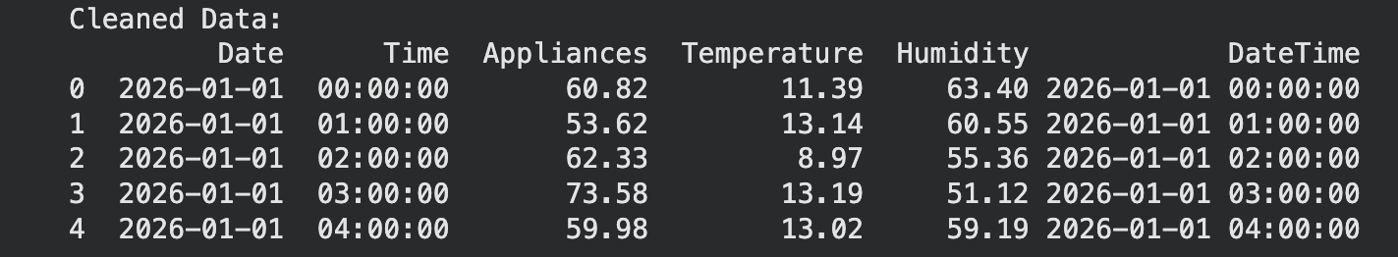
Fig. 2: Cleaned data displayed using head()

Chapter 4
System Design and Methodology

4.1 Proposed Methodology
The project follows a sequential data-analysis pipeline: load the household energy dataset, validate and clean the input, construct time information, calculate descriptive statistics, simulate streaming data, calculate running and moving averages, detect potential anomalies, identify peak consumption, perform hourly analysis, and visualize the results.

4.2 System Workflow / Architecture
The system is organized as a DataFrame-based analysis pipeline. CSV data forms the input. Pandas performs loading, type conversion, cleaning, sorting, grouping, and rolling operations. NumPy performs numerical calculations such as mean and standard deviation. Matplotlib presents the analytical results as graphs. Google Colab provides the execution environment. The implementation is a local simulation of streaming processing rather than a live streaming infrastructure.

4.3 Flowchart
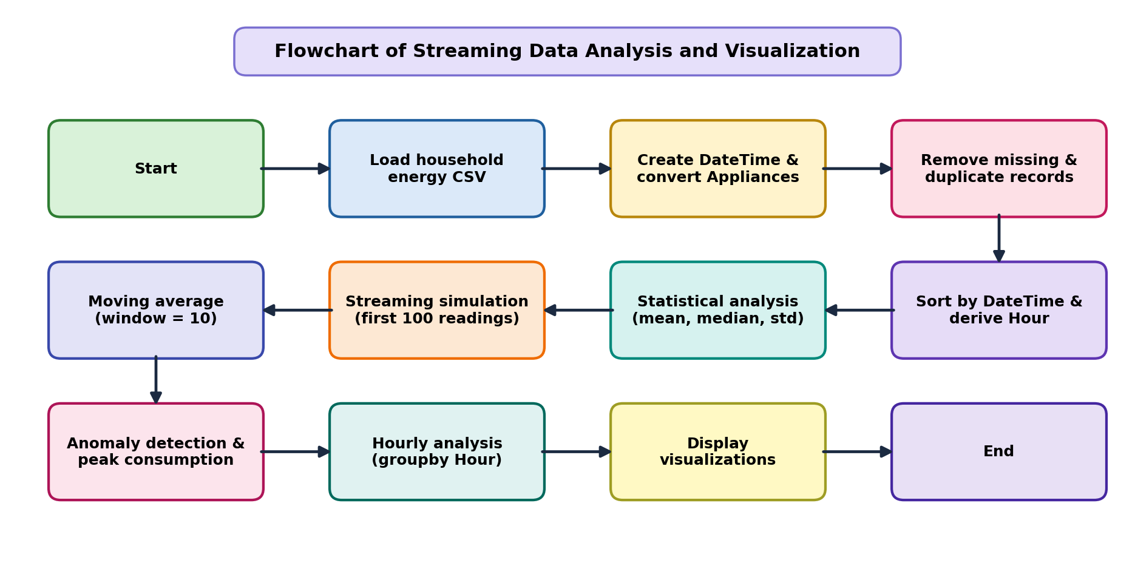
Fig. 1: Flowchart of the implemented analysis process

4.4 Tools and Technologies Used
S.No. | Tool / Technology | Purpose
1 | Python | Programming language
2 | Pandas | Data loading, cleaning, transformation and grouping
3 | NumPy | Statistical and numerical calculations
4 | Matplotlib | Charts and visualizations
5 | CSV | Input dataset format
6 | Google Colab | Development and execution environment
Table 4: Tools and technologies used
The Streaming Data Analysis and Visualization system uses Python for implementation. Pandas is used for importing, cleaning, organizing and analysing the dataset, and NumPy is used for numerical calculations. Matplotlib is used to create visualizations such as bar charts, line charts, histograms and box plots. Together, these tools transform raw household energy readings into meaningful insights.

4.5 Algorithm / Analysis Method
The project mainly uses descriptive data-analysis techniques with Pandas and NumPy; prediction using statistical or machine-learning models is considered a future enhancement. The steps followed are:
- Start the program and import Pandas, NumPy, and Matplotlib.
- Load household_energy_consumption.csv into a DataFrame.
- Create DateTime by combining Date and Time.
- Convert Appliances to numeric values.
- Remove records with missing DateTime or Appliances values.
- Remove duplicate records and sort the data by DateTime.
- Derive the Hour column from DateTime.
- Calculate mean, median, minimum, maximum, and standard deviation.
- Process the first 100 Appliances readings to simulate streaming data and calculate their running average.
- Calculate a 10-record moving average for trend analysis.
- Calculate mean ± 2 × standard deviation and flag readings outside this range as potential anomalies.
- Find the maximum Appliances value and its corresponding DateTime.
- Group Appliances by Hour and calculate average consumption.
- Generate bar, line, anomaly, histogram, and box-plot visualizations.
- Display the analytical results and stop.

Chapter 5
Implementation

5.1 Development Environment
Google Colab is used as the development and execution environment. The dataset is loaded from a CSV file available in the Colab environment. The analysis is implemented with Python, using Pandas, NumPy, and Matplotlib.

5.2 Dataset Loading and Exploration
The implementation reads the CSV file and uses head() and info() to inspect the first records and the structure of the dataset.
CODE:
df = pd.read_csv("/content/household_energy_consumption.csv")
print("First 5 records:")
print(df.head())
print("\nDataset Information:")
print(df.info())

5.3 Preprocessing Implementation
The demonstrated preprocessing includes constructing DateTime from Date and Time, converting Appliances to numeric type, removing records with missing DateTime or Appliances values, removing duplicate rows, sorting chronologically, and extracting the Hour of each reading (Chapter 3). The implementation does not use scaling, standardization, or encoding operations.

5.4 Exploratory Data Analysis (EDA)
The EDA calculates the mean, median, minimum, maximum, and standard deviation of the Appliances column.
CODE:
mean_value = df["Appliances"].mean()
median_value = df["Appliances"].median()
minimum = df["Appliances"].min()
maximum = df["Appliances"].max()
std_value = df["Appliances"].std()
print("STATISTICAL ANALYSIS")
print("--------------------")
print("Mean:", mean_value)
print("Median:", median_value)
print("Minimum:", minimum)
print("Maximum:", maximum)
print("Standard Deviation:", std_value)

OUTPUT:
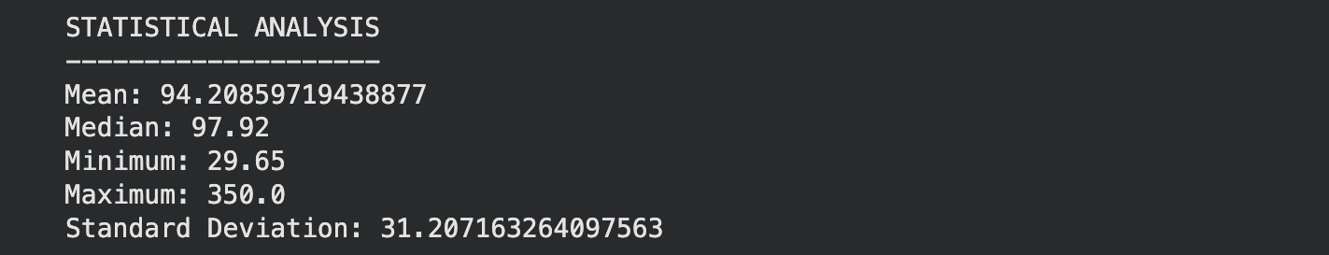
Fig. 3: Statistical analysis output

5.5 Model / Analysis Implementation
The main analysis is descriptive rather than predictive. It consists of a streaming simulation, a moving average, threshold-based anomaly detection, and peak and hourly analysis.

5.5.1 Streaming Simulation
The first 100 Appliances readings are processed one at a time, as if arriving from a stream, and a running average is calculated.
CODE:
stream_data = []
for value in df["Appliances"].head(100):
stream_data.append(value)
running_average = np.mean(stream_data)
print("Streaming Simulation")
print("--------------------")
print("Records processed:", len(stream_data))
print("Running Average:", running_average)

OUTPUT:
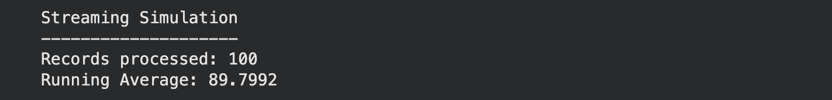
Fig. 4: Streaming simulation output

5.5.2 Moving Average
A rolling window of 10 records is used to calculate the moving average. This provides a smoothed representation of the appliance-consumption series for trend analysis.
CODE:
df["Moving_Average"] = (
df["Appliances"].rolling(window=10).mean()
)

5.5.3 Anomaly Detection
Readings that lie more than two standard deviations away from the mean are flagged as potential anomalies.
CODE:
mean = df["Appliances"].mean()
std = df["Appliances"].std()
upper_limit = mean + (2 * std)
lower_limit = mean - (2 * std)
df["Anomaly"] = (
(df["Appliances"] > upper_limit) |
(df["Appliances"] < lower_limit)
)
anomalies = df[df["Anomaly"]]
print("Number of anomalies:", len(anomalies))

OUTPUT:
Fig. 5: Anomaly analysis output

5.5.4 Peak and Hourly Analysis
The peak record is obtained using the maximum Appliances value. Hourly analysis groups readings by the derived Hour field and calculates the mean consumption for each hour.
CODE:
peak_value = df["Appliances"].max()
peak_record = df[
df["Appliances"] == peak_value
]
hourly_consumption = (
df.groupby("Hour")["Appliances"].mean()
)

OUTPUT:
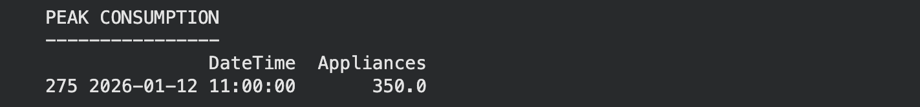
Fig. 6: Peak consumption output
S.No. | Measure | Value shown in implementation output
1 | Mean | 94.20859719438877
2 | Median | 97.92
3 | Minimum | 29.65
4 | Maximum | 350.0
5 | Standard Deviation | 31.207163264097563
6 | Records processed in streaming simulation | 100
7 | Running Average | 89.7992
8 | Number of anomalies | 4
9 | Peak consumption | 350.0 at 2026-01-12 11:00:00
Table 5: Statistical measures shown in the implementation output

5.6 Important Code Explanation
The following code operations are important in the Streaming Data Analysis and Visualization system:
- pd.read_csv() – Imports the household energy consumption dataset.
- head() / info() – Displays the first records and the structure of the dataset.
- pd.to_datetime() – Combines Date and Time into a single DateTime column.
- pd.to_numeric() – Converts Appliances to numeric type.
- dropna() / drop_duplicates() – Removes incomplete and duplicate records.
- sort_values() – Orders data chronologically by DateTime.
- dt.hour – Extracts the hour of day for hourly analysis.
- mean() / median() / min() / max() / std() – Core statistical measures.
- np.mean() – Calculates the running average of the streamed readings.
- rolling(window=10).mean() – Computes the moving average for trend analysis.
- Threshold (mean ± 2*std) – Statistical anomaly detection rule.
- groupby("Hour") – Aggregates consumption by hour of day.

Chapter 6
Data Visualization and Results

6.1 Bar Graph – Daily Average Consumption
The bar chart represents household appliance energy consumption aggregated by day. The groupby() function groups the readings by date and mean() calculates the average consumption for each day. The chart covers the first 30 days and allows daily variations to be compared visually.
CODE:
daily = df.groupby(df["DateTime"].dt.date)["Appliances"].mean()
plt.figure(figsize=(12, 5))
plt.bar(range(len(daily.head(30))), daily.head(30).values, color="steelblue")
plt.xlabel("Day")
plt.ylabel("Average Energy Consumption")
plt.title("Daily Average Household Appliance Energy Consumption")
plt.tight_layout()
plt.show()

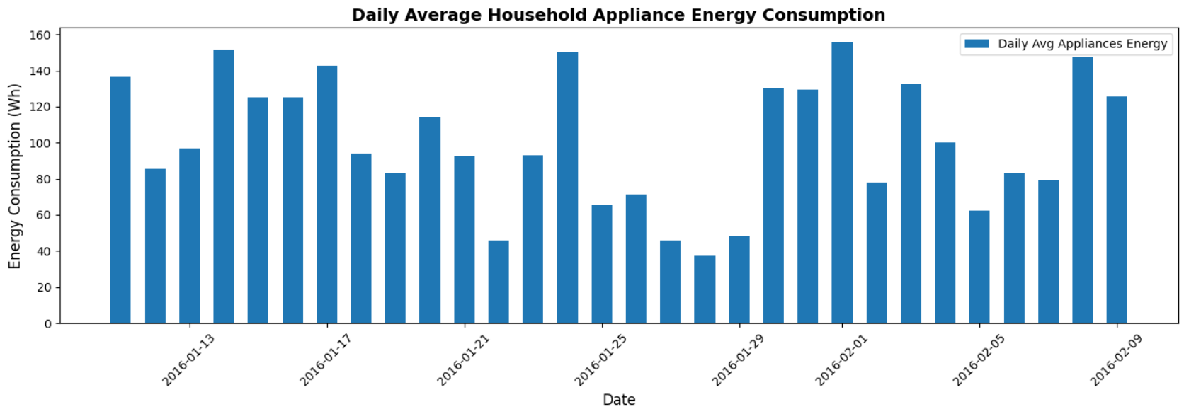
Fig. 7: Bar Chart on Daily Average Household Appliance Energy Consumption

6.2 Line Chart – Hourly Consumption
The line chart shows the mean Appliances value for each hour from 0 to 23. The groupby() function groups the readings by the derived Hour column. The visualization makes it possible to identify periods with comparatively higher or lower average consumption.
CODE:
hourly_consumption = df.groupby("Hour")["Appliances"].mean()
plt.figure(figsize=(10, 5))
plt.plot(hourly_consumption.index, hourly_consumption.values, marker="o")
plt.xlabel("Hour of the Day")
plt.ylabel("Average Appliance Consumption")
plt.title("Average Energy Consumption by Hour")
plt.xticks(range(24))
plt.grid(True, alpha=0.3)
plt.tight_layout()
plt.show()

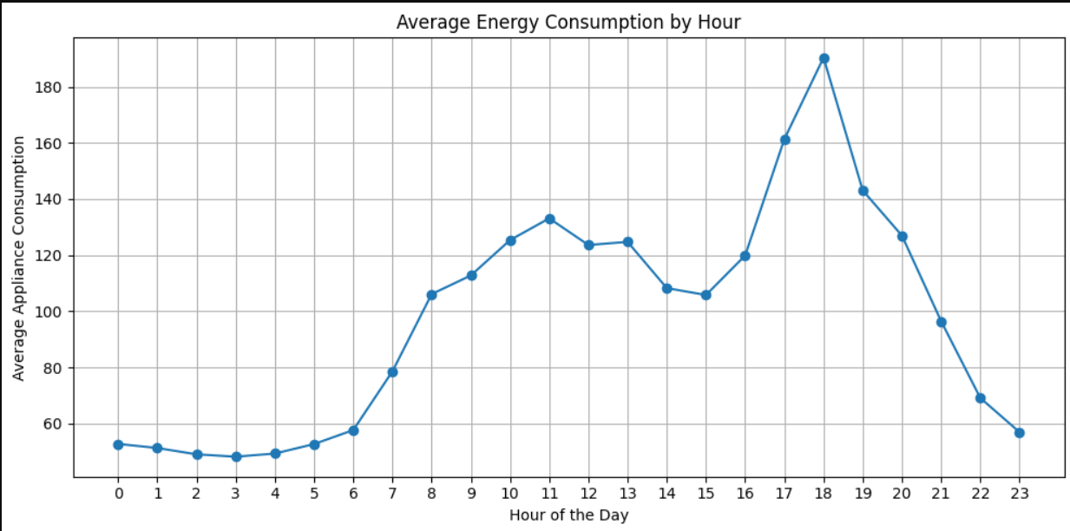
Fig. 8: Line Chart on Average Energy Consumption by Hour

6.3 Anomaly Visualization
The anomaly visualization compares energy consumption over time with the potential anomaly series. The implementation identifies readings outside the mean ± 2 standard-deviation threshold and plots them separately for inspection.
CODE:
plt.figure(figsize=(12, 5))
plt.plot(df["DateTime"], df["Appliances"], label="Energy Consumption")
plt.plot(anomalies["DateTime"], anomalies["Appliances"],
label="Potential Anomaly")
plt.xlabel("Time")
plt.ylabel("Energy Consumption")
plt.title("Energy Consumption with Potential Anomalies")
plt.legend()
plt.xticks(rotation=45)
plt.tight_layout()
plt.show()

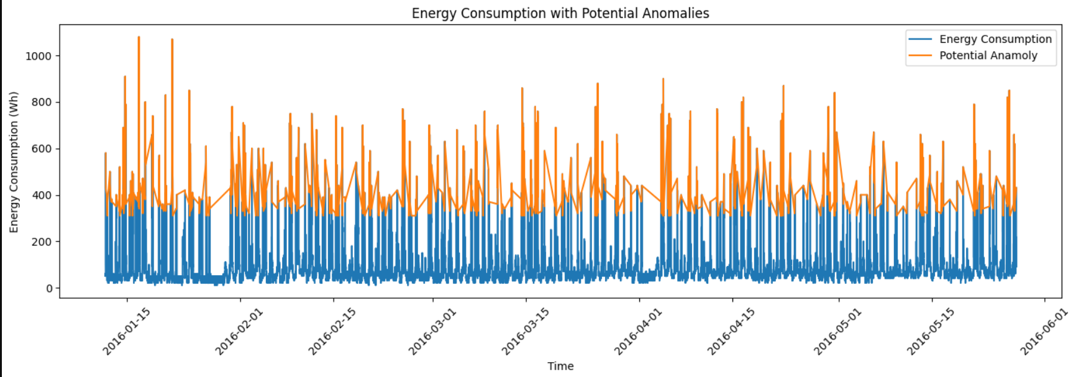\
Fig. 9: Line Chart on Energy Consumption with Potential Anomalies

6.4 Histogram
The histogram represents the distribution of household appliance energy consumption. It groups readings into intervals called bins, and each bar represents the number of readings within an interval. Taller bars indicate consumption values that occur more frequently, so the histogram helps identify common consumption ranges and unusually high readings.
CODE:
plt.figure(figsize=(8, 5))
plt.hist(df["Appliances"].dropna(), bins=20,
color="steelblue", edgecolor="black")
plt.xlabel("Appliance Energy Consumption")
plt.ylabel("Frequency")
plt.title("Distribution of Appliance Energy Consumption")
plt.tight_layout()
plt.show()

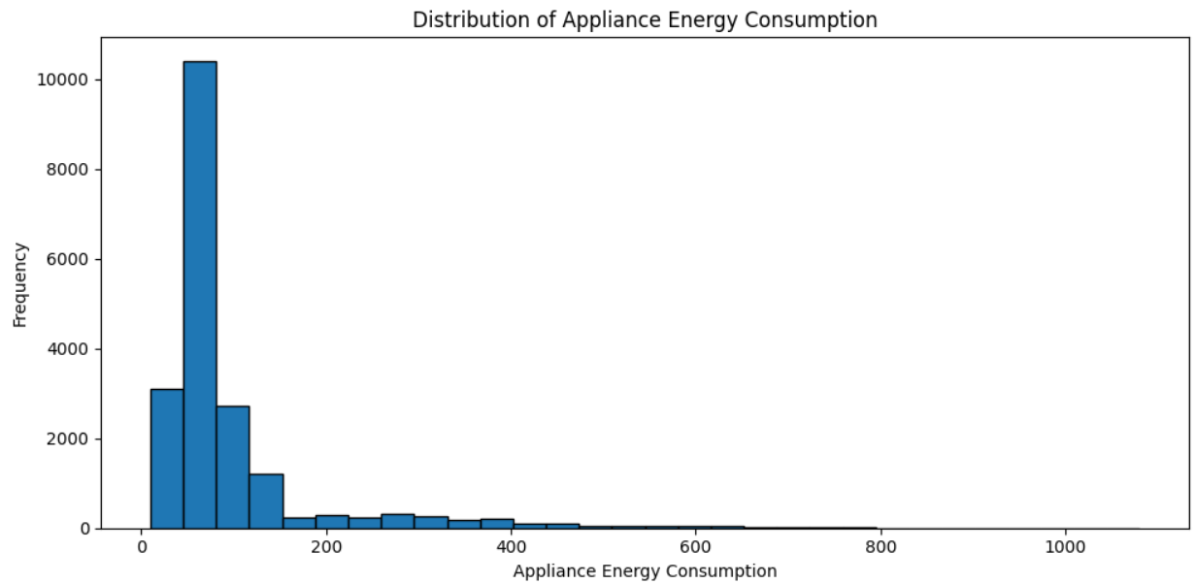
Fig. 10: Histogram on Distribution of Appliance Energy Consumption

6.5 Box Plot
The box plot represents the distribution of household appliance energy consumption. It shows the median, quartiles, and spread of the readings. The line inside the box represents the median, the box represents the middle 50% of the readings, and points beyond the whiskers indicate potential outliers.
CODE:
plt.figure(figsize=(6, 5))
plt.boxplot(df["Appliances"].dropna(), vert=True)
plt.ylabel("Appliance Energy Consumption")
plt.title("Box Plot of Household Appliance Energy Consumption")
plt.tight_layout()
plt.show()

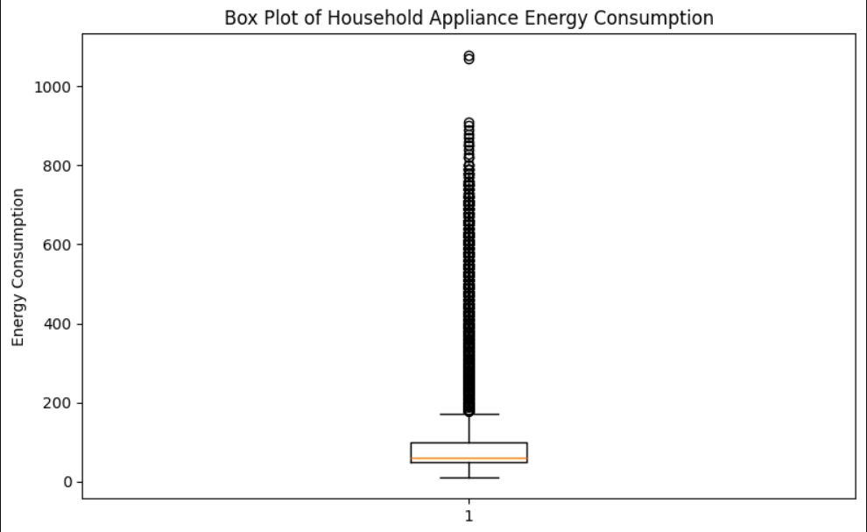
Fig. 11: Box Plot on Household Appliance Energy Consumption

6.6 Project-Specific Visualizations
The project uses different visualizations to present the results of the data analysis clearly. These visualizations help understand consumption trends, peak periods, and unusual readings.
- Daily Average Energy Consumption – compares average appliance consumption of different days using a bar chart.
- Average Energy Consumption by Hour – shows how average consumption changes across the 24 hours of the day using a line chart.
- Energy Consumption with Potential Anomalies – highlights readings outside the mean ± 2 × std threshold using a line chart.
- Distribution of Appliance Energy Consumption – shows the frequency of different consumption ranges using a histogram.
- Box Plot of Appliance Energy Consumption – shows the median, spread, and potential outliers using a box plot.

6.7 Interpretation of Visualizations
The visualizations provide a clear understanding of the household energy dataset and consumption patterns. The daily-average chart shows that appliance energy consumption varies from day to day. The hourly chart demonstrates that average consumption is not constant across the 24-hour period: it stays lowest during the early-morning hours, rises during the day, and reaches its highest level in the evening around 18:00. The anomaly chart highlights unusually high readings according to the implemented threshold. The histogram shows that the majority of appliance readings are concentrated in a lower range, with fewer higher readings. The box plot shows a compact central distribution with numerous high-value points treated as potential outliers. Overall, these visualizations make the dataset easier to understand and help identify energy-usage patterns.

Chapter 7
Analysis of Results

7.1 Evaluation Metrics
Because the project is descriptive data analysis rather than a predictive machine-learning model, predictive metrics such as accuracy, precision, recall, or F1-score are not reported. The evaluation measures are descriptive statistics and analytical outputs: mean, median, minimum, maximum, standard deviation, running average, moving average, anomaly count, peak consumption, and hourly mean consumption.

7.2 Experimental Results
S.No. | Measure | Value | Evaluation
1 | Mean | 94.21 | Average appliance consumption level
2 | Median | 97.92 | Central value of the readings
3 | Minimum | 29.65 | Lowest recorded consumption
4 | Maximum | 350.0 | Highest value in the console output
5 | Standard Deviation | 31.21 | Spread of readings around the mean
6 | Running Average (100 records) | 89.80 | Average of the simulated stream
7 | Number of anomalies | 4 | Readings beyond mean ± 2 × std
8 | Peak consumption | 350.0 | Recorded at 2026-01-12 11:00:00
Table 6: Evaluation summary of analytical measures
The table presents the analytical measures reported by the implementation. The streaming simulation processes 100 records and reports a running average of 89.7992. The anomaly analysis reports 4 potential anomalies, and the peak consumption shown is 350.0 at 2026-01-12 11:00:00.

7.3 Result Interpretation
The results demonstrate that the project can transform raw household energy readings into structured temporal and statistical information. The peak value identifies a high-consumption observation, while the anomaly count indicates readings that cross the selected statistical threshold. Hourly grouping and daily aggregation provide additional views of consumption behaviour.

7.4 Discussion
The project demonstrates a complete basic analysis pipeline from CSV data loading to descriptive statistics and visualization, in the style of streaming data analysis using a historical dataset. The implementation simulates continuous processing but does not establish a live event-stream connection. Therefore, the reported results should be interpreted as analysis of the supplied dataset rather than measurements from a production real-time streaming platform.

Chapter 8
Output Screenshots

8.1 Input / Dataset Screenshots
Fig. 12: Cleaned data and dataset input in Google Colab

8.2 Preprocessing and Analysis Outputs
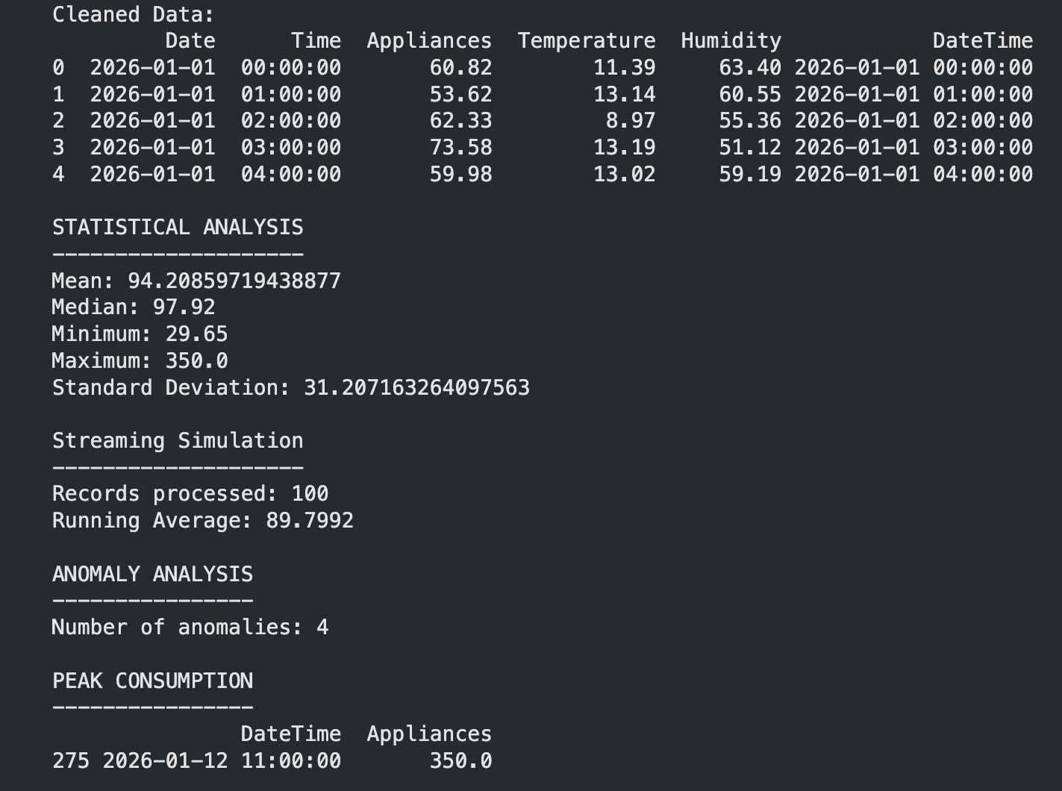
Fig. 13: Complete implementation console output

8.3 Visualization Outputs
Fig. 14: Daily average energy visualization
Fig. 15: Hourly average energy visualization
Fig. 16: Potential anomaly visualization
Fig. 17: Histogram of appliance energy consumption
Fig. 18: Box plot of appliance energy consumption

Chapter 9
Conclusion and Future Enhancements

9.1 Conclusion
The Streaming Data Analysis and Visualization project demonstrates how household energy consumption data can be cleaned, processed, analyzed, and visualized using Python. Pandas is used for data loading, cleaning, transformation, sorting, grouping, and rolling calculations. NumPy supports numerical analysis, while Matplotlib provides visual representations of the results.
The implementation constructs DateTime values, removes unusable and duplicate records, calculates descriptive statistics, simulates streaming by processing the first 100 readings, calculates a moving average, detects potential anomalies using a statistical threshold, identifies peak consumption, and performs hourly analysis. The resulting charts help interpret temporal patterns and unusual energy-consumption values. Overall, the project helps understand household energy usage patterns, identify unusual consumption, and gain useful insights for better energy management and decision-making.

9.2 Limitations
- The implementation uses a historical CSV dataset and simulates streaming rather than receiving a live event stream.
- No production Kafka, Spark Streaming, Flink, cloud streaming, authentication, fault-tolerant deployment, or real-time dashboard is implemented.
- Anomaly detection relies on a simple statistical threshold (mean ± 2 × std).
- No predictive machine-learning model or predictive evaluation metric is reported.
- The histogram, box plot, and anomaly chart show readings above the 350.0 maximum and more highlighted points than the 4 anomalies reported in the console output, so those charts and the console output may come from different runs or dataset versions and should be read separately.

9.3 Future Enhancements
- Extend the system from the current simulation to a live data pipeline using a streaming source such as an IoT feed or API.
- Consider scalable stream-processing technologies such as Apache Kafka, Apache Spark Streaming, or Apache Flink.
- Apply machine-learning models for more accurate anomaly detection and consumption forecasting.
- Build interactive dashboards for continuous monitoring of energy consumption.
- Explore stronger mechanisms for data quality, latency, scalability, fault tolerance, and security.
10
References
DAE Course Textbook and Study Material – Data Analysis Essentials.
· Python for Data Analysis – Wes McKinney
https://wesmckinney.com/book/
· Python Data Analytics – Fabio Nelli
https://link.springer.com/book/10.1007/978-1-4842-9532-8
· Pandas Documentation
https://pandas.pydata.org/docs/
· NumPy Documentation
https://numpy.org/doc/stable/
· Matplotlib Documentation
https://matplotlib.org/stable/
· Kaggle
https://www.kaggle.com/

11
Appendix – Source Code
The following source code was used to import, clean, analyse, and visualize the household energy consumption dataset using Python, Pandas, NumPy, and Matplotlib.
# Import libraries
import pandas as pd
import numpy as np
import matplotlib.pyplot as plt

# Load Data
df = pd.read_csv("/content/household_energy_consumption.csv")
print("First 5 records:")
print(df.head())
print("\nDataset Information:")
print(df.info())

# Convert Date and Time into one column
df["DateTime"] = pd.to_datetime(
df["Date"] + " " + df["Time"], errors="coerce")

# Convert Appliances to numeric
df["Appliances"] = pd.to_numeric(df["Appliances"], errors="coerce")

# Remove missing and duplicate records
df = df.dropna(subset=["DateTime", "Appliances"])
df = df.drop_duplicates()

# Sort data and create Hour column
df = df.sort_values("DateTime")
df["Hour"] = df["DateTime"].dt.hour
print("Cleaned Data:")
print(df.head())

# Statistical Analysis
mean_value = df["Appliances"].mean()
median_value = df["Appliances"].median()
minimum = df["Appliances"].min()
maximum = df["Appliances"].max()
std_value = df["Appliances"].std()
print("STATISTICAL ANALYSIS")
print("Mean:", mean_value)
print("Median:", median_value)
print("Minimum:", minimum)
print("Maximum:", maximum)
print("Standard Deviation:", std_value)

# Streaming Simulation
stream_data = []
for value in df["Appliances"].head(100):
stream_data.append(value)
running_average = np.mean(stream_data)
print("Records processed:", len(stream_data))
print("Running Average:", running_average)

# Moving Average
df["Moving_Average"] = df["Appliances"].rolling(window=10).mean()

# Anomaly Detection
mean = df["Appliances"].mean()
std = df["Appliances"].std()
upper_limit = mean + (2 * std)
lower_limit = mean - (2 * std)
df["Anomaly"] = ((df["Appliances"] > upper_limit) |
(df["Appliances"] < lower_limit))
anomalies = df[df["Anomaly"]]
print("Number of anomalies:", len(anomalies))

# Peak Consumption
peak_value = df["Appliances"].max()
peak_record = df[df["Appliances"] == peak_value]
print("Peak Consumption:")
print(peak_record[["DateTime", "Appliances"]])

# Hourly Analysis
hourly_consumption = df.groupby("Hour")["Appliances"].mean()
print("HOURLY CONSUMPTION")
print(hourly_consumption)

# Visualizations
daily = df.groupby(df["DateTime"].dt.date)["Appliances"].mean()
plt.figure(figsize=(12, 5))
plt.bar(range(len(daily.head(30))), daily.head(30).values, color="steelblue")
plt.xlabel("Day")
plt.ylabel("Average Energy Consumption")
plt.title("Daily Average Household Appliance Energy Consumption")
plt.tight_layout()
plt.show()

plt.figure(figsize=(10, 5))
plt.plot(hourly_consumption.index, hourly_consumption.values, marker="o")
plt.xlabel("Hour of the Day")
plt.ylabel("Average Appliance Consumption")
plt.title("Average Energy Consumption by Hour")
plt.xticks(range(24))
plt.grid(True, alpha=0.3)
plt.tight_layout()
plt.show()

plt.figure(figsize=(12, 5))
plt.plot(df["DateTime"], df["Appliances"], label="Energy Consumption")
plt.plot(anomalies["DateTime"], anomalies["Appliances"],
label="Potential Anomaly")
plt.xlabel("Time")
plt.ylabel("Energy Consumption")
plt.title("Energy Consumption with Potential Anomalies")
plt.legend()
plt.xticks(rotation=45)
plt.tight_layout()
plt.show()

plt.figure(figsize=(8, 5))
plt.hist(df["Appliances"].dropna(), bins=20,
color="steelblue", edgecolor="black")
plt.xlabel("Appliance Energy Consumption")
plt.ylabel("Frequency")
plt.title("Distribution of Appliance Energy Consumption")
plt.tight_layout()
plt.show()

plt.figure(figsize=(6, 5))
plt.boxplot(df["Appliances"].dropna(), vert=True)
plt.ylabel("Appliance Energy Consumption")
plt.title("Box Plot of Household Appliance Energy Consumption")
plt.tight_layout()
plt.show()

