# 7 Days Terraweek Challenge: Day 1 — Getting Started with Terraform

Hello connections, It’s my day 1 of the 7-day Terraweek challenge, where we will dive into the basic concepts of Terraform.

* **What is Terraform and how does it revolutionize infrastructure management?**
* **Why do we need it and how does it simplify provisioning?**
* **Learn crucial Terraform terminologies with examples.**
* **Understand Terraform Lifecycle.**
* **Easily install Terraform and configure environments for AWS.**

Before we deep dive into Terraform, let’s first understand the Infrastructure as Code (IaC).

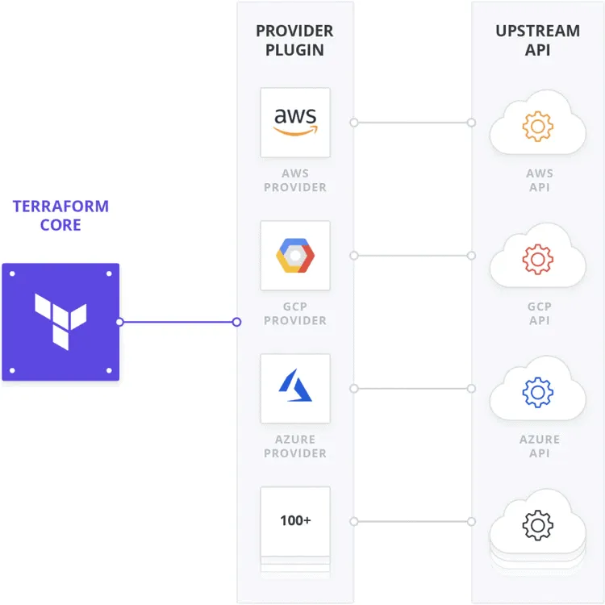

**Infrastructure as Code (IaC)**  
Infrastructure as Code (IaC) is a software engineering approach that involves managing and provisioning computing infrastructure using code and automation. In this paradigm, infrastructure configurations, including servers, networks, databases, and other resources, are defined and managed using human-readable and version-controlled files rather than manual configuration.

**Terraform**Terraform is an open-source infrastructure as code (IaC) tool used for building, changing, and version-controlling infrastructure efficiently. It enables users to define and provision infrastructure using a declarative configuration language. With Terraform, you can describe the components of your infrastructure (like servers, networks, databases, etc.) in a configuration file, and Terraform will then manage the provisioning and orchestration of these resources.

* **Why do we need it and how does it simplify provisioning?**

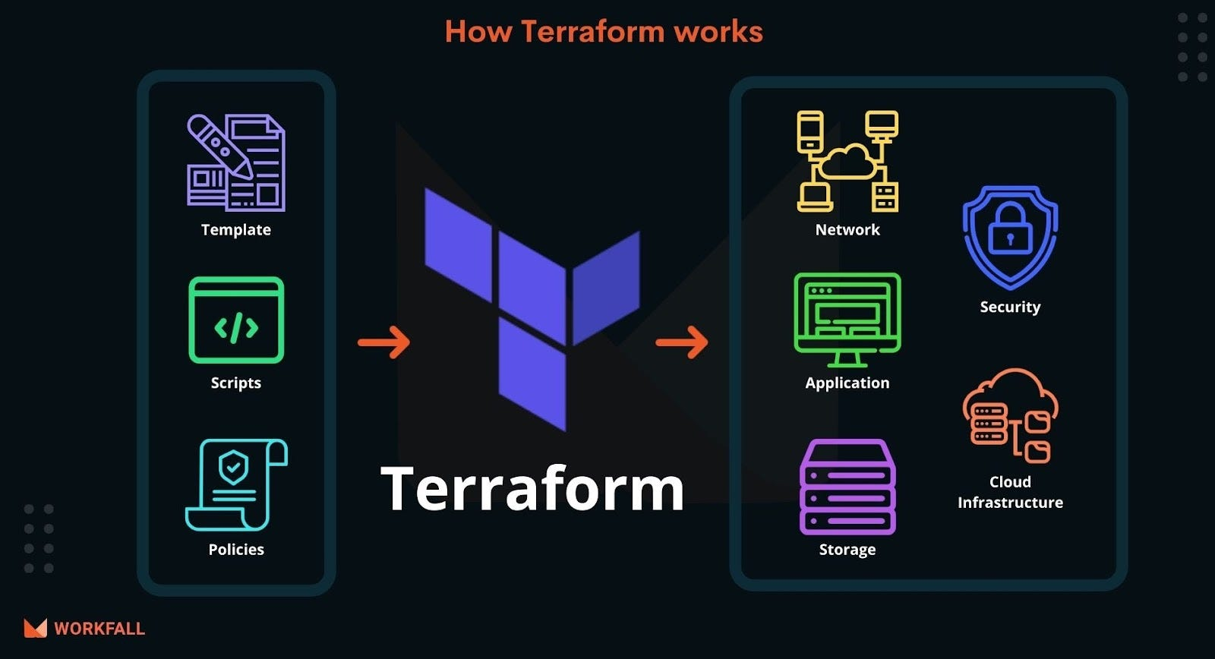

Terraform simplifies infrastructure provisioning and management in several ways, making it a valuable tool for modern software development and operations. Here’s a detailed explanation of why Terraform is essential and how it simplifies infrastructure provisioning:

1. Declarative Configuration:  
Terraform allows users to define the desired infrastructure in a declarative configuration file. You specify the resources and their configurations in a clear and human-readable language (HashiCorp Configuration Language — HCL).  
Example:

resource "aws_instance" "example" {  
 ami = "ami-0c94855ba95c71c99"  
 instance_type = "t2.micro"  
}

2. Resource Graph: Terraform builds a dependency graph of your resources based on the configuration, ensuring the provisioning of resources in the correct order to avoid dependency issues.

3. State Management: Terraform maintains a state file that keeps track of the state of your infrastructure. This allows Terraform to know the existing resources and their current state, enabling it to determine the necessary changes for updates.

4. Modularity and Reusability: Terraform promotes modularity by allowing you to organize your configuration into reusable modules. This fosters code reusability and easier management of complex infrastructures.

5. Multi-Cloud and Hybrid Cloud Support: Terraform is cloud-agnostic, supporting various cloud providers (e.g., AWS, Azure, GCP) and even on-premises and other infrastructure platforms.

9. Integration with Ecosystem: Terraform integrates well with other tools and services, allowing for enhanced automation, collaboration, and workflow integration. This includes version control systems, CI/CD tools, and more.

* **Learn crucial Terraform terminologies with examples.**

Key Terraform Terminologies with Examples:

1. Provider:

* A provider is a plugin that Terraform uses to interact with the API of a specific platform (e.g., AWS, Azure, GCP).

Example:

provider "aws" { region = "us-west-2" }

2. Resource

A resource is a provisioned entity in the target infrastructure, such as an EC2 instance, a VPC, or a database.

Example:

resource "aws_instance" "example" {  
 ami = "ami-0c94855ba95c71c99"  
 instance_type = "t2.micro"  
}

3. Module

* A module is a collection of related resources that can be used to organize and reuse Terraform configurations.

Example:

module "example_module" {  
 source = "./path/to/module"  
 some_parameter = "value"  
}

4. Variables

Variables are used to parameterize your configurations, allowing for flexibility and reusability.

Example:

variable "instance_type" {  
 description = "The type of EC2 instance"  
 default = "t2.micro"  
}

5. Output

Outputs are values that you can export from a module to use elsewhere.

Example:

output "instance_ip" {  
 value = aws_instance.example.private_ip  
}

These key concepts provide the foundation for creating infrastructure as code using Terraform, allowing you to effectively provision and manage your resources in a cloud-agnostic and repeatable manner.

**Installing Terraform and Setting Up the Environment:**

1. Install Terraform: You can download and install Terraform from the official website: [Terraform Downloads](https://www.terraform.io/downloads.html)

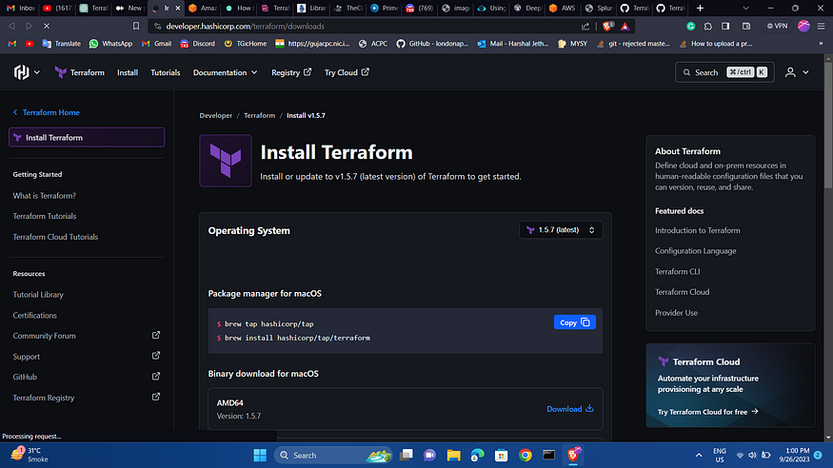

1. Set Up Environment for AWS:

* Configure AWS CLI with your credentials.
* Create an IAM user with appropriate permissions and generate access keys.

aws configure

2. Set Up Environment for Azure:

* Install Azure CLI: [Azure CLI Installation](https://docs.microsoft.com/en-us/cli/azure/install-azure-cli)
* Authenticate Azure CLI using az login.
* Create an Azure Service Principal for authentication.

3. Set Up Environment for GCP:

* Install Google Cloud SDK: [Google Cloud SDK Installation](https://cloud.google.com/sdk/docs/install)
* Authenticate with GCP using gcloud auth login.
* Create a service account and generate a JSON key file.

**Setup to Implement IAC using Terraform :**

1. Create Terraform configuration file:

* Create a new directory for your Terraform configuration files.
* Open a terminal and navigate to the new directory.
* Create a new Terraform configuration file with a .tf extension (e.g., main. tf). This file will contain your infrastructure code.
* In the configuration file, specify the AWS provider and any resources you want to create or manage.

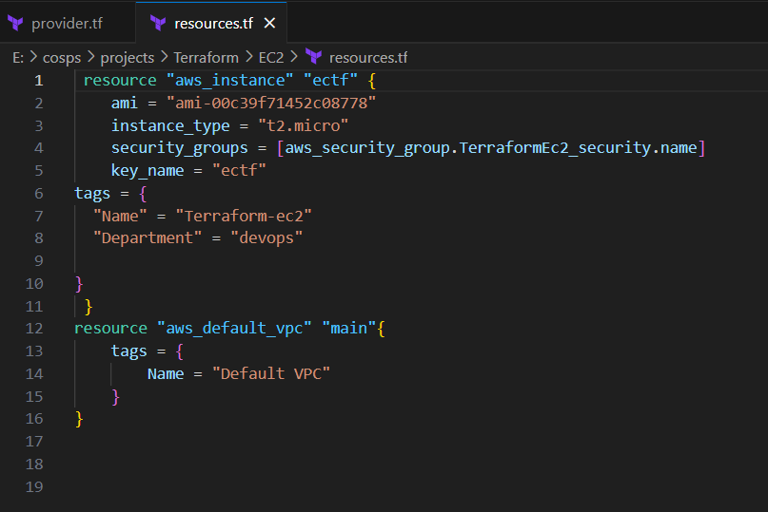

2. Initialize Terraform:

* In the terminal, navigate to your Terraform directory (where your configuration file is located).
* Run the following command to initialize Terraform and download the necessary provider plugins:

terraform init

3. Deploy Infrastructure:

* After initialization, run the following command to preview the changes Terraform will make to your AWS environment:

terraform plan

* Review the output and ensure it matches your intentions.
* If everything looks good, execute the following command to apply the changes and create the infrastructure:

terraform apply

Terraform simplifies infrastructure provisioning by providing a clear, declarative way to define infrastructure, manage dependencies, preview changes, maintain a consistent state, and facilitate collaboration across teams. Its cloud-agnostic approach and integration capabilities make it a powerful tool for managing infrastructure as code in various environments.

**Follow me:**

Linkedin: <https://www.linkedin.com/in/harshaljethwa/>

GitHub: <https://github.com/HARSHALJETHWA19/>

Twitter: <https://twitter.com/harshaljethwaa>

Thank You!